A chance to be themselves

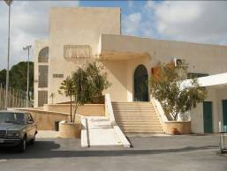
The YMCA’s family intervention work is one of the programmes funded by Christian Aid. Weekend camps are organised at their centre in Beit Sahour, near Bethlehem in the West Bank, bringing together counsellors, trainers, young boys who have faced imprisonment and their families for team building. They take part in fun games designed to create team spirit and confidence as well as developing leadership skills. Tree stumps, set in the grounds of the buildings in Beit Sahour, are used for balancing and team spirit building while the swimming pool and adjoining hard area amenities encourage sporting activity. Many of these young boys, especially those from the refugee camps, have not had the luxury of being able to play sports because open spaces and facilities are non-existent in the camps and limited or of poor quality in the West Bank.

Twice yearly away days are also arranged for the wives, mothers and sisters involved with those needing counselling. These days away are vital to the women as they provide them with a safe and secure environment with the chance to meet others in the same situation. Swimming in the onsite pool is always the highlight, with laughter filling the air as stress is released and problems shared. Many of the women struggle to understand the changes in their children after time in jail and want to keep them safe. However the young men want to be out with friends and this causes friction. The women know this may lead to more trouble and arrests and so continually worry. It is often the women who will keep a family going when husbands or sons are in jail.

So for the young men and their families these away days are a chance to recoup, refresh and revitalise as they continue to live with the difficulties experienced as a result of the Israeli occupation.

Image: lmead/cforl YMCA swimming pool at the Beit Sahour centre which is used as part of their family intervention work.

