**Maths and mulching**

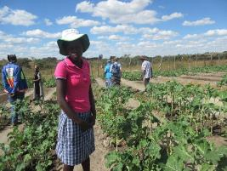Life ambitions are not easy to achieve for young people living in Zimbabwe today, especially those in the rural areas. With unemployment at 95%, many young men leave their home communities to find work in South Africa or Botswana. This leaves villages with women, children and older men.

For eighteen-year-old Nomthsndszo, the Mthombowesizwe Garden Project is providing the best possible start in life; an education. Located in Ward 18 of Inziza District, South Matabeleland, the community are mainly from the minority Xhosa tribe. Gender workshops run by ZimPro have given the women a voice. Before they were involved in this project they could not go to market by themselves. Now they barter for goods and have become stronger.

Originally started to provide a healthy diet and called ‘The Evergreen Project,’ today it is a flourishing market garden providing not only good food for families but an extra source of income too. Helped by Christian Aid partner, ZimPro, the area has been fenced and divided into plots. Water is brought from the nearby stream using a solar pump provided by ZimPro. The water goes into a large tank and is then distributed into four troughs. They have also been taught about mulching and different pests that attack the crops.

Nomthsndszo tends her plots diligently, growing food for her family and selling the excess. The money she has earnt from her vegetables has paid for her fees to take her exams at school. She is reading Agricultural Science, Maths and English, all of which will be useful for the future.

“I go to school and have paid the fees for my exams because of this project.”

Nomthsndszo’s future is still uncertain, in a country economically and politically weak, but her garden plot is giving her a chance in life that would not have been there otherwise. A little help goes a long way.

Image: Nomthsndszo’s plot has paid for her exam fees