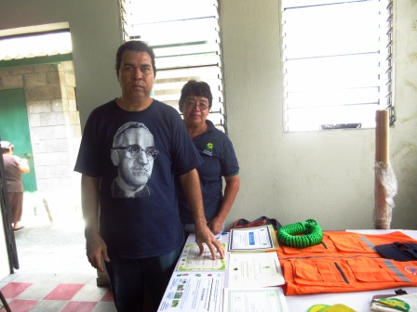
My name is Victor Alonso Velarde. I have a serious expression in this photo, but then life is serious and we face serious situations. I work in the local community here in one of the poorest urban areas of San Salvador. I know that I need people who will inspire me. That’s why you’ll often see me wearing this Oscar Romero T-shirt. Life is frightening here and we face overwhelming obstacles, so I need heroes. On the wall just outside this community hall is a painting of Oscar Romero, which says that he is reborn in the poor, that his blood is the seed of freedom, and that the liberation of the poor is the hope of the future. I love his words.
You may have forgotten the story of Oscar Romero, but for me, and for many of us here, his story is ours. He was against injustice. He spoke to the upper and middle classes, the bourgeoisie, but he became their enemy. He suffered with the poor and left a legacy to his people. His struggle is our struggle.
We have just written a letter to the Municipal Authority here about the way in which our environment is being destroyed and degraded. I don’t know how you would write such a letter. We quoted from a sermon that Romero delivered in 1979, on March 11th. People here still listen to the voice of Romero. This is what he said then;

“You know that the air and water are being polluted, as is everything we touch and live with, and we go on corrupting the nature that we need. We don’t realize we have a commitment to God to take care of nature. To cut down a tree, to waste water when there is so much lack of it, to let buses poison our atmosphere with those noxious fumes from their exhausts, to burn rubbish haphazardly – all that concerns our partnership with God.”

Our mother earth, the animals, the forests are all screaming. We are all part of one ecosystem. Did you know that El Salvador has done very little to contribute to global warming and climate change, but we are suffering much more than people in the UK from its effects. It is always the poor who will suffer the most.

Romero was accused by his opponents of setting back progress when he spoke about threats to the environment, but he replied,

‘If progress sets God aside, if it is causes harm or mutilates man, it cannot be called progress, because it is along that road that the minority pass, not the majority..’

Our country is vulnerable and we are looking at ways we can respond. When there is deforestation mud slides take place and rocks are dislodged and fall down – and this is happening even in the heart of our cities. There are people living just round the corner from here whose homes could disappear the next time there is a mudslide and many people will die. We have a ‘first response’ planned and the local government committee paid for equipment for the disaster risk reduction group. But I hope you can see that an even more radical response than that is needed, a response worthy of Romero..

I know that my expression here is rather serious. But I often think about Romero’s smile and his indestructible faith in the God who loves all creation and all the people.

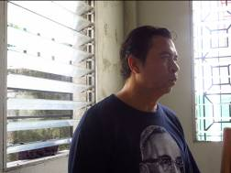

Susan Durber 2014

