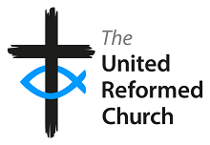

Staying Covid-19 Secure
We confirm we have complied with the government’s guidance on managing the risk of Covid-19.
5 steps to working together:
- We have carried out a Covid-19 risk assessment and shared the results with the people who we work with.
- We have cleaning, handwashing and hygiene procedures in line with the guidance.
- We have taken all reasonable steps to help people work from home.
- We have taken all reasonable steps to maintain 2m distance in the workplace.
- Where people cannot be 2m apart we have done everything practical to manage transmission risk.

Signed on behalf of the
United Reformed Church:

Date:

