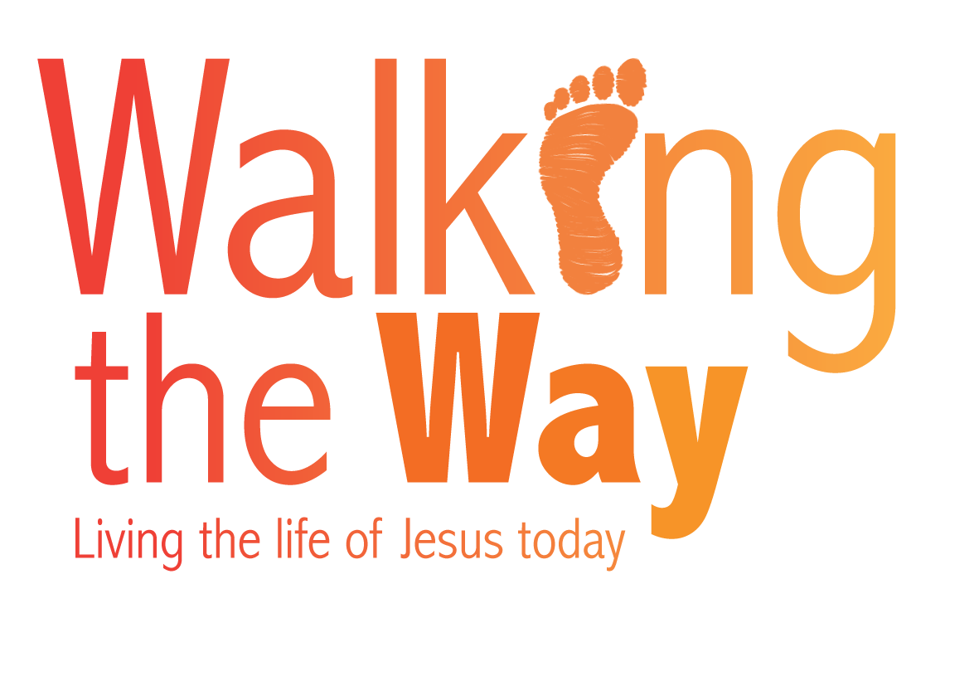

Week eight: Monday 23 October
Prayers for those working in the emergency services
From South Western Synod

O Lord God, in the beginning you created land and sea,
You gave us day and night,
You gave us times of work and times of rest.

Today we pray especially of those who risk their lives to keep us safe at sea,
Who go at a moment’s notice to rescue ships both large and small that have got into trouble on our oceans;
Those who crew our life boats
Those who staff our air sea rescue operations.

We pray for those who care for us as we live and play around our coasts;
The coastguards,
The life guards on our beaches,
Those who police our seaside resorts.

We pray that you who calmed the sea, may watch over those who battle rough seas.

We thank you that there are those who are willing to do these things for us and we pray that you will be with them, guide their paths and keep them safe as they seek to keep us safe.

In Jesus’ name.

Amen.

We pray for those in the emergency services, the police, the fire fighters, the ambulance service and the coast guards. They all carry out dangerous work, where both their own and other people’s lives often hang in the balance.

Dear Lord when they
… are facing danger – be their foothold.
… are feeling inadequate – help them to do everything with your help.
… are upset—give them your reassurance and peace.
… are totally exhausted – give them your mighty strength.
… are completely overwhelmed – may they always know Your love for them.
… have to make choices – please give them discernment and skill.
… are in trouble – may they be aware of your presence and help.
… don’t know which way to turn – give them a clear mind.
… are worried and scared – may you be their calming influence.
When their hearts grow weary – be their absolute rock.
And when things seem impossible – remind them that they can do all things through your strength and power.
Heavenly Father, we thank you for the many skills and dedication of these brave public servants.
We ask you to remain close beside them and bring them all safely through their experiences.
For Jesus’ sake we ask these things,
Amen.

© The United Reformed Church
This prayer may be used freely in worship, including in small groups and whole congregations. If used in printed form, acknowledgement of the source and author (where known) must be given.
The reproduction of the material for commercial gain and/or for use outside a local church is prohibited without written permission. For such permissions please email communications.pa@urc.org.uk

