Week seven: Monday 16 October
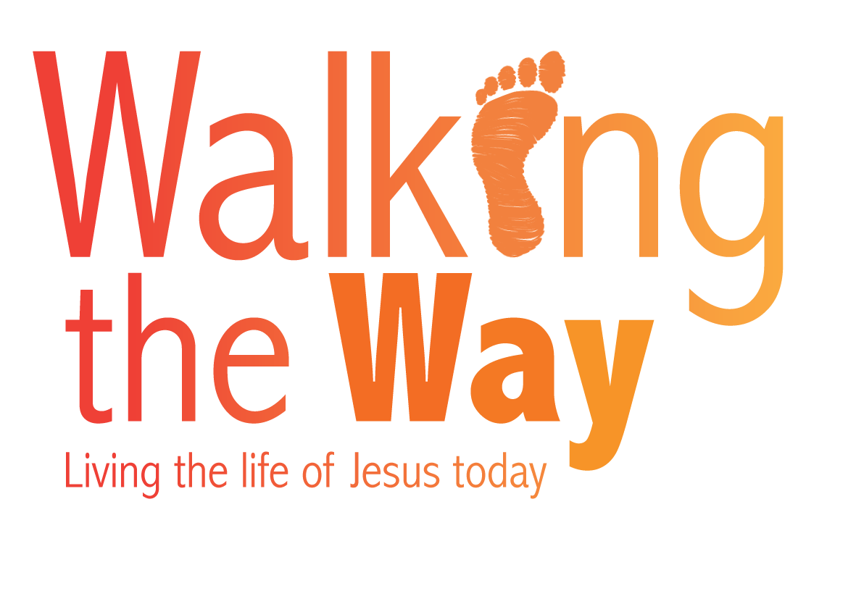
Prayers for the challenge of extremism and our response to it
From Eastern Synod

God of abundance, forgive our shallowness. Help us to care for those who are desperately hurting because of the inhumanity of one to another. Amen.

Biblical reflections
These two relatively random Biblical verses remind us that extremist terrorism is nothing new. Reflect on these and consider whether they say anything about some of the recent acts of terrorism that have hit our news headlines.

‘Then Samson pushed with all his might, and down came the temple on the rulers and all the people in it. Thus he killed many more when he died than while he lived.’ (Judges 16:30)

‘Then Elijah commanded them: “Seize the prophets of Baal. Don’t let anyone get away!” They seized them and Elijah had them brought down to the Kishon Valley and slaughtered there.’ (1 Kings 18:40)

Sunday
God of all, we confess our part in extremism, the times when we have let things go, failing to intervene as we should. Help us to seek and take opportunities of active caring. Amen.

Monday
God of all comfort, we remember victims of extremism, and all those who are affected. Strengthen those who deal with the aftermath – and we give you thanks for the resilience that so often finds that glimmer of light in the darkest moment. Amen.

Tuesday
God of forgiveness, who calls us to love our enemies, hear our reluctant prayers for those who are the perpetrators of extremism. As we seek to understand what drives them, we pray that they may see that there are better ways. Amen.

Wednesday
God of all knowledge, we realise that, while some hit the headlines, many who need are prayers are simply unnamed and forgotten. Hear our particular prayers for victims of extremism in those parts of the world that seem to be more readily ignored. Amen.

Thursday
God of love, forgive us our culture of blame. Forgive us our unreasonable phobias. Hear our prayers for those who get blamed for something they would never do and in which they wish no part. Amen.

Friday
God of justice, help us to recognise the causes of extremism, both those are justified and those that are not – and help us to work for a world in which peace and justice are properly valued and human beings respect each other as they should. Amen.

Saturday
God of hope, we believe that things can change. We pray for the healing of those who are hurting from past experiences of terror. We pray for those who would still seek that as a way of advancing their cause. We pray for a world of love and joy and we pray in hope, because we believe it is possible. Amen.

© The United Reformed Church
These prayers may be used freely in worship, including in small groups and whole congregations. If used in printed form, acknowledgement of the source and author (where known) must be given.
The reproduction of the material for commercial gain and/or for use outside a local church is prohibited without written permission. For such permissions please email communications.pa@urc.org.uk

