Week six: Monday 9 October
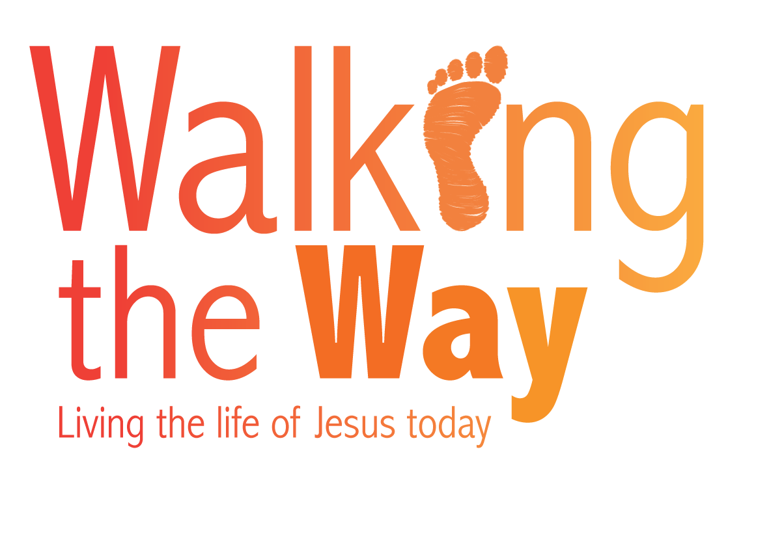
Prayers for those working in race and interfaith relations
From West Midlands Synod

The following prayers are based on the lectionary readings for the week and with a belief that the gospels are God’s Word which crosses boundaries of faith, race and culture to embrace all people in a new Kingdom.

Monday Read Luke 10: 25-28
Lord, it’s Love I do not understand so show me please what it means. I know who my neighbours are: some are black, some are white; some are strong, some are weak; some are young, some are old. I know who my neighbours are: It’s LOVE I do not understand so please show me what it means so that when I know it for myself I’ll find something in my heart that I can share.

Read Luke 10:29-37

Lord, I had FAITH that you would stop in my time of need, but you walked on by and left me there. Then my last HOPE passed me by and I thought that was the end but then came LOVE in a stranger’s face and took me to a place of healing. Thank you for LOVE that has time to stop and show that she is much greater than the words of FAITH and HOPE. Your LOVE is the everything for everyone and you are that Word that dwells in human flesh.

Tuesday Read Luke 10:38-end
Which YOU is visiting today, Lord. The Friend we know well and love or a stranger we have never met. Which YOU is standing at our door today? The one in need of food and drink? A homeless stranger wanting clothes or someone sick and praying for a healing touch? Which YOU is knocking at our door with a story to tell? May we dare open our door to friend and stranger and invite you to join us in the kitchen where we can all hear your story as we prepare food for you to eat.

Wednesday Read Luke 11:1-4
Lord, I reach the end of this prayer so often but maybe if the end is where I begin my faith journey I might make more progress. So, Lord, lead us not into the temptation of seeing differences of race, faith, culture and tradition which are never forgiven and so we keep our daily bread for ourselves which prevents the coming of your Kingdom where your name is hallowed. Lord, we SAY the prayer from the beginning, but may we LIVE the prayer from the end and then say it again, and live it again until it is a prayer with no ending.

Thursday Read Luke 11:5-13
Lord Jesus, is it you knocking on my door because I can provide a friend of yours with bread for their journey? You, God’s own Son, come to us as a Friend of ours, but our doors are so often locked and we want you to wait for a better time. Thank you that you don’t give up and keep on asking for our help; always seeking the YOU in us and will keep on knocking until our door is opened. Sorry, Jesus, that we keep you waiting and the friends of yours are hungry for the bread we can give. Our Father knows what His children need, but if our door is locked the world remains hungry. May we open it today and see you in the friend asking us to help!

Friday Read Luke 11:14-26
Lord, drive out the demons of pride and greed; doubt and fear for they are dividing your Kingdom and bringing ruin to your children. Forgive us when people of different cultures are persecuted and we do not speak out because they don’t think like we think. Forgive us when people of different faiths are abused and we don’t speak out because they don’t believe what we believe. Forgive us when foreigners are not welcomed and we don’t speak out because they don’t look like we look. Forgive us, Lord, when the authorities try to keep us out and we don’t speak out because we fear what they will do to us. Lord, you created all people of all nations so help us knock down the divisions of religion and build a new relationship of trust in you.

Saturday Read Luke 11:27-28
When we can love ourselves for who we are, the Word of God is being obeyed.
When the neighbour is loved for who they are, the Word of God is being obeyed.
When the stranger is welcomed whoever they are, the Word of God is being obeyed.
When the Word of God is living within us, the will of God is being done.
When justice refuses to be silenced, the will of God is being done.
When love seeks no hiding place, the will of God is being done.
When the will of God is being done, the Kingdom will come.
May we be blessed as the Word of God lives within us and we become a blessing for all who see.

Sunday Read Matthew 22:1-14
Lord, you invite people from all corners of the earth to share in your feast and we come as your guests praying that we are dressed in the right clothes. We don’t need to dress up, do we, Lord, with smart clothes which make us look better than we really are? The only clothes I have are those of compassion, kindness, humility, gentleness, patience and love which forgives all that has gone. Lord, we pray these clothes can be worn by everyone who comes to your feast so that we can eat together wherever we come from.

© The United Reformed Church
These prayers may be used freely in worship, including in small groups and whole congregations. If used in printed form, acknowledgement of the source and author (where known) must be given.
The reproduction of the material for commercial gain and/or for use outside a local church is prohibited without written permission. For such permissions please email communications.pa@urc.org.uk

