Week four: Monday 25 September
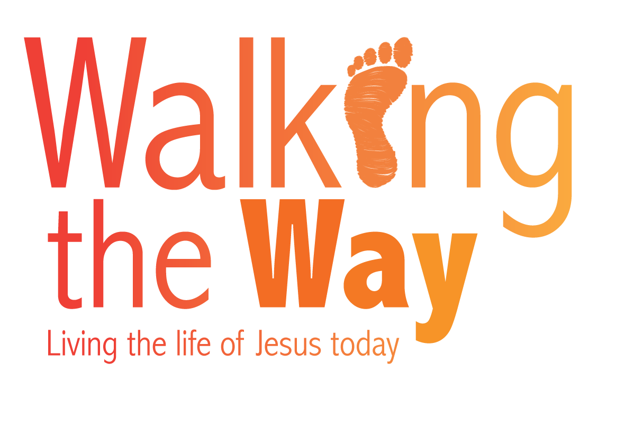
A prayer for those working in hospitals and social care

I always thank my God as I remember you in my prayers, because I hear about your love for all his holy people and your faith in the Lord Jesus. I pray that your partnership with us in the faith may be effective in deepening your understanding of every good thing we share for the sake of Christ. Your love has given me great joy and encouragement, because you, brother, have refreshed the hearts of the Lord’s people.
Philemon 1:4-7

Heavenly Father,

We bring before your throne those who work with the homeless and unemployed.
We give you thanks for their commitment and tenacity in the face of grinding hardship and apparent hopelessness. Help those who help others to either find homes or employment to first seek you for guidance and to rely on You for a deep well of life-giving hope and resilience.

We pray for charities that work with the homeless and unemployed, such as:
Inn Churches; Street Angels; Street Pastors; Shelter; Centrepoint; Emmaus; First Fruits; The Prince’s Trust; Church Housing Trust; Caring for Life; Springboard and many others …

Heavenly Father as we ask you to guide them in all they do, guide us also by the power and companionship of the Holy Spirit, to be effective in deepening our understanding and actions.

‘Do not let your hearts be troubled. You believe in God; believe also in me. My Father’s house has many rooms; if that were not so, would I have told you that I am going there to prepare a place for you? And if I go and prepare a place for you, I will come back and take you to be with me that you also may be where I am. You know the way to the place where I am going.’
John 14:1-4
We pray this in the name of our Lord and Saviour Jesus Christ, to His glory forever and ever
Amen.
© The United Reformed Church
This prayer may be used freely in worship, including in small groups and whole congregations. If used in printed form, acknowledgement of the source and author (where known) must be given.
The reproduction of the material for commercial gain and/or for use outside a local church is prohibited without written permission. For such permissions please email communications.pa@urc.org.uk

