United Reformed Church Mission Council
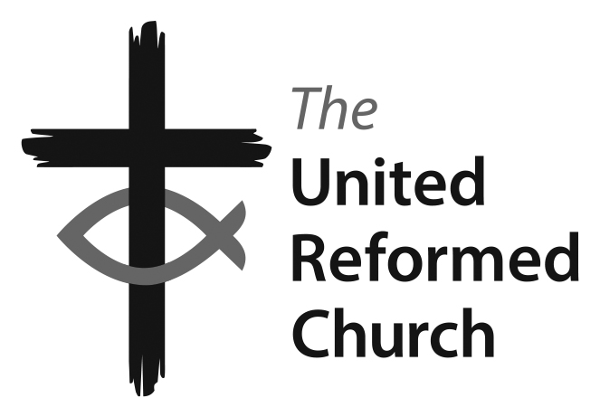
12-14 May 2017

ORDER PAPER

Friday 12 May 2017

PLEASE RETAIN THIS PAPER. ITS MATERIAL MAY BE RELEVANT THROUGHOUT THE MEETING

Paper D1 Future of the Windermere Centre

The presenter of the paper will submit an altered version of Paragraph 22, as follows:

‘At its meeting on 2nd March 2017 the Windermere Management Committee could not identify any credible proposal to keep the Centre open, based on the effect on marketing resulting from the Mission Council resolution in October 2016; the likelihood that most of the existing staff would have left by the end of May 2017; and the need for additional maintenance and repairs to the building. The other major factor was the December 2016 recommendation from the Education & Learning Committee to Mission Council to cease using the Windermere Centre building as a residential Resource Centre for Learning.’

The reason for the change is that the view of the WMC had to be reported to the officers of the Education & Learning and Finance Committees in time for the drafting of the Mission Council paper, and before the minutes of the 2nd March meeting had been prepared and agreed. The view reported was ‘at this stage the Committee supports the view that the Centre should close’. Subsequently some members of the WMC indicated that this was not an accurate reflection of their view. It would be more accurate to say that at the March meeting the WMC supported neither closure nor continuance, and, indeed, in its function as advisor on practical matters to the Education & Learning Committee this is what would be expected. The Convenor of the WMC apologises for this error, which the alteration above corrects.

Paper F1 ‘The Wider Fold’

The convenor will ask to amend Resolution 2, changing ‘this Roll’ (right in the middle of the resolution) to ‘the roll of isolated members’, for the sake of clarity.
------------------------
The Convenor will also submit an introductory paragraph, to go into the draft Rules of Procedure as 2.0, reading as follows:

‘2.0 Isolated Membership allows people who have belonged to one of the Church’s local congregations, and whose circumstances no longer permit meaningful local membership, to maintain their commitment to the United Reformed Church. It is intended for people who have joined the URC in the regular way through the decision of a Church Meeting, but who are now unable, for reasons of distance or mobility, to remain closely involved in an existing local church. It is not possible to list all the situations that might lead to people requesting Isolated Membership, but possible examples are:
- students and young adults, studying at a distance from home, or in a transitory lifestyle in the early years of a career;
- members of the armed forces and their households;
- members of the URC who have moved home, and no longer have a nearby URC that they can attend regularly;
- URC members worshipping in a church that had earlier been a LEP, but from which the URC has withdrawn;
- URC members whose local church has closed, and who are not able to worship in another URC congregation.’

Paper G4 New Treasurers arrangement

This paper has been tabled, and will be presented during Session Seven, directly after Paper D2.

(continued overleaf)
Paper I7 World Council of Churches Assembly, Glasgow 2021

The Convenor now asks to withdraw the resolutions in this paper. Churches Together in Britain and Ireland is not pursuing its attempt to organise a bid for the 2021 Assembly of the World Council of Churches. The level of interest and support from the various churches in Britain and Ireland has turned out a long way short of the level that CTBI had hoped for, and the CTBI AGM on 10th May took the formal decision to drop the proposal.

Item I9 Rural Advocate
Paper I10 The 2017 General Election

The Rural Advocate is not able to be with us at this meeting. So I9 has been held over to the autumn meeting of Mission Council. Grace Pengelly will speak to Paper I10, about the General Election, at that spot in Session Two.

Paper J1 Nominations

The Secretary of the Committee will ask to amend this paper as follows:

4.2.2 Education for Ministry Phase 2 and 3 (EM2/3) Sub-committee
At its meeting in September 2016 the Education & Learning Committee agreed that this sub-committee has done the foundational work that it was originally set up to do, and that the remaining work of the sub-committee is already being integrated into the routine work of the Education & Learning staff and Committee. Therefore the sub-committee has been stood down and the members are thanked for their contribution.

4.2.3 Education and Learning Finance Sub-committee
Add Member: Ms Delyth Doyle
Add Ex-Officio: Deputy General Secretary (Discipleship)
Delete Staff in attendance: Education & Learning Finance Officer

Paper M3 Youth Representation in Councils of the Church

As this involves a change to the Structure of the URC, we shall deal with it by majority vote, at the start of Session Seven.

Paper M5 Nominations Rubrics

The Clerk will ask to alter the last sentence of Paragraph 4, to read as follows:

‘Any committee may invite other Assembly Officers (or their deputies) or staff members to attend in a non-voting capacity where the business so requires.’

Paper M6 Marriage of Same-Sex Couples in Guernsey

This paper has been tabled, and will be presented during Session Ten.

Paper Y1 The Future of Lay Training and … of the Windermere Centre

This is a private members’ resolution in the names of the Revds Brian Jolly and Jacky Embrey (who are respectively the Clerk of North Western Synod and the Moderator of Mersey Synod).

