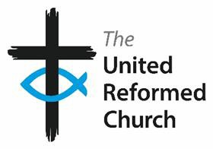

Addressee Name

Dear [name}

## **Committee Membership**

Thank you for agreeing to serve on the …………………….Committee. The ongoing work of the United Reformed Church is dependent of people like you who give generously of their time and talents.

In the course of your duties as a committee member you may:

* receive papers and documents which contain personal data (some of which may be sensitive) by hand, email and post;
* become aware through discussion or at meetings of confidential information.

In order to protect privacy and personal information in line with Data Protection laws, you are required to undertake to:

* provide the Church with a password protected email address to which **only you** have access;
* ensure that any PC you use is protected by up to date software which will guard against unauthorised access;
* not disclose any personal information about a third party to anyone;
* keep papers containing confidential information secure and inaccessible to others;
* delete emails containing personal information as soon as they are no longer needed;
* destroy securely paperwork which is no longer needed.

At the end of your term of office you will be asked to sign a declaration that you have destroyed or returned all papers and emails containing personal or confidential information.

We understand that this may seem onerous, but are sure that you understand the need to respect privacy and protect confidentiality.

Thank you once again for your willingness to support the work of the United Reformed Church.

Yours sincerely

On behalf of the Nominations Committee/ Committee Secretary?

I,………………………………….(full name) understand the requirement to protect privacy and personal information and agree to the undertakings listed above.

|  |  |  |  |
| --- | --- | --- | --- |
| Signature |  | Date |  |