Racial Justice Sunday
  - ‘What Kind of Love?’

Prayers  Prayers   | Hymns  Hymns  Prayers  Richard Becher   |  | Reflections & Poetry  Reflections & Poetry  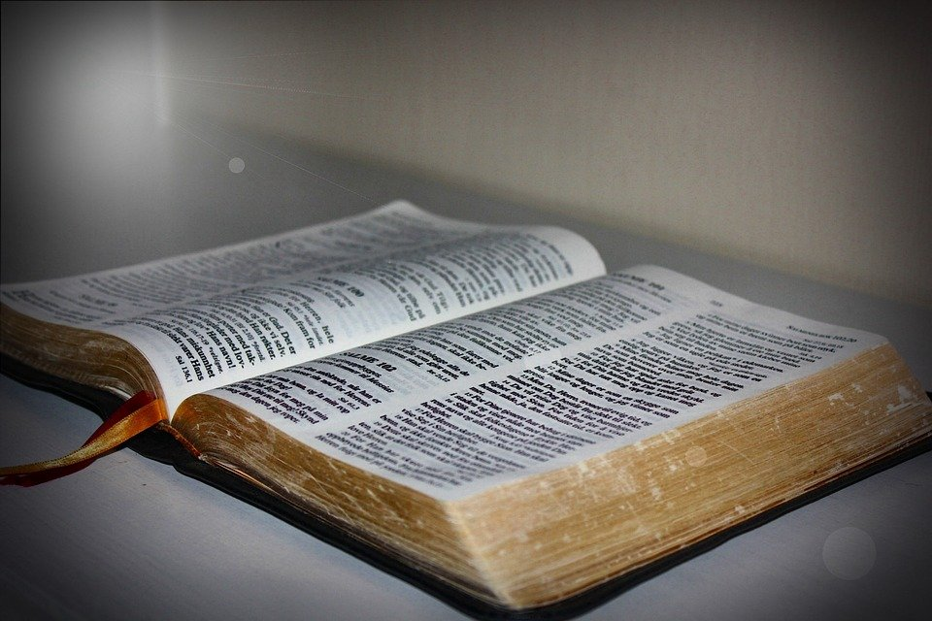

Racial Justice Sunday

 |  | INTRODUCTION  Racial Justice Sunday 2021 coincides with Valentine's Day. Here at The United Reformed Church’s Global and Intercultural Ministries we find ourselves considering the theme 'What kind of love...?' Questions that have bubbled up include:

- What kind of love does God call us to embody and demonstrate?
- What kind of love does the Church embody/preach/enact?
- What kind of love enables injustice to continue and even flourish?
- What kind of love will/can engender change?
- What kind of love do oppressed and marginalised communities strive for?

What are the questions, reflections and responses which occur to you?
We offer the following resources to help us all in our reflections. The resources include a sermon, reflections, poetry and hymns. They are stand-alone or interlinked. Please use them however you find helpful.

- INVITATION TO WORSHIP

More than an Invitation….

You have all been invited at this time to this special place
We don’t just want an invitation
We want to be welcomed

You are offered a special welcome to this place at this time
We don’t just want a welcome
We want to have a voice

Welcome to this place where there will be time for listening
We don’t just want a voice
We want to be heard

Welcome to this friendly space where your story will be heard
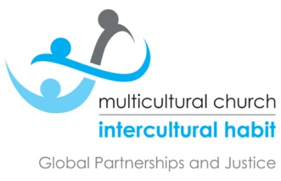
We don’t just want to be heard
We want to be believed

Welcome to this time and place where no-one’s truth is denied
We don’t just want to be believed
We want to be trusted

Welcome to this place and time where your words are accepted
We don’t just want to be trusted
We want to be loved

Welcome to this time and place where God’s love embraces everyone
We don’t just want to be loved
We want to know we belong

Welcome, and we pray you will feel you belong among us at all times
Richard Becher

- OPENING REFLECTION

Transfiguration in the Valley

Martin Luther King Jr. Day was the 18th Jan 2021… and I wonder what he would have made of the current situation in the USA? We have a saying in the Caribbean - when someone has died and then something happens with which they would not be happy, ‘they would be turning in their grave’. I am certain that Martin would be turning in his grave - but I believe he would also want us to continue to strive for racial justice.

I am not sure how many of us know the history of this memorable day. The initial request was made in 1983, but it was not celebrated until 1986, and it wasn’t until 2000 that the day was observed in all the states. Even in death, the striving for justice continued.
One of Martin Luther King Jr’s well-known speeches is his ‘I have been to the mountain top’. In this speech he talks about longevity, but this was not his concern - he just wanted to do God’s will. He felt that God had shown him the Promised Land, and he wanted the crowd to know that though he may not get there with them, as a people, we will get to the Promised Land. Today, I want to echo that message, wherever there is racial injustice.

Our Gospel reading for this Racial Justice Sunday is the Transfiguration, found in Mark 9:2-10. The reading tells us about Jesus and his three disciples going up the mountain to pray. While they were there, the disciples fell asleep. (As we read the rest of the Gospels, we learn that they had a habit of falling asleep at some really important moments!) They were awoken by the sound of Jesus talking – and, as they looked, they saw Jesus transformed right there in front of their eyes.

Like Peter, most of us would like to stay on the mountaintop – in that wondrous space, far from the trials of reality - but we know that there is work to be done in the valley, where we truly encounter life in all its complexity. So today, on this special Sunday, let us recommit ourselves to the journey, the striving, the determination to simply do God’s will. Let the words and thoughts we share today be a source of challenge and encouragement for all of us to shine the light of the transfiguration (revelation) on places where racial injustice reigns. Let us live as if we are still on the mountaintop, gazing at Jesus transfigured before us. May that vision be our unending source of hope as we journey down to where Jesus calls us, knowing that he is with us in all things.

Our lives are so much more than we experience through our senses. God, in Christ, gives us purpose and light – the ability to live our lives for others. The mountaintop experience is not about building tents to protect and contain what we have been given; the light of Christ is not for keeping to ourselves – these are gifts to be shared; gifts which can illumine the issues which divide our communities, our nations and our world today. Gifts which can help bring transformation – right here, in the valley, where we live and love and seek God’s will.

Today, as individuals and churches, let us focus our worship, prayers, reflections and actions on recognising and naming ‘racial injustice’. Let us be strengthened and emboldened by the mountaintop experience. And let us, in company with Jesus, strive tirelessly until we can truly say, ‘All Lives Matter’, because Black people and the people of Myanmar, USA, China, Africa, Asia and Palestine All Matter.
Zaidie Orr

Hymn 1  Racial Justice Transfiguration  Tune: “Faithfulness” - Runyan, Rejoice and Sing 96  © John Campbell | 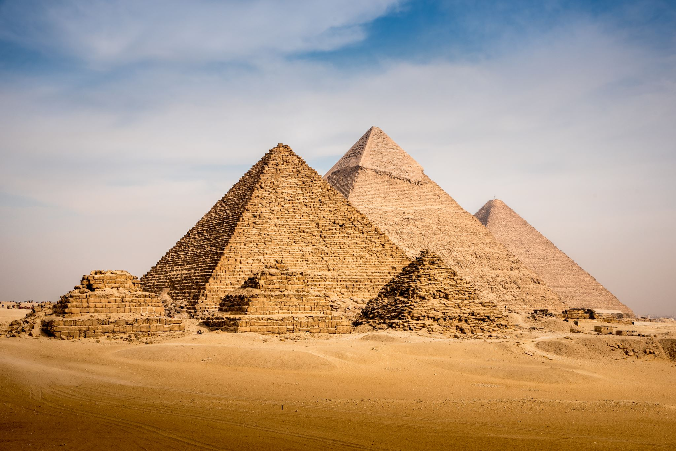
Moses in Egypt, for you, faced injustice;  challenging Pharaoh to set the slaves free;  round after round of resistant refusal  ended in freedom that just had to be.  God, keep your hope unfurled,  here in our unjust world,  lead in the struggle for justice for all;  till each and all are both valued and welcomed,  help us stay true to your cause and your call.  Prophet Elijah, for you, faced injustice,  battling the pow’rs of insatiable greed;  Ahab and Jezebel sought to destroy him,  yet he stayed true ’til the people were freed.  Jesus our Saviour, for us, faced injustice,  feeling the pain of those others don’t see;  lepers and outcasts grew strong in his welcome;  he gave his life so we all could be free.  James, John and Peter, for you, faced injustice,  down from the mountain, found much to be done.  Learning in life that your love has no limits,  changed them ’til they could embrace ev’ryone.  We, in your church today, still face injustice,  will we ignore, or collude, or despair,  or joining Moses, Elijah and Jesus,  struggle to make our world wholesome and fair? | God, keep your hope unfurled, here in our unjust world, lead in the struggle for justice for all…
PRAYER

Lord, turn me inside out,
so people can see
the You in me
with the same shape heart,
the same colour of blood
and one word in our flesh
that makes us like You
revealing the image of God
in our coats of many colours.
Lord, I love from the inside
what I see on the outside
so may we love what we see
and be loved for who we are:
Brothers and sisters,
united from inside out
to turn the world upside down!
Richard Becher




HYMN 2
What are the Reparations?
tune: “The Church’s One Foundation” – Aurelia
© Raymond Stanyon

It seems that God’s creation is not what was designed.
So easy to accept things and then become resigned
To never being different, wrongs ne’er to be repaired
Will ever come the time when your bounty’s fairly shared?

We see the world around us now lost and full of sin
What we bemoan in others too often found within
My heart as cold as any, my thoughts for self alone
Where are the seeds of hope that in me you’ve freely sown?

What are the reparations that we must make today?
What words and deeds can ever right wrongs of yesterday-

What are the reparations we must make today…

Life stolen, stunted, ended – in anger, hurt and pain.
How can we hope to ever Walk side by side again?

“Act justly and love mercy, walk humbly with your God!”
Still challenges us to action – to walk the way you trod,
To join you in your journey, to usher in your reign,
Share grace with broken-hearted, and live with healing pain

You are the generous sower – who still throws out your seed
For some the source of sharing, for others source of greed
Turn inward thoughts now outward, as equals let us stand
In brokenness and sorrow – still guided by your hand


POEM

Bound by Acceptance

From my head to my feet,
What I see and what I miss.
Through my eyes I see imperfections all around.
I hide my face and brace myself for opinions and
Judgments
I question what I can change, yet the change is
Impossible.
We live in a world where others tell us our
Imperfections
Before we ever thought we had any.

But no!
What I truly see is me –
From my complexion to my emotions –
Because God didn’t create me with flaws and
Imperfections.
The world did.
Helma Cardosa



GOSPEL READING

Mark 9:2-10
²Six days later, Jesus took with him Peter and James and John, and led them up a high mountain apart, by themselves. And he was transfigured before them, ³and his clothes became dazzling white, such as no one on earth could bleach them. ⁴And there appeared to them Elijah with Moses, who were talking with Jesus. ⁵Then Peter said to Jesus, “Rabbi, it is good for us to be here; let us make three dwellings, one for you, one for Moses, and one for Elijah.” ⁶He did not know what to say, for they were terrified. ⁷Then a cloud overshadowed them, and from the cloud there came a voice, “This is my Son, the Beloved; listen to him!” ⁸Suddenly when they looked around, they saw no one with them any more, but only Jesus. ⁹As they were coming down the mountain, he ordered them to tell no one about what they had seen, until after the Son of Man had risen from the dead. ¹⁰So they kept the matter to themselves, questioning what this rising from the dead could mean.

- HEBREW SCRIPTURE READING

Song of Songs 1:5-6
⁵ I am black and beautiful,
O daughters of Jerusalem,
like the tents of Kedar,
like the curtains of Solomon.
⁶ Do not gaze at me because I am dark,
because the sun has gazed on me.
My mother’s sons were angry with me;
they made me keeper of the vineyards,
but my own vineyard I have not kept!

SERMON NOTES
By Melanie Smith

What an extraordinary coincidence, that on Racial Justice Sunday we have a reading from the Gospel according to Mark that celebrates whiteness; drawing the connection of whiteness to things holy. Clothing, thrones, hair, and horses are all described in the Bible in glowing terms as white. The word ‘black’ in the Bible often carries more negative undertones, especially when it comes down to the translators’ choice of words. For instance, dark skies translated as black skies, as a portent of bad things. It’s hardly surprising that the assertion that white is good and black is bad is long established in our collective consciousness.

Yet with Racial Justice Sunday falling on Valentine’s Day, it seems appropriate to bring in the young woman’s declaration from the Bible’s collection of love poetry, the Song of Songs, that she is ‘black and beautiful’. However, even in our excitement at this bold statement, we see that the woman then feels it necessary to explain her tanned appearance as being caused by her being forced to work in the fields, a low-class activity. The class difference is highlighted; working in the dirt and exposure to the sun is associated with a low status in society. Conversely, white garments only remain white for those with the ability to stay away from earthy activities, and with the ability to clean them effectively. White clothes belong to the upper classes. What irony there is in acknowledging that light can both burn and spoil as well as bleach and make holy!

The point remains that, generally in Biblical literature, as in our collective psyche, white is good, indeed normative, whereas black is bad, indeed deviant. When it comes to colour and ethnicity, people in the Bible appear as capable of prejudice, extreme nationalism, and xenophobia as the people of today. Surely, this is not God’s purposes. Rather, the vision of those gathered before the throne of God being ‘from every nation, from all tribes and peoples and languages,’ is the vision of what the Church should be, as the Body of Christ.

How do we, in the United Reformed Church, reflect this multicultural vision of the Body of Christ? On an institutional level, it seems fair to say that we have adopted many policies and procedures to ensure that we have the tools to recognise and weed out racism when we see it. Starting in 1978, we affirmed the British Council of Churches Statement on Racism, and in 1987 adopted our own Declaration on Racism.

After being established by the 1996 General Assembly, our Racial Justice and Multicultural Ministry colleagues have produced many resources, from helping churches audit how they welcome diversity and how as a church we portray diversity. There is a network of Racial Justice Advocates in the Synods.

Yet, it wasn’t until 2007, after just having passed a resolution commemorating the 200th anniversary of the abolition of the slave trade, a resolution was put that each synod ‘shall appoint not less than one and preferably two of its representatives to Assembly from its black and minority ethnic constituencies.’ Owing to a divisive debate and pressure of time, this resolution was deferred to a later point in Assembly. It became the very last item on the agenda of that Assembly, and after attempts to either defer the business or make it less binding, the resolution was withdrawn.

Subsequently in 2008, General Assembly agreed to request that, ‘each synod [to] include at least one black minority ethnic member in their group of representatives to General Assembly.’ It was also resolved that Mission Council monitor and report this information back to General Assembly in 2012. If this report exists, it is well hidden.

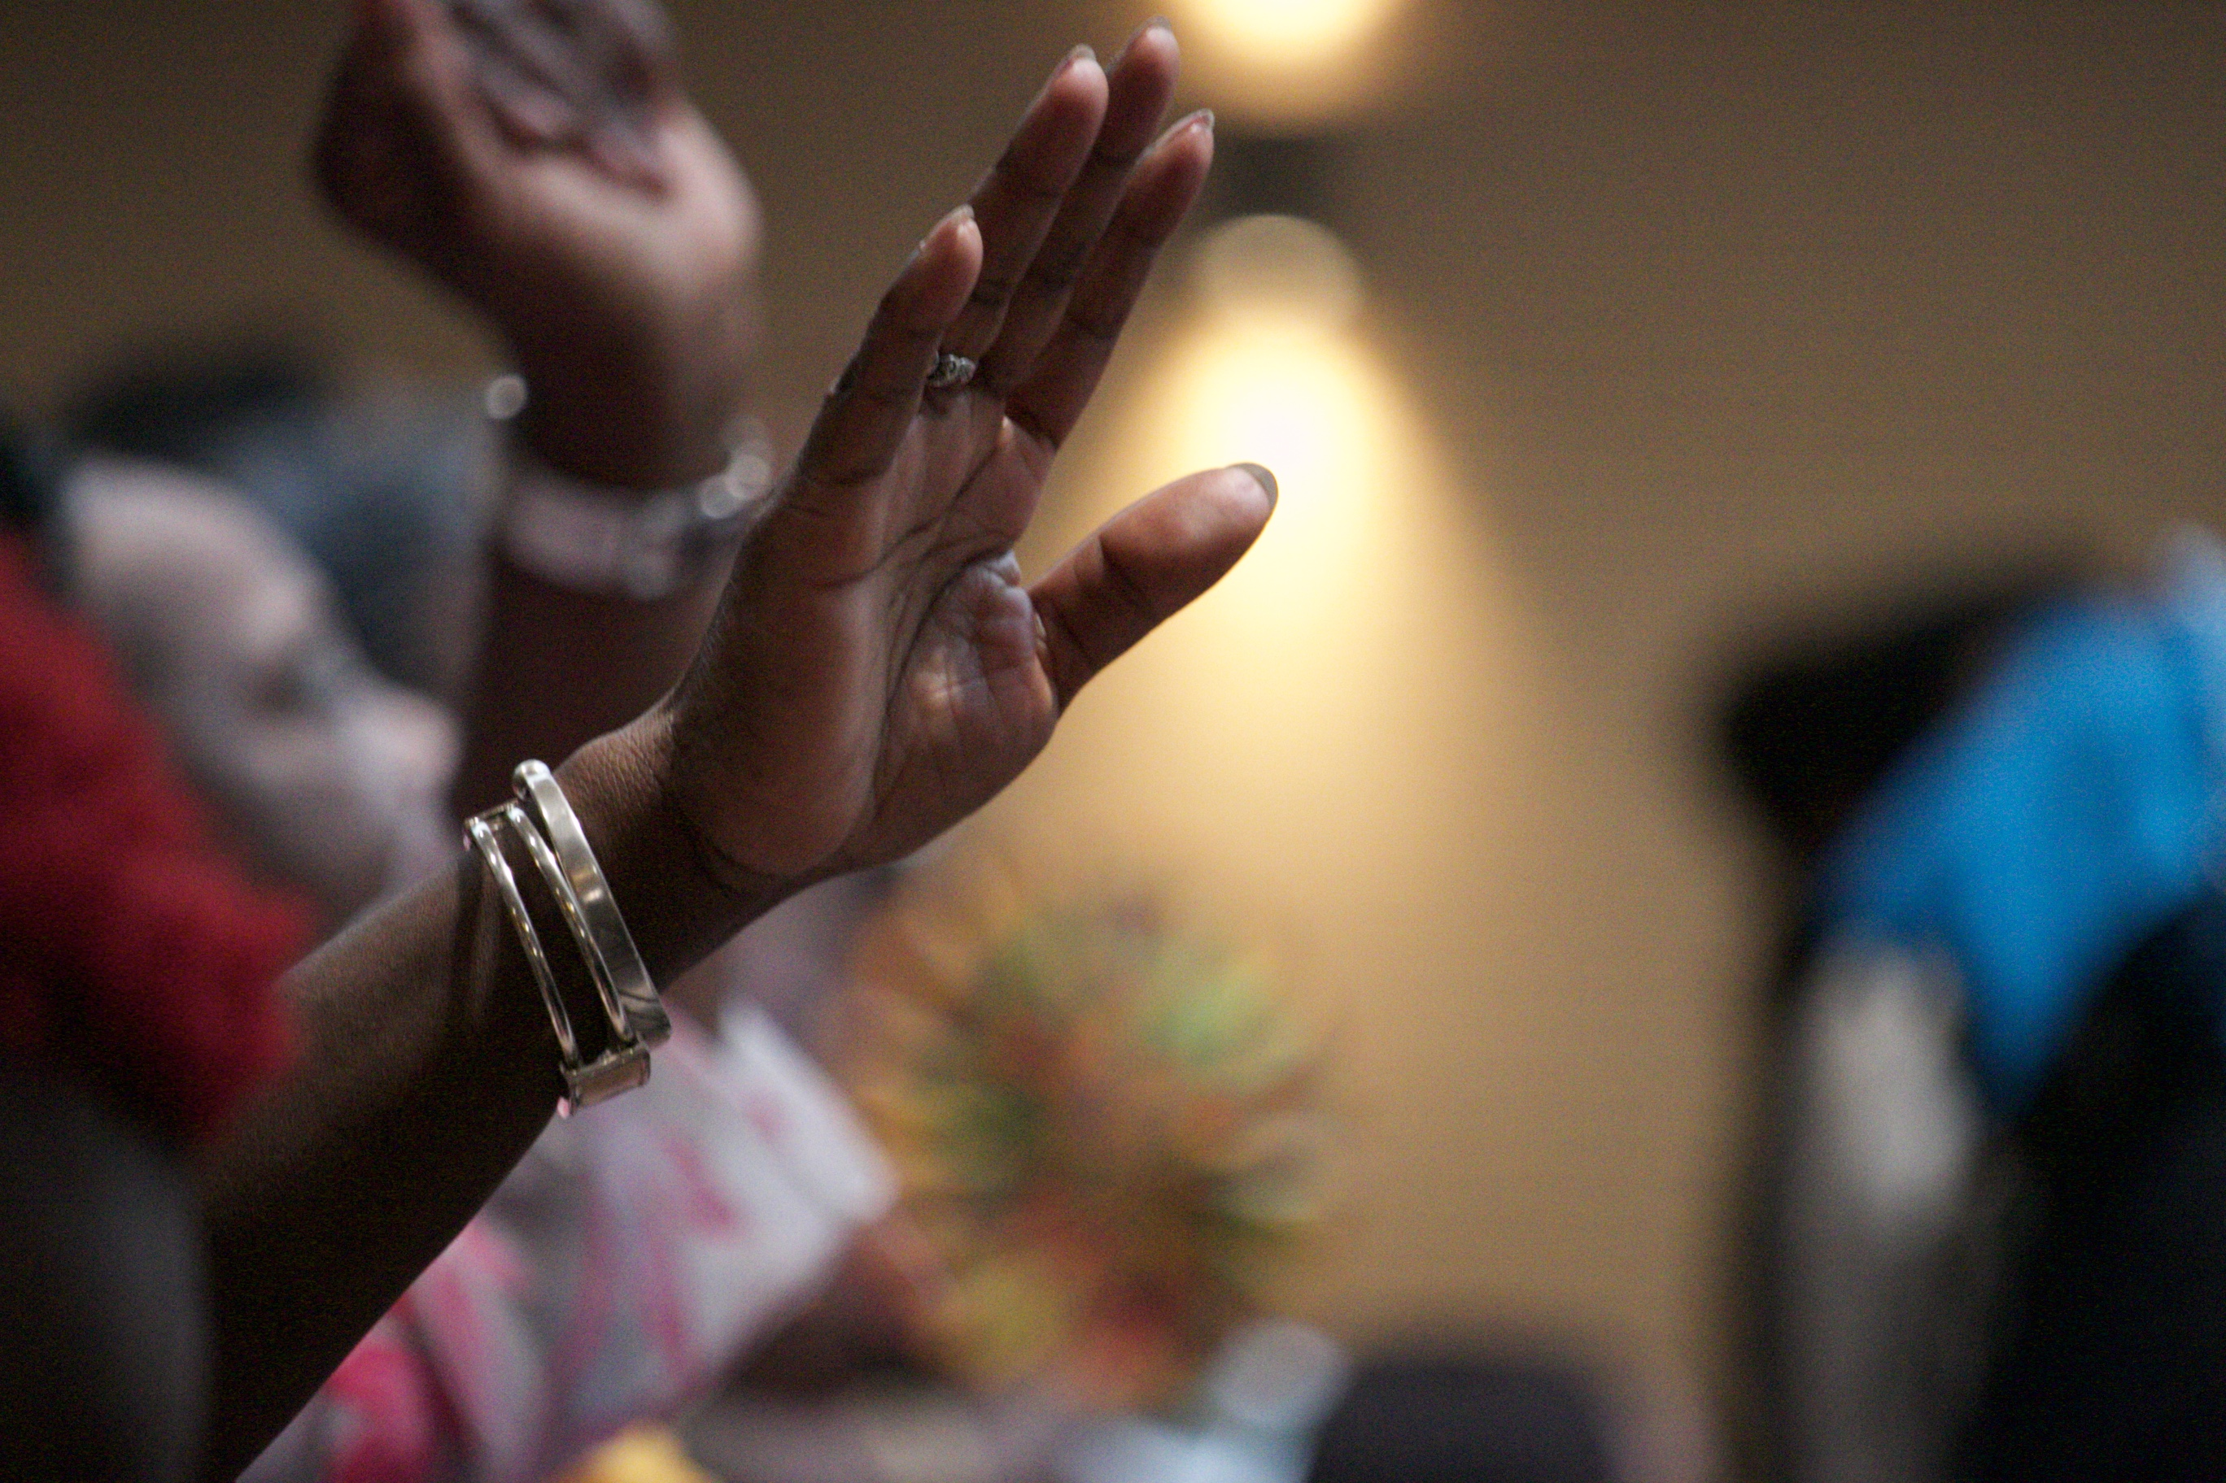
With all these ups and downs, can the United Reformed Church claim that we have recognised what racism looks like and have we gone far enough to eradicate it? Although our policies are in order, have we been slow to adopt rules and change our practices? Do you know the stories of BAME members of our church community who have had to fight glass ceiling after glass ceiling? Do we believe that we are a multicultural church with an intercultural habit, or simply that some of our local churches are such? Since becoming the URC in 1972, there has been a lack of visibility of BAME leaders; we have only had one General Assembly Moderator and one Synod Moderator who have been from BAME communities in the whole life of the URC.

Has the picture that is painted by this information shown that the URC has demonstrated less than consistent dedication to the positive action it declared in the commitment we made in 1994? Could we even go so far as to question that, rather than modelling God’s multicultural kingdom, the URC could stand accused of institutionalised racism? Institutionalised racism is defined as policies, rules, practices, etc. that have become a usual part of the way an organisation or society works, and that result in and support a continued unfair advantage to some people and unfair or harmful treatment of others based on race. Or are there are signs that the URC has done what it can in the circumstances, acknowledging Martin Luther King, Jr.’s quote, “The arc of the moral universe is long, but it bends toward justice”?

Even with the name ‘Melanie’, which is derived from the Greek meaning ‘black woman’, I am white. The voices of our own URC BAME members may be reflected here, but are not quoted here, and there are many individual stories of hurt and frustration that could be shared. By what right should I, a white woman, be saying these things? Simply, because we should all be saying these things. On this Racial Justice Sunday, the world is in turmoil over #BlackLivesMatter, the legacies of slavery, the violent divisions in the USA running along distinct racial lines, and we in the UK have much to do to tackle the inequalities exposed by the coronavirus pandemic. With that struggle being real in the communities in which we are grounded, it is no surprise that the URC has not yet arrived at a place of racial justice.

But that’s not to say we’ve failed outright or that there is no hope.

As the people of God, we are people in the world. We strive to live up to our holy calling as the Body of Christ. Our holy calling is not easy. Our holy calling takes us up mountains in the fog, to terrifying places, where we listen to strange, unfamiliar voices, saying things beyond our comprehension. We are called to set aside our usual customs and practices.

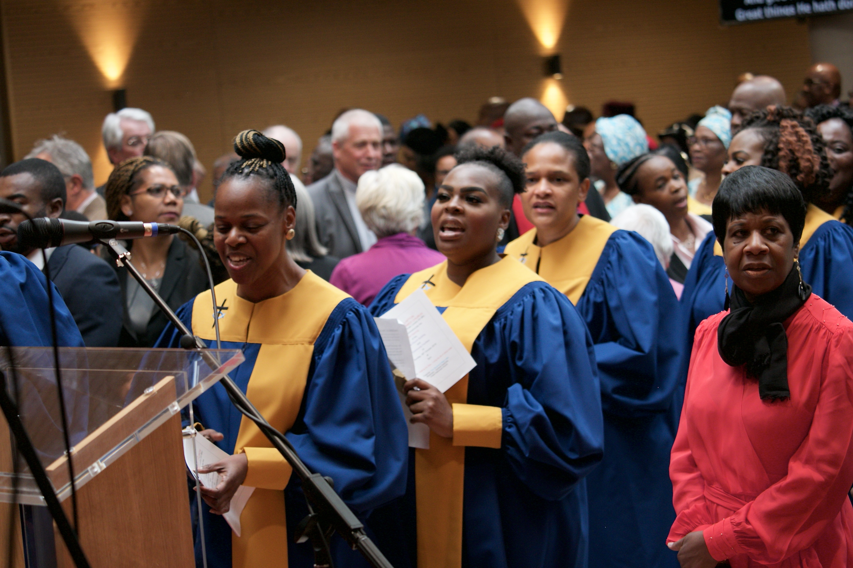
For us to become the multicultural people of God, we must risk being disorientated, being thrown into confusion, in order to be able to clarify who it is we are really called to be. In the turmoil of the pandemic, in this disorientation, in the rawness of truths exposed, we can hear distinctly the realities of the experiences of BAME people in the USA, the UK, in other countries, and in the URC. If all things are going well and we are comfortable, why would we challenge the status quo? Suddenly, these issues have been violently thrown to the forefront of our consciousness; what was seen as a minority issue has been exposed to the light of truth, and now we have no hiding place.

Our world has been bruised and battered in this past year. Added to the fears of the climate crisis, the situation we’re in can be bewildering for those of us who have led stable lives; it may feel like these issues are almost too great to contemplate. Yet, there is no way to deny the truth which we know now; exposing these historical injustices gives us the opportunity to tackle these injustices like never before. We have to acknowledge that we still have a mountain to climb, but climb it we must. We must set aside our old certainties and risk our comforts to join God on that mountaintop.

At this point, don’t worry – I am not going to attempt to echo the mountaintop sermon by the preacher already quoted – as that more than stands on its own as a beacon of hope.
The voice we must pay heed to is God’s voice, from the mountaintop, “This is my Son, the Beloved; listen to him!”

Listen to the call of Jesus, follow him.

Like Jesus, call out injustices, prejudice and falsehoods when you see them. Challenge the systems which enslave and keep people down. As Jesus listened to and helped people who were ignored and excluded, listen to and help those in our churches who are ignored and excluded. Challenge the church until it reflects the Body of Christ. Follow Jesus up that mountain, follow him down through the valley of despair, follow him to the cross.


Follow him, ultimately, to the new life where old distinctions of race and class are irrelevant and, as part of that great multitude before the throne of God, we look forward to the day when we can join in song with, ‘every creature in heaven and on earth and under the earth and in the sea, and all that is in them’.

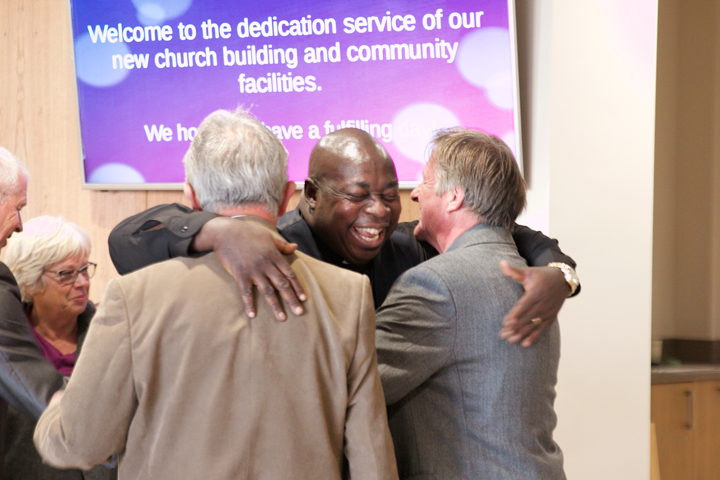

HYMN 3
Christian love
Tune: Ode to joy MP 600 or another pacey 87 87 D tune: a song created especially for Racial Justice Sunday, inspired by 1 Corinthians 13.4-7
© John Campbell

Christian love is not romantic,
not soft-focussed, twee or sweet,
Christian love’s not ‘likes’, nor dating,
far more real than text or tweet.
Christian love means life-long struggle;
lived-out kindness ev’rywhere.
Christian love must echo Jesus:
selfless, soulful, steeped in prayer.

Christian love respects the other,
seeks to understand, not judge;

Christian Love’s an arduous journey, finding self by giving all…

takes delight in mutual learning
doesn’t force and doesn’t fudge.
Christian love’s an arduous journey,
finding self by giving all;
serving, sharing, helping, caring;
full response to Jesus’ call.

Christian love cries out for justice
wheresoever it’s denied;
joins the struggle, makes the protest,
stays the course, eyes open wide.
Christian love rejects what’s racist,
sexist, ageist, prejudiced,
turns against each nurtured bias,
learning daily to resist.

Christian love is learned from Jesus,
walks his way and bears his cross;
self-surrenders, like our Saviour;
gains much more than what is lost.
Christian love is so persistent,
it outlasts all other things;
by its hope, its faith, its struggle,
it’s the song all heaven sings!

POEM
In God’s Image

I am a child of God –
As you are.
In my face is reflected the likeness of God –
As in yours.

Why then do you despise the colour of my skin,
The shape of my features,
Or the texture of my hair?

Why do you think that I must think
Like you,
Act like you,
Speak or believe like you?

I am me -
Made in the image of our Parent God –
In whose image
You are made.

How do you feel at ease, enjoying
The privilege you have
Not earned,
But have seized -
And seize -
From my own hand?

Why do you assume that those who are
‘Like you’
Are more desirable,
Deserving -
Somehow better?

‘Better’ how?
According to who?

Why must I have your approval -
Or permission -
To be me?
Fully me!
The ‘me’ our Parent God
Birthed me to be!

Why must my life be constrained by your norms,
Your customs,
Your rules,
Your ways,
Your judgment of who or what is acceptable –
Or not?

Who gave you the monopoly on ‘rightness’ –
And rightness in whose eyes?

Love others as you love yourself –
Or maybe, as you would wish to be loved.
And judge not in case you too
Are judged.

So says our Parent God -
In whose image
We both are made.
Karen Campbell

BENEDICTION

May God’s grace and love fill the earth and also our hearts
May justice flow like a roaring, mighty river
May peace descend like a dove upon quiet waters
And may we be mindful always
That in God’s Kingdom
All are loved to overflowing. Amen.

Revelation 7: 9
https://urc.org.uk/intercultural-good-practices.html
https://dictionary.cambridge.org/dictionary/english/institutionalized-racism
Revelation 5:13

