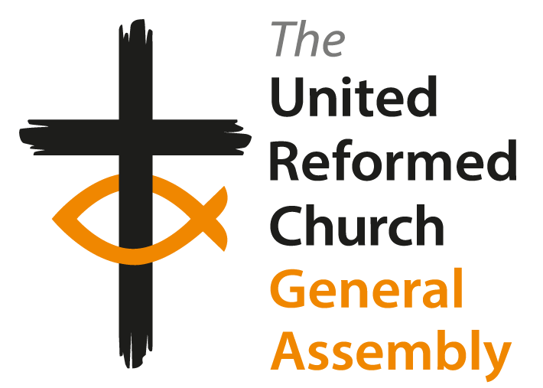
Sunday morning worship
Order of Service

11th July 2021, 11am
Responses are in bold

Call to worship

This is the day that the Lord has made;
We will rejoice and be glad in it.
It is good to give thanks to the Lord;
His love endures forever.

Hymn

1) The kingdom of God
Is justice and joy,
For Jesus restores
What sin would destroy;
God’s power and glory
In Jesus we know,
And her and hereafter
The kingdom shall grow.

2) The kingdom of God
Is mercy and grace,
The prisoners are freed,
The sinners find place,
The outcast are welcomed
God’s banquet to share
and hope is awakened
In place of despair.

3) The Kingdom of God
Is challenge and choice,
Believe the good news,
Repent and rejoice!
His love for us sinners
Brought Christ to his cross,
Our crisis of judgement
For gain or for loss.

4) God’s kingdom is come,
The gift and the goal,
In Jesus begun,
In heaven made whole;
The heirs of the kingdom
Shall answer his call,
And all things cry “Glory!”
To God all in all.
© 1973, words by Bryn A Rees, OCP,
One Licence
Prayers of Praise and Confession

Creator God,
You are holy beyond our wildest imagination.
You called everything into being and saw that it was good.
As we come to Your presence, You gather us together with the whole of creation.

Creator God, we worship You;
Creator God, we worship You.

Lord Jesus Christ,
Just as we are, you invite each one of us to your celebration feast,
You greet us each by name and welcome us into your family.
Lord Jesus Christ, we worship you;
Lord Jesus Christ, we worship you.

Holy Spirit, breath of Life,
You fill us with your love for all,
So that we are enabled to witness with and to your Word.

Holy Spirit, we worship you;
Holy Spirit, we worship you.

Prayer of Confession

Loving God,
As we draw near to you, we are painfully aware of our faults and failings,
We confess that we have been greatly influenced by other voices than yours,
We have been seduced by the superficial glamour of the culture of the world,
We have not spoken out against injustice and inequality in our society,
We have filled our own plates whilst other plates are empty,
We have been indifferent to the damage our way of life has caused to your creation.

Forgive us, Lord God. Help us to listen only to your voice, to do justice, love kindness and to walk humbly in your way.
Amen

Assurance of Pardon

Christ Jesus came into the world to save sinners.
To all who turn to him he says: ‘Your sins are forgiven.’
He also says: ‘Follow me.’

The Lord’s Prayer

Our Father who art in heaven,
hallowed be thy name.
Thy kingdom come.
Thy will be done,
on earth as it is in heaven.
Give us this day our daily bread,
and forgive us our trespasses,
as we forgive those who trespass against us,
and lead us not into temptation,
but deliver us from evil.
For thine is the kingdom, the power, and the glory,
forever and ever.
Amen.

Song

1) Noah built the most enormous boat,
That kept the birds and animals afloat,
The Lord was good, the Lord was strong,
And Noah lived his life for him.
2) Moses led his people through the sea,
Taking them away from slavery,
The Lord was good, the Lord was strong,
And Moses lived his life for him.
Chorus
Oh thank you, oh thank you,
That all through history you were faithful,
Thank you, oh thank you,
That you are just the same when it comes to me.
3) When it comes to me,
David fought Goliath and he won,
A humble shepherd boy became a king,
The Lord was good, the Lord was strong
And David lived his life for him.
4) Daniel was inside a lion's den,
But God brought him to safety once again,
The Lord was good, the Lord was strong,
And Daniel lived his life for him.
Chorus
Oh thank you, oh thank you,
That all through history you were faithful,
Thank you, oh thank you,
That you are just the same when it comes to me.
5) Jesus died to take away our sin,
So we could get to know our God again,
The Lord is good, the Lord is strong,
And we will live our lives for him.

Chorus
Oh thank you, oh thank you,
That all through history you were faithful,
Thank you, oh thank you,
That you are just the same when it comes to me.
© Nick & Becky Drake

Bible Story in words and pictures

Mark 6: 14-29. Artwork by Daniel Park, read by Jemimah White.

 |  | 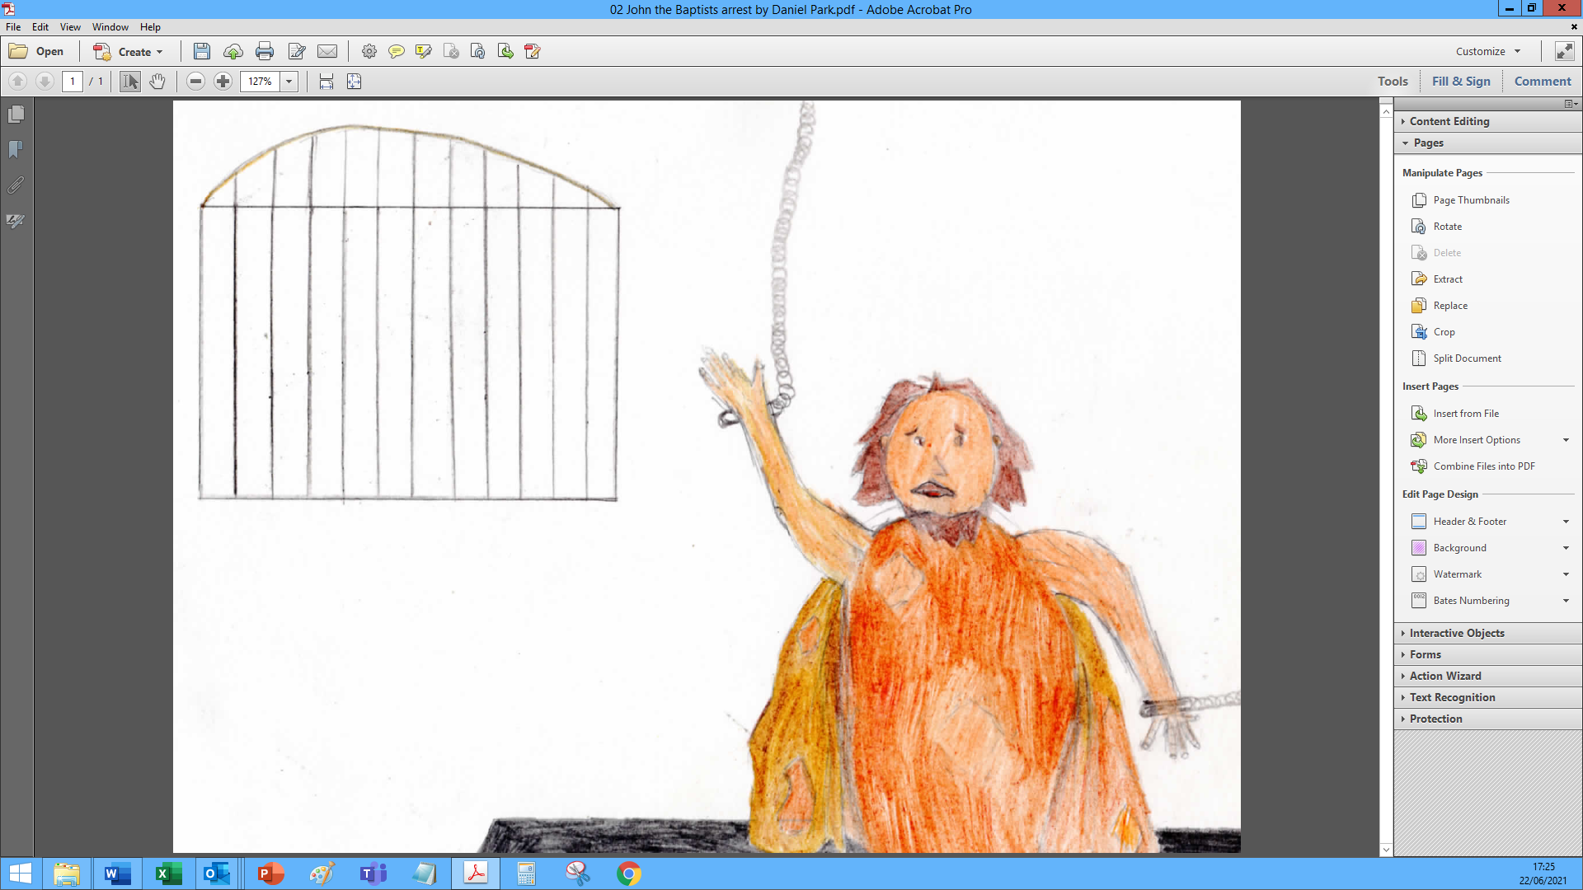
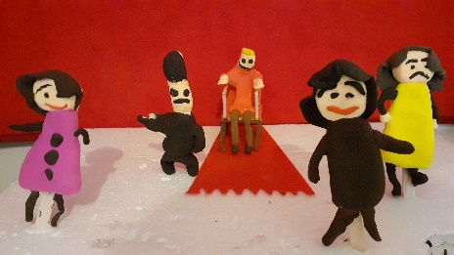 |  | 
 |  | 
 | 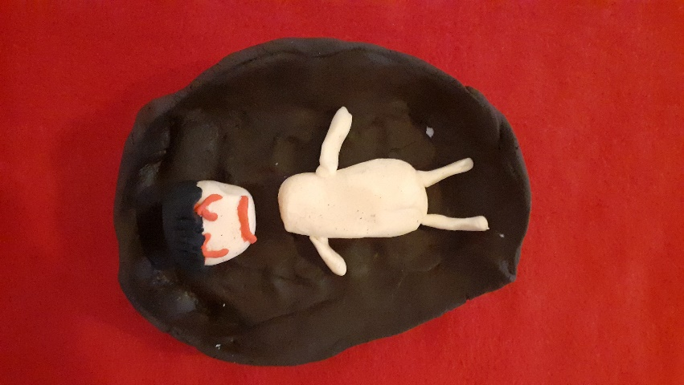

Hymn

1) Most villains prefer
that nobody knows
their self-serving schemes
or how their wealth grows;
with sly propaganda
they’d smooth-talk and charm,
so no-one will challenge
their vi’lence and harm.

2) Yet, prophets like John,
with selfless disdain,
cut right through the lies
and make God’s truth plain,
till villains, unsettled,
lash out in their hate,
expose their own evil
served up on a plate.
3) True heroes commit
to caring and cost,
to evil’s defeat,
to helping the lost;
they struggle for justice
and mercy for all,
exposing the villains
to hasten their fall.

4) Like John, Jesus came,
a hero to share,
who felt people’s pain,
and showed that he’d care;
unlike Herod’s feast, just
for cronies and cheats,
he’d feed starving thousands
with God-sharing feats.

5) So, what will we be,
which way will we take?
Will villainous ways
keep us on the make?
Or will we be heroes
and “sheroes” for right;
who live to bring justice,
for all, in life’s fight?

6) As people of God,
our shared call is clear:
exposing the wrong,
resisting the fear;
whatever the evils,
help justice win through,
with Jesus, for Jesus,
do all we can do!
© words by John Campbell, used with permission

Sermon
The Revd Clare Downing. Followed by a time for reflection.

“Plate Prayers” for others

Hymn

1) Eternal God, your love's tremendous glory
cascades through life in overflowing grace,
to tell creation's meaning in the story
of love evolving love from time and space.
2) Eternal Son of God, uniquely precious,
in you, deserted, scorned, and crucified,
God's love has fathomed sin and death's deep darkness,
and flawed humanity is glorified.
3) Eternal Spirit, with us like a mother,
embracing us in love serene and pure:
you nurture strength to follow Christ our brother,
as full-grown children, confident and sure.
4) Love's trinity, self-perfect, self-sustaining;
love which commands, enables, and obeys:
you give yourself, in boundless joy, creating
one vast increasing harmony of praise.
5) We ask you now, complete your image in us;
this love of yours, our source and guide and goal.
May love in us seek love and serve love's purpose,
till we ascend with Christ and find love whole.
© 1991, words by Alan Gaunt, Stainer & Bell Ltd, Hope Publishing Co, CCLI Event Licence: 672968

Blessing

Go into the world to speak with courage.
Go into the world to act with compassion.
Go into the world to encourage your neighbours.
Go into the world to share the good news.
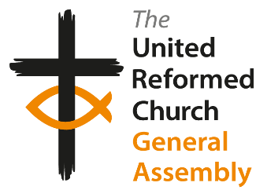
And may God - creator, son and spirit -
inform and inspire our thinking,
our speaking and our actions
and bless us today, and every day to come.
Amen

