Record
General Assembly, Loughborough 2010

© The United Reformed Church, 2010

URC084b
Published by
The United Reformed Church
86 Tavistock Place, London WC1H 9RT

All rights reserved. This material may be used freely within the churches.
No part of this publication may be reproduced outside the Church in any form or by any means – graphic, electronic, or mechanical, including photocopying, recording, taping or information storage and retrieval systems –
without the prior permission in writing of the publishers.

The publishers make no representation, express or implied, with regard to the accuracy of the information contained in this book and cannot accept any legal responsibility for any errors or omissions that may take place.

© Photography
Mark Howard, Twenty-Five Educational. www.base25.com and Chris Andrews, Reform, Church House. www.urc.org.uk

Environmental credentials

Papers used in the production of this book are Character Express: Wood fibre from sustainable forests, fully recyclable and biodegradable, PEFC, 14001 certified, ECF, iso 9706 long life archival usage

Designed and printed by the graphics office in Communications on behalf of the Assembly Arrangements Committee, The United Reformed Church, Church House, 86 Tavistock Place, London WC1H 9RT

Printed on a RISO HC5500: low energy consumption/low heat output.
Sample batches of RISO products have shown a 100% recycle rate (IT equipment target, WEEE directive).

Produced with reference to See it Right: Making information accessible to people with sight problems (2006), Royal National Institute of the Blind, London. ISBN 1 85878 704 1

If you require this text in another format please inform the graphics office, Church House. Please give two weeks notice.

Matters for consideration and action
United Reformed Church • General Assembly 2010

Resolution number | Report | Record |  | Synods | Local churches
1 | 7-29 | 17-18 | vision2020 | x | x
2 | 94-6 | 28 | Ethical investment policy | x | x
11 | 248-50 | 31 | Ministerial working week |  | x
12 | 215-20,  251 | 41 | Guidelines for conduct and behaviour |  | x
21 |  | 50 | Vetting and barring | x | x
32 | 113 | 44 | Olympics and Queen’s Jubilee | x | x
38 | 101-6 | 39 | Wesminster appeal | x | x
43-48 | 49-50,  58-59,  245-6,  259-61 | 46-53 | Constitutional resolutions  5-9 and 26 referred to synods | x

United Reformed Church • Record of General Assembly 2010 • 1

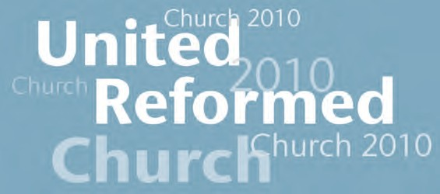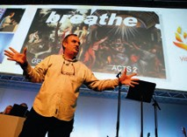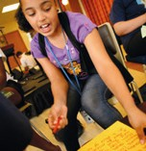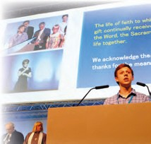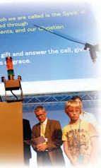

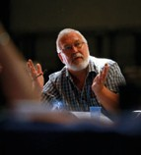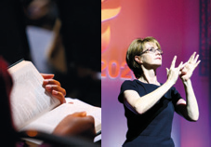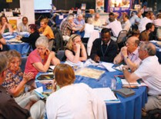
Record of Assembly

United Reformed Church General Assembly, Loughborough 2010

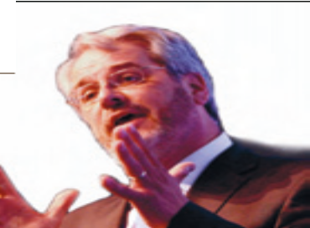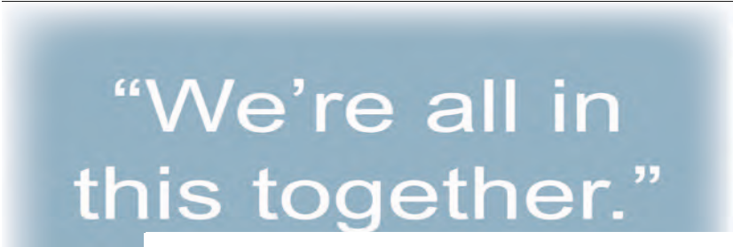

Revd Nigel Uden

4 • United Reformed Church • Record of General Assembly 2010

We’re all in this together
Synod Moderators’ report
Moderator and members of Assembly, you may not all share my devotion to the American industrial rock band, Nine Inch Nails and their 1999 album, The Fragile. If you don’t, you may have been absorbed by this year’s Reith Lectures; Martin Rees, the President of the Royal Society, has been speaking profoundly about humanity’s future on earth. And most of us will have looked with concerned fascination at David Cameron’s proposals in the recent Emergency Budget.

For all their diversity Nine Inch Nails, Martin Rees and David Cameron use a common mantra: ‘we’re all in this together’.

The Nails’ lead singer cries out intensely to the partner who is his only hope as their ‘world breaks in two’; 1 Lord Rees quietly reflects upon his deep concern that ‘we are destroying the book of life before we have read it.’ 2 And David Cameron offers a strategy for the nation’s financial recovery.
Each of them repeats time and again, ‘we’re all in this together.’

They and we may start from different places but the mantra is one we Christians can share. ‘We’re all in this together.’ Or, as Carole Elphick’s hymn had us sing yesterday, God calls us all to travel life together.

The Jewish Law and Jesus’ Love nudge us towards togetherness, encourage
us into community – whether it’s the church – many members, yet one body, 3 the New Commandment, 4 the Fruit of the Spirit 5 or the Torah’s thirty six prods to ‘love the stranger in our midst’. 6 ‘We’re all in this together.’

Perspectives on Christianity from other parts of the world make the same point. Minjung theology from Korea inspires ordinary people to work collaboratively for social welfare and social change. 7 Ubuntu thinking from Africa emphasises ‘I belong, therefore I am.’ 8 The Quaker Ecumenical Accompaniment programme of solidarity in Palestine and Israel ‘provides
protective presence to vulnerable communities.’ 9 ‘We’re all in this together,’ or as Loretta Minghella’s contact in Kenya put it, ‘We are the same.’

And such is the burden of the Synod Moderators’ report. Though the similarity between the Moderators and an industrial rock band may not be immediately obvious, our mantra is the same. ‘We’re all in this together.’

As we serve across the thirteen synods, and as we review the Book of Reports, like you, we see that, relentlessly, everything in the church and in the world is changing. Now, it may be that we are persuaded of the positive view
of change that some scientists offer, that it is ‘… the process of bringing a potentiality in a substance to fulfilment.’ 10 There’s some rich theology there.

- Available at http://www.sing365.com – accessed 26th June 2010.
- Rees, Martin 2009. The Times, 26th May 2009 ‘We’re all in this together.’ Available at http://www.timesonline.co.uk/tol/news/science/article6382080.ece – accessed 26th June 2010
- I Corinthians 12.20 4 John 13.34
- Galatians 5.22f
- Sacks, Jonathan 2000. Radical Then, Radical Now: on being Jewish, London: Continuum p.92
- Castle, Brian 2004. Unofficial God?: Voices from Beyond the Walls, London: SPCK pages 55ff
- Tutu, Desmond Mpilo 1999. No future without forgiveness, London: Rider p.35
- See http://www.eappi.org/ – accessed 26th June 2010
- Sweetman, Brendan 2010. Science and Religion: an introduction, London and New York: Continuum p.29

United Reformed Church • Record of General Assembly 2010 • 5

Friday, 2 July

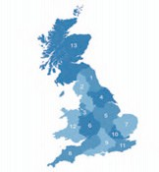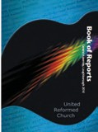By the same token almost without exception, the programmes and frameworks placed before this Assembly are born of shared passion for and dedication to a renewed future for the church and the world within God’s reign. We’re all in this together.
Synod Moderators’ report
But all the time we encounter examples of how change is also testing and even painful. And when things are changing – when they are not, too – we are convinced that the United Reformed Church’s life and work thrives most as we realise ‘we’re all in this together’ – on pilgrimage, in covenant with God and with each other.

Although the synods strategise differently in our varied national and regional contexts, we all feel similarly challenged by this era of decline, just
as we all feel similarly committed to the Gospel and the church, to the community and one another. We’re all in this together.

Vision4Life is a denomination-wide process of shared discovery and discipleship.
vision2020 is a strategy for integrated mission across our three nations.
The Marketing Campaign will open our door and smoothen our threshold.
All five elements of the Youth and Children’s Work Vision focus on togetherness.
The Pastoral Reference and Welfare Committee embodies our determined and durable caring.
Communications oils our connections.



Equal Opportunities encourages loving awareness of one another under the law.
The Guidelines on conduct of Elders, CRCWs and Ministers urge those boundaries that enable respectful closeness.
The North Western Synod resolution on Children in Immigration Centres is about campaigning against our inhumanity to one another.

6 • United Reformed Church • Record of General Assembly 2010

Synod Moderators’ report
Friday, 2 July

‘We’re all in this together’, just as we are in so much more that I could have highlighted from the Book of Reports.

To illustrate this togetherness there is a musical thread running through this report and the specific analogy is musical accompaniment.

Crucially, our accompanying is but an echo of God’s.

Drawing on the notion that God’s wholehearted love is ‘an enduring melody’ 11 the Moderators’ report buys into a point which emerges in a festschrift for Erik Routley: [that] all history is point and counterpoint – two melodies running side by side – God’s and [ours]. Alone one of them is always incomplete, even God’s.[God] preferred to die rather than be without us.’ 12

So God accompanies us. We accompany God. And accompaniers is what we are to one another and to the communities in which we are set.

That’s how we are best enabled to grow into Jesus Christ as friend and teacher and Saviour. That’s how discipleship is best nurtured. That how we’re best equipped ‘to give and account of the hope that is in us.’ 13 That’s how Ministerial service is best reviewed. Accompanying is how love is best embodied. That’s how justice is best achieved. That’s how creation’s integrity is best sustained. That’s how the church is best the church.


In mutual dependability, and pliable to the Holy Spirit, we’re all in this together. Moderator and members of Assembly, the things at the heart of this report are not always most adequately expressed in words. Sometimes we have to do togetherness; to demonstrate it more than to articulate it. That’s what the Minjung, the Bantu and the
Quakers teach us. It’s also the essence of Vision4Life, of Alpha and of Fresh Expressions.
So by way of illustration this afternoon we are going to make music together; to accompany one another, for, as Aldous Huxley has it, ‘After silence, that which comes nearest to expressing the inexpressible is music.’

We are going to sing, not a Nine Inch Nails number – but a version of Dona nobis pacem, which is sometimes attributed to their equally unconventional brother, Wolfgang Amadeus Mozart.
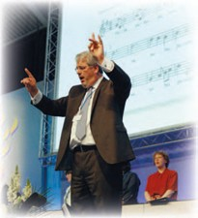
It’s a prayer for that peace which is the ultimate gift to us as we accompany one another in the church and the world celebrating the God who accompanies us in Christ.

Moderator, on behalf of my colleagues,
I present the report of the Synod Moderators.

N P Uden
Report of the Synod Moderators Saturday 3rd July 2010

- Mayne, Michael 2006. The Enduring Melody, London: Darton, Longman and Todd
- Leaver, Robin A. The Theological Character of Music in Worship, a chapter in Duty and Delight: Routley Remembered – a memorial tribute to Erik Routley (1917-82), eds Leaver, Robin A. and Litton, James H. Norwich: Canterbury Press 1985 p.48
- I Peter 3.15

United Reformed Church • Record of General Assembly 2010 • 7

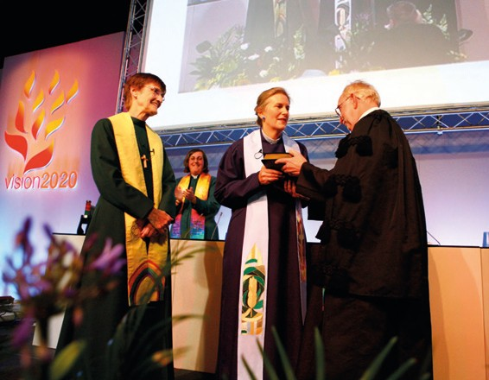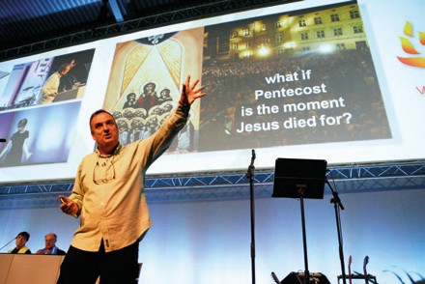

Mrs Valerie Morrison and the Revd Dr Kirsty Thorpe inducted as Moderators of the General Assembly 2010-2012.

Bible study, presented by Gerard Kelly

8 • United Reformed Church • Record of General Assembly 2010

First Session
Friday, 2 July

Constitution of Assembly
At 3.30 pm members of Assembly met in the Assembly Conference Hall in the University of Loughborough. The Moderator, the Revd John Marsh constituted the Assembly with prayer, the place and the time having been duly appointed.

Induction of Moderators
Mrs Valerie Morrison and the Revd Dr Kirsty Thorpe, Moderators-elect, were each inducted with prayer into the office of Moderator of the General Assembly of The United Reformed Church. They signed the Assembly Bible and were presented with inscribed copies of the Bible by the retiring Moderator.

Thanks to the retiring Moderator
The thanks of the Church were expressed by the Moderators to the Revd John Marsh and to Mrs Marsh, together with the Revd Mary Buchanan, his Chaplain. Mrs Marsh was presented with a photographic album.

Assembly then continued with Bible study, presented by Gerard Kelly, introducing the theme of ‘The Power of the Story’, after which both Moderators addressed the Assembly.

The Roll of Assembly was then placed on the table by the Clerk to Assembly, the Revd James Breslin.

Moderators Mrs Valerie Morrison Revd Dr Kirsty Thorpe
Clerk Revd James Breslin
General Secretary Revd Roberta Rominger
Deputy General Secretary Revd Richard Mortimer

Moderators of synods | I | Revd Rowena Francis
 | II | Revd Richard Church
 | III | Revd Howard Sharp
 | IV | Revd Kevin Watson
 | V | Revd Terry Oakley
 | VI | Revd Roy Lowes
 | VII | Revd Paul Whittle
 | VIII | Revd David Grosch-Miller
 | IX | Revd Adrian Bulley
 | X | Revd Dr Andrew Prasad
 | XI | Revd Nigel Uden
 | XII | Revd Peter Noble
 | XIII | Revd John Humphreys

Conveners of General Assembly Standing Committees and Task Groups
Assembly Arrangements Dr David Robinson
Communications and Editorial Revd Dr Kirsty Thorpe
Education and Learning Prof Malcolm Johnson
Equal Opportunities Ms Morag McLintock
Finance Mr John Ellis
Ministries Revd Peter Poulter
Mission Revd Edward Cox
Mission Council Revd John Marsh
Nominations Revd Malcolm Hanson
Pastoral Reference and Welfare Revd Alasdair Pratt
Youth and Children’s Work Revd Rob Weston
United Reformed Church • Record of General Assembly 2010 • 9

Friday, 2 July

Theological College Representatives
Northern College: Staff Revd Dr Kathy White Student Mrs Anthea Wickens

Scottish United Reformed Staff
and Congregational College: Student Mr William Young

Westminster College: Staff Revd Dr Susan Durber Student Mrs Melanie Frew

Youth Representatives

FURY Moderator Mr David Harvey Representative Miss Jane Hoddinott

Chaplain (URC) to HM Forces in Britain Revd Mike Thomason

Synod Representatives

Synod I – Northern
Revd Elizabeth Blair, Revd John Durell, Revd William Ellerby, Revd Philip Gray, Revd Meg Robb, Revd Val Towler

Mr Matthew Appleyard , Mrs Joyce Calcraft, Mrs Rhona Dunn, Mrs Chris Eddowes, Mr Henry Gowland, Mrs Ann Honey, Mrs Maranny Jones, Dr Donna Moore

Synod II – North Western
Revd Michael Aspinall, Revd Janet Calderley, Revd Geoffrey Clarke, Revd David Coaker, Revd Michelle Jarmany, Revd Dr John Parry, Revd John Piper, Revd Sally Thomas,
Revd Marion Tugwood, Revd Wendy White, Revd Ruth Wollaston

Mr David Amvam, Mrs Dorothee Buurma, Miss Kathleen Cross, Mrs Pamela Dent,
Mr Derek Estill, Mrs Kate Grand, Mrs Jean Gordon, Revd Brian Jolly, Mrs Linda Rayner, Miss Charis Unsworth, Miss Katy Unsworth, Mrs Sue Wilkinson, Mr Keith Whiting,
Mr Kaze Yemtsa

Synod III – Mersey
Revd Caroline Andrews, Revd Hilary Bell, Revd Debbie Brown, Revd Alan Crump, Revd Gary McGowan Revd Gordon Smith, Revd Dr Ronald Reid

Mrs Barbara Ellis, Mr John Grundy, Dr Janet Large, Mr Gary Leighton, Mr Chris Maple, Ms Alison Micklem, Miss Emma Pugh, Mrs Pam Sharp, Mr Arthur Swift

Synod IV – Yorkshire
Revd Philip Baiden, Revd Peter Clarkson, Revd Claire Gouldthorp, Revd John Hayton, Revd Jamie Kissack, Revd Sue Macbeth, Revd Alison Termie

Mr Michael Beard, Mrs Judith Drake, Mrs Pat Evans, Mr Andrew Murison,
Mrs Suzanne Punter, Mr Chris Reed, Mrs Barbara Robinson, Miss Miriam Webb

Synod V – East Midlands
Revd Nick Adlem, Revd Paul Bedford, Revd Jane Campbell, Revd Clare Downing, Revd David Featonby, Revd Jenny Mills, Revd Richard Turnbull

Miss Helen Carr, Miss Ruth Hodgson, Mrs Una Hubbard, Mr Dennis Russell, Mr Duncan Smith, Mr Philip Timson, Mr Allan Tinnie, Mrs Jill Turner

10 • United Reformed Church • Record of General Assembly 2010

Synod VI – West Midlands
Revd Elizabeth Caswell, Revd Helga Cornell, Revd Diana Cullum-Hall, Revd Jacky Embrey, Revd Louise Franklin, Revd Tim Mullings
Mrs Brenda Climer, Ms Jean Creighton, Mr John Desmond, Mr Andrew Evans, Mr Jim Hewitson, Mr Michael Harvey, Mrs Julie Jeffries, Mrs Margaret Marshall,
Miss Lucy Noble, Mrs Zaidie Orr, Mr Gerald Peters, Mrs Val Phillips, Mrs Adella Pritchard, Mr Bill Robson, Mr Mark Tubby

Synod VII – Eastern
Revd Catherine Ball, Revd Peter Ball, Revd Alison Davis, Revd Sohail Ejaz,
Revd Kenneth Forbes, Revd John Hardaker, Revd Andrew Royal, Revd Michael Shrubsole, Revd David Vincent, Revd Ruth Whitehead
Prof Sir Tony Bottoms, Mr Tunde Biyi, Mrs Wendy Cooper, Mr Clive Goodhew, Miss Lisa Guest, Mrs Linda Harrison, Mrs Moira Kleissner, Mr Clifford Patten, Miss Victoria Paulding, Mr Ron Wade

Synod VIII – South Western
Revd Dick Gray, Revd Roz Harrison, Revd Viv Henderson, Revd Robert Jordan, Revd Tracey Lewis, Revd Norman Price, Revd Graham Tarn, Revd Heather Whyte
Mrs Jean Cleare, Mr George Faris, Miss Katherine La Fleur, Ms Sarah Lane Cawte, Mr Tony Langmead, Mrs Maria Mills, Mrs Joanna Morling, Mr Jon Oliverio

Synod IX – Wessex
Revd Carla Grosch-Miller, Revd Brian Harley, Revd Michael Hopkins, Revd Paul Holmes, Revd Phillip Jones, Revd Owiny Laber, Revd Mark Meatcher, Revd Romilly Micklem,
Revd Tanya Rasmussen, Revd Timothy Searle, Revd Edward Symmons, Revd Mary Thomas, Revd Dick Wolff
Mrs Margaret Carrick Smith, Mrs Mary Cooper, Mr Andrew Gibb, Mr David Hoadley, Ms Saz Holland, Mrs Virginia Lawson, Mr Nick Lowe, Revd Patrick McManus,
Mr James Meachin, Mr Peter Pay, Mr Philip Ray, Miss Alison Southwood, Mr Graham Thatcher, Mrs Sheila Thatcher, Mr Malcolm Townsend

Synod X – Thames North
Revd Ray Adams, Mrs Joyce Berry, Revd Ute Blohm, Revd Meryl Court, Revd John Danso, Revd Kate Hackett, Revd Naison Hove, Revd David Lawrence, Revd Dr Rosalind Selby, Revd Kevin Swaine, Revd Rosemary Tusting, Revd Jane Wade
Mr Stephen Amoah, Mr Steven Ansa-Addo, Mr Solomon Aryee-Brown,
Mr Simon Fairnington, Mrs Wendy Gray, Dr Malcolm Haslett, Mr Brian Hosier,
Mrs Marian Mole, Mr Ulric Quee, Mrs Memona Shahbaz, Mr Keith Webster, Mrs Joan Young

Synod XI – Southern
Revd Andrew Birch, Revd Robert Bushby, Revd Michael Davies,
Revd Derrick Dzandu-Hedidor, Revd Nicola Furley-Smith, Revd Ian Gow,
Revd Richard Grocott, Revd Jenny Morgan, Revd Kristin Ofstad, Revd Andrew Sellwood, Revd Darryl Sinclair, Revd Raymond Singh, Revd Peter Southcombe, Revd Bruce Stuart, Revd Wendy Swan
Mr Jacob Bali, Mrs Hilary Birch, Mr Stephen Brockett, Mrs Lisa-Maria Browning,
Mr Alex Cameron, Mrs Jeanette Chamberlain, Mr Frank Liddell, Mr Ben Littlejohns, Miss Eleanor MacIntyre, Mrs Hilary Miles, Mrs Dawn Powell, Ms Katie Steel,
Mr Lyndon Thomas, Mrs Christine Thompson, Mr David Walters

Synod XII – Wales
Revd Keith Forecast, Revd Stephen Gilbert, Revd Nanette Lewis-Head, Revd Shelagh Pollard,
Mr Matt Barkley, Mr Andrew Buxton, Mrs Rosie Buxton, Ms Janet Drogan, Mr Patrick Hickey, Ms Bethan Noble, Ms Helen Stenson

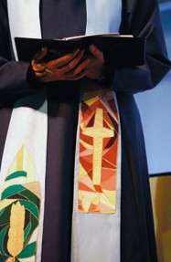Friday, 2 July

Synod XIII – Scotland
Revd Jan Adamson, Revd John Bremner, Revd Steven Manders, Revd Leslie Morrison, Revd Dr Lesley Moseley, Revd Carolyn Smyth, Revd Mary Taylor, Revd Ian Wilkie

Mr Barclay Bannister, Mr Bob Christie, Ms Eilidh Forsyth, Mr Matthew Henderson, Ms Mary Mbae, Mrs Irene Merrilees, Dr Jim Merrilees, Mr Michael Smerdon,
Mr Patrick Smyth, Miss Sheena Young, Mr William Young, Mrs Kathleen Ziffo
British and Irish ecumenical representatives
Rt Revd John Christie Church of Scotland
Revd Michael Cleaves The Baptist Union of Great Britain
Revd Peter Colwell Churches Together in Britain and Ireland
Dame Anne Doyle Roman Catholic Bishops Conference
Revd Aled Edwards CYTUN
Revd Llunos Gordon Union of Welsh Independents
Rt Revd Onye Obika Independent Methodist Churches of Great Britain Revd Gwenda Richards Presbyterian Church of Wales
Ven Dr Joy Tetley Church of England
Revd Philip Turner The Methodist Church
Revd Sandra Turner The Congregational Federation
Revd Dr Donald Watts Presbyterian Church in Ireland
Revd David Howarth British Province of the Moravian Church

Overseas representatives
Revd Dr Lal Engzau Presbyterian Church of Myanmar
Revd Joel Ortega Dopico Presbyterian Reformed Church in Cuba Revd Ernesto Langa Presbyterian Church of Mozambique
Revd Davide Ollearo Waldensian Church
Revd Jose Tovelo Junior Presbyterian Church of Mozambique Dekan Michael Pernt-Weigel Evangelische Kirche der Pfalz
Revd Deborah Streeter United Church of Christ (USA)
Revd Randolph Turner Council for World Mission
Revd Reinerio M Arce Valentin Presbyterian Reformed Church in Cuba

The presiding Moderator announced adjournment of the first session and reminded Assembly to reconvene at 7.00 pm.

12 • United Reformed Church • Record of General Assembly 2010

Second Session

Welcomes
The Moderator, the Revd Dr Kirsty Thorpe, welcomed new members of Assembly and introduced the people on the platform and explained their roles.

Reception of guests
British and Irish ecumenical representatives were introduced by the Revd David Tatem: Revd Michael Cleaves The Baptist Union of Great Britain
Revd Peter Colwell Churches Together in Britain and Ireland
Dame Anne Doyle Roman Catholic Bishops Conference
Revd Aled Edwards CYTUN
Revd Trevor Gribben Presbyterian Church in Ireland
Revd Llunos Gordon Union of Welsh Independents
Rt Revd Onye Obika International Ministerial Council of Great Britain. Ven Dr Joy Tetley Church of England
Revd Philip Turner The Methodist Church
Revd Sandra Turner The Congregational Federation
Revd David Howarth British Province of the Moravian Church

Overseas guests were introduced by the Revd Jane Rowell:
Revd Dr Lal Engzau Presbyterian Church of Myanmar
Revd Ernesto Langa Presbyterian Church of Mozambique
Revd Davide Ollearo Waldensian Church
Revd Jose Tovela Junior Presbyterian Church of Mozambique Dekan Michael Pernt-Weigel Evangelische Kirche der Pfalz
Revd Deborah Streeter United Church of Christ (USA)
Revd Randolph Turner Council for World Mission


Revd Dr Lal Enzgau and the Ven Dr Joy Tetley were invited to address the Assembly.

The Mayor of Charnwood, Councillor Jill Vincent, was introduced by Mrs Daphne Beale. Councillor Vincent addressed the Assembly.

Procedural notices and general information were given by the Convener of the Assembly Arrangements Committee, Dr David Robinson.

The Moderator outlined the ‘consensus’ method of decision making.

The Clerk proposed resolutions 35 and 36.
Resolution
35
Appointment of Deputy Clerk
General Assembly appoints Mrs Melanie Frew to serve as Deputy Clerk on Saturday afternoon or at such other times as the Clerk may require.

Resolved by consensus.

Friday, 2 July
Resolution
36 Appointment of the Convener of
Tellers for the election of the Moderators
General Assembly appoints Dr Jim Merrilees to serve as Convener of Tellers for the election of Moderators 2012.

Resolved by consensus.

The Clerk moved resolution 24.

Resolved by consensus.
Resolution
24
Proposed changes to the
Assembly Rules of Procedure
Term of appointment of the Clerk to the Assembly
General Assembly resolves to amend paragraph 5.1 of the Rules of Procedure to read:

5.1 The General Assembly may appoint a Clerk of Assembly as distinct from the General Secretary. In that case the Nominations Committee shall submit a name to the General Assembly for appointment as Clerk, for six years in the first instance, renewable for a maximum additional period of
four years, but ensuring an overlap with a period of service of the General Secretary.

The General Secretary proposed resolution 30.

Resolution
30 Mission Council: (Resolution 24
of General Assembly 2008)
General Assembly resolves to amend the Structure of the United Reformed Church paragraph 2(5)(f) to read:

A staff representative and a student representative being members of the URC, from each of such theological colleges as the General Assembly has designated as resource centres for learning, and a staff representative and a student representative being members of the URC, from such other colleges or centres as shall from time to time be designated by the Education and Learning Committee as engaged in significant training for the United Reformed Church.

and to add a new paragraph 2(5)(o) to read:

The Chair of the United Reformed Church Trust
The resolution was passed nem con.

14 • United Reformed Church • Record of General Assembly 2010

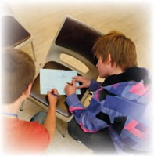
Introduction to the Children’s Assembly
Mr Leo Roberts and a group of children explained some of the work being undertaken by the Children’s Assembly.

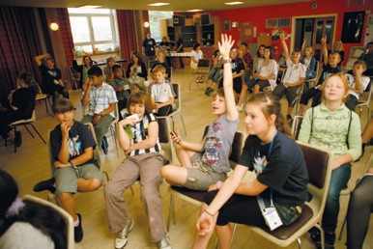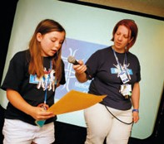
Children’s Assembly

The Clerk moved resolution 25.

Resolved by consensus.
Resolution
25
Proposed changes to the Rules
of Procedure: application of the standing orders
General Assembly resolves to amend clause 1.3 of the Rules of Procedure to read:
1.3 All meetings of the Assembly shall be convened and held as provided by these rules. The Standing Orders which are printed in the Book of Reports to General Assembly shall apply to all meetings of the Assembly and the Mission Council and, in so far as they are applicable, to meetings of synods, district councils and their committees.

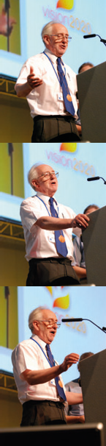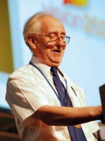
Friday, 2 July
Reflections of the outgoing Moderator
Revd John Marsh offering his reflections provided Assembly with information about the visits and preaching engagements he had undertaken during his two years in office.

He was exhilarated by the experience of two years as Moderator but noted that the workload was only possible because he was retired. He commented enthusiastically on his trip to Zimbabwe which included visiting Christian Aid funded projects.

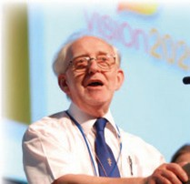
The Revd John Marsh

Closing prayers
These were led by the Chaplain, the Revd Dr James Coleman. The Assembly stood adjourned.

16 • United Reformed Church • Record of General Assembly 2010

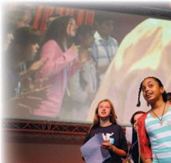First Session
Saturday, 3 July

United Reformed Church • Record of General Assembly 2010 • 17
Saturday, 3 July

Opening worship was led by the Chaplains, the Revd James Coleman and the Revd Rachel Poolman. The children left to continue their own work.

With the Moderator, Mrs Val Morrison in the chair, Bible study was again led by Gerard Kelly, continuing the theme from the Acts of the Apostles. At this point, the children rejoined the Assembly.

The Moderator welcomed visitors for the day and explained the new format of the morning’s business.

Themed session 1: vision2020
The Moderator invited the Revd Ed Cox to introduce the session.
Introductory comments – Mr Cox referred to vision2020 and the importance of mission. He offered brief thanks for responses and reflected on the consultation process. He introduced the statements and indicators.

A number of children reported views from the Children’s Assembly from a DVD presentation.

Presentation by the Children’s Assembly

On behalf of Ministries committee, Revd Peter Poulter supported the framework with the local church at the heart of mission and the vision2020 framework.

Mr Tim Reith from Crossway URC shared the story from his local church experiencing numerical growth with strong emphasis on work with children and young people. The Revd Tracey Lewis of Trinity Henleaze URC shared a story about her local church engaging with issues of climate change.

United Reformed Church • Record of General Assembly 2010 • 17

Saturday, 3 July
Members of Assembly were invited to discuss a series of questions.

Revd Terry Oakley introduced the Revd Carolyn Smyth of the Synod of Scotland, and Revd Roy Lowes, Moderator of West Midlands Synod, who gave perspectives from their own synods.

Members of Assembly were invited to discuss further questions.
Mrs Linda Mead spoke about the Commitment for Life programme and its emphasis on justice and peace issues.
She introduced Ms Loretta Minghella the new director of Christian Aid, who addressed the Assembly.

Mr Cox spoke how vision2020 is being applied at Assembly level. The members of the ‘Mission Team’ introduced themselves and their work.

Ms Loretta Minghella

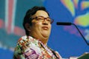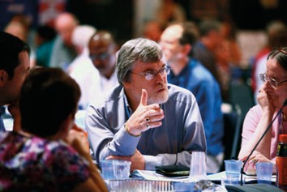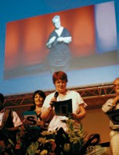
Mr Cox thanked the members of the team for the way they are working together.
The Revd Brian Harley and Revd Dr Susan Durber updated members of Assembly on the progress of the ‘Prayer year’, part of the Vision4Life programme.
The General Secretary, Revd Roberta Rominger co-chair of the steering group, introduced the
‘Identity and Marketing Campaign’. She introduced Denese Chikwendu the campaign co-ordinator.
Mr Lawrence Moore, co-chair emphasised that the campaign, is not contrary to the United Reformed Church’s ecumenical stance.

The ‘Mission Team’ introduced themselves

Plenary Feedback
Members of Assembly shared their views and offered suggestions from the morning’s discussions. Mr Cox and Mr Moore responded to the points raised.

The Clerk moved adjournment of the debate and Assembly concurred. The Assembly stood adjourned.

Discussions at Assembly

18 • United Reformed Church • Record of General Assembly 2010

Second Session
The Moderator, the Revd Dr Kirsty Thorpe took the chair.

The Clerk of Assembly moved the adoption of the minutes from Friday July 2 sessions one and two. Assembly concurred.

Themed session 2

Synod Moderators’ report
The report, on the theme, ‘We’re all in this together’, was presented by the Revd Nigel Uden, Moderator of Southern Synod (see p 4-7 of the Record).
Assembly discussed the report, and how it might be disseminated to churches, in buzz groups. The Moderator thanked Mr Uden for the report.

Equipping people for service
Professor Malcolm Johnson, on behalf of the Education and Learning Committee, and the Revd Peter Poulter, on behalf of Ministries Committee, presented the report.
Assembly was asked to identify a vivid experience of being equipped for service by the United Reformed Church.
Saturday, 3 July

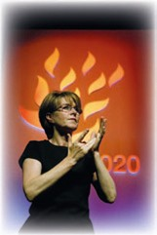

Signers were present throughout the Assembly

The Revd Craig Bowman interviewed Mrs Joanna Morling, Mr David Harvey and Mr Kaze Yemtsa about their learning experiences in the United Reformed Church.
Members of Assembly were asked to respond to the stories they heard, and asked what they believed the United Reformed Church needed to hear to shape future work.

The Moderator invited questions and comments on the reports which were not the subject of resolutions.

Communications and Editorial Committee
Mrs Morrison took the chair for Dr Thorpe to respond to questions as Convener of the committee.
Dr Thorpe resumed the chair.

Education and Learning Committee
The Revd Fiona Thomas, Secretary, responded to questions.

Equal Opportunities
The Revd Elizabeth Nash, Convener-elect, responded to questions.

Ministries Committee
Revd Craig Bowman, Secretary, and Revd Peter Poulter, Convener, responded to comments and questions.

In response to a question concerning Ministerial retirement age the Revds Craig Bowman and Peter Poulter stated that discussions regarding retirement age for Ministers are already taking place in the committee.

Saturday, 3 July

Pilots
The Revd Rob Weston, Convener of the Youth and Children’s Committee introduced the DVD of the Pilots’ Big Day Out at Warwick Castle.
Mr Weston invited comments on the day and a number of affirmations were received.
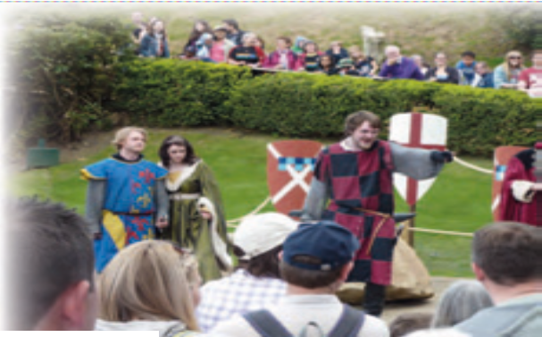
Mr Weston thanked the
Pilots Officer Mrs Karen Bulley-
Morrison and her team for all their hard work in preparation for the day.
Re-enactments at Warwick Castle

The Clerk moving resolution 23 requested the permission of Assembly for the Revd Professor David Thompson to introduce the resolution.

Resolution
23 Homerton College, Cambridge
Assembly sends greetings and good wishes to the Principal, Fellows and students of Homerton College on the occasion of its reception of a Royal Charter as a college of the University of Cambridge and expresses gratitude to all who have served as Trustees.

The resolution was resolved by acclamation.

Professor Thompson read the following message from the principal:
The Principal apologises for not being present to respond to the resolution, concerning Homerton College. She, and the Fellows and Students of Homerton College, thanks the General Assembly for its greetings and good wishes; and in turn wishes to thank all those who have served as Trustees on behalf of the United Reformed Church in recent decades – and before that the Congregational Union – for their constant wisdom and guidance over more than two centuries.

20 • United Reformed Church • Record of General Assembly 2010

Community Awards sponsored by Congregational and General Insurance Company
Ms Margaret Slater, from the Congregational and General Insurance Company, joined Mrs Val Morrison, as two of
the judges, to make the awards. Ten projects were shortlisted from eighty-two applications.
Five winners were selected:

3rd place winners, awarded £1,000 Peaceful Solutions for Conflict Resolution, High Cross URC Tottenham.
The award was received by Lorraine Downer-Mattis and Steven Ansa-Addo

Cafe Unity Heald Green.
The award was received by Revd Mike Walsh and Sarah Pritchard
2nd place winners awarded £2,000

Sleaford Community Shop.
The award was received by
Lynne Higgins and Audrey Wilson Children’s allotment, Southchurch Park United Reformed Church, Southend.
The award was received by Elaine Stevens and Shannon Manning.

1st place winner awarded £3,000 Asylum Justice, City Church, Cardiff.
The award was received by Mr Patrick Hickey and Mr Mike Addlington

Reception of local ecumenical guests
Saturday, 3 July

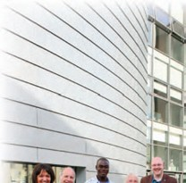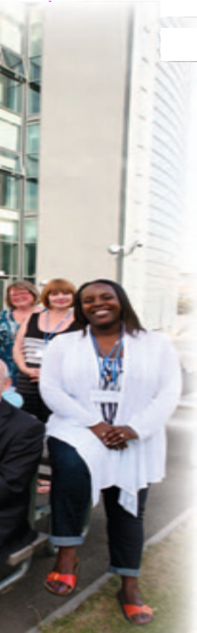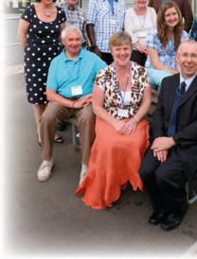Community Awards winners with Martin Hazell (Director of Communications, URC) and Margaret Slater (Congregational and General Insurance Company)

The Revd Terry Oakley Moderator of East Midlands Synod introduced:
Father John-Joe Maloney Roman Catholic Episcopal Vicar for Leicestershire and Rutland Mrs Dianne Tidball Regional Minister for the East Midland Baptist Association Mr Michael Hockaday Representing the Congregational Federation
Revd Peter Hancock Chair of the Northampton District of The Methodist Church Rt Revd Malcolm McMahon Roman Catholic Bishop of the Diocese of Nottingham
Mr Vic Allsop County Ecumenical Officer for Churches Together in Leicestershire
The Moderator greeted these guests.

Moderator’s election for 2012 - 2014
The Clerk explained the method for the election of an Elder and a Minister. The Moderator led Assembly in prayer and members were then invited to vote.

Closing prayers were led by the Chaplain, the Revd Rachel Poolman.



22 • United Reformed Church • Record of General Assembly 2010

First Session
Sunday, 4 July
Assembly met for worship led by the Revd Rachel Poolman and the Revd Dr James Coleman. Bible study was again led by Mr Gerard Kelly. This included the Sacrament of Holy Communion and the commemoration of Ministers and Missionaries who had died since the last Assembly in 2008.

We remembered: ANDREWS, Bertram Jacklin BAKER, Alfred TJ BESSANT, Colin Peter BIDMEAD, Stuart BINDEMAN, George BARBER, Derrick BENNETT, Maurice James
BRITTAIN, Albert Ernest John BROWN, Elizabeth Robertson BROWN, William John BUTLER, Owen Harmsworth BYERS, Howard CARRUTHERS, Robert William CHAMBERS, Eric
CHARLTON, Clifford CHRISTIE, Pauline Jeanne CLARK, George Dudley CLARK, John
CLARKE, David Edward CLARKE, Donald George COLLIN, Christine Elizabeth COX, Dennis Alfred
CROSS, Arthur Howard DAVIES, Constance Olive Maud DAVIES, Granville
DOWNIE, William
EVANS, Colin
FINCH, Alan Frederick FLAWN, Donald Frederick FOX, David
FRANKS, Cyril GOOD, Robert GORDON, Henry GRIFFITHS, Philip HALL, Francis HEWITT, George
HOWELLS, Ivor David Alexander

HUGHES, Francis Edward JOHNSON, Harold Eaton KAAN, Frederik Herman KEMP, Norman Watts LOVEITT, Peter MACARTHUR, Arthur Leitch MAITLAND, Robert Anthony MARSDEN, David Edward MERCER, Graham Allison NEADS, George Mortimer NEALE, Elisabeth Joyce NICHOLSON, Thomas Arthur PAGE, Malcolm David PETERS, William Edward PLOWMAN, Jeffrey Room PORTER, Raymond
SEAGER, Alan Edward SHAPLAND, Howard SHELDON, Ann
SLEIGH, Robin John STARKEY, Henry STENTIFORD, Harold
STOUT, Thomas SWANSBURY, Derek Harry THOMAS, George Harry UNDY, Harry
WALKER, Richard George
WALL, Daniel
WARNER, Christopher Frederick
WEBB, Phillip
WIGLEY, Thomas WILSON, Anne Dorothea WOOD, Gilbert
Former Missionaries: CATMAN, Mrs Annie
TODMAN, Mrs Margaret
Former Moderator: GOODFELLOW, Mrs Rosalind

United Reformed Church • Record of General Assembly 2010 • 23

Welcome to new churches/mission projects
The Moderator welcomed representatives of the new Mission Projects:

West London Asian Christian Church, Thames North Synod Revd Noble Samuel accompanied by Mr Shahzad Qadir Bournemouth International Church, Wessex Synod
Pastor Joshua Han
The Bristol Korean Church, South Western Synod
Revd Douglas Burnett accompanied by Mr Paul Kim and Mr Seghun Choi

Reception of new Ministers, Church Related Community Workers (CRCWs) and Children and Youth Development Officers (CYDOs)
(Those names in italics were unable to be present)

Moderator of Northern Synod, the Revd Rowena Francis, introduced
Ann Claire Honey, CRCW Robert Stewart Memorial, Newcastle-upon-Tyne

Moderator of North Western Synod, the Revd Richard Church, introduced
Revd Michael Aspinall Chapel Street and Hope
Michele Susan Jarmany Clitheroe, Barrow and Newton Pastorate Wendy Elaine White Ecumenical Chaplain to Middlebrook Retail and
Business Park

Moderator of Mersey Synod, the Revd Howard Sharpe, introduced
Caroline Andrews Peasley Cross, Toll Bar with Prescot, St Helen’s and Newtown
Hilary Emma Bell Parkgate and Neston
Debbie Brown Highfield, Higher Bebington and Tranmere
Alan Geoffrey Crump St James’ Woolton Methodist and URC, Liverpool and
St Columba’s
Timothy Meadows Liverpool City Centre

Moderator of Yorkshire Synod, the Revd Kevin Watson, introduced
Philip Baiden Hallgate and Intake Claire Marie Gouldthorp Shiregreen
Shirley Margaret Knibbs Sheffield South Group

Moderator of East Midlands Synod, the Revd Terry Oakley, introduced
Nancy Babarinde Corby and Rothwell
Helen Carr Toller and Desborough
Jennifer Mary Mills Newport Pagnell and Milton Keynes Mission Partnership

Moderator of West Midlands Synod, the Revd Roy Lowes, introduced
George Okoro Kalu Weoley Castle Community Church and Weoley Hill
Peter James Little South Aston and Bloomsbury
Timothy Peter Mullings Tettenhall Wood
James Taylor Tetbury, Fairford and South Cerney
Mark John Tubby, CRCW Weoley Castle Community Church

Moderator of Eastern Synod, the Revd Paul Whittle, introduced
Sohail Ejaz Southend-on-Sea, The Cornerstone and Southchurch Park
Paul Thomas Ellis Witham and Terling
Mary Janet Playford Bury St Edmunds, Whiting Street, West Suffolk Area
Andrew Royal Saxmundham; Framlingham United Free Church

Moderator of South Western Synod, the Revd David Grosch-Miller, introduced
Robert Jordan Immanuel Swindon and Highworth
Graham Ronald Tarn Ottery St Mary, Primley Road Sidmouth and Ayelbeare
Peter Scott Pilgrim Plymouth

Ulrike Bell Aston Tirrold United Reformed Church Mark Rickard Meatcher Christchurch Group
Romilly Wakefield Micklem Walton-on-Thames; Weybridge Timothy Andrew Searle South West Hants Group
Tanya Rasmussen Wheatley (also Chaplain, Mansfield College)

Moderator of Thames North Synod, the Revd Andrew Prasad, introduced
Uta Blohm Trinity, Camden Town
Karen Campbell, CRCW Berry Park and Beech Hill Council of Churches Katrina Irene Hackett Muswell Hill
Janet Hopewell Burnham and Cores End
Shahbaz Javed UR Asian Christian Church, Walthamstow

Moderator of Southern Synod, the Revd Nigel Uden, introduced
Ian Alexander Gow Centrepiece, Cade Road and Faversham Road, Ashford Darryl Brenda Sinclair Hassocks URC
Hilary Mary Nabarro Folkestone and Hythe
Hans Stein Swanley
Wendy Anne Swan St John’s, Orpington
Roger David Wood Hounsom Memorial, Hove, Portslade and Central

Moderator of The National Synod of Wales, the Revd Peter Noble, introduced
Kevin Snyman Tabernacle, Newport and Synod of Wales Training/ Development Officer

Moderator of The National Synod of Scotland, the Revd John Humphreys, introduced
Steven Manders Nairn
Frances Jean Ruthven Morningside United

The Revd Rob Weston introduced newly appointed Children and Youth Development Officers (CYDOs)
Mr Philip Ray Wessex
Ms Jan Murphy South Western
Mrs Judy Harris Wales
Mr Simon Rudiger Thames North The Moderator led the Assembly in prayer.

The General Secretary read the names of Ministers celebrating jubilees:

50 years 51 years
Alan Gerald Burroughs Erik John Bentliff
William Sydney Campbell Sidney Bindemann
Donald James Finnan John Robinson Brunskill
John Allen Flack Thomas Cecil Cheesebrough
Christopher (Keith) Forecast Michael John Davies
Alan James Frost John McBride Dean
Mary Elaine Frost Thomas Leslie Haywood
George (Derek) Gill William Philip Kennerley
Conrad Thomas Husk Ronald Hugh Lewis
Norman Barry Jones John Martin
John Adrian Key Robert John (Jack) McKelvey
Peter Russell MacKenzie Colin Edward Richards
David Maldwyn Owen Stanley Herbert Russell
Peter Leonard Pittaway Alan Philip Sell
Clifford Gerrard Prenton William Ewart Sewell
Brian Godfrey Prior Noel Lewis Shepherd
Antony Richmond Ritchie Bernard Sheppard
Kenneth Ernest Roach Hubert John Smith
Kenneth Maltus Smith John Alan Stanyon
Andrew Woodside Taggart John Eric Ticehurst
Richard Francis Taylor David Wilson Turner
Lionel John Thomas David Roy Viles Stanley James Whiffen
Thomas Owen Williams Wendy Irene Williams John Branscombe Wilmot

60 years 61 years
Edwin Malcolm Chubb Edmund Arthur Banyard
John Stronach Henderson Ronald Arthur Bocking
Hugh Kember Peter John Brewer
Walter Phillips John Fuller
Geoffrey William Satchell James Graham
Alfred Victor Smith Cyril Handel Grant
Gwyn Lewis Thomas David Murray Main
Ernest Stanley Walters Stuart Hardy Marsh Albert Edward Molineux Leslie Newton
Ronald William Talmey John Horace Taylor

70 years 75 years
Lawrence Squires Ian Latto

The Moderators welcomed those present as follows:

50th Anniversary in 2009 50th Anniversary in 2010
Revd John and Mrs Dorothy Bentliff Revd Donald and Mrs Barbara Finnan Revd Michael and Mrs Rosemary Davies Revd Derek and Mrs Ruth Gill
Revd Jack and Mrs Myrtle Mckelvey Revd Dr David Owen
Revd Colin and Mrs Elizabeth Richards Revd Peter and Mrs Enid Pittaway Revd Dr Stanley and Mrs Pam Russell Revd Kenneth and Mrs Mavis Smith Revd Antony and Mrs Sheila Ritchie Revd Richard and Mrs Veronica Taylor Revd Prof Alan and Dr Karen Sell Revd Lionel and Mrs Deidre Thomas Revd David and Mrs Avril Turner Revd Wendy and Mr Trevor Williams
Revd David and Mrs Josie Viles Revd Stanley and Mrs Rosemary Whiffen
Revd Keith Forecast

60th Anniversary in 2009 60th Anniversary in 2010
Revd Ronald Bocking Revd Geoffrey and Mrs Margaret Atchell Revd Peter Brewer
Revd David and Revd Pauline Main Revd Ronald and Mrs Evelyn Talmey

75th Anniversary in 2010
Revd Ian Latto

Assembly adjourned briefly and then resumed with the report of the Mission Council.

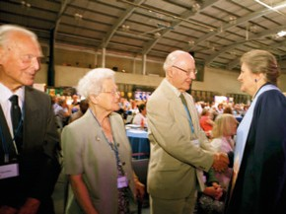

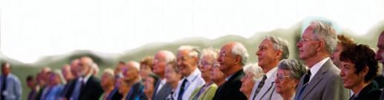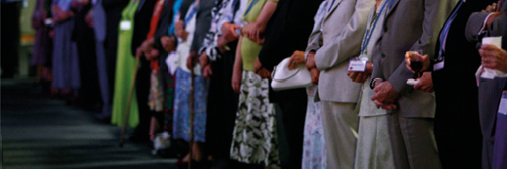
Jubilee Ministers were welcomed by the Moderators and General Assembly

Mission Council report
The past Moderator, the Revd John Marsh, invited the Revd Malcolm Hanson and the Revd Richard Mortimer to respond to questions on parts of the report not subject to resolutions. Revd John Waller, Convener of the Human Sexuality Task Group, responded to a question from Revd Brian Harley.

Mission Council, ethical investment statement of principle
The Honorary Treasurer, Mr John Ellis introduced the resolution and moved the adoption of resolution 2.


Resolution
2 Ethical investment principles
for the use of the United Reformed Church
General Assembly welcomes the statement ‘Ethical investment principles for the use of the United Reformed Church’ for the guidance of those responsible for making investment decisions and commends the summary statement ‘Recommended Mandate for Investors’.

Resolved by consensus.
Recommended mandate for investors
- General Assembly recommends that trustees and all those with investment responsibilities connected with the United Reformed Church should avoid any investment in:

  - Companies directly engaged in the manufacture or supply of weapons;
  - Companies a significant part of whose business is in the manufacture or supply of alcoholic drinks, or tobacco products, or military equipment (other than weapons); or the provision of gambling facilities; or the publication or distribution of pornography.

General Assembly is of the view that in the definition of the activities outlined in b), “significant” means that the share of turnover derived from the activity concerned is more than 10% of the company’s total turnover.

- In addition to the exclusions listed above, the URC’s investment bodies should reserve the right to avoid investment in companies whose operations are deemed to:

- contribute directly to human rights violations or support the maintenance of oppressive regimes who are guilty of gross human rights violations;
- contribute to a systematic, harmful impact on the social or natural environment;
- harm the society in which they operate more than they benefit it;
- promote injustice.
- Further it is expected that governance standards of our advisers, our fund managers, their agents, and the companies in which we invest, both directly and indirectly, should meet internationally accepted norms. By focusing on these standards, investors will favour companies which will be seeking to develop their businesses sustainably in the long term interests of their shareholders and other stakeholders.

- General Assembly recognises that this policy cannot be binding upon those with responsibility for specific investment decisions but when these bodies seek advice on investment matters they should apply due diligence to ensure that the integrity and reputation of the United Reformed Church is, as far as is practical, protected.

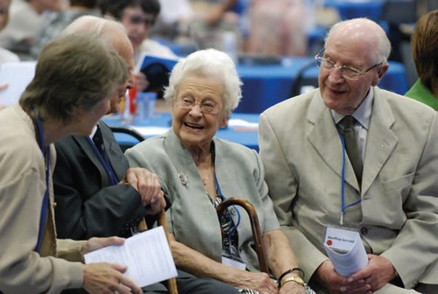Sunday, 4 July
Sunday, 4 July

United Reformed Church • Record of General Assembly 2010 • 29

Resolution 3, Nestlé
General Assembly:
- agrees that Nestlé should no longer be treated on a different investment basis from all other companies;
- recognises that this means URC bodies may consider engagement with Nestlé through the selective purchase of shares if and when the appropriate investment managers deem such purchase appropriate. This will facilitate better engagement with Company policies and practices from within; and
- instructs that this decision and its context be reported to those entrusted with investment decisions on behalf of the URC as well as Nestlé management and the Church Investors Group.

Mr Ellis introduced the resolution and he and Mr Andrew Middleton, the legal advisor, responded to questions. Revd Ed Cox indicated that he would encourage the Mission Committee to monitor investments made under the ethical investments policy.

No consensus being reached a Facilitation Group was asked to rework the resolution over lunch. The Assembly adjourned for lunch.

Record of General Assembly 2010 • United Reformed Church • 29

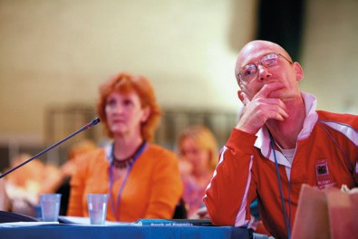

30 • United Reformed Church • Record of General Assembly 2010

Second Session

The Moderator, Mrs Val Morrison took the chair.

On the motion of the Clerk the Assembly adopted the minutes of Saturday 3 July Sessions one and two.

The Clerk then moved resolution 13.

Resolved by consensus.
Church changes
- General Assembly welcomes the Bournemouth International Church and the West London Asian Christian Fellowship as Mission Projects of the United Reformed Church.

- Assembly receives notice of the closure of the local churches listed on pages 198-209 of the Book of Reports 2010 and gives thanks to God for their worship, witness and service.
13
Resolution

Ministries Committee
Resolution 11, Minister’s/CRCW’s working hours
General Assembly approves the following as the principles governing the Ministerial working week:
- there should be more clarity in defining working hours;
- the working week, translated into hours in a four week period, should be not less than 160 hours and not more than 192;
- a note on the working week should be included in the Plan for Partnership and the rationale for the working week, set out as supporting text for this resolution, should be available on request from the Ministries office.

The Convener of the committee, the Revd Peter Poulter introduced the resolution
and moved its adoption. A number of questions were asked, and comments made and Mr Poulter responded. Clause b) was amended to:

Resolved by agreement.
Resolution
11 Minister’s/CRCW’s working hours
General Assembly approves the following as the principles governing the Ministerial working week:
- there should be more clarity in defining working hours;
- the working week, translated into hours in a four week period, is recommended to be not less than 160 hours and not more than 192;
- a note on the working week should be included in the Plan for Partnership and the rationale for the working week, set out as supporting text for this resolution, should be available on request from the Ministries office.

Dissent was recorded by Revd Michael Aspinall.

The Convener agreed that the committee would continue to work on the issue to integrate it into the work of Local Mission Ministry Review (LMMR).

Dr Kirsty Thorpe took the chair.
The Assembly returned to consideration of resolution 3.
Mr Ellis moved resolution 3 in a form reworded by the Facilitation Group.

Resolved by consensus.
Resolution
3
Mission Council, Nestlé
General Assembly agrees that for investment purposes, all companies should be treated in accordance with our ethical investment policy.
Resolution 4, Mission Committee Nestlé
Mrs Melanie Frew moved the adoption of the resolution as recommended by the Facilitation Group.
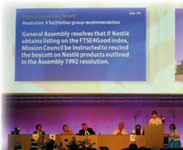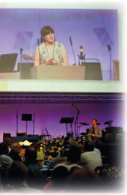
Facilitation group recommendation
General Assembly resolves that if Nestlé obtains listing on the FTSE4Good index, Mission Council be instructed to rescind the boycott on Nestlé products outlined in the Assembly 1992 resolution.
4
Resolution

Resolved by agreement.
Dissent was recorded by David Featonby and Chris Maple.

A suggestion was made that the Children’s Assembly be invited to write to Nestlé to make their views known.

Mrs Val Morrison resumed the chair.

32 • United Reformed Church • Record of General Assembly 2010

Mission Committee
The Revd Ed Cox responded to questions and comments and moved the adoption of resolution 1 agreeing to amended wording of section c).

Resolved by agreement.
Resolution
1
vision2020
- General Assembly celebrates God’s calling to each and every member, local church, synod, council and committee to join in God’s transformational journey of good news for all creation.

- General Assembly gives thanks for the mission journey of the United Reformed Church in years gone by but recognizes the significant challenges ahead in our denomination and in our world.

- General Assembly adopts vision2020 as the framework of mission planning and church growth for the United Reformed Church in the coming decade.

Dissent was recorded by Andrew Buxton, Janet Calderley, Kenneth Forbes, Linda Harrison, Brian Harley and Chris Maple.

Finance Committee and URC Trust

Trustee’s Report and Accounts
There were no questions and comments on the Finance report.
Mr Ellis spoke positively about the finances of the church at this time and moved the adoption of resolution 27.

This was agreed.
Trustee’s Report and Accounts
General Assembly receives the Trustee’s Report and adopts the Annual Accounts for the year ended 31st December 2009.
27
Resolution

Mr Ellis moved the adoption of resolution 29.

This was agreed.
Resolution
29
Giving to the Ministry and
Mission Fund
General Assembly gives gratitude to God for the giving of local churches to the Ministry and Mission Fund and expresses its thanks to synod and
church treasurers and to all those who made possible a total fund income of
£20.6m in both 2008 and 2009.

Mr Ellis moved the adoption of resolution of 28 and responded to comments and questions.

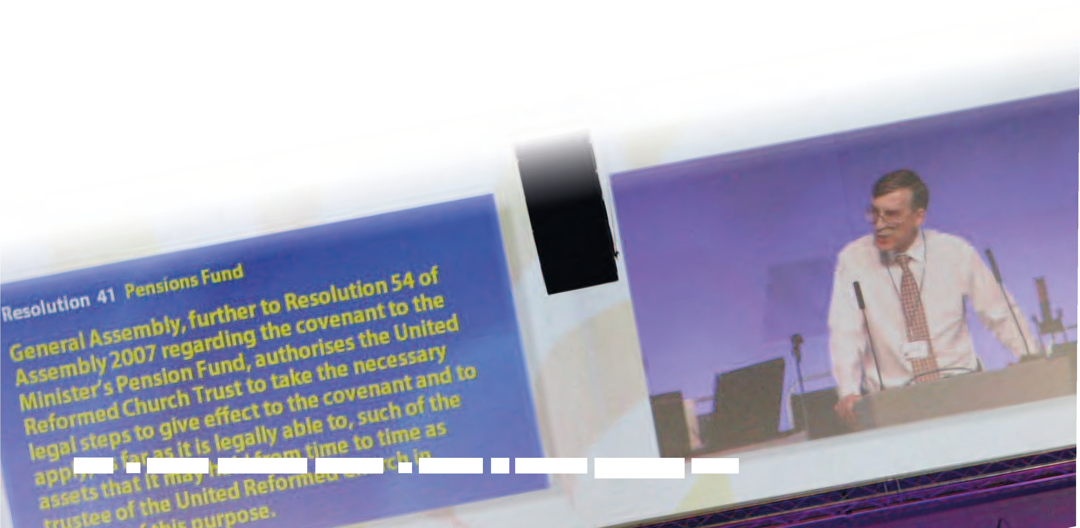
In response to a question Mr Alan Small stated that the Governing document relating the Church to the Trust is in process of being updated
and will be presented in due course.
34 • United Reformed Church • Record of General Assembly 2010

This was agreed.

Appointment of Auditors
General Assembly resolves that Pricewaterhouse Coopers LLP be appointed auditors of the United Reformed Church Trust for such period as determined by the Trust and for their remuneration to be set by the Finance Committee.
28
Resolution

Mr Ellis moved the adoption of resolution 41.

Resolution
41
Pension Fund
General Assembly, further to Resolution 54 of Assembly 2007 regarding the covenant to the Minister’s Pension Fund, authorises the United Reformed Church Trust to take the necessary legal steps to give effect to the covenant and to apply, as far as it is legally able, to such of the assets that it may hold from time to time as trustee of the United Reformed Church in support of this purpose.

This was agreed.

Mr Alan Small, Chair of the Trust, introduced and moved the adoption of resolution 31.

Resolution
31
Memorandum and Articles of
Association of the United Reformed Church Trust
(appendices 4a and 4b)
General Assembly approves the adoption of the Memorandum of Association and the Articles of Association of the United Reformed Church Trust.

This was agreed.

Nominations Committee
The report containing the complete list of committees and appointments was presented by the Convener, the Revd Malcolm Hanson. (See Appendix 1)
In presenting the report Mr Hanson commented that resolution is still required of how the report is published in non-assembly years.

Mr Hanson moved the adoption of resolution 14.

This was agreed.
Appointment Extensions
General Assembly agrees that:
- the present term of service of Mr John Ellis as Honorary Treasurer of the United Reformed Church be extended from July 2011 until 30th June 2013;
- the present term of service of Dr David Robinson as Convener of the Assembly Arrangements Committee be extended from Assembly 2012 to the close of Assembly 2014;
- the appointment of Mr Andrew Perkins as a member of the URC Ministers’ Pension Trust Ltd be extended to 2012.
14
Resolution

Mr Hanson moved the adoption of the resolution 15.

This was agreed.
Resolution
15
Clerk to the General Assembly
2012-18
General Assembly appoints Mrs Margaret Carrick Smith as Clerk to General Assembly from the close of Assembly 2012 to the close of Assembly 2018.

Mr Hanson moved the adoption of resolution 16.

This was agreed.
Resolution
16
Power of appointment
General Assembly agrees that the power to appoint Assembly staff members, other than officers of Assembly and Synod Moderators, shall be delegated to appointing groups duly appointed so long as appropriate processes and employment and related criteria have been met. All such appointments shall have effect from the date determined by the appointing group, and shall be reported to the next meeting of Mission Council or
General Assembly.

Mr Hanson moved the adoption of resolution 17.


Moderator of the Mersey Synod
General Assembly reappoints the Revd Howard Sharp to serve as Moderator of the Mersey Synod from 1 February 2011 to 30 June 2014.
17
Resolution

This was agreed.

Mr Hanson moved the adoption of resolution 37.

This was agreed.
Moderator of the Synod
of Scotland
General Assembly reappoints the Revd John Humphreys to serve as Moderator of the Synod of Scotland from September 1 2012 to 30 June 2016.
37
Resolution

The Moderator greeted those Moderators who will have retired, or moved to a local pastorate, before the next Assembly. The Revds Nigel Uden, Adrian Bulley and Terry Oakley.

Mr Hanson moved the adoption of resolution 18.

Director of Old Testament Studies, Westminster College
General Assembly reappoints the Revd Dr Janet Tollington to serve as Director of Old Testament Studies at Westminster College, Cambridge, from 1 August 2011 to 31 July 2016, subject to review.
18
Resolution
Resolved by majority vote.

Mr Hanson moved the adoption of resolution 19.

Resolved by majority vote.
Appointment of committees
and groups
General Assembly appoints committees and representatives of the Church as set out on pages 176-187 (sections 2 – 10) of the Book of Reports, subject to additions and corrections contained in the Supplementary Report to Assembly.
19
Resolution

(N.B. The full list of appointments appears as Appendix 1 to the Record of Assembly)

36 • United Reformed Church • Record of General Assembly 2010

Mr Hanson moved the adoption of resolution 20.

Resolved by acclamation.
Resolution
20
Vote of thanks
General Assembly records its deep appreciation for all the work done by those who serve as committee members and representatives.

The Moderator thanked Mr Hanson as he completed his term of Convener of the Nominations Committee.

Interfaith guests
The presentation of the Nominations Committee report was interrupted by an ‘Order of the Day’ where the Assembly received a number of Inter-Faith Guests who were introduced by Mrs Daphne Beal.

Sughra Ahmed Research Fellow, Policy Research Centre, Islamic Foundation Dr Ram Chhabra Secretary, Geeta Bhawan Hindu Temple, Loughborough Mrs Fafar Catling Member of the Bahá’í Community in Loughborough Gurbaksh Singh Liddar Committee member, Loughborough Gurdwara
Tony Nelson Member of Synagogue Board with responsibility for Inter
Faith matters and Vice Chair of Leicester Council of Faiths

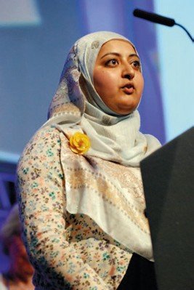The Moderator welcomed the guests and invited
Sughra Ahmed (pictured right) to address the Assembly. The Chaplain Revd James Coleman led Assembly in prayer.

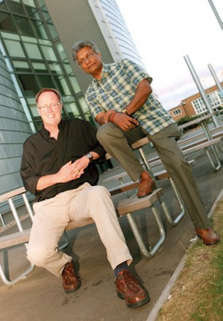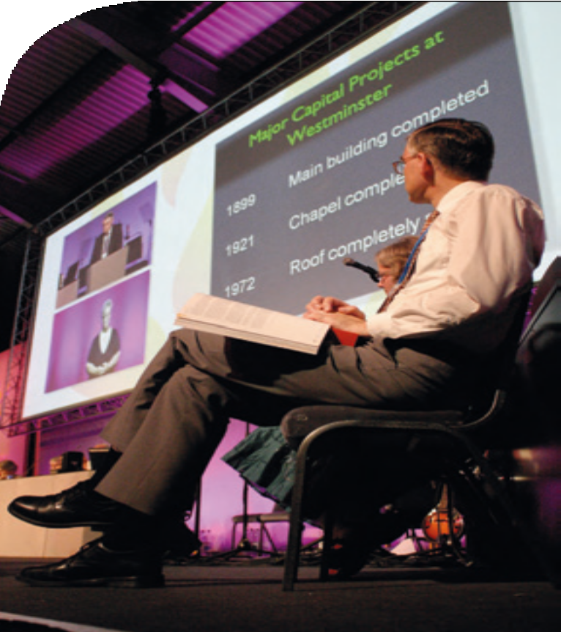

Mr Lawrence Moore and
the Revd Dr Michael Jagessar, Moderators for 2012 to 2014

Westminster College appeal presentation

38 • United Reformed Church • Record of General Assembly 2010

Third Session

The Moderator, the Revd Dr Kirsty Thorpe took the chair.

Announcement of Moderators for 2012 to 2014
Dr Jim Merrilees announced the result of the election. 275 papers were returned for each post, 3 were spoiled in each case. The Revd Dr Michael Jagessar and Mr Lawrence Moore were duly elected.

Westminster College appeal
The Revd Dr Susan Durber presented the vision for refurbishment of Westminster College, the reason for the appeal. She explained the need for changes to the building to enable the college to be a resource to meet the challenges of education, hospitality and community for the United Reformed Church in the twenty first century. The plans will cost £7m. A business plan has been scrutinised by the Finance Committee. £1m is already available with the possibility of a further million. £5m will need to be raised.
Professor Sir Anthony Bottoms, on behalf of the Governors, assured Assembly that the Governing body is unanimous in its support. Planning permission and Listed Building support has already been sought. The Governors have sold a valuable manuscript for
£400,000 to raise money for the fund. Mr Brian Long, who has considerable experience in this field, has been appointed to co-ordinate the appeal.
A number of questions and comments were raised to which Sir Tony responded.
Mr John Ellis, Honorary Treasurer reported that the results of the finance Committee’s deliberations were very positive but recognised that non URC business would have to grow to maintain another strong income stream. He offered two resolutions for discussion.
A number of questions were raised.
The Moderator invited the Revd Fiona Thomas to respond on behalf of the Education and Learning Committee. Dr Durber responded on behalf of the College.

Westminster College Development resolutions 38 and 39.

Resolved by agreement.

General Assembly:
- welcomes the Westminster College Development Plan;

- authorises the College to make this Plan the subject of an Assembly Appeal throughout the United Reformed Church; and

- encourages all synods, local churches and members to demonstrate support for this Appeal through their commitment to prayer, publicity and generosity.
38
Resolution

A number of questions were raised to which Mr Ellis responded.

Sunday, 4 July
Resolution
39
General Assembly authorises the Finance Committee to release denominational funds to assist the Westminster College Development Plan as and when building works are agreed by the Governors of the College and the URC Trust and particularly:

- to provide support from the Legacy Fund to offset the loss of income during the temporary closure of parts of the College;

- to invest £1m in the Westminster buildings from money held from the proceeds of the sale of the former New College, London;

- to consider bridging loans against future expected Appeal income.

Resolved by consensus.

Ministries Committee
Resolution 12, Guidelines on conduct and behaviour
General Assembly, recognising the high standard of conduct and behaviour displayed by the vast majority of Ministers of Word and Sacrament, Church Related Community Workers, and Elders within the United Reformed Church, encourages all in leadership positions within the Church to continue to maintain those standards. Realising, however,
there are times in the life of the Church when disagreement arises over the boundaries of acceptable conduct and behaviour, General Assembly adopts the Guidelines on Conduct and Behaviour for Ministers of Word and Sacrament, Church Related Community Workers and Elders.

The resolution was introduced by the Convener the Revd Peter Poulter; he commended the document to Assembly and moved the adoption of the resolution.
A number of questions were raised to which Mr Poulter and the Revd Craig Bowman responded. Mr Poulter agreed that the guidance could be widened to include church members and others who work for the church, but did not feel it should be the task of Ministries Committee. Vulnerable adults will be included when policies are next
updated. Ms Karen Bully-Morrison emphasised that two adults should be present when transporting children in a car.
A point was made that single Ministers could be placed in difficult situations by the current wording in the documents referring to Ministers, (line 3c).
Mr Poulter responded to the concerns raised.

Consensus not being achievable, Assembly moved to working under non-consensus standing orders, Mr John Ellis proposed and Revd Ruth Wollaston seconded that “the motion be not put”.

The proposal was lost.

The Chaplain, the Revd Rachel Poolman led Assembly in prayer.

After further discussion it was moved and agreed that “The motion be now put”.

40 • United Reformed Church • Record of General Assembly 2010

The resolution was agreed.

Guidelines on conduct
and behaviour
General Assembly, recognising the high standard of conduct and behaviour displayed by the vast majority of Ministers of Word and Sacrament, Church Related Community Workers, and Elders within the United Reformed
Church, encourages all in leadership positions within the Church to continue to maintain those standards. Realising, however, that there are times in the life of the Church when disagreement arises over the boundaries of acceptable conduct and behaviour, General Assembly adopts the Guidelines on Conduct and Behaviour for Ministers of Word and Sacrament, Church Related Community Workers and Elders.
12
Resolution

The Revd Ruth Whitehead, incoming Convener, recommended the Sexual Ethics Training
and promised to continue the work in this area in the coming months.

Synod Resolutions

Resolution 33, East Midlands Synod: properties advice for local churches

Mr Duncan Smith proposed the adoption of resolution 33; seconded by the Revd Paul Bedford.

Mr Ellis responded that the time is right for beginning a new piece of work with the Methodist Church.

Resolved by consensus.
Resolution
33
properties advice for
local churches
In the light of the 2008 resolution seeking closer co-operation between the United Reformed Church and the Methodist Church, Assembly instructs its officers to explore the possibility of collaboration in the area of property advice to local churches.

The Moderator responded to a question about the handling of the previous debate. The Revd Rachel Poolman led evening prayers.

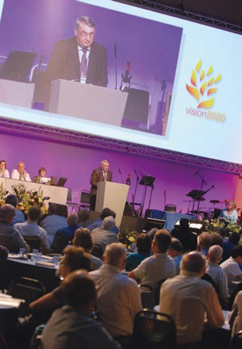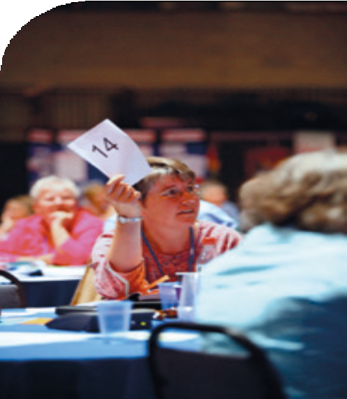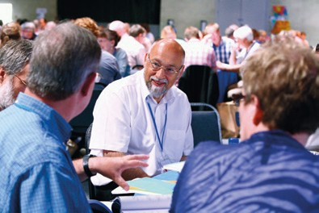

42 • United Reformed Church • Record of General Assembly 2010

First Session
Monday, 5 July

The Moderator, Mrs Val Morrison took the chair.
Worship was led by the Chaplains, the Revd James Coleman and the Revd Rachel Poolman, followed by Bible study. Gerard Kelly completed his study from the Acts of the Apostles. The Moderator thanked Gerard for his contribution to the Assembly.

The Moderator also thanked the Revd Terry Oakley for his service to the Church in the East Midlands, as he will complete his service before the next Assembly. Minutes from Sunday were not available due to the over running of the evening session. A draft hardcopy was available for scrutiny.

Ecumenical Relations

World Communion of Reformed Churches.
The Revd Jane Rowell gave a report of the recent Uniting Council. The Clerk moved the adoption of resolution 42

Resolved by acclamation.
Resolution
42
World Communion of
Reformed Churches
General Assembly noting that the Presbyterian Church in England and the Congregational Union of England and Wales were respectively founder members of the Alliance of Presbyterian and Reformed Churches in 1875 and the International Congregational Council in 1891 which in 1970 united to form the World Alliance of Reformed Churches, of which the United Reformed Church was a
member rejoices in its union with the Reformed Ecumenical Council to create the World Communion of Reformed Churches and resolves that all references to WARC in governing documents and guidelines issued by the Assembly or any of its committees or agents should be understood hereafter to refer to the World Communion of
Reformed Churches.

United Reformed Church • Record of General Assembly 2010 • 43

Communicatons and Editorial
The Revd Dr Kirsty Thorpe introduced the resolution, responded to questions and moved its adoption.

Resolved by consensus.
Resolution
32
2012 Olympics and
Queen’s Jubilee
General Assembly welcomes the work being done by the Mission and Communications and Editorial Committees in preparation for the Church’s involvement in the Queen’s Jubilee celebrations and in events surrounding the Olympic and Paralympic Games in 2012. It encourages churches to engage in the celebrations and events that will take place throughout the year as an opportunity for witness and service, doing so wherever this is possible with partners from their community, including members of other churches and faiths.

Assembly Arrangements Committee
Dr David Robinson, Convener of the committee announced the total of the offertory (£2,200.07 of which £1,900 was gift aided). He presented the resolution:

Resolved by majority vote.
Dates and venue of 2012 Assembly
General Assembly resolves to meet in the Southport Conference Centre from the Fri 6 July – Monday 9 July 2012 or at such other place and time as may duly be determined.
22
Resolution

A question regarding the size of Assembly was asked and the Convener promised that the matter will be discussed further in other places.

Members of Assembly were invited to complete feedback sheets on their table.
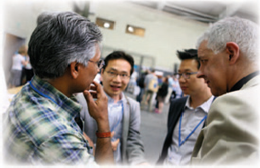

Marketing and Identity Campaign
The General Secretary gave further explanation of preparations being made and she and Mr Lawrence Moore responded to questions asked in a previous session.

The Revd Dr Kirsty Thorpe took the chair.

Reports not subject to resolutions
Questions and comments were invited about the Assessment Board; Church Related Community Workers sub-committee; Leadership in Worship sub-committee; Maintenance of the Ministry sub-committee and Retired Ministers’ Housing sub-committee.

The Revds Peter Poulter, Paul Whittle, Craig Bowman, and Mr John Ellis responded.

Report from the Children’s Assembly
Children’s Assembly shared their experiences of meeting together in words and song and presented a DVD.

They also shared a DVD they had made with regard to resolution 34, Children in Detention. Three children offered prayers for children currently in detention centres. The Moderator thanked the children and their leaders whose work had enriched and enhanced Assembly.

Resolution 34, North Western Synod: children in immigration detention centres
Permission was granted for the North Western Synod to withdraw the original resolution 34 and replace it with:

Resolved by consensus.
Resolution
34
Children in immigration
detention centres
The General Assembly of the United Reformed Church calls upon Her Majesty’s government to end the detention of children for immigration purposes immediately and ensure that alternatives to detention should not involve the separation of children from their parents.
Proposed by Revd Marian Tugwood Seconded by Revd Geoffrey Clarke

Youth and Children’s Committee Report
The Moderator thanked the Revd Rob Weston for the report and work of the committee.

Remaindered business

Mission Council – Two
The Clerk moved the adoption of resolutions 5, 7 and 10.

Resolution 5

Disciplinary Process Part I
(requiring a two thirds majority)


General Assembly agrees to make the following changes to Part I of the Disciplinary Process (Section O):
Paragraph 1.1
In the second sentence after the words ‘Assembly Commission’ remove the words ‘or, in the event of an appeal, the Appeals Commission’.
In the final sentence, after the words ‘is also able to’ remove the words ‘make recommendations (other than recommendations under Paragraph 1.3) and’.
After the words ‘Section F’ insert ‘or, in the event of an appeal, Section G’.
Paragraph 1.3.1
Remove the words ‘or, in the event of an appeal, the Appeals Commission’.
Paragraph 1.3.2
Replace the words ‘within the time limit therein specified’ with ‘with all due expedition, consistent with the consultation process laid down by the Incapacity Procedure’.
Remove the words ‘or the Appeals Commission’.
Paragraph 1.3.3 and Paragraph 1.3.4
Remove the words ‘or the Appeals Commission’.
Paragraph 2
After the words ‘Appeals Commission’ insert ‘, the Special Appeals Body’.
Paragraph 7.2
After the words ‘case law’ add ‘and/or official statements of good practice issued by a government department or agency’.

Resolved by majority vote.

The General Secretary moved that this be referred to synods with dissent to be communicated to her by 31 March 2011.
This was agreed.


Resolution 7
Disciplinary Procedure Part I
General Assembly agrees to make the following change to Part I of the Disciplinary Process (Section O):
Paragraph 7
Remove this paragraph in its entirety.

Resolved by majority vote.

The General Secretary moved that this be referred to synods with dissent to be communicated to her by 31 March 2011.
This was agreed.

Resolution 10

Disciplinary Procedure Part II

General Assembly agrees to make the following changes to Part II of the Disciplinary Process (Section O):
Paragraph A.4.1
Remove the words ‘recommendations or’ Paragraph A.5.20
Remove the words ‘the particular recommendation(s) or’ and insert the word ‘any’ before the word ‘guidance’.
Paragraph E.9.3
Replace the words ‘and/or to append recommendations to its decision under Paragraph F.2.3 or where, of its own accord, it might have it in contemplation to adopt either or both of those courses’ with the words ‘or where, of its own accord, the Assembly Commission might have it in contemplation to adopt that course’.
Paragraph F.2.3 Delete entirely.
Paragraph F.2.4
Renumber as F.2.3.
Paragraph F.5.2
Remove the words ‘recommendations or’ and ‘or Paragraph F.2.4’.* Paragraph F.6.4
Remove the words ‘recommendations or’.
Paragraph G.8.4
Remove the words ‘recommendations or’ and ‘or Paragraph F.2.4 as the case may be’.
Paragraph G.13.4
Delete entirely, renumbering the subsequent subparagraphs of G.13 Paragraph G.13.6 (to become G.13.5)
Replace the existing paragraph with the following:
‘In addition to its power to offer guidance under Paragraph G.13.4, the Appeals Commission may if it sees fit endorse, overrule, vary or modify in any way any guidance offered by the Assembly Commission in the case in question. For the avoidance of duplication, the Decision Record shall in
every case set out in full any guidance offered by the Appeals Commission, even where this simply endorses that offered by the Assembly Commission in its entirety.’
Paragraph G.14.4
Remove the words ‘recommendations or’ and ‘or Paragraph G.13.5 as the case may be’.
Paragraph G.14.6
Remove the words ‘recommendations or’.
Paragraph J.1.5
Remove the words ‘Recommendations or’ and give the word ‘guidance’ a capital G.

Resolved by majority vote.

Section O costs
The General Secretary reported that eight cases have been heard with the cost £47,435. Since the last report to the Assembly the names of four Ministers had been deleted from the roll:
Ronald Alistair MacNab (deleted September 07); Sidney Owen North (deleted September 08); Barry Griffin (deleted November 08);
Geoffrey Rodgers (deleted February 2010).
An appeal from a church member against decisions of a Church Meeting had been heard by an Assembly Commission at a cost of £10,072.

Mission Committee Report
Questions and comments were received to which Ms Francis Brienen responded.

Incapacity Procedure Part I
The Clerk moved the adoption of resolutions 6, 8 and 9.

Resolution
6
General Assembly agrees to make the following changes to Part I of the Incapacity Procedure (Section P):
Paragraph 1.1
The existing Paragraph 1 to become 1.1.
Paragraph 1.2
Add a new paragraph as follows:-
‘The Review Commission may also decide to make a recommendation/ referral in accordance with Part II Section H. The Review Commission or, in the event of an appeal the Appeals Review Commission, is also able to make recommendations (other than recommendations under Part II Section H) and
offer guidance, but only within the limits prescribed in Part II Sections K and L’ Paragraph 2
After the words ‘Appeals Review Commission’ insert ‘, the Special Appeals Body’.
Paragraph 7
After the words ‘case law’ insert ‘and/or official statements of good practice issued by a government department or agency’.

Resolved by majority vote.

The General Secretary moved that this be referred to synods with dissent to be communicated to her by 31 March 2011.
This was agreed.

Resolution
8
Incapacity Procedure Part I
General Assembly agrees to make the following change to Part I of the Incapacity Procedure (Section P):
Paragraphs 6 and 7
Remove these two paragraphs in their entirety.

Resolved by majority vote.

The General Secretary moved that this be referred to synods with dissent to be communicated to her by 31 March 2011.
This was agreed.

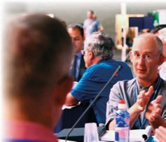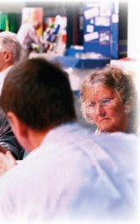

Resolved by majority vote.
Resolution 9
Amendments to the Structure
General Assembly agrees to make the following changes to the Structure of the United Reformed Church:
Paragraph 2(6)(A)(xi)
Remove the words ‘Part I of the Statement of the Ministerial Disciplinary Process referred to in Function (xxxiii) below, and Part I of the Incapacity Procedure referred to in Paragraph 6 of the Structure.’
Paragraph 3.(1)
Change the reference in the text from ‘Paragraph 2.5.xi.’ to ‘Paragraph 2(6)(A)(xi)’.
Paragraph 5.(2)
Change the reference in the text from ‘Paragraph 5(3)’ to ‘Paragraph 6’.

The General Secretary moved that this be referred to synods with dissent to be communicated to her by 31 March 2011.
This was agreed.

Ministries and Youth and Children’s Work
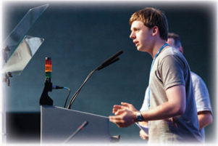
In light of recent government announcements the committee sought and received permission to withdraw and replace resolution 21, Ministries and Youth and Children’s Work: Vetting and barring.

The Revd Rob Weston (pictured right) introduced the replacement resolution and moved its adoption. He responded to questions.

The United Reformed Church has committed itself to being a Safe Church. General Assembly therefore encourages local churches to make themselves aware of the implications of the introduction of the Vetting and Barring scheme (England, Wales and Northern Ireland), to follow
guidance on safer recruiting when appointing people to work with children, young people and/
or vulnerable adults, and others working on behalf of the denomination who will be undertaking ‘regulated activity’, to be ISA registered and, following the principles of safer recruiting, to obtain a Criminal Records Bureau enhanced disclosure.

The replacement resolution reads:

Resolution
21
Safeguarding
The United Reformed Church has committed itself to being a Safe Church. General Assembly has stated that local churches must follow best practice when appointing people to work with children, young people and/or vulnerable adults and to this end commends ‘Recruiting Safely’ produced by the Children’s Workforce Development Council to provide guidance
in addition to the United Reformed Church’s Good Practice pack. General Assembly reasserts the need for those Assembly Appointees and others working on behalf of the denomination to obtain a Criminal Records Bureau enhanced disclosure when their role can involve work with children, young people and/or vulnerable adults.

Resolved by consensus.

The Clerk moved resolution 26.

Resolution 26, Changes to the Structure (section B of the Manual): the ‘Two Assemblies’ rule

General Assembly resolves to amend paragraph 3 of the Structure of the United Reformed Church to read:

3.(1) No exercise of the function of constitutional amendment contained in 2.5.xi shall have effect unless the following procedure has been followed:

- The proposal for the amendment shall be made in accordance with the Standing Orders of the General Assembly.

- Either The General Assembly or, in years when the General Assembly does not meet, the Mission Council shall vote on a motion to approve the proposal which shall require a majority of two-thirds of the members present and voting to pass.

- If such motion to approve the proposal is passed the General Assembly or the Mission Council, as the case may be, shall refer the proposal to synods and may, if it deems appropriate, in exceptional cases also to local churches.

- If the proposal has been agreed by the General Assembly it shall set a final date for responses to be made, which shall normally be at an appropriate time before a meeting of the Mission Council not less than nine months after the meeting of the General Assembly at which the proposal was agreed.

- If the proposal has been agreed by the Mission Council it shall set a final date for responses to be made which shall normally be at an appropriate date before the next ordinary meeting of the General Assembly.

- If by such date notice has been received by the General Secretary from more than one third of synods (or, if it has been so referred, more than one third of local churches) that a motion ‘that the proposal be not proceeded with’ has been passed by a majority of members present and voting at a duly convened meeting of such body, then the Assembly or the Mission Council, as the case may be, in its concern for the unity of the church shall not proceed to ratify the proposal.

- If by such date such notice has not been received, a motion to agree the proposed amendment shall come before the General Assembly at its next meeting or before the Mission Council at a meeting specified by the General Assembly. Such a motion shall require a majority of two-thirds of the members present and voting to pass. In its concern for mutual understanding within the life of the church, before voting on such a motion the General Assembly or Mission Council shall invite a representative of any synod from which the General Secretary has duly received notification under 3(1)(e) to present the main reasons for its objection.

- If such a motion is passed by such a majority the amendment shall have effect.

(i) For the purposes of this paragraph 3(1), only synods and local churches in existence on the date set for responses to be made shall be counted in the calculations.

3.(2) In the case of motions which would have the effect of terminating the separate existence of the United Reformed Church, or of a synod within it, by union with other churches, the voting process to be used shall be not less stringent than in 3 (1) and that process shall be determined by a single vote of the General Assembly which shall require a two-thirds majority of those present and voting to pass. In the case of a proposed union affecting only Scotland or Wales no action will be taken by the General Assembly until a decision in favour of union has been taken by the relevant synod.

An amendment was moved by Mrs Margaret Carrick Smith, Seconder David Grosch-Miller.

In the proposed revised wording of paragraph 3.(1) of the Structure of the United Reformed Church and in sub-paragraph (g) remove the sentence ‘Such a motion shall require a majority of two-thirds of the members present and voting to pass’ and replace it with: ‘If such a motion is before the General Assembly it shall require a majority of two-thirds of the members present and voting to pass. If the motion is before the Mission Council it shall require a simple majority of the members present and voting to pass.’

This was agreed.
The amended resolution 26 was then voted upon.

Resolution 26

Changes to the Structure

(section B of the Manual): the ‘Two Assemblies’ rule
General Assembly resolves to amend paragraph 3 of the Structure of the United to read:

3.(1) No exercise of the function of constitutional amendment contained in
2.5.xi shall have effect unless the following procedure has been followed:

- The proposal for the amendment shall be made in accordance with the Standing Orders of the General Assembly.

- Either The General Assembly or, in years when the General Assembly does not meet, the Mission Council shall vote on a motion to approve the proposal which shall require a majority of two-thirds of the members present and voting to pass.

- If such motion to approve the proposal is passed the General Assembly or the Mission Council, as the case may be, shall refer the proposal to synods and may, if it deems appropriate, in exceptional cases also to local churches.

- If the proposal has been agreed by the General Assembly it shall set a final date for responses to be made, which shall normally be at an appropriate time before a meeting of the Mission Council not less than nine months after the meeting of the General Assembly at which the proposal was agreed.

- If the proposal has been agreed by the Mission Council it shall set a final date for responses to be made which shall normally be at an appropriate date before the next ordinary meeting of the General Assembly.

- If by such date notice has been received by the General Secretary from more than one third of synods (or, if it has been so referred, more than one third of local churches) that a motion ‘that the proposal be not proceeded with’ has been passed by a majority of members present and voting at a duly convened meeting of such body, then the Assembly or the Mission Council, as the case may be, in its concern for the unity of the church shall not proceed to ratify the proposal.

- If by such date such notice has not been received, a motion to agree the proposed amendment shall come before the General Assembly at its next meeting or before the Mission Council at a meeting specified by the
General Assembly, If such a motion is before the General Assembly it shall require a majority of two-thirds of the members present and voting to pass. If the motion is before the Mission Council it shall require a simple majority of the members present and voting to pass. In its concern for mutual understanding within the life of the church, before voting on such a motion the General Assembly or Mission Council shall invite a representative of
any synod from which the General Secretary has duly received notification under 3(1)(e) to present the main reasons for its objection.

- If such a motion is passed by such a majority the amendment shall have effect.

- For the purposes of this paragraph 3(1), only synods and local churches in existence on the date set for responses to be made shall be counted in the calculations.



3.(2) In the case of motions which would have the effect of terminating the separate existence of the United Reformed Church, or of a synod within it, by union with other churches, the voting process to be used shall be not less stringent than in 3 (1) and that process shall be determined by a single vote of the General Assembly which shall require a two-thirds majority of those present and voting to pass. In the case of a proposed union affecting only Scotland or Wales no action will be taken by the General Assembly until a decision in favour of union has been taken by the relevant synod.

This was agreed.

The General Secretary moved that this be referred to synods with dissent to be communicated to her by 31 March 2011.
This was agreed.
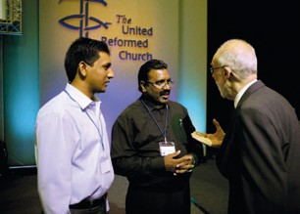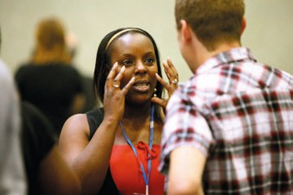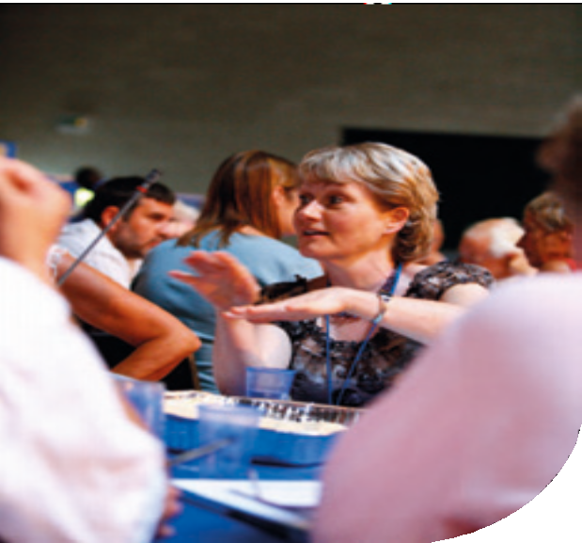

Address to the Throne
The past Moderator, the Revd John Marsh presented the address to the throne from the General Assembly.

To the Queen’s Most Excellent Majesty.

Grace, mercy and peace from God the Father and Christ Jesus our Lord! The General Assembly of the United Reformed Church, meeting in Loughborough, sends greetings in this the 59th year of Your Majesty’s reign!

We give thanks to God for Your Majesty’s continued good health and strength and look forward with anticipation to celebrating your Diamond Jubilee during the first week of June 2012. This will take place shortly before the London Olympic Games and we look forward to celebrating a season of goodwill and comradeship with representatives from the Commonwealth and the rest of the world over
this period. As churches, we are participating in the More Than Gold campaign to reach out to visitors with love and hospitality and to mobilise our members to
engage in a range of volunteer activities from welcoming the Torch, to providing chaplaincy services to athletes and officials, and responding to issues of social concern surrounding the games.

As we look forward with anticipation to these events, it is also important for us to reflect on the past two years (since our General Assembly in Edinburgh), and to highlight current challenges to Church and Society in the UK. The past two years have been dominated by the global financial crisis and ensuing economic recession, and the political crisis surrounding the MPs’ expenses scandal. These two crises have served to seriously erode public trust in financial and political institutions which will take considerable time to rebuild. We are concerned at the underlying moral dimension to these crises as institutions created to serve the public – Banks and Parliament – assumed the role of leaders in pursuit of ever greater profits with high risk products in the case of the financial services sector, and developed a culture of graft and unaccountability in the case of some Members of Parliament.

We are grateful for the decisive action by leaders of the main political parties to clean-up politics in response to the MPs’ expense scandal and for the prompt
action taken by the Committee on Standards in Public Life in producing a report on MPs’ expenses and allowances. We are particularly supportive of the principles of public life outlined in this report – especially those of selflessness, integrity and accountability – and will continue to hold the newly elected MPs’ and Your Majesty’s Coalition Government in our prayers as they embark on a formidably challenging term of Parliamentary office. Great wisdom, courage and resolve
will be required in the months and years ahead as they seek to respond to the multiple challenges of reducing the budget deficit while defending frontline services and ensuring the principles of freedom, fairness and responsibility are maintained in implementing the decisive cuts that are necessary.

We are less enamoured with the response by the financial services sector to the financial crisis caused by their blatant disregard for principles of accountability, sustainability, transparency, and honesty in their business practices. Despite the massive bailouts of banks with taxpayers’ money and the stringent warnings and tax penalties for paying huge bonuses, the financial sector appears intent on returning to ‘business as usual’ with the return to profit they have experienced over the past year. This has been achieved at the expense of the livelihoods of millions of people across the world and in the UK who have lost their jobs or earning ability as a result of the global economic recession caused by the financial

Monday, 5 July

crisis. We believe that it is patently unjust and immoral for those who were least responsible for this crisis to now be required to pay the greatest price in terms of spending cuts whilst those who were responsible are once more pocketing huge salaries and bonuses.

For this reason, the United Reformed Church passed a motion at their Mission Council in November last year supporting the call for the introduction of a global financial transaction tax to be levied against the financial institutions as a means of curbing their excessive behaviour and as an innovative means of raising finance for good causes. This call has evolved into an international campaign supported by trade unions and agencies working on international development, climate change, the environment, health related issues such as HIV and AIDS, domestic poverty, and faith groups. Now known as the Robin Hood Tax campaign in the UK, we believe that a small tax of around 0.05% on all financial transactions could raise billions of pounds which would make a significant contribution to helping reduce the public deficit, prevent cuts in public services, tackle climate change and reduce global poverty.

Other pressing issues announced in Your Majesty’s speech at the opening of Parliament on the 25th May will need to be carefully monitored and special mention is made here of the treatment of migrants and asylum seekers in the UK. We are grateful to hear that the detention of children is due to stop and would like to see this implemented as soon as possible. We have made submissions to the Home Office calling for this ruling to be expedited and urging officials not
to split families as this adds to the stress and trauma of children at a particularly vulnerable time of their lives. Britain has a long and proud tradition of offering sanctuary to people uprooted by political, religious or sectarian violence and we are concerned that this tradition will be compromised by the changes to migration law which is creating a fortress mentality in Europe and the UK. In response to this concern, the United Reformed Church is participating in the programme of European Churches responding to migration in 2010. During this
year, the programmes of churches in Europe with and for migrants, refugees and ethnic minority people shall be made visible, and churches shall be encouraged to share their work and experience with each other.

Finally, we trust that Your Majesty and HRH The Duke of Edinburgh’s visit to Canada and Your Majesty’s address to the UN General Assembly on the 6th July 2010 went well and that the outstanding UN resolutions pertaining to Israel and Palestine will be speedily implemented as the first step towards creating a sustainable peace in the Holy Land!

May the God who gives endurance and encouragement strengthen and sustain Your Majesty in the coming years!

Resolved by a majority vote.

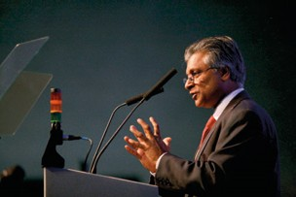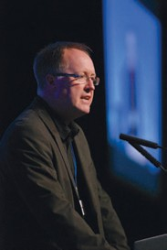Saturday, 3 July
Moderators acceptance speeches
Mr Lawrence Moore and the Revd Dr Michael Jagessar addressed the Assembly.

Mr Lawrence Moore

Revd Dr Michael Jagessar

Thanks
Dr David Robinson thanked the staff of the University of Loughborough for the care and attention they had shown.

The Moderator of Mersey Synod thanked the host synod, East Midlands, for the local arrangements; Daphne Beale and the local stewards; the communications team;
Tony Pendlebury and his technical team; Grace and Linda the British Sign Language interpreters; the Chaplains; the consensus facilitation group; the band; Ann Barton and the office staff group. He welcomed General Assembly in advance to the next meeting in Southport.

A presentation of flowers was made to Mrs Ann Barton, Secretary of the Assembly Arrangements Committee and Assembly Office Manager.

The General Secretary offered the thanks of Assembly to the two Moderators for their teamwork in their preparation for and presentation of Assembly.

The General Secretary announced:

“Moderator, the General Assembly has completed its business and now adjourns to meet at Southport on Friday 6 July 2012, or in such other place or on such other date as may be necessary.”

Closing prayers were led by the Chaplains.

56 • United Reformed Church • Record of General Assembly 2010

Nominations Committee List of Assembly Committees and other appointments
Appendix 1
Notes:
- The Moderators, the immediate past Moderator and the General Secretary are members ex officio of every standing committee.
- Symbols have been used as follows:
* denotes those appointed since the 2009 Mission Council report;
** denotes those whom General Assembly is invited to appoint for the first time;
† denotes those who have been invited to extend their periods of service; # denotes a Convener-elect who will become Convener in 2011;
/ the name after the slash is the alternate for the one before it.
- The number in round brackets following the name indicates the member’s synod: Northern (1), North Western (2), Mersey (3), Yorkshire (4),
East Midlands (5), West Midlands (6), Eastern (7), South Western (8),
Wessex (9), Thames North (10), Southern (11), Wales (12), Scotland (13). This numbering is not shown where it is not relevant.
- When a member of a committee is there as a representative of another body or a particular category this is indicated in round brackets following the name.
- Committee membership is normally for a period of four years, though this may sometimes exceptionally be renewable. Committee Conveners serve an additional preliminary year as Convener-elect. In sections 1-4 of the report, appointments with a different term are noted.
- The date in square brackets following the name indicates the date of retirement, assuming a full term.
- In accordance with the decision of General Assembly 2000 some nominations are made directly by the National Synods of Wales and Scotland.
- In years when General Assembly meets, new committee members normally take up their roles at the conclusion of Assembly. In years when General Assembly does not meet, they normally begin on 1st July.

Mission Council
Mission Council acts on behalf of General Assembly. It consists of the officers of Assembly, the Synod Moderators and three representatives from each synod together with the Conveners of Assembly committees.
(Synods appoint and decide terms for their representatives)
Northern Synod Revd John Durell, Miss Elaine Colechin, Mr Justice Semuli North Western Synod Mr Geoffrey Clarke, Mr George Grime, Revd Sally Thomas Mersey Synod Mr Arthur Swift, Miss Emma Pugh, Revd Gordon Smith Yorkshire Synod Mr Chris Reed, Revd Kay Alberg, Mrs Jenny Poulter
East Midlands Synod Mr Duncan Smith, Mrs Jill Turner, Revd Jane Campbell West Midlands Synod Mr Bill Robson, Mrs Adella Pritchard, Mrs Val Phillips Eastern Synod Revd Catherine Ball, Mrs Linda Harrison, Mr Clifford Patten South Western Synod Revd Roz Harrison, Revd Stephen Newell,
Mrs Sarah Lane Cawte
Wessex Synod Mr Peter Pay, Mrs Margaret Telfer, Revd Mary Thomas Thames North Synod Mr Simon Fairnington, Revd Maggie Hindley,
Revd David Lawrence
Southern Synod Revd Derrick Sena Dzandu-Hedidor,
Revd Christopher Parker, Revd Zamantha Walker National Synod of Wales Revd Shelagh Pollard, Revd Peter Cruchley-Jones,
Miss Iris Williams
National Synod of Scotland Mrs Barbara Bruce, Miss Irene Hudson, Revd John Sanderson

United Reformed Church • Record of General Assembly 2010 • 57

  - Mission Council Advisory Group Convener: Moderator of General Assembly Secretary: Deputy General Secretary
Revd David Grosch-Miller (2011) Revd Derrick Sena Dzandu-Hedidor (2014)
Revd Elizabeth Nash (2014) Moderator-elect of General Assembly [ex officio: General Secretary Honorary Treasurer]

  - Staffing Advisory Group Convener: Revd Rowena Francis Secretary: General Secretary
Revd Ann Jack Mr Peter Pay Mr Keith Webster Head of Human Resources

  - Law and Polity Advisory Group Convener: Revd Prof David Thompson (2012) Secretary: Dr Auger Pearce
Mr David Eldridge (2012) Ms Morag McLintock (2012)
Revd John Durell (Synod Clerk) Mr Donald Swift [ex officio: Clerk to General Assembly, Legal Adviser]

Listed Buildings Advisory Group
Convener: Mr Hartley Oldham Secretary: Mr David Figures Correspondent for each synod

Ethical Investment Advisory Group
Convener: Revd Raymond Singh
Secretary: Secretary for Church and Society
Mr Mark Chaloner Mr Richard Nunn (Investment Committee)
Mr Simon Loveitt Mr Simon Peters
Chief Finance Officer Deputy General Secretary [ex officio: Honorary Treasurer]

  - Sexual Ethics Advisory Group Convener: Revd David A L Jenkins** [2014] Revd Rowena Francis (Synod Moderator)
Revd Elizabeth Gray-King (Education and Learning) Revd David Skitt [ex officio: Deputy General Secretary, Coordinator Pastoral Response Team]

  - MIND (Ministerial Incapacity and Discipline) Advisory Group
Convener: Revd Julian Macro Secretary: Vacancy
Mrs Kathleen Cross Revd Alison Davis Mrs Wilma Frew
Revd Heather Kent Mr Hartley Oldham Revd David Skitt Clerk to General Assembly Secretary for Ministries Legal Adviser

  - Resource Sharing Task Group Convener: Revd David Grosch-Miller Secretary: Mr John Rea
Treasurer: Revd Dick Gray
Miss Margaret Atkinson Mr Richard Turnbull Mrs Rachel Wakeman [ex officio: Honorary Treasurer]

  - Human Sexuality Task Group (2008)
Convener: Revd John Waller
Secretary: Revd Lucy Brierley
Revd Dr John Bradbury | Revd Richard Church | Ms Doreen Daley
Sr M Cecily Boulding OP | Revd Claire Gouldthorp | Mrs Val Morrison

  - London Synod Task Group Convener: Revd Bill Mahood Secretary: Mrs Sheila Brain
Revd Nicola Furley-Smith (11) Revd Raymond Singh (11)
Revd David Varco (10) Mr Keith Webster (10)
- Mission department
  - Mission Committee
Convener: Revd Ed Cox [2012]
Deputy Convener: Mr Peter Pay** [2012]
Mrs Chris Eddowes (1) [2011] Revd Michael Walsh (2) [2012]
Revd Andrew Willett† (3) [2014] Mrs Anne Parker (4) [2011]
Revd Clare Downing (5) [2012] Revd Louise Franklin† (6) [2014]
Revd Nicola Furley-Smith** (11) [2012] Revd Peter Ball (7) [2011]
Revd Tracey Lewis (8) [2012] Revd Peter Hurter** (9) [2014]
Revd John Macaulay* (10) [2011] Vacancy (12) [2014]
Revd Lindsey Sanderson* (13) [2011]

International Exchange Reference Group
Convener: Revd Linda Elliott [2011] #Mr Chris Wright** [2015] Secretary: Secretary for World Church Relations
Members: Revd Andrew Prasad ** (Synod Moderator) [2014] Miss Angela Quinn** (13) [2014]

    - Commitment for Life Reference Group
Convener: Mrs Helen Lidgett [2012]

    - Methodist/URC Interfaith Reference Group
(Members normally serve for six years – in parallel with Methodist terms)
Co-convener: Revd Peter Brain [2013]
Revd Clare Downing (5) [2013] Mr David Jonathan (10) [2014]
Revd Bill Burgess (3) [2015] Revd Tim Clarke (10) [2015]

    - Joint Public Issues Team Strategy and Policy Group
Mr Simon Loveitt (Spokesperson on Public Issues for the URC)
(Other members appointed by the Methodist Church and the Baptist Union of Great Britain.)

    - Rural Strategy Group (URC/Methodist)
Revd Peter Noble (Co-Chair) Revd Elizabeth Caswell Revd David Herbert

    - Vision4Life Steering Group
Revd Dr John Hall (Co-Chair) Revd Roberta Rominger (Co-Chair)
Ms Francis Brienen (Secretary) Revd Dr Janet Lees (Coordinator) Revd Ray Adams Mr John Brown
Ms Denese Chikwendu Revd Robert Day
Revd Dr Susan Durber Revd Brian Harley
Revd Dr Michael Jagessar Mr Lawrence Moore
Revd Paul Snell Mr Steve Summers
Revd Michael Walsh Revd Sally Willett

    - Marketing Campaign Steering Group
Revd Roberta Rominger (Co-Chair) Mr Laurence Moore (Co-Chair) Ms Lucy Berry (10) Ms Denese Chikwendu
Ms Francis Brienen Revd Martin Hazell
Mr Graham Law (6) Revd Peter Noble (12)
Miss Victoria Paulding (7) Mr Simon Peters (13) Revd Michael Walsh (2)

Ministries of the Church department
  - Ministries Committee Convener: Revd Ruth Whitehead [2014] Secretary: Secretary for Ministries
Mrs Helen Renner (3) [2011] Revd Yolande Burns (2) [2012]
Ms Brenda Jesse (8) [2013] Revd David Skitt (11) [2013]
Revd John Cox** (7) [2014] Mr Andy Buxton** (12) [2014] Convener, Assessment Board

    - Ministries – Accreditation Sub-committee Convener: Revd Geoffrey Townsend [2013] Secretary: Secretary for Ministries
Revd Sue Henderson (11) [2011] Revd Malcolm Fife (5) [2013]
Revd Terry Oakley (Synod Moderator) [2011] Mrs Tessa Henry-Robinson (7) [2013] Mr Jim Murison** (4) [2014]

    - Ministries – CRCW Programme Sub-committee
Convener: Revd Paul Whittle [2012] Secretaries: CRCW Development Workers
Ms Janine Atkinson (CRCW) [2012] Revd Susan Macbeth (4) [2012] Ms Cristine Smalligan (10) [2012] Prof John Mellor (9) [2013]
Ms Marie Trubic**(CRCW) [2014]

    - Ministries – Leadership in Worship Sub-committee Convener and Assembly Lay Preaching Advocate: Mrs Jan Harper [2011] # Mrs Judith Johnson** (1) [2015]
Mr Ed Strachan (2) [2011] Revd Gwynfor Evans (3) [2011]
Mr Alan Cotgreave (6) [2011]

Ministries – Maintenance of Ministry Sub-committee
Convener: Revd Dr Anthony Haws [2013]
Mrs Jane Mackerness (12) [2011] Miss Margaret Atkinson (4) [2012]
Revd Catey Morrison (1) [2012] Mr Andrew Martlew** (3) [2014]
Revd Alison Hall** (3) [2014]
[ex officio: Honorary Treasurer, Convener, Pensions Executive]

Ministries – Retired Ministers’ Housing Sub-committee
(In future, members will normally serve for four years but appointments may be extended for a further two years.)
Convener: Revd David Bedford [2015]
Secretary: Secretary, Retired Ministers Housing Society Ltd
Revd Michael Spencer (6) [2011] Revd Nanette Lewis-Head (12) [2012]
Revd Anne Bedford (3) [2015] Revd John Humphreys (Synod Moderator) [2013] [ex officio: Honorary Treasurer]
(Properties are managed by a Company viz: Retired Ministers’ Housing Society Ltd.
Details of the Members of the Board etc may be obtained from the Secretary, Mr Tony Bayley, at Church House.)

Assessment Board
(Members normally serve for five years as training is required.)
Convener: Dr Graham Campling [2014]
Retiring 2011 Revd Jan Adamson (13), Revd Sian Collins (12), Mrs Wendy Smith (2) Retiring 2012 Mr Geoffrey Harrison (3), Mr James Horton (4), Mrs Margaret Jenkins (3),
Revd Janet Maxwell (1), Revd William Young (6)
Retiring 2013 Mrs Irene Wren (5), Revd Lis Mullen (2), Revd Gary McGowan (3), Revd Val Towler (1)
Retiring 2014 Mr Mark Hayes (7), Mr Robin Pencavel (8), Revd Jamie Kissack (4), Revd Paul Floe (12)
Retiring 2015 Mrs Judith Garthwaite** (4), Mr Rod Morrison** (4),
Ms Mercy Nimako** (11), Mrs Maureen Campbell** (10)

Education and Learning Committee
Convener: Professor Malcolm Johnson [2011] #Revd John Smith** [2015] Secretary: Secretary for Education and Learning
Revd Dr Robert Pope (12) [2011] Revd Jennifer Snashall (11) [2012]
Revd Dr James Coleman (4) [2012] Mrs Fiona Weighton-Smith (4) [2012] Revd Dr Susan Durber (Resource Centre) [2013] Revd Dr David Whiting (1) [2013]
Mr Celvon Binns** (6) [2014] Mrs Lindsey Cole** (5) [2014]
Ms Sue Matthews** (6) [2014]

Windermere Management Committee
Convener: Revd Howard Sharp* [2013]
Minute Secretary: Mrs Jenny Poulter ** (4) [2013]
Dr Peter Clarke (1) [2011] Mr Nick Andrews (1) [2011]
Mr Graham Law (6) [2013] Mrs Joan Stocker (representative of Carver URC)
Secretary for Education and Learning
(The number of members may change in the light of future experience.)

Education for Ministry Phase 2 and 3 (EM2/3) Sub-committee
Convener: Dr Ian Morrison
Minute Secretary: Revd Elizabeth Gray-King (EM2/3 Officer) Revd David Poulton (EM3 Minister)
Revd Zam Walker (EM2 Minister) Ms Pat Oliver (CRCW)
Revd Stephen Collinson (Training and Development Officer) Ms Sandra Wellington (Training and Development Officer)
Vacancy (Resource Centre) Secretary for Education and Learning
[ex officio: Convener, Education and Learning Committee Secretary for Ministries]

    - Education and Learning Finance Sub-committee
Convener: Mr Mike Downing
Minute Secretary: Secretary for Education and Learning
Professor Malcolm Johnson (Convener, Education and Learning Committee)
Mr Graham Law
[ex officio: Honorary Treasurer; in attendance: Chief Finance Officer]

  - Youth and Children’s Work Committee Convener: Revd Robert Weston [2013] Secretary: Children’s Work Development Officer
Mrs Anthea Coates (8) [2011] Mr Chris Gill (11) [2011]
Mr Matthew Franks (8) [2011] Mrs Memona Shahbaz (10) [2012]
Revd Stuart Radcliffe (2) [2012] Mr Phillip Timson (5) [2013]
Revd Shirley Knibbs (4) [2013] Revd Meg Robb (1) [2013]
Miss Tamara Oates (5) [2013] Ms Angela Such** (10) [2014]
FURY Chair FURY Council Member

    - Pilots Management Sub-committee
Convener: Revd David Downing [2011] #Mrs Soo Webster ** [2015] Member: Vacancy [2014]
(Other members of the sub-committee are appointed by the Youth and Children’s Work Committee. The Congregational Federation also has two representatives.)

Administration and resources department
  - Assembly Arrangements Committee Convener: Dr David Robinson [2012] Secretary: Facilities Manager
Moderator, Moderators-elect, General Secretary, Clerk to General Assembly, Convener, Local Arrangements Committee

4.1.1 Tellers at Assembly 2010 for the election of the General Assembly Moderators 2010-2014
Dr Jim Merrilees (Convener) Mr Simon Fairnington Mr Duncan Smith
(These are all synod Clerks who are appointed in rotation.)

Communications and Editorial Committee
Convener: Revd Dr Kirsty Thorpe [2011] #Revd Richard Bittleston** [2015] Secretary: Director of Communications
Mrs Esther Searle (8) [2011] Ms Lucy Berry (10) [2012]
Mr Andy Littlejohns (11) [2012] Mr Justin Brierley (11) [2012]
Mr Stanley Hazell (8) [2012] Revd Peter Lyth (3) [2013]
Mr Peter Ranscombe (13) [2013] Mr Orin Stephens (10) [2013]
Mrs Helen Jones (6) [2013]

  - Equal Opportunities Committee Convener: Revd Elizabeth Nash [2014] Secretary: Mr Andrew Jack (10) [2013]
Ms Mary Jeremiah (12) [2012] Revd Barbara Exley (11) [2012]
Mrs Gwynneth Tilley (7) [2013] Mrs Tina Ashitey (10) [2013]
Revd Tom Arthur (12) [2013] Mr Tunde Biyi** (7) [2014]

  - Faith and Order Reference Group (Members normally serve for six years.) Convener: Revd Dr Robert Pope [2012] Secretary: Deputy General Secretary
Revd Dr John Bradbury [2012] Revd Dr Susan Durber [2012] Revd Fleur Houston [2012] Revd Dr Michael Jagessar [2014] Revd Dr Sarah Hall [2014] Revd Dr Neil Messer [2014]

  - Finance Committee Convener: Honorary Treasurer Chief Finance Officer
Mrs Jane Humphreys (7) [2011] Mr Brian Hosier (10) [2011]
Revd David Walton (13) [2012] Mr Angus Massie (10) [2012]
Dr Harry Potter OBE (3) [2013] Mr Richard Dewar (9) [2013]
Mr David Aplin (10) [2013] Revd Edward Sanniez** (10) [2014] Chairman of the Trustees

Stewardship Sub-committee
Convener: Mrs Faith Paulding [2013]
Vacancy [2011] Mr Keith Berry (10) [2012]
Revd Dick Gray (8) [2013] Revd Leslie Morrison** (13) [2014]
(The members of this sub-committee are appointed by the Finance Committee.)

Nominations Committee
(Synods appoint and decide terms for their representative.)
Convener: Revd John Durell [2014] Secretary: Miss Sarah Dodds [2013] Synod Representatives:
Revd Val Towler (1) Revd Chris Weddle (2) Revd John Oldershaw* (3) Mr Chris Reed* (4) Mr Duncan Smith (5) Mrs Margaret Marshall* (6) Mr Mick Barnes (7) Revd Roz Harrison (8) Mr Peter Pay (9)
Mr Simon Fairnington (10) Revd Derrick Sena Dzandu-Hedidor (11) Dr Jean Silvan-Evans (12) Miss Myra Rose** (13)
with the Immediate Past Moderator and the General Secretary.

Panel for General Assembly appointments
(Members normally serve for five years as training is required.)
Retiring 2011 Dr Graham Campling (11), Mrs Janet Gray (8), Revd Cecil White (7), Revd Mary Buchanan (13), Mrs Helen Brown (3),
Revd Nanette Lewis-Head (12)
Retiring 2012 Revd Raymond Singh (11), Revd Lesley Charlton (11),
Mrs Sally Abbott (10), Mr Simon Rowntree (6), Dr Jean Silvan Evans (12), Mr Alun Jones (4)
Retiring 2013 Revd John Durell (1), Revd Roz Harrison (8), Revd John Oldershaw (3), Revd Deborah McVey (7), Revd Robert Street (9), Mrs Susan Wilkinson (2), Mrs Carol Dixon (1), Revd John Young (13),
Retiring 2015 Revd Terry Hinks** (9), Mr Chris Maple** (3), Mr Duncan Smith** (5), Ms Helen Stenson** (13)

Pastoral Reference and Welfare Committee
Convener: Revd Alasdair Pratt [2011] #Revd Sheila Maxey ** [2015] Secretary: Deputy General Secretary
Mrs Delyth Rees (12) [2011] Revd Adrian Bulley (Synod Moderator) [2011] Revd Birgit Ewald (7) [2012] Dr Paul Ashitey (10) [2013]
[ex officio: Honorary Treasurer General Secretary Secretary for Welfare]

Disciplinary Process – Commission Panel
(Members serve for five years as regular training is required. They may be invited to continue serving beyond this as experience is especially valuable on this panel. Members may not serve beyond the age of 70 for legal reasons.)
Convener: Miss Kathleen Cross [2014]
Deputy Convener: Revd Christine Craven [2014] Secretary: Mrs Wilma Frew [2011]
Secretary-elect: Vacancy [2016] Members:
Retiring 2011 Mr Geoffrey Milnes (5), Revd David Pattie (13), Mr Neil Robinson (4), Revd Yvonne Stone (6)
Retiring 2012 Revd Nicholas Adlem (8), Revd Kay Cattell (5),
Revd Kenneth Chippindale (6), Revd Alison Davis (7), Revd John Du Bois (11), Revd Joan Grindrod-Helmn (1), Miss Judith Haughton (2), Miss Elizabeth Lawson QC (10),
Revd Julian Macro (9), Dr Jim Merrilees† (13), Revd Colin Offor (1),
Mr Nicholas Pye (3), Revd Raymond Singh (11), Revd Carolyn Smyth (13), Revd Prof David Thompson (7), Mr David Westwood (4)
Retiring 2013 Revd Pauline Calderwood (4), Revd Bill Bowman (11), Dr Peter Campbell Smith (11), Mr Roger Tucker (9)
Retiring 2014 Revd Hazel Allen (8), Mr Mick Barnes (7), Revd James Brown (6),
Revd Mary Burgess (8), Miss Kathleen Cross (2), Mrs Mary Cummings (6), Mr Peter Etwell (1), Revd Christine Fowler (8), Mrs Barbara Groom (8), Mr Andrew Harvey (8), Revd Naison Hove (10), Mr Peter Jolly (9),
Mrs Barbara Lancaster (2), Mrs Barbara Madge (8), Revd Nicholas Mark (5), Mrs Pat Poinen (1), Revd Shelagh Pollard (12), Mrs Lynne Upsdell (12),
Ms Elizabeth Whitten (7)
Retiring 2015 Revd Meryl Court† (10), Mrs Pat Crozier** (3), Dr Fiona Liddell† (12), Mr Colin Macbean** (9), Mrs Pamela Sharp† (3), Mr Patrick Smyth† (13)

Standing Panel for the Incapacity Procedure
(This panel is normally convened by the member with legal experience.)
Secretary: Revd Heather Kent [2012]
Revd Bill Mahood (Past Moderator of General Assembly) [2012] Revd Rowena Francis (Synod Moderator) [2013]
Mr Donald Swift (Legal experience) [2013] Dr Gillian Patterson (GP) [2013]

Criminal Records Bureau (Churches’ Agency for Safeguarding) Advisory Group
Revd Adrian Bulley (Synod Moderator) Ms Liz Crocker (Child Care Specialist) Mrs Wilma Frew (Magistrate) Youth Work Development Officer Children’s Work Development Officer Deputy General Secretary

United Reformed Church Trust
(Directors normally serve for six years. The Directors of the trust elect the chair from among their own number and appoint a Secretary and Deputy Secretary.)
Chair: Mr Alan Small
Secretary: Ms Sandi Hallam-Jones Deputy Secretary: Mr Tony Bayley Directors:

Group 1
Mr Alan Small (3) [2012]
Dr David Robinson (4) [2014]
Mr Andrew Atkinson** (1) [2016]
Group 3
Group 2
Dr Augur Pearce (12) [2112]
Mrs Rachel Wakeman (6) [2014]
Revd Richard Gray** (8) [2016]

Revd Prof David Thompson (7) [2012]
Mr John Woodman (7) [2014]
Revd Michael Davies** (11) [2014]

Mission Council nominated Directors:
Mrs Claudette Binns [2014] Mr Andy Littlejohns** [2016] Coopted Directors:
Miss Joyce Bain† [2014] Mr Brian Woodhall† [2014] [ex officio: Moderator(s) of General Assembly General Secretary
Deputy General Secretary Honorary Treasurer Clerk to General Assembly
In attendance: Convener, Investment Committee]

Church House Management Group
Convener: Mr Donald Swift
Revd Meryl Court Mr Mike Gould Mr John Woodman Head of Human Resources
[ex officio: General Secretary Chief Finance Officer Director of Communications]

    - Remuneration Sub-committee Convener: Deputy General Secretary Secretary: Head of Human Resources
Ms Carmila Legarde (Methodist HR) Mr William McVey (URC Elder) Mrs Mary Steele (Church House Staff representative) Honorary Treasurer
Chief Finance Officer

  - The United Reformed Church Ministers’ Pension Trust Ltd Board Members (Members normally serve for six years. Terms run until the AGM in September. The board members elect the Chair from among their own number and appoint the company Secretary.) Chair: Revd Rowena Francis [2014]
Secretary: Ms Sandi Hallam-Jones
Members of URC: Mr Andrew Perkins [2011] Revd Dr John Dyce [2014] Revd Rowena Francis [2014] Revd Roger Woodall** [2016] Members of Fund: Revd Kate Gartside* [2015] Revd Duncan Wilson [2012] Revd David Bedford [2012] Revd Jacky Embrey [2014]
[ex officio: Honorary Treasurer Convener, Investment Committee Convener, Maintenance of Ministry Sub-committee Convener, Pensions Executive]

  - Pensions Executive Convener: Mr Maurice Dyson [2012] Secretary: Mrs Judy Stockings
Members: Revd Kathryn Taylor [2012] Revd Roger Woodall* [2013]
[ex officio: Convener, Maintenance of Ministry Sub-committee Honorary Treasurer] (The Pensions Executive reports to the United Reformed Church Ministers’ Pensions Trust Board, the Maintenance of Ministry Sub-committee and to the Finance Committee.)

  - Investment Committee Convener: Mr Richard Nunn [2012] Secretary: Ms Sandi Hallam-Jones Members:
Mr Michael Goldsmith [2011] Dr Brian Woodhall [2012]
Mr Malcolm Littlefair [2013] Mr Andrew Perkins [2013]

Representatives to meetings of sister Churches
  - Presbyterian Church in Ireland Mrs Val Morrison [2011]
Revd Dr James Coleman [2011]

  - General Synod of Church of England Revd Graham Maskery [2013]
  - Methodist Conference Secretary for Ecumenical Relations
  - Congregational Federation Secretary for Ecumenical Relations

General Assembly of Church of Scotland [note 7]
Mrs Val Morrison [2011]
Revd Dr James Coleman [2011] Revd Mitchell Bunting [2011]

  - United Free Church of Scotland [note 7] Revd John Humphreys

Scottish Assembly of the Congregational Federation [note 7]
Revd John Humphreys

  - Scottish Episcopal Church [note 7] Revd Mitchell Bunting
  - Methodist Church in Scotland [note 7] Revd J Ross McLaren
  - Baptist Union of Scotland [note 7] Revd John Humphreys
  - Presbyterian Church of Wales [note7] Revd Peter Noble/Revd Peter Trow
  - Union of Welsh Independents [note 7] Revd Peter Noble/Revd Peter Trow

Church in Wales Governing Board [note 7]
Revd Peter Noble/Revd Peter Trow

  - Provincial Synod of the Moravian Church To be decided

Representatives on ecumenical Church bodies
The following have been nominated as URC representatives at the major gatherings of the Ecumenical Bodies listed.

  - Council for World Mission (CWM) from Assembly 2008-11
Revd Dr John Parry, Ms Patricia Akoli, Revd John Sanderson, Secretary for World Church Relations

6.1.1 CWM European Region Meeting 2008-11
Revd Dr John Parry, Ms Patricia Akoli, Revd John Sanderson, Secretary for World Church Relations, Secretary for Mission

  - World Communion of Reformed Churches (WCRC) General Council Revd Dr Sarah Hall, Ms Emma Pugh, Revd Dr David Pickering, Secretary for World Church Relations, General Secretary

  - World Council of Churches (WCC) Central Committee
Represented indirectly

  - WCC Faith and Order Commission
Represented indirectly

  - Conference of European Churches Assembly
Secretary for Ecumenical Relations

  - Churches Together in Britain and Ireland (CTBI) Church Leaders’ Meeting
General Secretary

    - CTBI Senior Representatives’ Forum
General Secretary, Secretary for Ecumenical Relations

    - CTBI Environmental Issues Network
Revd David Coaker, Revd Dr David Pickering

    - CTBI Church and Public Issues Network
Mr Simon Loveitt, Secretary for Church and Society

    - CTBI Churches’ Criminal Justice Forum
Mrs Wilma Frew

    - CTBI Stewardship Network
Mrs Faith Paulding

CTBI Churches’ International Students’ Network
Ms Eleri Evans** (12) [2014]

CTBI Consultative Group on Ministry amongst Children (CGMC)
Mrs Karen Bulley-Morrison, Ms Jo Williams

CTBI Inter-Religious Network
Secretary for Ecumenical Relations

CTBI Racial Justice Network
Secretary for Racial Justice and Multicultural Ministry

CTBI Churches’ Network for Mission
Secretary for Mission

CTBI China Forum
Revd Dr Walter Houston

Churches Together in England (CTE) – from Forum 2009-12
Mrs Val Morrison, Revd Dr Kirsty Thorpe, Revd Bernie Collins, Revd Ian Smith, Revd Stephen Wilkins, General Secretary, Deputy General Secretary, Secretary for
Ministries, Secretary for Mission, Secretary for Racial Justice and Multicultural Ministry, Secretary for Ecumenical Relations

CTE – Enabling Group
Secretary for Ecumenical Relations

CTE – Coordinating Group for Local Unity
Revd Terry Oakley, Secretary for Ecumenical Relations

CTE – Churches Together for Healing
Revd Deborah McVey, Vacancy

CTE – Churches’ Joint Education Policy Committee
Mr Graham Handscomb

    - CTE Churches’ Theology and Unity Group Secretary for Ecumenical Relations

CTE – Group for Evangelisation
Secretary for Mission

CTE – Spirituality Coordinating Group
Revd Sue Henderson

CTE – Churches’ Rural Group
Revd David Herbert

CTE – Minority Ethnic Affairs Group
Revd John Danso, Secretary for Racial Justice and Multicultural Ministry

CTE Youth Work Matters Group
Secretary for Youth Work

Action of Churches Together in Scotland (ACTS) Members Meeting
[see note 7] Revd John Humphreys, Revd Mitchell Bunting/Revd Sue Kirkbride

  - National Sponsoring Body for Scotland [see note 7] Revd John Humphreys, Revd Mitchell Bunting

  - Churches Together in Wales (CYTUN) [see note 7] Revd Peter Noble/Revd Peter Trow

  - Commission of Covenanted Churches [see note 7] Revd Peter Noble/ Revd Peter Trow

Joint Liturgical Group
Secretary for Mission

Free Church Education Committee
Mr Graham Handscomb, Mrs Gillian Kingston

European Churches’ Environmental Network
Revd David Coaker

Churches’ Refugee Network
Mr Geoff Duncan, Revd Fleur Houston

Churches’ Committee on Funerals and Crematoria
Revd Sally Thomas, Revd Kate Hackett** [2014]

Churches’ Agency for Safeguarding
Secretary for Youth Work

Churches’ Forum for Safeguarding
Secretary for Youth Work

Churches’ Network for Non-Violence
Secretary for Youth Work

  - Fresh Expressions
(Still under discussion)

Representatives on formal bi-lateral and multi-lateral committees
  - Methodist/United Reformed Church Liaison Committee
Co-convener: Revd Terry Oakley (Synod Moderator)
Revd Kay Alberg, Miss Emma Pugh, Vacancy, Vacancy, Revd Peter Rand (co-opted) Secretary for Ecumenical Relations

  - Roman Catholic – United Reformed Church Bilateral Dialogue Revd Prof David Thompson, Revd Dr John Bradbury, Revd Dr Sarah Hall, Mrs Ann Shillaker, Mr Malcolm Townsend
Staff Secretary responsible to be decided.

  - Church of England – United Reformed Church Bilateral Dialogue (‘God’s Reign and our Unity’)
Revd Elizabeth Welch, Revd Dr David Peel, Deputy General Secretary

  - Partnership Conversations of the Scottish Episcopal Church, the Methodist Church and the National Synod of the United Reformed Church
Revd John Humphreys, Revd Mary Buchanan, Revd John Young

URC Representatives on Governing Bodies of Theological Colleges, etc
  - Northern College
Miss Margaret Atkinson (4) [2011] Mrs Helen Brown [2011] Revd Dr Robert Pope [2011] Revd David Jenkins [2013]
Mr Steve Wood [2013] Secretary for Education and Learning

    - Luther King House Educational Trust
Secretary for Education and Learning

  - Westminster College: Board of Governors Convener: Professor Sir Anthony Bottoms [2014] Clerk: Revd Cecil White [2012]
Honorary Treasurer: Mr Anthony Williams** [2016]
Members: Dr Jean Stevenson [2013] Revd Craig Muir [2015] Revd Nigel Appleton [2015] Mr Brian Long †[2016]
Revd Kristin Ofstad** [2016] Secretary for Education and Learning

Cheshunt Foundation
Mr Guy Morphett** [2013] Revd Craig Muir [2011]

Cambridge Theological Federation
Convener, Westminster College Governors

The Queen’s Foundation
Revd Roy Lowes Mr Simon Rowntree [In attendance: Secretary for Education and Learning]

Governors of colleges and schools with which the URC is associated
  - Caterham School Revd Nigel Uden [2011]
  - Eltham College Revd Terry Sparks [2011]
  - Walthamstow Hall Mrs Isabel Heald [2011]
  - Milton Mount Foundation
Mr Graham Rolfe [2011] Mr Brian West [2011] Revd Nicola Furley-Smith [2011] Ms Hilary Miles† [2013] Revd David Cuckson† [2013]

  - Silcoates School
Prof Clyde Binfield [2011] Mrs Valerie Jenkins [2011] Dr Peter Clarke [2013]
Dr Moira Gallagher [2013] Revd Janet Lees [2013] Revd Steven Knapton** [2014]

  - Taunton School
Revd David Grosch-Miller (Moderator, South Western Synod)

  - Wentworth College Revd Martin Ambler [2011]
  - Bishops Stortford College Mr Anthony Trigg [2011]

Miscellaneous
The URC is represented on a variety of other national organisations and committees as follows:

  - Arthur Rank Centre Revd David Herbert [April 2011]
  - Churches Legislation Advisory Service
Mrs Sheila Duncan General Secretary Deputy General Secretary

  - Congregational Fund Board
Revd Margaret Taylor [2012] Revd Eric Allen [2012]
Mr Anthony Bayley [2011] Revd Geoffrey Roper [2011] Mrs Jackie Haws [2013]

Congregational Memorial Hall Trust
Mr Hartley Oldham [from before 1999] Mr Graham Stacy [from before 1999] Dr John Thompson [from 2004] Dr Brian Woodhall [from 2006]
Revd Derek Wales [2011] Mrs Margaret Thompson** [2014]

Discipleship and Witness Board of Trustees
Mrs Patricia Hubbard [from before 1999]

Publications Development Group
Ms Jo Williams [from 2008]

English Heritage’s Places of Worship Forum
Mr Hartley Oldham (Convener of the Listed Buildings Advisory Group)

  - Guides’ Religious Advisory Panel Mrs Susan Walker [from before 1999]
  - Lord Wharton’s Charity Dr John Thompson [2013]

Retired Ministers’ and Widows’ Fund
Mr Ken Meekison [from before 1999] Mrs Jill Strong [from 1999] Revd Julian Macro [from 2004]

  - Samuel Robinson’s Charities Mr Tony Alderman [from 2004]

Scouts’ Religious Advisory Group
Revd David Marshall-Jones [from before 1999]

United Reformed Church History Society Council
Revd Michael Hopkins [2012] Revd Dr Kirsty Thorpe [2013]
Dr David Robinson [2011] Revd Fleur Houston** [2014] Revd Prof David Thompson† [2014]

United Reformed Church Scout and Guide Fellowship
Revd David Marshall-Jones

Westhill Endowment Fund
Mr Howard Bridge
Revd Dr Stephen Orchard
Revd Elizabeth Welch (co-opted)

Methodist Faith and Order Committee Revd Anne Sardeson*** [2014]
Consensus Advisor Revd Pauline Barnes** [2014]

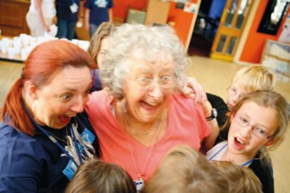

The following report was omitted in error from the list of closed churches contained in the Reports to the Assembly.
Appendix 2

Tabernacle URC, Narberth, Pembrokeshire
The original chapel was built in 1813 to hold 400 people. An increase in the number of members called for a larger chapel to built and so it was that in 1858 the existing chapel was built to accommodate 600. The old chapel from 1858 was to become ‘The Schoolroom’ and served the local community whilst also being used for concerts and as a dining room for pupils from a nearby school.

It is an interesting fact that the collection taken on the day the new chapel was opened was sufficient for the chapel to be declared ‘free from debt’. It is also interesting to note that the chapel members were ordinary, hard working local men and women. It is a tribute to their faith that the chapel was built.

An entry in the Register of Deaths for 1861, reads ‘ He troubled himself much
with the theory of perpetual motion…’. The entry in the next column reads, simply ‘dead’. Both entries conjure up thoughts of just what was it the deceased had been doing in his lifetime.

Other interesting facts include that in 1899 a pipe organ was bought and a heating ‘apparatus’ installed. In 1923 a new memorial organ costing £750 was installed. The organ was dedicated to the 15 men from Tabernacle who had been killed in the Great War. Their names are displayed on a brass plaque fixed to the front of the organ.

In 1959 the BBC broadcast ‘Sunday Half Hour’ from Tabernacle. It was, as it is today, a programme of community hymn singing. Local chapels were invited to attend the rehearsals which took place over several weeks prior to the broadcast. The chapel’s acoustics together with the very high standard of singing delivered a sound described later as “majestic”.

Tabernacle has been pivotal over the years in providing not just a place of worship but also as a refuge for those seeking solace from the rigours of poverty, the carnage of wars and the challenges of daily life.

Sadly Tabernacle held its last service on 23rd September 2008. The deterioration in the fabric of the building together with dwindling numbers attending, brought about its demise in its anniversary of 150 years in the service to God. With its closure a void has appeared in the lives of many, but, who knows? God moves in a mysterious way. We ask for your prayers.

United Reformed Church • Record of General Assembly 2010 • 71

