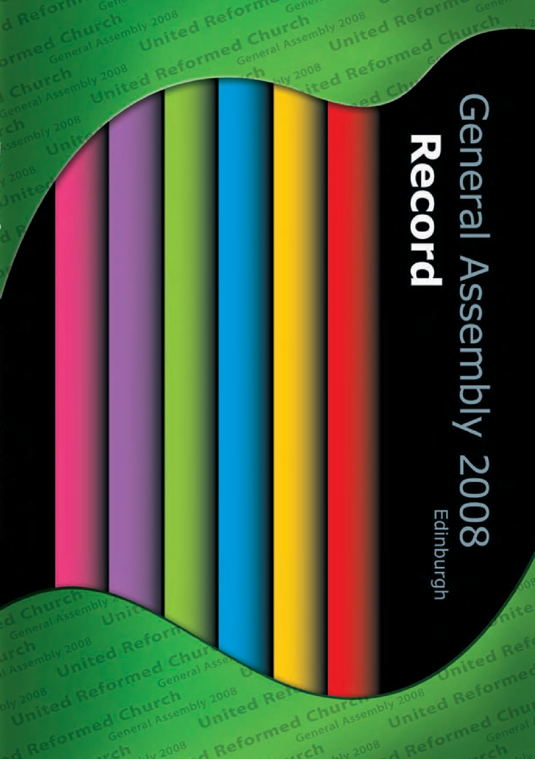

Children’s Assembly

Signers present at Assembly for the first time

Assembly Hall

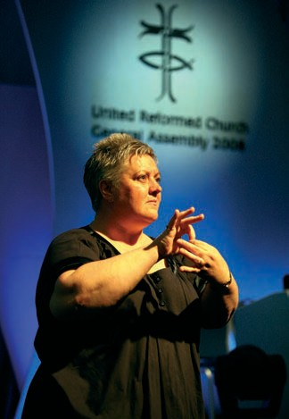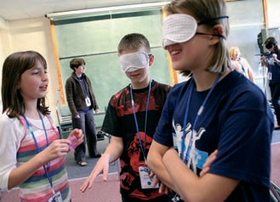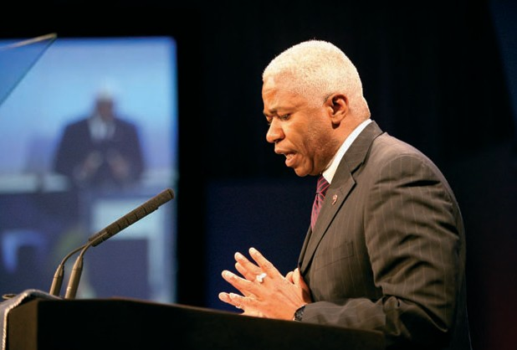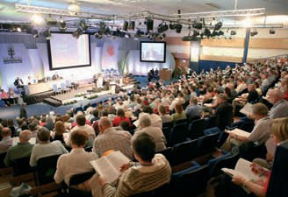

The United Church of Christ (USA) Mr Ron Buford

General Assembly 2008
Record United Reformed Church

© The United Reformed Church, 2008

URC075
Published by
The United Reformed Church
86 Tavistock Place, London WC1H 9RT

All rights reserved. This material may be used freely within the churches. No part of this publication may be reproduced outside the Church in any form or by any means – graphic, electronic, or mechanical, including photocopying,
recording, taping or information storage and retrieval systems – without the prior permission in writing of the publishers.

The publishers make no representation, express or implied, with regard to the accuracy of the information contained in this book and cannot accept any legal responsibility for any errors or omissions that may take place.

Designed and printed by the graphics office in Communications on behalf of the Assembly Arrangements Committee, The United Reformed Church, Church House, 86 Tavistock Place, London WC1H 9RT

Photographs credit: © Mark Howard, Twenty-Five Educational


Produced with reference to See it Right: Making information accessible to people with sight problems (2006), Royal National Institute of the Blind, London. ISBN 1 85878 704 1

Printed by Healeys Printers using Bio inks.
Healeys Printers hold the following environmental accreditations: FSC (certificate SGS-COC-004497); PEFC; ISO 9001; ISO 14001.

If you require this text in another format please inform the graphics office,
Church House. Please give two weeks notice.

Matters for consideration and action
iii
General Assembly 2008

Resolution number | Reports | Record | Title | Synods | Local churches
19 | 113-126,  223 | 26 | Equal Opportunities updated policy | x | x
22 | 224 | 55 | Giving to Ministry and Mission Fund |  | x
23 | 225-227 | 41 | Challenge to the Church | x | x
28 | 236 | 74 | Lay preachers | x
32 | 69, 243 | 25 | Representation to General assembly | x
33 | 73 | 24 | Living Wage | x | x
36 | 96 | 19 | Vision for Youth and Children’s Work | x | x
38 | 99-111 | 25 | YCWTDO in every synod | x
44 | 38a, 247 | 27 | Reform |  | x
45 | 38b, 247 | 66 | Bookshop | x | x
49 |  | 57 | Amendment to Structure | x
(Constitutional amendment – |  | responses f | rom synods due to General Secretary by 31st March 2009)
51 |  | 68 | Support of Rural Community |  | x
52 |  | 27 | Membership of synods | x
55 |  | 55 | Registration of assets |  | x
57 |  | 23 | Zimbabwe  (emergency resolution) |  | x
Index  Index of resolutions |  | 83  87



the United Reformed Church General Assembly 2008
Record of
iv

Presentation of the Synod Moderators’ Report to General Assembly 2008 by the Moderator of the Synod of Wales, the Revd Peter Noble
Synod Moderators
General Assembly 2008

Prisoners of Hope
Moderator, members of General Assembly, I am delighted to present the report of the synod moderators.

I want to offer you an image. I was recently invited to a memorial concert in St Martin in the Fields in Trafalgar Square, London. The building has recently undergone a £36m refurbishment programme.
It is a baroque church built in 1720 and is at the symbolic edge of the way the Church exists and serves its community. A major visual feature of the refurbishment is the newly installed east window above the altar. The Vicar, the Reverend Nicholas Holtam says of the window that it is: ‘reminiscent of Christian symbols, such as Jacob’s ladder and the cross. But its black frames also suggest an urban setting, “somewhere twixt heaven and Charing Cross.”’

In the context of the Baroque Church, this window is indeed as striking as it is astonishing. I found it extremely moving. The strong horizontal and vertical lines forming the grid structure presents an ordered world
– the one we ‘make’, the one we like to inhabit – a world of structure and security and comfort zones; a world, and a society, and a church which does not make demands, but which, at the same time, feels strangely limiting.

However the ellipse set at an angle penetrates this world and re- contours ‘the way things are’, the way we ‘see’ our world. This ellipse represents for me the Divine, birthing, incarnation, a cross, the man hanging discarded, resurrection, ascension, and the glory of God. This dynamic activity offers an alternative vision of the world. We are forced to see the world differently through the life, death and resurrection; Christian imagery which represents risk and rejection and crucifixion.
That is the hope of God.

This window seems to symbolise the very foundation of God-promise. And indeed the re-contoured lines change the way I see the world outside, the way I looked at the very materiality of the buildings opposite through the glass itself.

And it struck me at the same time that in the context of St Martin in the Fields this is no mere abstraction; rather it represents this church’s engagement with the people of that city through their ministry to those who might be described as hope-less, home-less, poor, floundering in the heart of a city that is rich but excluding.

This is a God-shaping piece of art.

Record of the United Reformed Church General Assembly 2008 1
Record of the United Reformed Church General Assembly 2008



Synod Moderators’ Presentation

This might sound terribly romanticised. But in a sense this is at the heart of what the synod moderators’ report offers to our Church at this moment in our life together.

As moderators, we encounter churches who can best be described as ‘cannot’, or even sometimes ‘will not’ do churches. It is time for that to change. It is time again for us to become a ‘can-do’ church; a church that is dissatisfied with being inextricably bound up in decline. Despite all that we have done in terms of re-structuring, we need to absorb to ourselves, again and again, the message that is core to the Gospel – that our hope does not lie in ourselves, or our strategies, or our programmes, but in bearing witness to the Good News. God is at the heart of it all, and we must allow the hope of God to re-contour our vision of our communities and the people in them. We are called to a constant re-
understanding of God in Jesus Christ, challenging and enabling us, with courage, to determine what the shape and priorities of our Church need to be as we go about our calling to bear witness to the gospel in the 21st century.

Our report is an attempt to point us again towards the centre of our hope, the God who in Jesus breaks through into our world and reaches toward us to reform us, and through our witness to offer an alternative vision of reality.
Our report does not come from either a committee or a council of the Church.
It is a reflection arising from our ministry; a reflection that we offer to our churches. We hope everyone will find here something that resonates, something that echoes their story and their Christian journey.

There have been some excellent and challenging theological reflections commissioned by Mission Council that I’m not sure we’ve visited with enough seriousness. I certainly identified with a reflection offered by Dr Robert Pope. He wrote this to our Mission Council, and therefore to our Church:

‘We certainly live in what is potentially a kairos moment. We have recognised that the Church sits at a crossroads. We rightly see the need to orient our activity toward realistic, manageable and achievable mission rather than maintenance. Our divine calling as well as the context in which we find ourselves require us now to be imaginative and prayerful as we seek a direction for the Church in which our discipleship will be more faithful and our witness more effective to the God who in Christ calls us to himself and bestows on us eternal life. We can look to the future with hope in our hearts. Nothing is fixed; all can be changed (revived or renewed). That really is good news.’


We will soon return to our homes and churches, those cells of the Kingdom, those cells of hope, where corporately and personally we bear witness to God in Jesus Christ. May it be with this God- promised, God-given, God-assured hope, that in the end God has had the last say in Jesus Christ. That resurrection is the sign of a new order of things, with new possibilities for our world and the people in it, and crucially for the shaping
of our Church and our churches. God pierces the ‘grids’ of our securities, our thinking, and even our ways of being Church, presenting this re-contoured newness of hope-ful life reaching to us in Jesus Christ that, echoing the words of Cornel West:

2 Record of the United Reformed Church General Assembly 2008



‘generates this energy to be courageous, to bear witness,
to see what the end is going to be. No guarantee,
unfinished,
open-ended.
(We) are prisoners of hope.’

The irony is that it is in being prisoners that we find liberation.

Moderator, I present the synod moderators’ report to General Assembly and our Church.

Record of the United Reformed Church General Assembly 2008 3
ecord of the United Reformed Church General Assembly

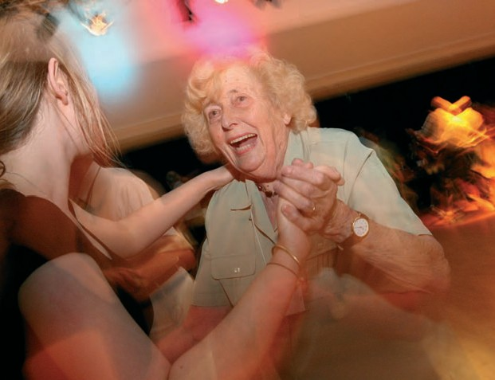

4 Record of the United Reformed Church General Assembly 2008

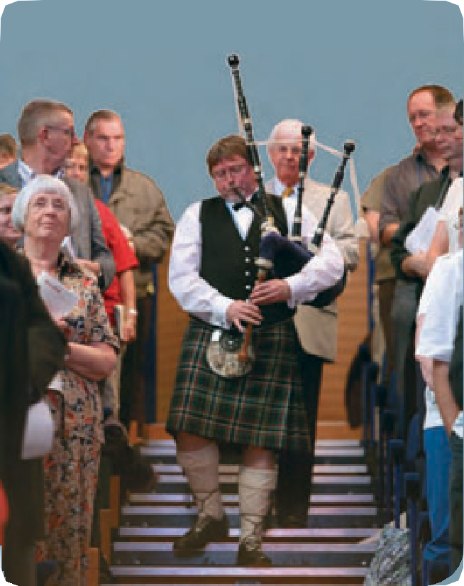

In 2007 the Assembly adopted new Standing Orders which use Consensus in reaching decisions.
Record
General Assembly 2008

Consensus
Accordingly in this Record where a decision is shown as having been carried by Consensus it means that a Resolution has been supported by all those present.
of the United Reformed Church

Agreement
Where a decision is shown having been carried by Agreement it means that the Resolution has
been supported by most of those present but that a small number of people, who do not support it, have agreed that they have been heard and are prepared to have the result declared by agreement.

Majority
Those who choose to, have recorded their dissent. Where a decision is recorded as being carried by a Majority it means that either the matter was
of such urgency or importance that although consensus or agreement could not be achieved a decision was necessary and therefore majority
voting was used or else it was of a constitutional or legal nature where majority voting is required.

5

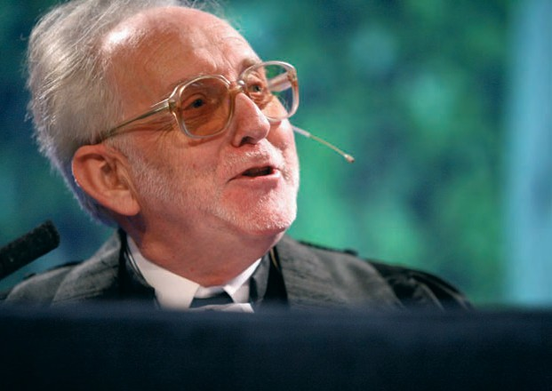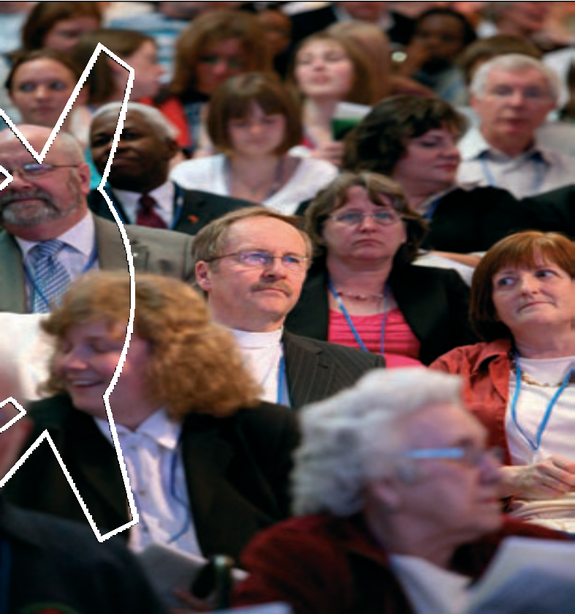

The Revd John Marsh, Moderator

6 Record of the United Reformed Church General Assembly 2008

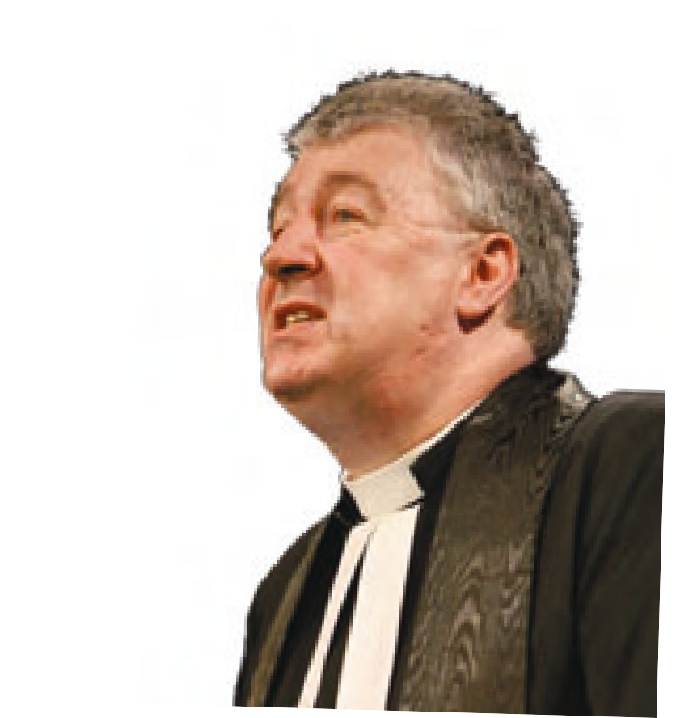First Session
Friday July 11th
General Assembly 2008

Constitution of Assembly
At 3.30 pm members of Assembly met in the James Watt Centre of the Heriot-Watt University in Edinburgh. The Moderator, the Revd Prof Stephen Orchard constituted the Assembly with prayer, the place and the time having been duly appointed.

Induction of Moderator
The Revd John Marsh, Moderator-Elect, was inducted with prayer into the office of Moderator of the General Assembly of The United Reformed Church. He signed the Assembly Bible and was presented with an inscribed copy of the Bible by the retiring Moderator of Assembly.

Thanks to the Retiring Moderator
The thanks of the Church were expressed by the Moderator to the Revd Prof Stephen Orchard and Mrs Linda Orchard, together with the Revd Lucy Brierley, her chaplain.

Assembly then continued with an introduction to the theme of ‘Pilgrimage’ in addition to worship, during which the Moderator gave his address to Assembly.

The Roll of Assembly was then placed on the table by the Clerk to Assembly, the Revd James Breslin.

Revd James Breslin, Clerk to Assembly

7

Moderator: Revd John M Marsh
Clerk: Revd James Breslin
General Secretary: Revd Roberta Rominger
Deputy General Secretary: Revd Ray Adams

Moderators of Synods:

I Revd Rowena Francis II Revd Richard Church III Revd Howard Sharp IV Revd Kevin Watson V Revd Terry Oakley
VI Revd Elizabeth Welch VII Revd Paul Whittle
VIII Revd David Grosch-Miller IX Revd Adrian Bulley
- VACANT
- Revd Nigel Uden XII Revd Peter Noble
XIII Revd John Humphreys


Conveners of General Assembly Standing Committees and Task Groups:

Assembly Arrangements: Mr William McVey
Communications and Editorial: Revd Dr Kirsty Thorpe
Education and Learning: Prof Malcolm Johnson
Equal Opportunities: Ms Morag McLintock
Finance: Mr John Ellis
Ministries: Revd Peter Poulter
Mission: Revd Edward Cox
- Church and Society Mr Simon Loveitt
- Doctrine, Prayer and Worship Revd Dr Susan Durber
- Ecumenical and International Revd Elizabeth Nash
- Interfaith Relations Revd Peter Cowell
- Life and Witness Revd Peter Ball
- Racial Justice and Multicultural Ministries Revd Carla Grosch-Miller
Mission Council: Revd Prof Stephen Orchard
Nominations: Revd Malcolm Hanson
Pastoral Reference and Welfare: Revd Alasdair Pratt
Youth and Children’s Work: Revd Neil Thorogood

Synod Clerks:

- Revd John Durell
- Mr George Morton
- Mr Donald Swift
- Mrs Val Morrison
- Mr Duncan Smith
- Mr Bill Robson
- Mr Mick Barnes
- Revd Roz Harrison
- Mr Peter Pay
- Mr Simon Fairnington
- Dr Graham Campling
- Revd David Fox
- Dr Jim Merrilees

8 Record of the United Reformed Church General Assembly 2008

Synod Treasurers:

- Mr Danny Pigeon
- Mr Gordon Eccles
- Mr Andrew Martlew
- Mr Andrew Murison
- Revd Richard Turnbull
- Revd Roger Woodall
- Mr Ron Wade
- Revd Richard Gray
- Mr Nick Lowe
- Mr Maurice Dyson
- Mr Robert Caffyn
- Revd Kenneth Graham
- Mr Tom Woodbridge


Theological College Representatives:

Mansfield College: Revd Julian Templeton
Northern College: Revd Dr Lesley Husselbee, Mrs Alison Claxton Queen’s Foundation: Revd Dr Michael Jagessar, Miss Clare Gouldthorp Scottish United Reformed
and Congregational College: Revd Dr Jack Dyce, Mr Steven Manders Westminster College: Revd Dr Susan Durber, Mrs Sue Fender
Youth Representatives: Mr James Wickens, Miss Jane Hoddinott Assembly Members from Other Churches in the United Kingdom: Church of England Mrs Naomi Lumutenga
Church of Scotland Rt Revd David Lunan
Revd Valerie Ott International Ministerial Council of Great Britain Rt Revd Sheila Douglas The Moravian Church Mr Blair Kesseler
The Presbyterian Church in Ireland Rt Revd Dr Donald Patton The Presbyterian Church of Wales Revd Thomas Phillips
The Scottish Episcopal Church Mrs Norma Higgot
The Congregational Federation Revd Dr Alan Argent
The Methodist Church Deacon Jane Middleton

Assembly Members from Churches outside Britain and Ireland:

The Church of Jesus Christ in Madagascar Revd Charles Rakotonirina
Revd Jean Takotomalala
Guyana Congregational Union Revd Keith Haley
Kiribati Protestant Church Revd Bureieta Karaiti
Maraland Presbyterian Church Revd Beiho Beilua Revd Hmaoka Hlychho
Presbyterian Church of Nigeria Pastor Ofe-em Okoi

Chaplain (URC) to HM Forces in Britain: Revd Michael Thomason

Past Presidents, Chairmen and Moderators:
Mrs Gwen Hall, Revd Arthur Macarthur, Revd John Johansen-Berg, Revd Martin Cressey, Mrs Rosalind Goodfellow, Revd John Francis, Revd Bentley Webster, Revd Dr Peter Arthur, Revd George Sharpe,
Revd Victor Smith, Revd Alasdair Walker, Revd Cyril Franks, Revd Edmund Banyard, Revd Keith Forecast, Revd Graham Cook, Revd Malcolm Hanson, Mrs Ruth Clarke, Revd Donald Hilton, Revd Dr Jack McKelvey, Revd John Reardon,

Record of the United Reformed Church General Assembly 2008 9

Revd Prof David Thompson, Revd David Jenkins, Mrs Wilma Frew,
Revd Peter McIntosh, Revd Bill Mahood, Revd Elizabeth Welch, Revd John Waller, Revd Alasdair Pratt, Revd Sheila Maxey, Revd Dr David Peel, Revd Elizabeth Caswell, Revd Prof Stephen Orchard

Synod Representatives:
(Names appearing with an asterisk were appointed to fill synod vacancies
cf. Resolution 10 pg 21 Assembly Record 1978)

Synod I – Northern
Revd David Bedford, Revd Edward Butlin, Revd Janet Flawn, Revd Philip Gray, Revd Julie Martin, Revd Tjarda Murray, Revd Catharine Morrison, Revd Colin Offor, Revd Peter Rand

Mr Matthew Appleyard, Miss Jennifer Barclay, Mrs Chris Eddowes, Mr Peter Etwell, Ms Jan Harper, Mrs Margaret Humberston, Ms Pat Poinen, Mr Justice Semuli,
Mr Maurice Taylor

Synod II – North Western
Revd Paul Brewerton, Revd Philip Brooks, Revd Hilary Collinson, Revd Helga Cornell, Revd David Harkison, Revd Helen Higgin-Botham, Revd Rachel Poolman,
Revd Stuart Ratcliffe, Revd Alistair Smeaton, Revd Martin Smith, Revd Janet Sutton, Revd Sally Thomas, Revd Alan Wickens

Mrs Deborah Brooks, Mr Derek Estill, Miss Claire Fletcher, Mrs Rosalind Fearon, Mrs Margie Jenkins, Mr James McKinnon, Mrs Elizabeth McKinnon,
Mrs Diane McKnight, Miss Katie Unsworth, Miss Lynne Wigginton, Mr Michael Williams, Mrs Sylvie Yernaux

Synod III – Mersey
Revd David Coaker, Revd Gwynfor Evans, Revd Martin Hardy, Revd Richard Howard, Revd Gordon Smith, Revd Kenneth Summers

Miss Zoey Arrowsmith, Mr Bill Dixon, Mrs Janet Dixon, Mrs Barbara Ellis, Mrs Gail Jones, Ms Alison Micklem, Mr David Powell, Mrs Helen Renner, Mrs Lorraine Threlfall

Synod IV – Yorkshire
Revd Kay Alberg, Revd Erica Beglin, Revd Paul Breeze, Revd Pauline Calderwood, Revd Dr James Coleman, Revd Anthony Gardiner, Revd Annette Haigh,
Revd John Jenkinson, Revd Graham Maskery, Revd Dr David Stec

Mrs Cynthia Feather, Mrs Linda McHale, Mr Jim Murison, Mrs Margaret Nicholls, Miss Rachel Pickering, Mr Chris Reed, Ms Helen Singleton, Mr Ron Sweeney,
Mr Kevan Shuttleworth, Mrs Gwen Smithies, Mrs Marguerite Sobol, Mrs Lisa Wigfield

Synod V – East Midlands
Revd Colin Bones, Revd Jane Campbell, Revd David Downing, Revd Richard Eastman, Revd Steven Faber, Revd Gillian Heald, Revd David Legge, Revd Paula Parish West, Revd Elizabeth Nash, Revd Hamish Temple

Mrs Sheila Ashmore, Mrs Margaret Davies, Mrs Margaret Gateley, Mr Tom Hackett,
Mrs Tricia Legge, Ms Tamara Oates, Mrs Valerie Smith, Mrs Jenny Theirs,
Mr Philip Timson

10 Record of the United Reformed Church General Assembly 2008

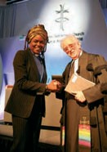

Synod VI – West Midlands
Revd Stuart Drummond, Revd Jacqueline Embrey, Revd Marcus Hargis, Revd Anthony Howells, Revd John Johansen-Berg, Revd Kathryn Louch, Revd Leslie Mather, Revd Helen Pope, Revd Richard Pope,
Revd Anne Sheldon, Revd Andrew Mann-Ray

Miss Helen Carr, Mr Martin Clarke, Mrs Brenda Climer, Mr Chris Collins, Ms Jean Creighton, Mr John Desmond,
Mrs Wilma Frew, Mr Nebiyou Gesse, Miss Kathryn Griffin, Mrs Olive Hall, Mr David Harvey, Mr Daniel Holmes,
Miss Kirsty Mabbott, Mrs Margaret Marshall, Ms Mary McIntosh, Ms Mhari McLintock, Mrs Adella Pritchard, Mr Jonthan Salter, Miss Isobel Simmons, Mr Martin Stokes, Miss Wayde Taylor, Mrs Diane Turner, Miss Miriam Webb

Synod VII – Eastern
Revd Catherine Ball, Revd Peter Ball, Revd Alison Davis,
Revd Birgit Ewald, Revd Kenneth Forbes, Revd Murray George, Revd Trevor Jamison, Revd Kenneth Lynch, Revd Deborah McVey, Revd Donald Nichols, Revd Peter Peirce, Revd Michael Rigney, Revd Ruth Whitehead

Mr Nicholas Berry, Mr Tunde Biyi, Mrs Wendy Cooper, Mr Tony Gilbert, Mrs Wendy Gilbert, Mr Clive Goodhew, Mr Joel Green, Mr David Halls, Mrs Linda Harrison,
Mr Mike McCullagh, Miss Alice Nicholls, Mrs Faith Paulding, Miss Victoria Paulding, Mrs Anne Stokes, Mr Ron Stokes, Mr Peter West

Synod VIII – South Western
Revd Craig Bowman, Revd Peter Brain, Revd Douglas Burnett, Revd Roy Fowler, Revd Carla Grosch-Miller, Revd Robert Jones, Revd Jacquiline Knight, Revd Tracey Lewis, Revd Michael Harvey *, Revd Dawn Mather, Revd Iain McDonald, Revd Helena McKinnon, Revd Glyn Millington, Revd Paul Snell, Revd Angela Steele,
Revd Philip Wagstaff, Revd Michael Whitfield

Mrs Jean Baker, Miss Emily Beaumont, Mrs Josie Carpenter, Mrs Janet Gray, Mrs Grace Hempstock,
Mr Douglas Hempstock, Mrs Brenda Jesse, Mr Brian Knight, Ms Sarah Lane, Mrs Lorna Letters, Mrs Maria Mills,
Mrs Caroline Muhone, Miss Sylvia Nutt,
Mrs Margaret Skyrme, Mr Malcolm Summers, Mr John Waines

Synod IX – Wessex
Revd Clifford Bembridge, Revd Anne Bray, Revd Anne Dove, Revd Brian Harley, Revd Michael Hopkins, Revd Peter Hurter, Revd Philip Jones, Revd Owiny Laber, Revd Pauline Main, Revd Julian Thomas, Revd Diana Townsend,
Revd Caroline Vodden

Mr Titus Auta, Mrs Ann Baker, Ms Michelle Bradley,
Ms Rebecca Casey, Mrs Mary Cooper, Mrs Christine Hardwick, Ms Sarah Holland, Mrs Joan McGavin, Dr Kaihsu Tai,
Mrs Margaret Telfer, Mr Graham Thatcher, Ms Megan Thomas, Mr Malcolm Townsend, Mrs Lynne Upsdell
Record of the United Reformed Church General Assembly 2008 11

Synod X – Thames North
Revd Susan Chapman, Revd Donald Elliott, Revd Ashley Evans, Revd James Gould, Revd Ann Jack, Revd Shahbaz Javed, Revd Heather Kent, Revd Geoffrey Roper, Revd Edward Sanniez, Revd Dr Alan Spence, Revd Jane Weedon

Mr Charles Aidoo, Mrs Tina Ashitey, Dr Paul Ashitey, Mrs Isobel Bala,
Mrs Viv Barthram, Mrs Joyce Berry, Miss Melissa Burrell, Mr David Eldridge, Mrs Fredwyn Hosier, Mrs Margaret Ingram, Mr Andrew Jack, Mr Asif Jamshaid, Mr Emmanuel Osae, Mr Matthew Prevett, Mr Vic Russell, Mrs Sue Russell,
Ms Lesley Trenkel, Mr Keith Webster, Mrs Kate Yates

Synod XI – Southern
Revd Richard Alford, Revd Grahame Allan, Revd Bruce Allinson, Revd Elaine Dunn, Revd Diane Farquhar, Revd John Gordon, Revd Dominic Grant, Revd Suk In Lee, Revd John Potter, Revd Jane Rowell, Revd David Skitt, Revd Jennifer Snashall,
Revd Pauline Sparks, Revd Kenneth Thom, Revd Zamantha Walker, Revd George Watt

Mrs Sophie Akwagyiram, Mr Steven Allinson, Mr Richard Bailey, Mrs Marion Bayley, Mr Grant Gulczynski, Miss Lizzie King, Mr John Prestage, Mr Tim Reith,
Mrs Christine Roberston, Mrs Anne Rowan, Mrs Cynthia Stock, Mr David Walters, Mr Nathan Watt, Miss Louisa Weeks, Mrs Nancy Welch, Mrs Susan Wootton,

Synod XII – Wales
Revd Ruth Browning, Revd Christopher Coe, Revd Janet Conway, Revd Nanette Lewis-Head, Revd Peter Nunn, Revd Shelagh Pollard,
Revd David Salsbury, Revd Malcolm Shapland, Revd Nicholas Stanyon, Revd Peter Trow

Mr Ian Ashton, Mr Matthew Barkley, Mrs Miriam Griffiths, Mr Bryn Griffiths, Mr Alun Jones, Mr Richard Laws, Ms Sitsengisiwe Moyo, Miss Tina Ngoma, Miss Ruby Ngoma, Mrs Barbara Shapland, Mrs Liz Tadd

Synod XIII – Scotland
Revd Janet Adamson, Revd Ian Baillie, Revd Connie Bonner, Revd Stephen Brown, Revd Irene John, Revd Dr Lesley Moseley, Revd Alan Patterson, Revd Kathryn Price, Revd Stephen Taylor, Revd Ian Wilkie, Revd John Young

Mr Stephen Alexander, Mrs Barbara Bruce, Miss Cristy Carr, Mr Bob Christie, Mrs Patricia Jupp, Mr James Maguire, Mrs Brenda Moon, Mr John Park,
Miss Myra Rose, Miss Wilma Sinclair, Miss Penelope Smirthwaite, Dr Scott Spurlock

Reception of Visitors and Assembly members from other Churches:
Visitors and Assembly members from other Churches in Scotland
were introduced by the Revd John Humphreys, Moderator of the Synod of Scotland:

Church of Scotland Revd Valerie Ott
Revd John R Smith, Presbytery of Edinburgh
The Scottish Episcopal Church Most Revd Dr Idris Jones, Primus & Bishop of Glasgow and Galloway
Mrs Norma Higgot
The Methodist Church Dr William Reid, Connexional Liaison
Officer – Scotland
Deacon Jane Middleton
Baptist Union of Scotland Revd Bill Slack, General Director The United Free Church of Scotland Revd Andrew McMillan, Convener
– Ecumenical Relations Committee Scottish Catholic Bishops’ Conference Miss Margaret Long

12 Record of the United Reformed Church General Assembly 2008


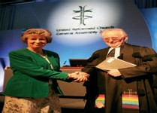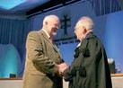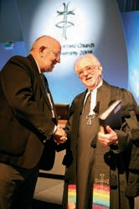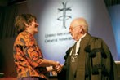

Visitors and Assembly members from Churches in the United Kingdom and Overseas were introduced by the Revd Edward Cox, the Convener of
the Mission Committee:

Church of England Mrs Naoma Lumutenga
Presbyterian Church of Ireland Rt Revd Dr Donald Patton, Moderator
Presbyterian Church of Wales Revd Tom Phillips, Clerk of the Assoc in the East
Congregational Federation Revd Dr Alan Argent, outgoing President
Ms Jane Giscombe
Baptist Union of Great Britain Revd Michael Peat International Ministerial Council of
Great Britain Rt Revd Sheila Douglas, International Moderator
ACTS Br Stephen Smyth,
General Secretary
CTBI Revd Claudette Douglas
The British Province of the Moravian Church Mr Blair Kesseler The Union of Welsh Independants Revd Llunos Gordon
The Salvation Army Major Alan Dixon

They were greeted by the Moderator of General Assembly. Dr Jones was invited to respond on their behalf.

Greetings by the Moderator on behalf of
General Assembly 2008

Record of the United Reformed Church General Assembly 2008 13

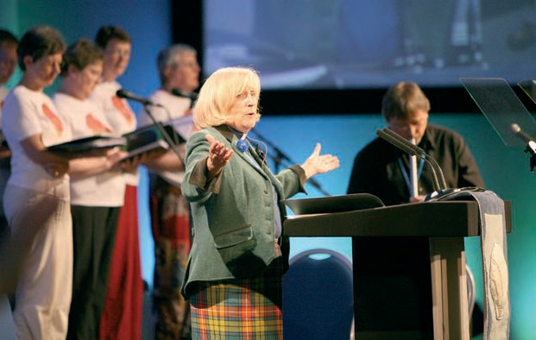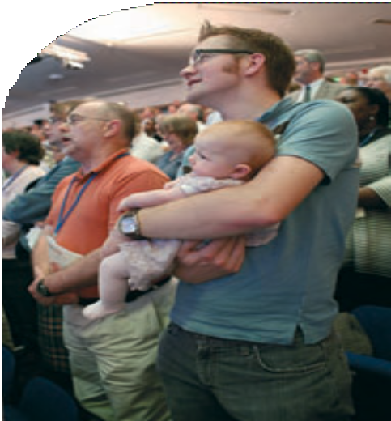

Visitors and Members from Overseas were introduced by the Revd Edward Cox: Kiribati Protestant Church Revd Bureita Karaiti, General Secretary
Guyana Congregational Union Revd Keith Haley, General Secretary Churches of Jesus Christ in
Madagascar (FJKM) Revd Charles Rakotonirina, General Secretary
Revd Jean Olivier Rakotomalala, President of
Synod of the East Andona, Miara-Mifoha Anglican Diocese of Jerusalem Mr Khalil Abdennour
Mrs Eliane Abdennour The United Church of Christ (USA) Mr Ron Buford

The Moderator of the General Assembly of the Church of Scotland, the Rt Revd David Lunan and the URC Ghanaian Minister in London, Revd Sylvanus Tettey, were greeted later in the Assembly.
The Representatives of the Maraland Presbyterian Church, Revd Beiho Beilua,
Senior Executive Secretary and Hmaoka Hlychho, Moderator, were not present having been refused visas by HM Government.

The Moderator invited a response on behalf of the international guests from Revd Bureita Karaiti.

The Chaplain, the Revd Mary Buchanan closed with worship and prayer.

The Chaplain, Revd Mary Buchanan, leading worship

14
Record of the United Reformed Church General Assembly 2008

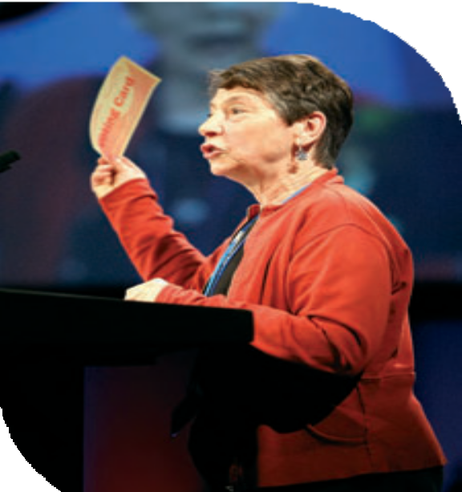Second Session
Friday July 11th
General Assembly 2008
The Moderator welcomed those who were attending the Assembly for
the first time and introduced the people on the platform.

The Chaplain, the Revd Mary Buchanan and Revd Dr Jane Leach led the Assembly in worship and Spiritual Direction.

The Convener of the Assembly Arrangements Committee, Mr William McVey, presented the Order of Business, drawing attention to the list of errors and omissions in the Book of Reports.

The Revd Elizabeth Nash introduced the concept and process of consensus decision-making, and moved adoption of Resolution 61.

The move to Consensus voting requires a small group of people to enable group work, collate responses from groups, assist in the drafting of contentious text and generally to assist the Moderator in the management of resolutions. Under Standing Order 2c.(b) this group is to be appointed at the beginning of each Assembly. It is therefore moved that:
Resolution61

Appointment of the Facilitation Group
The General Assembly appoints the Revds Ray Adams, Kay Alberg, Jane Campbell, John Durrell, Steve Faber, Iain McDonald, Elizabeth Nash, Rachel Poolman,
Ruth Whitehead and Jacky Embrey, Mrs Margaret Gateley and Mr Peter Pay, to serve as the Facilitation Group for General Assembly 2008.

Resolution 61 was carried by consensus.

Revd Elizabeth Nash introduces the concept
and process of consensus voting

15


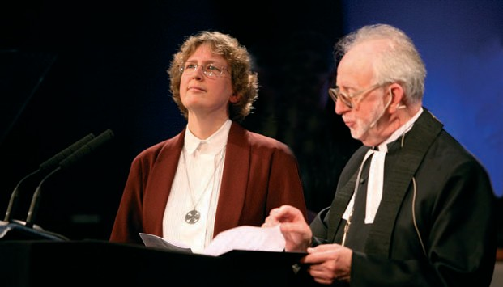
16 Record of the United Reformed Church General Assembly 2008
Revd Roberta Rominger being inducted as General Secretary

The Clerk moved adoption of Resolution 48:

Resolution48
Appointment of Deputy Clerk
General Assembly appoints Mr Matthew Prevett to act as Deputy Clerk on the afternoon session of Saturday 12th July.
Resolution 48 was carried by consensus.

The Deputy General Secretary outlined and clarified the remits of Mission Council and
the Mission Committee.

The Revd Dr Stephen Orchard reflected upon his year in office as Moderator of the
General Assembly.

Children’s Assembly
Ms Jo Williams and a group of young people introduced the Children’s Assembly.

General Secretary
The Moderator led the Assembly in an act of worship during which the Revd Roberta Carol Sears Rominger was inducted as General Secretary to serve for a period of seven years until July 31st 2015.

The Moderator thanked the Revd Ray Adams for his gracious willingness to undertake an increased workload since the resignation of the Revd Dr David Cornick, and presented a gift on behalf of the Assembly.

The session was closed in prayer led by the Chaplain.

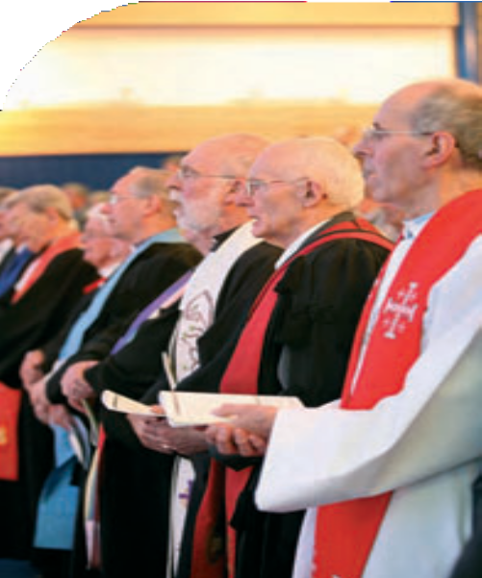First Session
Saturday July 12th
General Assembly 2008

Worship was led by the Chaplain. Spiritual Direction was offered by Revd Dr Jane Leach.

The Convener of the Assembly Arrangements Committee, Mr William McVey, presented the Order of Business, and offered guidance on the conduct of the Assembly.

Election of Moderators of General Assembly 2010-2012
The Clerk outlined the procedure for the election of Moderators.
The Moderator led the Assembly in prayer. Ballot slips were collected.

Nominations Committee
The Revd Malcolm Hanson moved adoption of Resolution 9:
Resolution 9

Reappointment of Wessex Synod Moderator
General Assembly reappoints the Revd Adrian Bulley to serve as Moderator of the Wessex synod from 1st February 2009 to 31st August 2014.

Resolution 9 was carried by consensus.

Mr Hanson moved adoption of Resolution 10:

Resolution10

Reappointment of East Midlands Synod Moderator
General Assembly reappoints the Revd
Terry Oakley to serve as Moderator of the East Midlands synod from 1st September 2010 to 31st May 2012.

Resolution 10 was carried by consensus.

Mr Hanson moved adoption of Resolution 34:

Past Moderators attending Assembly 2008 17


Mr Hanson moved adoption of Resolution 63:

Resolution63
Appointment of Secretary for Education and Learning
Assembly appoints the Revd Fiona Thomas as Secretary for Education and Learning from 1st November 2008.
Resolution 63 was carried by consensus.
18
Record of the United Reformed Church General Assembly 2008
Resolution34
Appointment of West Midlands Synod Moderator
General Assembly appoints the Revd Roy Lowes to serve as Moderator of the West Midlands synod from 1st September 2008 to 31st August 2015.
Resolution 34 was carried by consensus.

Mr Hanson moved adoption of Resolution 56:

Resolution56

Appointment of Thames North Synod Moderator
General Assembly appoints the Revd Andrew Prasad to serve as Moderator of the Thames North synod from 1st October 2008 to 30th September 2015, subject to review before the end of that period.

Resolution 56 was carried by consensus.

Mr Hanson moved adoption of Resolution 60:

Resolution60

Appointment of Secretary for Ministries
Assembly appoints the Revd Craig Bowman to serve as Secretary for Ministries from 1st September 2008 until 31st August 2013, subject to review before the end of that period.

Resolution 60 was carried by consensus.




Youth and Children’s Work
The Report of the Youth and Children’s Work Committee was presented by the Convener, the Revd Neil Thorogood.

Mr Thorogood moved adoption of Resolution 36:

Resolution36
Vision for Youth and Children’s Work
General Assembly welcomes the Vision for Youth and Children’s Work across the United Reformed Church and commends it to local churches and synods as a way of prioritising and shaping ministry with children and young people.

After brief discussion, Resolution 36 was carried by consensus. Mr Thorogood moved adoption of Resolutions 37-42:
In discussion:
- It was suggested that in resolution 40, two further elements should be added to the remit of the task group:
- A review of the process of appointment of YCWTDOs;
- A review of meetings and membership of the YCW team;
- It was suggested that the name of the post should be Youth and Children’s
Development Officer;
- It was suggested that resolution 38 should more strongly encourage every
synod to appoint a YCWTDO by 2011.

Resolution37

YCWTDO programme
General Assembly, reaffirming the importance of resourcing and equipping local churches in their ministries with children and young people, agrees to continue the Youth and Children’s Work Training and Development Officer programme.

Resolution 37 was carried by consensus.

Resolution 38 A YCWTDO in every synod
General Assembly, believing that it is desirable that there be at least one Youth and Children’s Work Training and Development Officer in each synod, requests every synod where such an officer does not exist to explore the possibility of making an appointment by 2011.

Resolution 38 was remitted to the Facilitation Group.

Record of the United Reformed Church General Assembly 2008 19
19
008

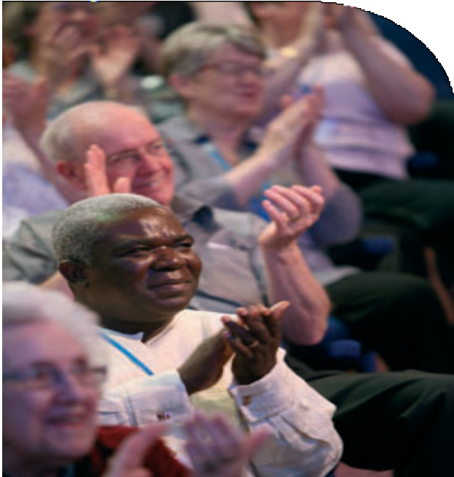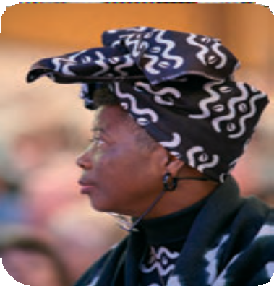
20 Record of the United Reformed Church General Assembly 2008

Resolution 39 Line management
General Assembly agrees that synods should be responsible for the line management
of their respective Youth and Children’s Work Training and Development Officers. Youth and Children’s Work staff at Church House, in conjunction with the respective synod line managers, will allocate, monitor and evaluate Assembly-level work undertaken by the Youth and Children’s Work Training and Development Officers.

Resolution 39 was remitted to the Facilitation Group.

Resolution40
Task Group
General Assembly instructs the Youth and Children’s Work committee to create a task group to:
- ensure that any appropriate training is provided to Church House staff for this changed role and responsibility;
- put in place the necessary procedures to ensure that synod line management and Youth and Children’s Work Training and
Development Officer staff development and appraisal are effective;
- ensure that Youth and Children’s Work Training and Development Officer job descriptions confirm and maintain that an agreed share of each of their time is devoted to Assembly-level work;
- report to Mission Council in May 2009.

In response to questions, the Convener stated that he had heard the concerns expressed concerning the possibility of broadening the remit of this task group and undertook to bear in mind the ecumenical dimension.

Resolution 40 was carried by consensus.

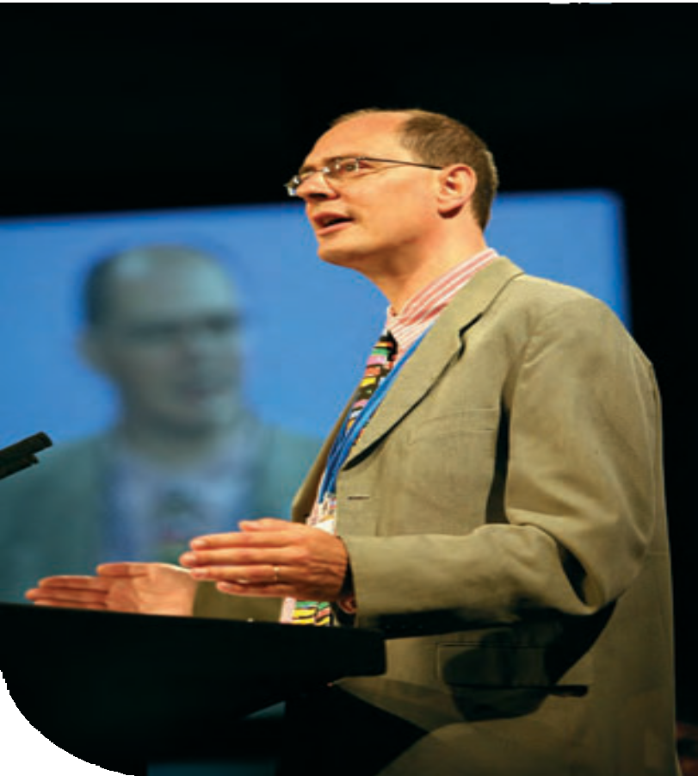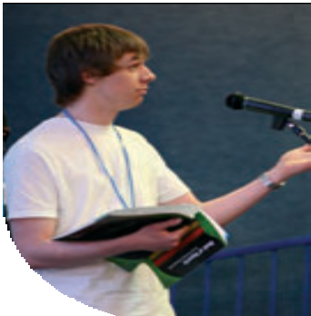

Revd Neil Thorogood presenting the report of the Youth and Children’s Work Committee

Fury member joins debate at Assembly

Resolution41

Funding arrangements
General Assembly agrees that the current split funding arrangements for Youth and Children’s Work Training and Development Officers be phased out by 2011, with all costs then being paid via synod funds.

Resolution 41 was carried by consensus.

Resolution 42 Children’s and Youth Officers
General Assembly agrees that the title of Youth and Children’s Work Training and Development
Officer be simplified to Children’s and Youth Officer (CYO).

Resolution 42 was remitted to the Facilitation Group.

FURY
The Assembly received a report from the Fellowship of United Reformed Youth which included a presentation on the work of Jerusalem ARC by Mr Khalil Abdennour.

Record of the United Reformed Church General Assembly 2008 21

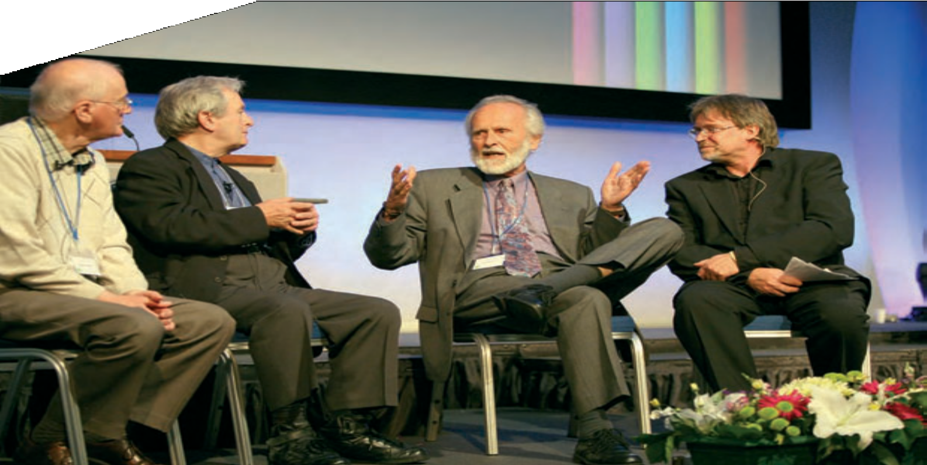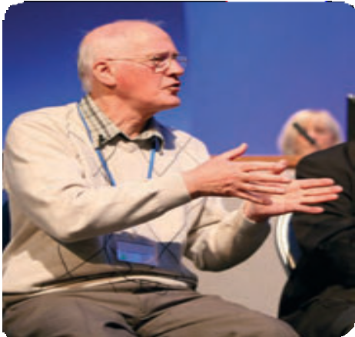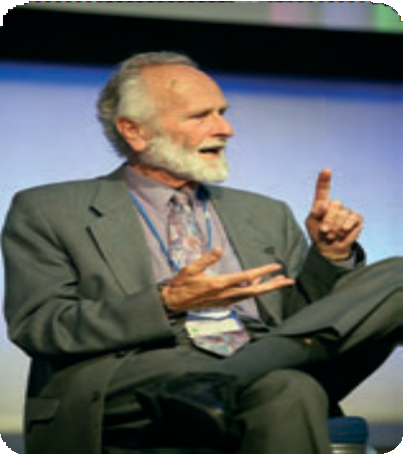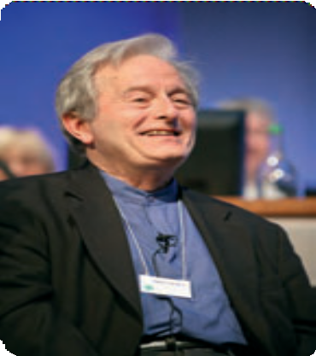Celebrating Hymn-writers
The Assembly welcomed with warm applause the Revds Alan Gaunt, Fred Kaan and Brian Wren, who were interviewed by the Revd Stephen Brown.

The Assembly adjourned.

Revd Fred Kaan

Revd Alan Gaunt Revd Brian Wren

22
Record of the United Reformed Church General Assembly 2008

Second Session
Saturday July 12th
General Assembly 2008
The Clerk presented the minutes of Friday 11th July, first session which,
with minor amendments, were approved.

Mission Committee
The Church and Society report was presented by Mr Simon Loveitt. Mr Loveitt moved adoption of Resolution 57:

Resolution57

Emergency Resolution on Zimbabwe
General Assembly, reflecting on the continuing humanitarian and political crisis in Zimbabwe following the flawed presidential run-off held at the end of June:

  - strongly condemns the violent tactics employed by the ruling party to intimidate, abuse and destroy Zimbabwean people;

  - commends our church partners in the Zimbabwe Council of Churches, Evangelical Alliance of Zimbabwe and Catholic Bishops’ Conference in Zimbabwe and other regional and international agencies for condemning this brutality;

  - adds the voice of the United Reformed Church to those calling for an immediate end to the violence and human rights violations in Zimbabwe and for the establishment of a transitional government to negotiate a framework for political and economic recovery;

  - calls on local churches to continue praying for justice and peace to be restored to Zimbabwe, and to offer hospitality and support to Zimbabweans living in their communities;

  - calls on the Government of the United Kingdom to stop all deportations to Zimbabwe and to give urgent attention to the welfare of the thousands of destitute Zimbabweans in the United Kingdom awaiting Appeal Court rulings;

  - instructs the Mission Committee to send a delegation from the United Reformed Church including Zimbabwean nationals to raise these issues with the Foreign Secretary.

23

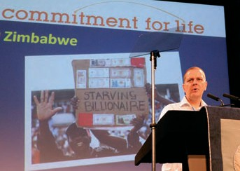
33:

In discussion:
- it was suggested that a clause 7 be added registering the Assembly’s disappointment that President Thabo Mbeki of South Africa has failed to act as an independent mediator in this dispute (Dr Alan Spence)

No consensus was reached on the additional clause, and the Assembly addressed the original Resolution, which was carried by consensus.

Mr Loveitt moved adoption of Resolution

Resolution33

Living Wage
General Assembly calls on all the United Reformed Church’s synods and churches:

- to support Church Action on Poverty’s call for churches to pay a living wage as determined by the Living Wage Campaign;1

- to ensure that all employees have a written contract of employment;

- to ensure that the terms and conditions of employment of employees at least comply with the minimum legal requirement stipulated;

- to implement the equal opportunity policy developed by the United Reformed Church;

- where contract or agency staff are employed, to engage with contractors and agencies on the payment of their employees to ensure compliance with this resolution;

- To monitor this through the annual returns from local churches and report back to Assembly in 2010.

1 currently, £7.20 per hour in London and £7.00 per hour elsewhere in the UK (see www.church-poverty.org.uk and follow the campaign’s link)

Resolution 33 was carried by agreement. The Revd George Watt, Southern Synod, and
Mr Emmanuel Osae, Thames North Synod, requested that their dissent be recorded.

Operation Noah
Mr Loveitt introduced Mr Mark Dowd, who addressed the Assembly about climate
change and the work of Operation Noah.

Pilots
The Assembly viewed a DVD film about the Pilots visit to Longleat.

24 Record of the United Reformed Church General Assembly 2008


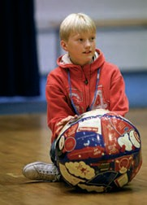

Racial Justice and Multicultural Ministries
The Revd Edward Cox moved adoption of Resolution 32:


Resolution32
Representation to General Assembly
a)
General Assembly requests each synod to include at least one black minority ethnic member in their group of representatives to General Assembly as from Assembly 2010.
b)
General Assembly instructs Mission Council to monitor and review the representation of black minority ethnic members in General Assembly in relation to the growth trends of the United Reformed Church and report back to the 2012 Assembly.

Mr Cox responded to a number of questions and comments. Resolution 32 was carried by consensus.

Youth and Children’s Work
The Convener of the Youth and Children’s Work Committee, having consulted the Facilitation Group, presented revised wording for Resolutions 38, 39 and 42.

Resolution38

A YCWTDO in every synod
General Assembly, believing that it is desirable that there be at least
one Youth and Children’s Work Training and Development Officer in each synod, request every synod where such an officer does not exist to explore seriously the possibility of making an appointment by 2011.

Resolution 38 was carried by consensus.

Resolution39

Line management
General Assembly agrees that synods should be responsible for the line management of their respective Youth and Children’s Work Training and Development Officers. Youth and Children’s Work staff at Church House, in co-operation with the respective synod line managers, will allocate, monitor and evaluate Assembly- level work undertaken by the Youth and Children’s Work Training and Development Officers.

Resolution 39 was carried by consensus.

Record of the United Reformed Church General Assembly 2008 25

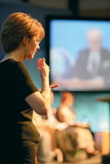
26
Record of the United Reformed Church General Assembly 2008
Signers present at Assembly
for the first time
26
Record of the United Reformed Church General Assembly 2008
Resolution42
Children’s and Youth Officers
General Assembly agrees that the title of Youth and Children’s Work Training and Development Officer be simplified to Children’s and Youth Development Officer (CYDO).
Resolution 42 was carried by consensus.

Equal Opportunities
Ms Morag McLintock, Convener of the Equal Opportunities Committee, presented the Equal Opportunities report and moved adoption of Resolution 19:

Resolution19
Equal Opportunities updated policy
General Assembly urges all churches, synods and United Reformed Church committees to embrace the General Assembly updated Equal Opportunities policy (as adopted on General Assembly’s behalf by Mission Council in October 2006) by 31st January 2010 and thereafter to implement said updated policy.
Resolution 19 was carried by consensus.



Mission Council
The Revd Prof Stephen Orchard and the Deputy General Secretary presented the
report of Mission Council, and responded to a number of comments and questions.

Synod Resolution
On behalf of Thames North synod, Mr Keith Webster seconded by
Mr Simon Fairnington, moved adoption of Resolution 52.

Resolution52
Membership of Synods
General Assembly resolves to amend the Structure of the United Reformed Church, paragraph B.2.(4)(g) to read:
“Such members of local churches, normally elders, not exceeding 10 per cent of the Synod’s notional establishment (or such other number as the General Assembly may from time to time determine), as may be co-opted by the synod”.

After debate, the Revd Geoffrey Roper, Thames North Synod, proposed an Alternative Resolution “That General Assembly under its powers to vary the number
of co-opted places on synods resolves to increase the limit of members co-opted from 12 to 24,” seconded by the Revd Michael Hopkins.

This alternative resolution was carried by consensus, and therefore became the substantive Resolution.

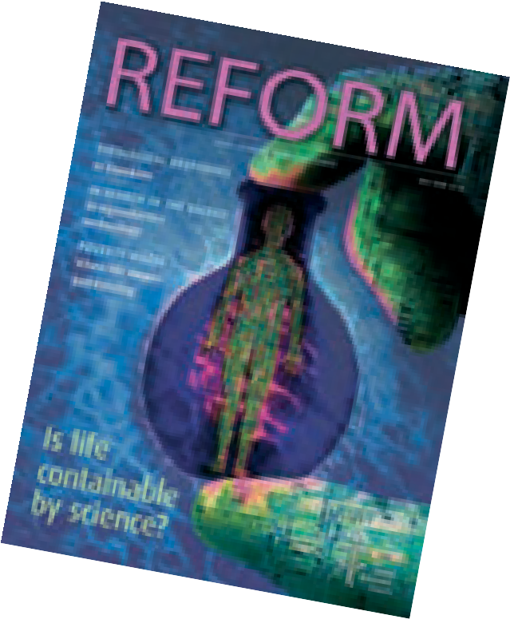The Resolution was carried by consensus.
Reform
The Revd Dr Kirsty Thorpe presented the new Reform magazin . The Assembly welcomed the new editor of Reform, Ms Kay Parris.

Dr Thorpe moved adoption of Resolution 44:

Resolution44
Reform
General Assembly celebrates all that Reform has given to the United Reformed Church over the past 35 years and urges all church members to read their free copy of the re-launch issue and consider buying it regularly.
e.
.

Resolution 44 was carried by consensus.

Worship was led by the Chaplain, and the Assembly adjourned.

Record of the United Reformed Church General Assembly 2008 27

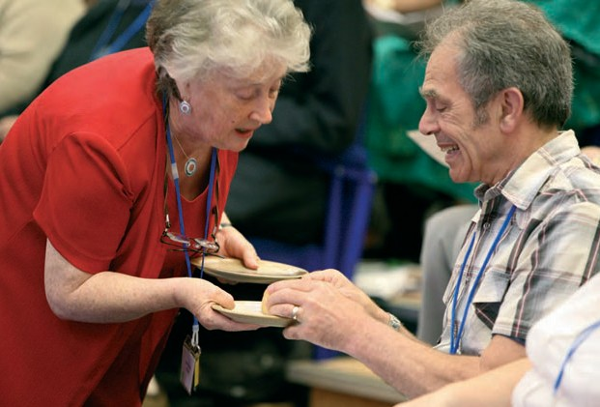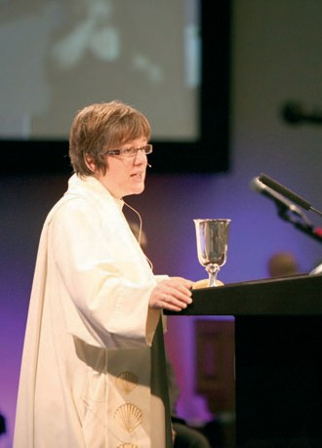

Revd Dr Jane Leach

Communion

28

First Session
Sunday July 13th
General Assembly 2008

Opening worship, which included the Sacrament of Holy Communion, was conducted by the Moderator, the Chaplain, and Communion Liturgist, Revd Vaughan Jones; Spiritual Direction was offered
by the Revd Dr Jane Leach.The Moderator thanked Dr Leach for her spiritual direction over the three days of Assembly.

The General Secretary led the Assembly in commemoration of those Ministers and Missionaries whose deaths have been reported to us since the last meeting of the Assembly:

Ministers
David Arthur Brigitta Johnson
David Avis Howard Jones
James Badcock Eric Lord
Robert Banham Ranald MacDonald
Kenneth Bell Ronald Manley
Margaret Berridge Thomas Morrison
John Brearley Richard Murray
Frank Brown John Murray
John Caton Geoffrey Nuttall
George Corfield David Idris Owen
Donald Davis Baron Pont
William Else Timothy Royds
Derek Galloway Alvin Satchwell
Charles George Thomas Shepherd
Peter Grey Arthur Stubbs
Kathleen Hendry Francis Summers
Frank Hewis Ronald Tansley
Donald Howell

Also Elfed Jones who died in 2004, but whose death had not been reported.

Missionaries
Clare Anderson May Collins Muriel Sleigh

New Ministers and CRCWs
Synod Moderators introduced Ministers and Church Related Community Workers
who had been ordained or commissioned since the previous meeting of the Assembly, or who had not been received by previous Assemblies. Each of those present was greeted in turn and received by the Assembly with applause.

Northern Synod (Moderator: the Revd Rowena Francis)
Mrs Mary Bellshaw CRCW – Gosforth: Trinity LEP
Revd Stan May West End and Robert Stewart Memorial, Newcastle

29



North Western Synod (Moderator: the Revd Richard Church) Revd Philip Brooks Christ Church, Farnworth and Wharton
Revd Helen Higgin-Botham Fulwood URC and Longridge Christ Church UM Revd Stuart Radcliffe Edgeley Road, Stockport and The Heatons
with Reddish
Revd Elizabeth Jewitt Pendle and Burnley Group

Mersey Synod (Moderator: the Revd Howard Sharp)
Revd Richard Howard Hoole, Chester and Long Farndon
Revd Anne Bedford Hamilton Memorial, Prenton and Upton, Birkenhead

Yorkshire Synod (Moderator: the Revd Kevin Watson)
Revd Annette Haigh Halifax Group

West Midlands Synod (Moderator: the Revd Elizabeth Welch)
Revd Carolyn White Herefordshire Team
Revd Robert Maloney Mission in the World of Work, and the Coventry and Warwickshire Area
Revd Marcus Hargis Clayton and Burslem
Revd Andrew Mann-Ray Bridgnorth Pastorate, Broseley Methodist,
Madeley Fletcher Methodist and Much Wenlock Methodist Churches
Revd Anne Sheldon The Gracechurch Centre, Sutton Coldfield

Eastern Synod (Moderator: the Revd Paul Whittle)
Mrs Liz Kam CRCW – Norwich Team, Church in Community
Revd Donald Nichols Norfolk and Waveney Area Partnership

Wessex Synod (Moderator: the Revd Adrian Bulley)
Revd Pauline Main Summertown, Oxford
Revd Anne Dove Bournemouth, Iford
Revd Caroline Vodden Broadstone and Lytchett

Thames North Synod (Clerk: Mr Simon Fairnington)
Revd Rosalind Selby Wanstead and Gants Hill
Revd Ashley Evans Plaistow Christian Church and the
Brickfields Christian Centre, Stratford

Southern Synod (Moderator: the Revd Nigel Uden)
Revd Diane Farquhar Christ Church, Tonbridge
Revd Zam Walker Brighthelm
Revd John Potter Church of the Cross, Thamesmead
Revd Dominic Grant Crowborough URC/Meth

Synod of Scotland (Moderator: the Revd John Humphreys)
Revd Lesley Moseley Giffnock
Revd Jack Muir Kirkwall
Revd Dr Kirsty-Ann Burroughs Campbeltown
Revd Helen Mee Livingston Ecumenical Parish

30 Record of the United Reformed Church General Assembly 2008


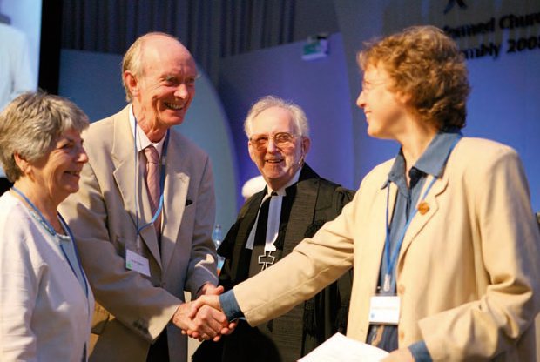
31

Jubilee Ministers
The General Secretary named those Ministers who were celebrating ministerial jubilees during the year:

Ordained 1958 |  | Ordained 1948
Anthony Ashcroft | Robert McVey | Norman Jenkinson
Beryl Bennett | Raymond Royston–Bishop | Pearce Jones
John Carrier | David Robinson | John Parry
Martin Cressey | George Sharpe | Glanville Rees
Derek Fitch | Geoffrey Tillison | Howard Shapland
Alan Gaunt | Edward Towson | Derek Stockwell
Terence Girling | Alasdair Walker
Alan Green | Janet Webber
Keith Havers | Harry Welshman
Maurice Husselbee | Samuel William

Those present were greeted by the Moderator and received with the warm applause of the Assembly.

The Moderator and his chaplain left to visit the Children’s Assembly. Revd Elizabeth Welch took the chair.

Alan Green and other jubilee ministers were greeted by
the Moderator and General Secretary


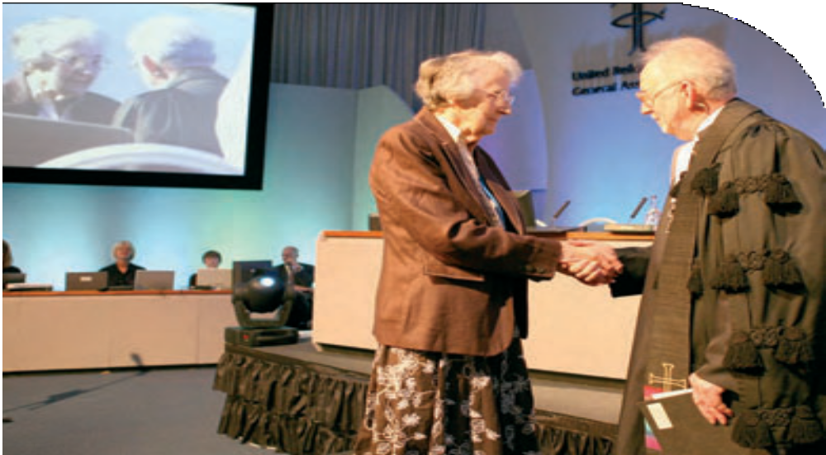


Vision4Life
The Revd Dr Kirsty Thorpe and Revd Paul Snell reported on the progress of the Vision 4Life process.

Mission Committee

Revd Ed Cox presented the report of the Mission Committee, underlining the need for a clear future strategy for the United Reformed Church.

The convener responded to the questions and comments posed.

A series of points for reflection was presented on behalf of the Mission Committee
by the Revd Ed Cox.

Notices
The Convener of the Assembly Arrangements Committee updated Assembly with notices.

The Revd Peter Noble conveyed the thanks of Penarth URC to the Assembly, and in particular to Mr Stuart Dew, for their prayers, concern and messages of sympathy and support following the disappearance of their Minister, the Revd David Fox, while on holiday. The Moderator led the Assembly in prayer.

The Assembly adjourned.

Stuart Dew, press officer

32


Sunday July 13th
General Assembly 2008


Second Session
The Assembly met in groups to reflect on the discussion points from the
Mission Committee.

Children’s Assembly
On return to plenary session the Assembly viewed a DVD film
reporting on the activity of the Children’s Assembly.

Minutes
The Clerk presented the minutes of Friday 11th July, second session, and Saturday 12th July, first and second sessions, and moved that the minutes of Sunday and Monday be inserted in the Record of Assembly after review and any necessary correction by the officers of the assembly. This was agreed.

Ministries
The report of the Ministries Committee was presented by the Convener, the Revd Peter Poulter, who paid tribute to the dedication of the
Revd Christine Craven during her term as Secretary for Ministries. The Moderator led the Assembly in prayer.

In responding to questions and comments, Mr Poulter gave an assurance that synods not involved in the pilot scheme would nonetheless be consulted about the Ministerial Development Scheme. He noted that geographical availability is an important factor in the issuing of Certificates of Eligibility, and that the Committee was conscious of the need to consider ministerial ethics.

Mr Poulter moved adoption of Resolution 23:

Resolution 23 Challenge to the Church
General Assembly:
- believes that each congregation and mission group has a need of its own local leader to work in partnership with the elders’ meeting to challenge, enable and equip the saints and be a focus of Christian presence in the local community; and

- affirms the value of team pastorates in providing pastoral support, encouragement and training for those in local leadership;

- therefore requests synods
  - to identify and quantify the leadership needs of each local situation,
  - make arrangements for the recruitment, training, calling and support of local leaders, and
  - to encourage the development of team pastorates to provide pastoral support, encouragement and training.

33



In discussion:

- ecumenical possibilities should be explored;
- have not synods been doing this all along?
- the timetable is very tight;
- synods have been unable to identify local leadership in many places;
- creative ministry is being hindered by lack of accreditation and financial support;
- we need more theological reflection on the difference between leadership and ministry;
- training for lay church members will be vital – could the URC collaborate with other denominations in this respect?

Resolution 23 was remitted to the Facilitation Group.

The Revd David Bedford moved adoption of Resolution 30:

Resolution30
A fairer and more affordable system for helping ministers, in retirement, with housing
General Assembly accepts the revised guidelines (Appendix 6 page 185) for the provision of Retired Ministers’ Housing and their staged implementation over 10 years from September 2008.

In discussion:

  - some ministers were advised to sell their houses to finance their training and now have no means of purchasing property;
  - people in their late 20’s may be discouraged from candidating for ministry;
  - this should be considered as part of a review of ministerial funding;
  - service of ministry should commence from the time of training;
  - the pastoral care implications of this are disappointing;
  - on what terms would a widow or partner be assisted;

Mr Bedford and Mr Ellis responded.

The Convener stated that the matter of 40 years service eligibility would be re- examined at the September meeting of the Trust.

The Assembly having failed to reach consensus or agreement a vote was taken and
Resolution 30 was carried.

Mr Bedford moved adoption of Resolution 31:

Resolution31
Retired ministers’ housing – synod partnership
General Assembly requests that conversations begin with the synods about possible partnerships in the provision of Retired Ministers’ Housing.

Resolution 31 was carried by consensus.

34 Record of the United Reformed Church General Assembly 2008




Mr Poulter moved adoption of Resolution 29:

Resolution29

Amendments to the Plan for Partnership
General Assembly agrees the following changes to the Plan for Partnership in Ministerial Remuneration.

Deletions are shown in [square brackets] and additions are shown in italics.

[2. Principles of the Plan
  - The whole ministry of the URC is to be made available to the whole of the Church, and the financial responsibility for this ministry is to be shared throughout the whole of the Church. It is recognised that the extent and type of ministry will vary in different situations.
  - Payment to ministers/CRCWs of a basic stipend and other payments provided for by the Plan will be charged to the Ministry and Mission Fund, which will be funded from local church contributions.]

- Principles of the Plan
  - The whole ministry of the United Reformed Church is to be made available to the whole of the Church and the financial responsibility for this ministry is to be shared throughout the whole of the Church.
  - The General Assembly has agreed that the ministers and church related community workers of the Church should be deployed by synods in ways that respond to the many different mission opportunities in different places. There will be no one pattern and the patterns that emerge should not be constrained by the availability of local finance.
  - The complementary commitment of local churches is to contribute to the costs of the whole Church’s ministry according to the congregation’s means. This payment is the first charge on the local church’s income. The contributions of local churches will be paid into the Ministry and Mission Fund, from which the stipend of ministers and CRCWs, and other payments detailed in the Plan, will be drawn.
  - Consistent with this approach to funding ministry, the General Assembly discourages the payment of local stipend supplements.

Sickness Provision
[6.1.2 Payment during sickness: remuneration shall be paid during sickness for such periods and in such sums as shall be determined from time to time by the MoM sub-committee, which will take into account the regulations and benefit schemes of the Department for Work and Pensions (DWP).

      - Ministers/CRCWs who are unable to work because of sickness or accident shall be paid full stipend (less any Incapacity Benefit Long-term or Industrial Injuries Disablement Benefit received) for a period of six months. However, any sickness arising in the twelve months prior to the first day of a new period of illness will be taken into account in the calculation of those six months. At the appropriate times after the beginning of any illness, the MoM sub-committee shall take steps
to determine, in consultation with the synod moderator, what further help, if any, should be given when the entitlement to full stipend comes to an end. Ministers/ CRCWs who are unable to work for more than three days are required to advise the MoM office as soon as possible during their illness in order that the necessary records can be maintained.

Record of the United Reformed Church General Assembly 2008 35

      - Ministers/CRCWs who are sick for periods in excess of twenty eight weeks will claim Incapacity Benefit long-term from the DWP and should notify the MoM Office of the amount of benefit received in order that the next available stipend payment may be reduced.]

    - Payment during sickness: stipend shall be paid during periods of sickness in such sums as shall be determined from time to time by the MoM sub-committee and will take into account the regulations and benefit schemes of the Department for Work and Pensions (DWP).

      - Ministers/CRCWs who are unable to work because of sickness or accident shall be paid full stipend (less any Incapacity Benefit Long-term or Industrial Injuries Disablement Benefit received) for a period of six months. However, any sickness arising in the twelve months prior to the first day of a new period of sickness will
be taken into account in the calculation of those six months. At the appropriate time after the beginning of any sickness, the MoM sub-committee shall determine, in consultation with the synod moderator, what further help, if any, should be given when the entitlement to full stipend comes to an end.

      - Ministers/CRCWs who are unable to work for more than three days because of sickness must advise the MoM Office as soon as possible to ensure that the necessary records can be maintained. The first seven days of sickness may be self certified (by letter, email or telephone) but after that all continuing sickness must be covered by
a doctor’s certificate, ensuring that the date of return to work is advised. If a period of sickness extends for more that twenty eight weeks ministers/CRCWs will be able to claim Incapacity Benefit Long-term from the DWP. Any benefit received when in receipt of full stipend should be advised to the MoM Office for it to be deducted from the next available stipend payment.

Maternity/Adoption/Paternity provisions:
3.3.3 Maternity/Adoption/Paternity provisions: [details of arrangements for parental leave and pay can be obtained from the MoM office] ministers/CRCWs are entitled to statutory pay and leave and full details of the arrangements can be obtained from the MoM office. Although office holders are not entitled to additional maternity/adoption leave and Keeping in Touch (KIT) days, the General Assembly has agreed that these provisions should be extended to ministers/CRCWs.

Broadband provision
6.3.5 Expenses: the local church or other appropriate body shall reimburse the minister/CRCW for the cost of postage, telephone, broadband internet connection, stationery and any other expenses necessarily incurred on church business. This may well include expenses relating to the use of a computer and in some instances the provision of a computer. The reimbursement of expenses will be on the basis of actual cost incurred, and not by a predetermined lump sum.

Resettlement Grants The text will be included when finalized
    - Every stipendiary minister/CRCW, whether full-time or part-time, shall be entitled to a [full] resettlement grant (see Appendix A) upon settling into their first pastorate and each subsequent pastorate or into an appointment paid under the terms of the Plan and upon final retirement; always provided that the settlement involves a change in the place of residence and that the grant shall not be payable more than once in any period of three years.

    - Except at the time of a minister/CRCW’s initial induction (when a full resettlement grant is payable) where the pastorate is part-time the grant shall be pro rata according to the scoping of the pastorate to be served. [A full retirement resettlement grant will be paid to ministers/CRCWs who have completed 10 years

36 Record of the United Reformed Church General Assembly 2008




service up to their retirement. The grant will be reduced pro rata where the minister/CRCW has not been in stipendiary service for 10 years, or the years of service have not been full-time.] Upon retirement the resettlement grant shall be calculated based on the last ten years of service up to age 65 or earlier retirement.
The grant will be reduced pro rata where the minister/CRCW has not been in the stipendiary service of the Church for all of those ten years or those years of service have not all been full-time.

APPENDIX C – REMOVAL COSTS
The receiving local church is responsible for paying the costs of removal (see para 6.3.3). Where the removal is within the United Kingdom reimbursement of up to 50% of the cost incurred (subject to a maximum reimbursement of [£1,000] £1,500) is available from the Ministry and Mission Fund and application should be made via the MoM Office. Where a minister/CRCW is called from abroad reimbursement from that Fund to the local church will be based on the removal costs from the port of entry.

For ministers/CRCWs called to the URC under the Overseas Recruitment programme in conjunction with the Ministries committee, 75% of the cost of removal of themselves, their families, and their baggage from abroad to the pastorate in the UK, up to a maximum of £2,000, will be reimbursed from the Ministry and Mission Fund. A similar reimbursement will be made for their return on termination provided that the period of service has continued for more than three years.

- The Plan for Partnership is a substantial document which sets out the entitlements of ministers and church related community workers, as agreed by past Assemblies. This resolution tidies up some wording, removes any ambiguities and updates the Plan for existing practices.

- Parental leave and Pay
As self-employed office holders, ministers are entitled to receive statutory benefits by virtue of their payment of Class 1 National Insurance Contributions (NICs) deducted from stipend payments. Statutory benefits paid by the Church cover Statutory Sick Pay (SSP), Statutory Maternity Pay (SMP), Statutory Adoption Pay (SAP), Statutory Paternity Pay (SPP). Recent changes in legislation have increased the parental pay which is automatically available to ministers and also extended the leave period attaching to these benefits to 52 weeks. However such additional unpaid leave, beyond the statutory pay period, is not applicable to office holders.

Legislation has also introduced ‘Keeping In Touch’ (KIT) days. This enables women to undertake some paid work during the maternity pay period without losing SMP for that week, up to a maximum of 10 KIT days.

To provide best practice Terms and Conditions of Service, the option of additional unpaid leave and the provision of KIT days will be extended to ministers and CRCWs.

- Revenue and Customs has confirmed that where the broadband internet connection is provided by the employer on the understanding that this is primarily for business purposes with minimal personal use, no taxable benefit will arise.

Resolution 29 was carried by consensus.

Record of the United Reformed Church General Assembly 2008 37

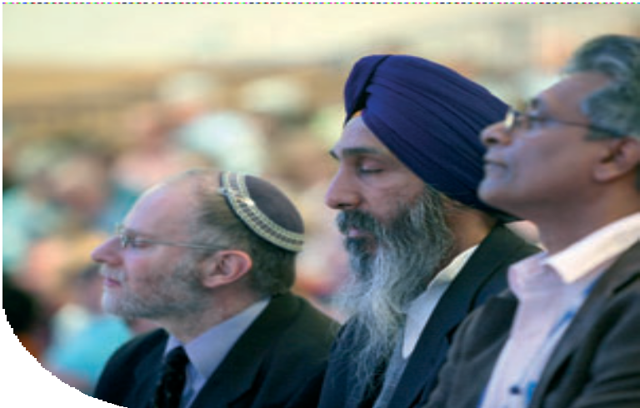

Other Faiths Representatives
Representatives of other faiths were welcomed Rabbi David Rose – Jewish Community
Mr Wege Singh – Sikh Community

Rabbi David Rose responded on behalf of the faiths representatives.

Church Changes
The General Secretary moved adoption of Resolution 17:

Resolution17

Closure of local churches and mission projects
General Assembly receives notice of the closure of the local churches and mission projects listed on page 31 of the Book of Reports and on the Order Paper for Sunday 13th July and gives thanks to God for their worship, witness, and service.

Bishops Lydeard, South Western Synod Castleton United Reformed Church, Rochdale
Claydon Old Chapel Mission Project, Eastern Synod
Falkirk (Pleasance Gardens)
Gorleston United Reformed Church, Eastern Synod
St John’s, Great Chart Methodist/United Reformed Church, Southern Synod North Petherton United Reformed Church, Somerset, South Western Synod St Ninian’s United Reformed Church, Solihull
Worrall Hill United Reformed Church (1884-2008), Forest of Dean Group Whiteley LEP
Ingleby.net
Church of the Holy Family, Killingworth
Trinity United Reformed Church, Harehills Avenue, Leeds Resolution 17 was carried by consensus.
The General Secretary moved adoption of Resolution 17A:
Resolutio1n7a
New Churches and Mission Projects
General Assembly receives the London GaDangme Fellowship as a Mission Project of the United Reformed Church.
Resolution 17a was carried by consensus.

The Moderator welcomed the Revd Sylvanus Tettey and the Revd Edward Sanniez representing the London GaDangme Fellowship, and led the Assembly in prayer.

The Moderator greeted the Moderator of the General Assembly of the Church of Scotland, the Right Revd David Lunan.

The Assembly was adjourned.
38 Record of the United Reformed Church General Assembly 2008

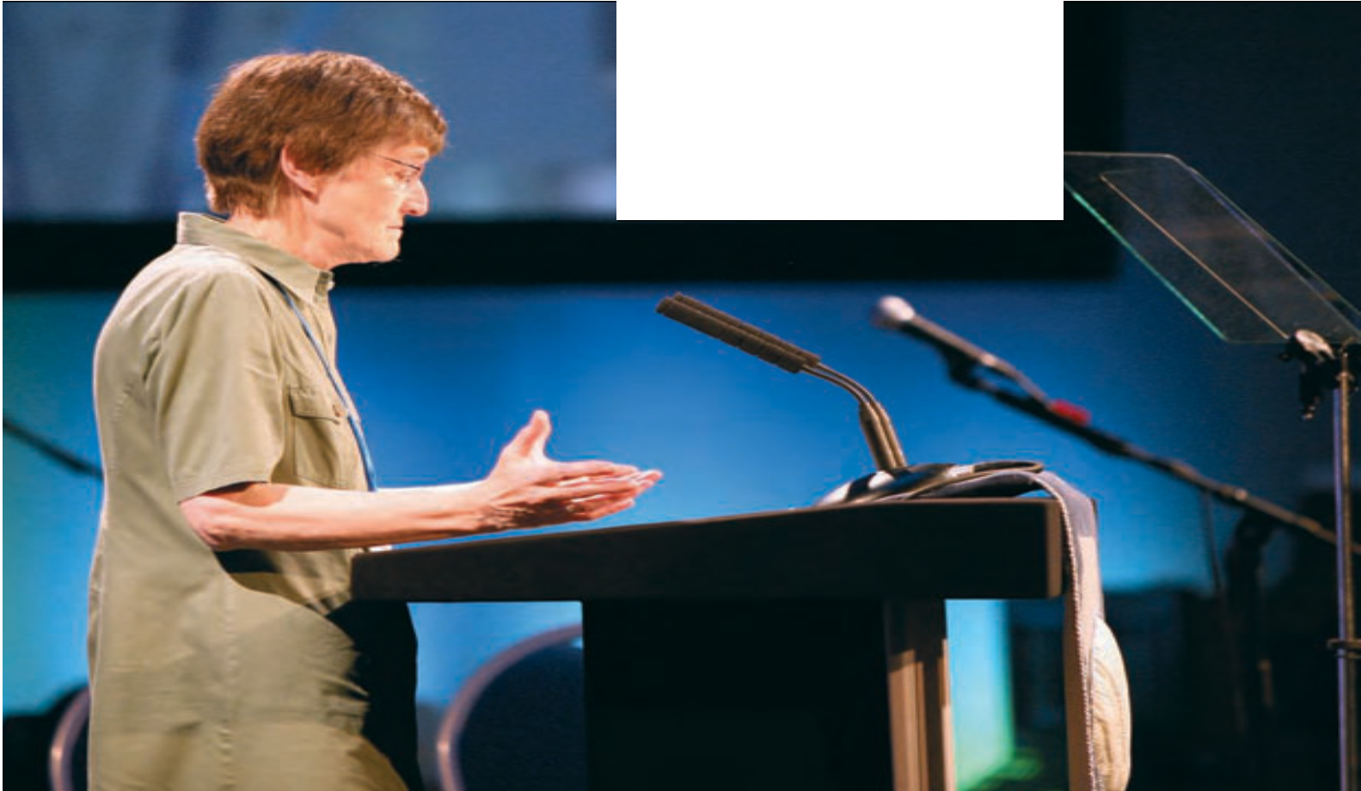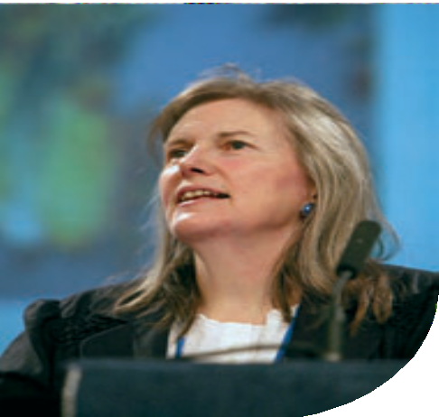Third Session
Sunday July 13th
General Assembly 2008
Moderators of General Assembly 2010-12
Dr Graham Campling, the Convener of Tellers for the election of moderators of the General Assembly, reported that, in the election for a Lay Moderator, 354 votes had been cast, 6 papers had been spoiled, and that Mrs Gwen Valerie Morrison had been duly elected as Lay Moderator of the General Assembly 2010-12; and that, in the election for an ordained Moderator,
361 votes had been cast, 5 papers had been spoiled, and that the Revd Dr Kirsty Elizabeth Thorpe had been duly elected as Ordained Moderator of the General Assembly 2010-12.

Revd Dr Kirsty Thorpe

Mrs Val Morrison

39

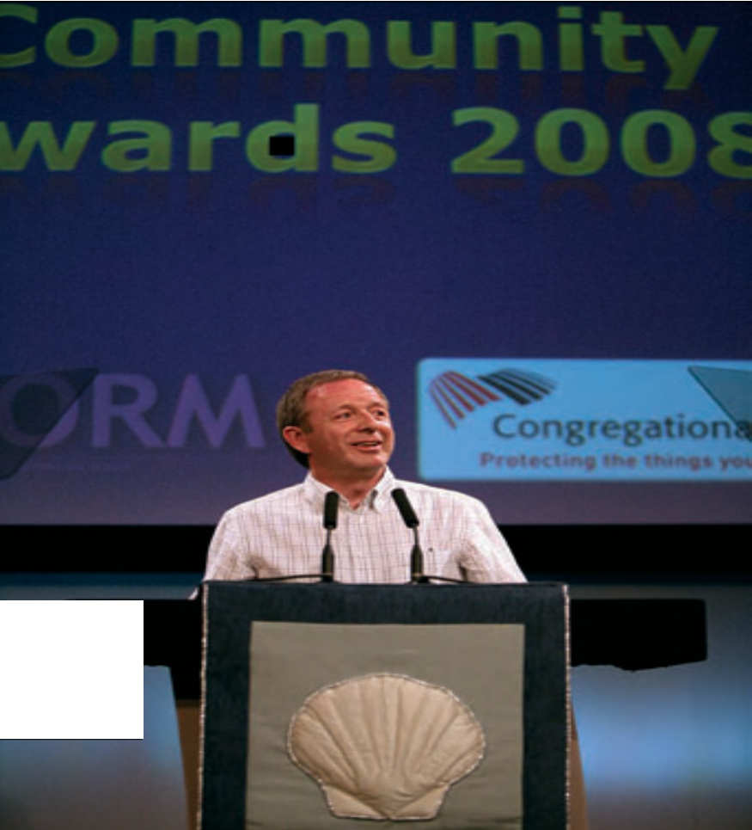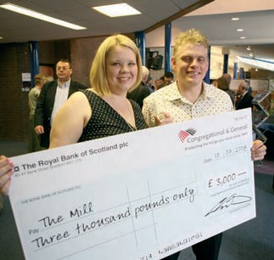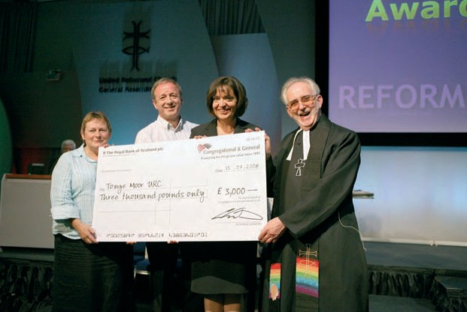Awards
The General Secretary introduced the Congregational and General Community Awards 2008. Awards were presented to The Mill, and to Tonge Children’s Centre.

40



Ministries
Following consultation with the Facilitation Group, the Revd Peter Poulter moved adoption of the amended Resolution 23:

Resolution23

Challenge to the Church
General Assembly:
- believes that each congregation and mission group has a need of its own local leader to work in partnership with the elders’ meeting to challenge, enable and equip the saints and be a focus of Christian presence in the local community; and

- affirms the value of team pastorates in providing pastoral support,
encouragement and training for those in local leadership;

- recognises that congregations and communities may sometimes be best served by ecumenical teams;
- therefore requests synods
  - to identify and quantify the leadership needs of each local situation,
  - make arrangements for the recruitment, training, calling and support of local leaders, and
  - to encourage the development of team pastorates to provide pastoral support, encouragement and training,
  - to explore ecumenical opportunities for sharing ministry and developing, where possible, cross-denominational team pastorates.

Resolution 23 was carried by consensus.

Mr Poulter moved adoption of Resolution 24:

Resolution24
Grievance Procedure for Ministers of Word and Sacraments and Church Related Community Workers
General Assembly approves the Ministerial Grievance Procedure which replaces the current grievance procedure approved by General Assembly 1990.

Resolution 24 was carried by agreement. Mr Andrew Jack and the Revd Ann Jack, Thames North Synod, requested that their dissent be recorded.

Record of the United Reformed Church General Assembly 2008 41


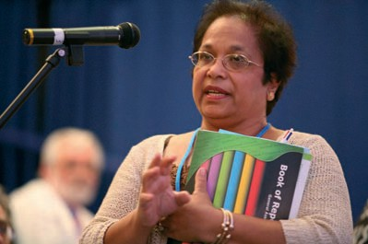
42

Mr Poulter moved adoption of Resolution 25:
Resolution25
Capability Procedure
General Assembly approves the Capability Procedure for ministers of Word and Sacraments and church related community workers.

Resolution 25 was carried by agreement. Mr Andrew Jack and the Revd Ann Jack, Thames North Synod, requested that their dissent be recorded.

Mr Poulter moved adoption of Resolution 26:
Resolution26
Certificates of Limited Service
General Assembly agrees that Certificates of Limited Eligibility should be renamed Certificates for Limited Service.

Resolution 26 was carried by consensus.

Mr Poulter moved adoption of Resolution 27:
Resolution27
Extension of Certificates for Limited Service
General Assembly extends the scope of Certificates of Limited Eligibility (hence to be known as Certificates for Limited Service) to be applied in exceptional cases to fixed termed appointments.

Resolution 27 was carried by consensus.




Mr Poulter moved adoption of Resolution 28:

Resolution 28
United Reformed Church Recognition for lay preachers
General Assembly requests synods to:
- recommend to General Assembly, through the Ministries committee,
the names of those lay preachers who have completed appropriate training
for Assembly Accreditation;
- keep lists of lay preachers who are locally recognised.

In the light of discussion, the Assembly agreed that the Resolution be remitted to the Facilitation Group.

Nominations Committee
The Revd Malcolm Hanson presented the report of the Nominations Committee, and moved adoption of Resolution 35:
Resolution35
Nominations
General Assembly appoints committees and representatives of the Church as set out on pages 77–88 of the Book of Reports subject to additions and corrections contained in the Supplementary Report before Assembly.

Resolution 35 was carried by consensus.

Assembly Boards, Committees and Sub-committees
Notes:
- The Moderator, the Moderators-elect, the immediate past Moderator and the General Secretary are members ex officio of every standing committee.
- Officers and members appointed since Assembly 2007 are indicated by one asterisk (*), two asterisks (**) denotes those whom Assembly 2008 is invited to appoint for the first time (#) indicates a Convener Elect who will become Convener in 2009, the symbol (†) denotes someone who has been invited to extend his/her period of service.
- The number in round brackets following the name indicates the member’s synod:
  - Northern, (2) North Western, (3) Mersey, (4) Yorkshire, (5) East Midlands,
(6) West Midlands, (7) Eastern, (8) South Western, (9) Wessex, (10) Thames North, (11) Southern, (12) Wales, (13) Scotland. This numbering is not shown where it is not relevant.
- The date in square brackets following the name indicates the date of retirement, assuming a full term.
- In accordance with the decision of General Assembly 2000 some nominations are made directly by the National Synods of Wales and Scotland.

Record of the United Reformed Church General Assembly 2008 43

MISSION COUNCIL

Mission Council acts on behalf of General Assembly. It consists of the officers of Assembly, the synod Moderators and three representatives from each synod together with the conveners of Assembly committees.

Northern Synod Revd John Durell, Miss Elaine Colechin, Mr Justice Semuli North Western Synod Revd Rachel Poolman, Ms Marie Trubic, Mr George Grime Mersey Synod Mr Donald Swift, Miss Emma Pugh, (Vacancy)
Yorkshire Synod Mrs Val Morrison, Revd Pauline Calderwood,
Mr Roderick Garthwaite
East Midlands Synod Mrs Irene Wren, Mrs Margaret Gateley, Revd Jane Campbell West Midlands Synod Revd Anthony Howells, Mr Bill Robson, Mrs Adella Pritchard Eastern Synod Mr Mick Barnes, Mrs Joan Turner, (Vacancy)
South Western Synod Revd Roz Harrison, Mrs Janet Gray, Revd Stephen Newell Wessex Synod Mr Peter Pay, Revd Cliff Bembridge, Mrs Margaret Telfer Thames North Synod Mr Simon Fairnington, Revd Maggie Hindley,
Revd David Lawrence
Southern Synod Dr Graham Campling, Mrs Maureen Lawrence, Mr Nigel MacDonald
National Synod of Wales Revd Stuart Jackson, Mrs Liz Tadd, Mrs Barbara Shapland National Synod of Scotland Miss Irene Hudson, Mr Patrick Smyth, Revd John Sanderson

MISSION DEPARTMENT

  - MISSION COMMITTEE
Convener: Revd Ed Cox * [2012]
Deputy Convener: Revd Elizabeth Caswell * [2010] Mrs Chris Eddowes * (1)[2011] Revd Michael Walsh * (2)[2012] Revd Andrew Willett * (3)[2010] Mrs Anne Parker * (4)[2011] Revd Clare Downing * (5)[2012] Revd Louise Franklin * (6)[2010] Revd Peter Ball * (7)[2011] Revd Tracey Lewis * (8)[2012]
Mr Peter Pay * (9)[2010] Mr David Jonathan * (10)[2011] Revd Pauline Sparks * (11)[2012] Revd Simon Walkling * (12)[2010] (Vacancy) (13)[2011]

    - FAITH AND ORDER REFERENCE GROUP
Convener: Revd Dr Robert Pope **[2012]
Secretary: The Secretary for Ecumenical Relations and Faith and Order Revd Dr Susan Durber ** [2012] Revd Fleur Houston ** [2012] Revd Dr Michael Jagessar ** [2014] Revd Dr Sarah Hall ** [2014]
Revd Dr Neil Messer ** [2014] Revd Dr John Bradbury ** [2012]

    - INTERNATIONAL EXCHANGE REFERENCE GROUP
Convener: Revd Linda Elliott [2011]
Secretary: Secretary for World Church Relations
Revd Nigel Uden [2010] Dr Pamela Cressey [2010]

    - COMMITMENT FOR LIFE GROUP
Convener: Mrs Melanie Frew

    - METHODIST/URC INTERFAITH REFERENCE GROUP
Group membership to be decided.

44 Record of the United Reformed Church General Assembly 2008



MINISTRIES OF THE CHURCH DEPARTMENT

  - MINISTRIES COMMITTEE Convener: Revd Peter Poulter [2010] Secretary: Secretary for Ministries
Revd Alan Evans (4)[2009] Mrs Joanna Morling (8)[2009]
Dr Roger Allen (3)[2010] Mrs Helen Renner (3)[2011] Revd Ruth Whitehead (7)[2011] Revd Yolande Burns ** (2)[2012] Convener of Assessment Board

    - MINISTRIES – Accreditation Sub-Committee
Convener: Revd Gwen Collins [2009] #Revd Geoffrey Townsend** [2013] Secretary: Secretary for Ministries
Revd Howard Sharp (3)[2009] Mr Simon Rowntree (6)[2009]
Mr Rod Morrison (4)[2009] Mrs Pat Evans (4)[2010] Revd Sue Henderson (11)[2011]

    - MINISTRIES – CRCW Programme Sub-Committee
Convener: Revd Paul Whittle [2012] Secretaries: The CRCW Development Workers
Mrs Maureen Thompson (6)[2009] Mrs Shirley Rawnsley (4)[2010] Revd Helen Pope (6)[2011] Revd Susan MacBeth ** (4)[2012] Ms Cristine Smalligan ** (10)[2012] Ms Janine Atkinson ** (8) [2012]

    - MINISTRIES – Leadership in Worship Sub Committee
Convener and Assembly Lay Preaching Advocate: Mrs Jan Harper [2011]
Mr Ed Strachan (2)[2011] Revd Gwynfor Evans (3)[2011] Mr Alan Cotgreave (6)[2011]

    - MINISTRIES – Maintenance of Ministry Sub-Committee
Convener: Revd Geoffrey Roper [2009] #Revd Dr Anthony Haws ** [2013]
Mr Brian Knight (8)[2010] Revd Ken Summers (3)[2010]
Mrs Jane Mackerness (4)[2011] Miss Margaret Atkinson ** (4)[2012] Revd Catey Morrison ** (1)[2012] The Treasurer
Convener of Pensions Executive

    - MINISTRIES – Retired Ministers Housing Sub-Committee
Convener: Revd David Bedford [2010]
Secretary: Secretary Retired Ministers Housing Society Ltd
Mrs Liz Tadd (12)[2009] Revd Michael Spencer (6)[2011] Revd Nanette Lewis-Head (12)[2012] Revd John Humphreys ** (13)[2013] The Treasurer
Note: Properties are managed by a Company viz: RETIRED MINISTERS HOUSING SOCIETY LTD. Details of the Members of the Board etc may be obtained from the Secretary, Mr Tony Bayley, at Church House

    - ASSESSMENT BOARD
Convener: Prof David Cutler [2009] #Dr Graham Campling ** [2014] Retiring 2009 Mrs Tina Ashitey (10), Dr Peter Clarke (4), Mr Hugh Abel (9) Retiring 2010 Revd David A L Jenkins (10), Revd Dr Irene John (13),
Revd Edward Sanniez (10), Revd Lesley Charlton (11)
Retiring 2011 Revd Wilf Bahadur(9), Revd Jan Adamson (13), Revd Sian Collins (12), Mrs Wendy Smith (2)
Retiring 2012 Mr Geoffrey Harrison (3), Mr James Horton (4), Mrs Margaret Jenkins (2), Revd Janet Maxwell (1), Revd William Young (6)
Retiring 2013 Mrs Irene Wren ** (5), Revd Lis Mullen ** (2), Revd Gary McGowan ** (3), Revd Val Towler ** (1)

Record of the United Reformed Church General Assembly 2008 45

  - DISCIPLINARY PROCESS – Commission Panel
Convener: Mrs Helen Brown [2009] #Miss Kathleen Cross [2014]
Deputy Convener: Miss Kathleen Cross Secretary: Mrs Wilma Frew [2011] Members:
Retiring 2009 Revd Wendy Baskett (8), Revd David Bedford (1), Revd James Bolton (5), Revd James Brown (6), Mr Peter Jolly (9), Mrs Barbara Lancaster (2),
Mrs Barbara Madge (8), Revd Nicholas Mark (5), Revd Sandra Pickard (8), Revd Shelagh Pollard (12), Mrs Lynne Upsdell (9), Ms Elizabeth Whitten (7) Revd Joan Winterbottom (6), Mr Kenneth Woods (7)
Retiring 2010 Revd Meryl Court (10), Mr Derek Craig (3), Mr David Eldridge (10),
Revd Nanette Lewis-Head (12), Dr Fiona Liddell (12), Dr Jim Merrilees (13), Mrs Pamela Sharp (3), Mr Patrick Smyth (13)
Retiring 2011 Mr Geoffrey Milnes (5), Revd David Pattie (13), Mr Neil Robinson (4), Revd Yvonne Stone (5)
Retiring 2012 Revd Nicholas Adlem (8), Miss Ina Barker (4), Revd Kay Cattell (5),
Revd Kenneth Chippindale (6), Miss Kathleen Cross (2), Revd Alison Davis (12), Revd John Du Bois (11), Revd Joan Grindrod-Helmn (1),
Mrs Jessica Hannen (1), Miss Judith Haughton (2),
Miss Elizabeth Lawson QC (10), Revd Julian Macro (9), Revd Colin Offor (1), Mr Nicholas Pye (3), Revd Raymond Singh (11), Revd Carolyn Smyth (13), Revd Prof David Thompson (7), Mr David Westwood (4)
Retiring 2013 Revd Pauline Calderwood ** (4), Revd Bill Bowman ** (11), Dr Peter Campbell Smith ** (11), Mr Roger Tucker ** (9)

  - EDUCATION AND LEARNING
Convener: Professor Malcolm Johnson [2011] Secretary: The Secretary for Education and Learning
Revd Dr John Campbell (2)[2009] Mr John Saunders (8)[2009] Revd John Smith (13)[2010] Revd Ruth Allen (3)[2010]
Mr Clive Parsons (6)[2010] Revd Dr Robert Pope (12)[2011] Revd Jennifer Snashall ** (11) [2012] Revd Dr James Coleman ** (4)[2012] Mrs Fiona Smith ** (4)[2012]

    - WINDERMERE ADVISORY GROUP
Convener: Revd Bernard Collins [2009] #Revd Dr Jan Berry [2013]
Secretary: The Director of the Windermere Centre
Revd Carole Gotham (2)[2009] Dr Tony Jeans ** (6)[2012] Convener of Windermere Management Committee Representative of Carver URC

  - YOUTH AND CHILDREN’S WORK Convener: Revd Neil Thorogood [2010] Secretary: The Secretary for Youth Work
Revd Sian Collins (12)[2009] Revd Robert Weston (9)[2009] Miss Rosemary Simmons (5)[2009] Mrs Rita Griffiths (3)[2009] Revd Heather Whyte (6)[2010] Mrs Anthea Coates (8)[2011]
Mr Chris Gill (11)[2011] Mr Matthew Franks * (8)[2011] Mrs Memona Shahbaz ** [2012] Revd Stuart Radcliffe ** (2)[2012] FURY Chair FURY Council Member

    - PILOTS MANAGEMENT Sub Committee
Convener: Revd David Downing [2011] Member: Mrs Denise Beckley [2010]
[Other members of the sub-committee are appointed by the Youth and Children’s
Work Committee. The Congregational Federation also has two representatives.]

46 Record of the United Reformed Church General Assembly 2008



ADMINISTRATION AND RESOURCES DEPARTMENT

  - ASSEMBLY ARRANGEMENTS Convener: Dr David Robinson [2012] Secretary: Ann Barton
Synod Representative for forthcoming Assembly
Synod Representative for previous Assembly who is then replaced after ‘review’ meeting by Synod Representative for Assembly two years hence.
Moderator, Moderator(s)-elect, General Secretary, Clerk to Assembly

    - TELLERS AT ASSEMBLY 2008 FOR THE ELECTION OF THE GENERAL ASSEMBLY MODERATORS FOR 2010
Dr Graham Campling [Convener], Dr Jim Merrilees, Revd John Durrell

  - COMMUNICATIONS and EDITORIAL Convener: Revd Dr Kirsty Thorpe [2011] Secretary: Director of Communications
Mrs Valerie Jenkins (4)[2009] Ms Catherine Lewis-Smith (4)[2009]
Mr Ron Sweeney (4)[2009] Mr Richard Lathaen (3)[2009]
Mrs Esther Searle (8)[2011] Ms Lucy Berry ** (10)[2012] Mr Andy Littlejohns ** (11)[2012] Mr Justin Brierley ** (11)[2012] Mr Stanley Hazell ** (8)[2012]

  - EQUAL OPPORTUNITIES Convener: Ms Morag McLintock [2010] Secretary: Revd David Coleman ** [2012]
Revd Kate Gartside (12)[2009] Revd John Macaulay (10)[2010]
Revd Pam Ward (1)[2010] Mr Jim Hurst (2)[2010]
Ms Mary Jeremiah ** (12)[2012] Revd Barbara Exley (11) ** [2012]

  - FINANCE
Convener: The Treasurer
Chief Finance Officer: Mr Andrew Grimwade
Revd Dick Gray (8)[2009] Mr Graham Morris (3)[2009]
Mr John Kidd (11)[2009] Revd Kathryn Taylor (8)[2010]
Mrs Jane Humphreys (7)[2011] Mr Brian Hosier (10)[2011] Revd David Walton ** (13)[2012] (Vacancy) ** [2012] Chairman of the Trustees

    - STEWARDSHIP Sub-Committee
The members of this sub-committee are appointed by the Finance Committee.

  - NOMINATIONS COMMITTEE Convener: Revd Malcolm Hanson [2010] Secretary: Revd Elizabeth Brown [2009] Secretary-Elect: Miss Sarah Dodds ** [2013] Synod Representatives:
Revd Val Towler * (1) Revd Chris Weddle * (2) Mr Chris Maple * (3) Mrs Val Morrison (4) Mr Duncan Smith * (5) Dr Anthony Jeans (6) Mr Mick Barnes * (7) Revd Roz Harrison (8) Mr Peter Pay (9)
Mr Simon Fairnington * (10) Dr Graham Campling (11) Dr Jean Silvan-Evans (12) Dr James Merrilees (13)
with the Immediate Past Moderator and the General Secretary.

Record of the United Reformed Church General Assembly 2008 47

    - PANEL FOR THE APPOINTMENT AND REVIEW OF THE SYNOD MODERATORS, THE GENERAL SECRETARY AND THE DEPUTY GENERAL SECRETARY
Retiring 2010 Revd Craig Bowman (8), Mrs Irene Wren (5), Mr Okeke Azu Okeke (11),
Revd Dr Susan Durber (7), Mr Ron Todd (1)
Retiring 2011 Dr Graham Campling (11), Mrs Janet Gray(8), Revd Cecil White (7), Revd Mary Buchanan (13), Mrs Helen Brown (3),
Revd Nanette Lewis-Head (12)
Retiring 2012 Revd Raymond Singh (11), Revd Lesley Charlton (11), Mrs Sally Abbott (10) Mr Simon Rowntree (6), Dr Jean Silvan Evans (12), Mr Alun Jones (4)
Retiring 2013 Revd John Durell ** (1), Revd Roz Harrison ** (8),
Revd John Oldershaw ** (3), Revd Deborah McVey ** (7), Revd Robert Street ** (9), Mrs Susan Wilkinson ** (2), Mrs Carol Dixon ** (1)

  - PASTORAL REFERENCE COMMITTEE Convener: Revd Alasdair Pratt [2011] Secretary: Deputy General Secretary
Mrs Margaret Carrick Smith (9)[2009] Mrs Delyth Rees (12)[2011] Revd Adrian Bulley (9)[2011] Revd Birgit Ewald ** (7)[2012] [ex officio: The Treasurer The General Secretary The Secretary for Welfare]

    - STANDING PANEL FOR THE INCAPACITY PROCEDURE
Secretary: Revd Arnold Harrison ** [2012]
Members: Revd Bill Mahood ** [2012] Revd Rowena Francis ** [2013] Mr Donald Swift ** [2013] Dr Gillian Patterson ** [2013}

  - UNITED REFORMED CHURCH TRUST
Chairman: Mr Alan Small Secretary: Mr Eric Chilton (Acting) Trustees:
Miss Joyce Bain (13)[2010] Mr Ernest Gudgeon (8)[2010]
Dr Brian Woodhall (2)[2010] Mr John Ellis (11)[2011]
Dr Augur Pearce (12)[2012] Mr Alan Small (3)[2012]
Revd Prof David Thompson (7)[2012] Miss Rachel Greening (6)[2014] Dr David Robinson (4)[2014] Mr John Woodman (7)[2014]
Mission Council Appointed Trustees: Mrs Val Morrison [2012]
Miss Isobel Simmons * [2010] Mrs Claudette Binns * [2014]
Co-opted Trustee: Revd Michael J Davies [2010] [ex officio: Moderator of General Assembly, General Secretary,
Deputy General Secretary]

  - THE UNITED REFORMED CHURCH MINISTERS’ PENSION TRUST LTD BOARD MEMBERS
Chairman: Mr Brian Moere
Secretary: Revd Michael Davies (Acting)
Members of URC: Mr Michael Goldsmith [2009] Mr Andrew Perkins [2011]
Revd Dr John Dyce ** [2013] Revd Rowena Francis ** [2013] Members of Fund: Revd Graham Spicer [2009] Revd Duncan Wilson **[2012]
Revd David Bedford **[2012] (Vacancy) ** [2013] [ex officio: Honorary Treasurer, Convener Investment Committee, Convener Maintenance of Ministry Sub-Committee, Convener Pensions Executive]

  - PENSIONS EXECUTIVE Convener: Mr Maurice Dyson [2010] Secretary: Mrs Judy Stockings
Members: Revd Kathryn Taylor † [2012] (Vacancy) ** [2012]

48 Record of the United Reformed Church General Assembly 2008



[Ex officio: Convener of Maintenance of Ministry Sub-Committee, Honorary Treasurer]
The Pensions Executive reports to the United Reformed Church Ministers’ Pensions Trust Board, the Maintenance of Ministry Sub Committee and to the Finance Committee.

REPRESENTATIVES of the UNITED REFORMED CHURCH to MEETINGS of SISTER CHURCHES
Presbyterian Church in Ireland Revd Prof Stephen Orchard
General Synod of Church of England Revd Graham Maskery
Methodist Conference Revd Jason Askew
Congregational Federation To be decided
General Assembly of Church of Scotland [note 5] Revd Prof Stephen Orchard,
Revd Lucy Brierley, Revd Mitchell Bunting,
United Free Church of Scotland [note 5] Revd John Humphreys Scottish Episcopal Church [note 5] Revd Mitchell Bunting
Methodist Church in Scotland [note 5] Revd John Humphreys
Baptist Union of Scotland [note 5] To be decided
Presbyterian Church of Wales [note 5] Revd Stuart Jackson
Union of Welsh Independents [note 5] Revd Keith Jones Church in Wales Governing Board [note 5] Revd Stuart Jackson Provincial Synod of the Moravian Church Revd David Bunney

REPRESENTATIVES OF THE UNITED REFORMED CHURCH ON ECUMENICAL CHURCH BODIES
The following have been nominated as URC representatives at the major gatherings of the Ecumenical Bodies listed.
Note: A list of representatives to other ecumenical bodies, commissions and committees, co-ordinating groups and agencies, who are appointed by the relevant committees, will be distributed to all members of General Assembly. Additional copies are available, on request, from the Secretary for Ecumenical Relations and Faith and Order.

  - Council for World Mission (CWM) from Assembly 2006
Revd David Coleman, Mrs Ann Shillaker, Ms Catherine Lewis-Smith (CWM Trustee). Secretary for World Church Relations

    - CWM European Region Meeting 2005-08
Revd David Coleman, Mrs Ann Shillaker, Ms Catherine Lewis-Smith, Secretary for World Church Relations, Deputy General Secretary (CWM Europe Trustee)

  - World Alliance of Reformed Churches (WARC) General Council
Revd Dr Sarah Hall, Ms Emma Pugh, Revd Dr David Pickering, Secretary for World Church Relations, General Secretary

  - Churches Together in Britain and Ireland (CTBI) Church Leaders’ Meeting
General Secretary

    - CTBI Senior Representatives’ Forum
General Secretary, Secretary for Ecumenical Relations and Faith and Order

Record of the United Reformed Church General Assembly 2008 49

    - CTBI Environmental Issues Network
Revd David Coaker, Revd Dr David Pickering

    - CTBI Church and Society Forum
Mr Simon Loveitt, Secretary for Church and Society

    - CTBI Churches’ Criminal Justice Forum
Mrs Wilma Frew

    - CTBI Consultative Group on Ministry amongst Children (CGMC)
Mrs Karen Bulley (Moderator), Ms Jo Williams

  - Churches Together in England (CTE) – from Forum 2006
Miss Alison Micklem, Revd Peter Poulter, Revd Andrew Prasad, Mrs Helen Renner, Revd Elizabeth Nash, Mrs Wilma Frew, Mr Stuart Dew, Mr John Brown, Dr Suzanne McDonald General Secretary, Secretary for Ecumenical Relations and Faith and Order

    - CTE – Enabling Group
Secretary for Ecumenical Relations and Faith and Order

    - CTE – Coordinating Group for Local Unity
Revd Terry Oakley
Secretary for Ecumenical Relations and Faith and Order

    - CTE – Churches Together for Healing
Revd Delia Bond, Revd Deborah McVey

    - CTE – Women’s Coordinating Group
Revd Samantha White

    - CTE – Churches’ Committee on Funerals and Crematoria
Revd Delia Bond, Revd Sally Thomas

    - CTE – Free Churches’ Education Committee
Mr Graham Handscomb, Mrs Gillian Kingston

    - CTE – Churches’ Joint Education Policy Committee
Mr Graham Handscomb

  - Action of Churches Together in Scotland (ACTS) Forum [see note 5] Revd John Humphreys, Revd Mitchell Bunting (alternate Revd Sue Kirkbride)

  - National Sponsoring Body for Scotland [see note 5] Revd John Humphreys, Revd Mitchell Bunting

  - Churches Together in Wales (CYTUN) [see note 5] Revd Peter Noble

    - Commission of Covenanted Churches [see note 5] Revd Peter Noble, Revd Stuart Jackson, Mrs Ann Shillaker

  - Free Church Council for Wales [see note 5] Revd Peter Noble, Revd Stuart Jackson

50 Record of the United Reformed Church General Assembly 2008



UNITED REFORMED CHURCH REPRESENTATIVES AT FORMAL BI-LATERAL AND MULTI-LATERAL COMMITTEES

  - Methodist/United Reformed Church Liaison Committee
Revd Kay Alberg, Miss Emma Pugh, (Vacancy), (Vacancy), Revd Peter Rand (co-opted)
Secretary for Ecumenical Relations and Faith and Order

  - Roman Catholic – United Reformed Church Bilateral Dialogue Revd Prof David Thompson, Revd Dr John Bradbury, Revd Dr Sarah Hall, Mrs Ann Shillaker, Mr Malcolm Townsend
Secretary for Ecumenical Relations and Faith and Order

  - Church of England – United Reformed Church Bilateral Dialogue (“God’s Reign and our Unity”)
Revd Elizabeth Welch, Revd Dr David Peel
Secretary for Ecumenical Relations and Faith and Order

  - Anglican/Moravian Contact Group
Revd David Tatem

  - Tri-lateral Conversation of the Scottish Episcopal Church, the Methodist Church and the United Reformed Church
Revd John Humphreys, Revd Mary Buchanan, Revd John Young

URC REPRESENTATIVES ON GOVERNING BODIES OF THEOLOGICAL COLLEGES, ETC.

  - Mansfield College:
Ministerial and Educational Training Committee:
Revd Fiona Thomas [2009], Revd Nigel Appleton [2010], Convener of the Education and Learning Committee, Secretary for Education and Learning

  - Northern College
Secretary for Education and Learning, Revd David Jenkins [2009],
Mr Bill McLaughin [2009], Miss Margaret Atkinson [2011], Mrs Helen Brown [2011], Revd Dr Robert Pope [2011], Luther King House Educational Trust,
Secretary for Education and Learning

  - Westminster College: Board of Governors
Convener: Professor Sir Anthony Bottoms [2014]
Clerk: Revd Cecil White [2012], Revd Craig Muir [2009], Mr John Kidd [2009], Mr Brian Long [2010], Revd Fleur Houston [2010], Dr Jean Stevenson [2013], Secretary for Education and Learning

    - Cheshunt Foundation
Mr David Butler [2010], Revd Craig Muir ** [2011]

    - Cambridge Theological Federation
Convener Westminster College Governors

  - Homerton College Trustees
Lady Sally Williams [2010], Revd Dr David Thompson † [2011], Mr John Chaplin [2009], Mrs Elisabeth Jupp [2010]

  - The Queen’s Foundation
Revd Elizabeth Welch, Mr Simon Rowntree, Secretary for Education and Learning in attendance

Record of the United Reformed Church General Assembly 2008 51

GOVERNORS OF COLLEGES AND SCHOOLS WITH WHICH THE URC IS ASSOCIATED
  - Caterham School Revd Nigel Uden [2011]

  - Eltham College Revd Terry Sparks [2011]

  - Walthamstow Hall Mrs Isabel Heald *[2011]

  - Milton Mount Foundation Mr Graham Rolfe † [2011]
Mr Brian West † [2011]
Revd Nicola Furley-Smith † [2011] Ms Hilary Miles [2010]
Revd David Cuckson † [2010]

  - Silcoates School Prof Clyde Binfield [2011]
Dr Peter Clarke [2009]
Dr Moira Gallagher [2009] Mrs Val Morrison [2010] Revd Alan F T Evans [2010] Mrs Valerie Jenkins † [2010]

  - Taunton School Revd David Grosch-Miller

  - Wentworth College Revd Martin Ambler [2011]

  - Bishops Stortford College Mr Anthony Trigg [2011]

MISCELLANEOUS
The URC is represented on a variety of other national organisations and committees as follows:

Arthur Rank Centre Revd David Herbert ** [April 2011]

Churches Legislative Advisory Service General Secretary
Mrs Janet Knott Mrs Sheila Duncan Mr Hartley Oldham
Congregational Fund Board Revd Margaret Taylor † [2012] Revd Eric Allen † [2012]
Mr Anthony Bayley [2011] Revd David Helyar [2011] Revd Geoffrey Roper [2011]

Congregational Memorial Hall Trust Mr Hartley Oldham
Mr Graham Stacy Dr John Thompson Dr Elaine Kaye
Dr Brian Woodhall
Revd Derek Wales * [2011]

Discipleship and Witness
Board of Trustees Mrs Patricia Hubbard Publications Development Group Ms Jo Williams

English Heritage’s Places of Worship Forum
Mr Hartley Oldham (as Convener of the Listed Buildings Advisory Group)

52 Record of the United Reformed Church General Assembly 2008

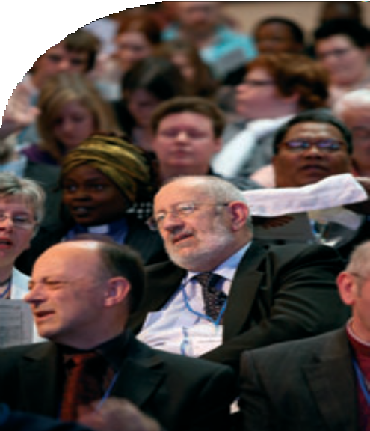Guides’ Religious Advisory Panel Mrs Susan Walker

Retired Ministers’ and Widows’ Fund Mr Ken Meekison
Mrs Jill Strong Revd Julian Macro

Samuel Robinson’s Charities Mr Tony Alderman

Scouts’ Religious Advisory Group Revd David Marshall-Jones

United Reformed Church History Society
Mrs Mary Davies, Revd Michael Hopkins, Revd Dr Kirsty Thorpe, Revd Prof David Thompson, Dr David Robinson [2011]

Wharton Trust Dr John Thompson [2009]

Record of the United Reformed Church General Assembly 2008 53

Mr Hanson paid tribute to the work of the Revd Liz Brown as Secretary of the Nominations Committee, who will retire from the post before the Assembly next meets.

The Assembly Clerk outlined the proposed process for the appointment of General Secretaries, and moved adoption of Resolution 47:

Resolution47

Appointment of General Secretaries
Proposed Amendment to the Rules of Procedure

- General Assembly agrees to amend the Rules of Procedure by replacing paragraph 4.2 with the following:

The group to appoint or review the General Secretary or Deputy General Secretary shall consist of the Moderators of the General Assembly (one of whom shall act as Convener), the Clerk of the General Assembly (who shall act as Secretary), three Conveners of the Assembly standing committees, and six members of the Appointment and Review Panel selected by the Nominations Committee. This group shall have the authority to make a nomination for the appointment or reappointment of a General Secretary or a Deputy General Secretary. That nomination shall be brought to the next General Assembly or Mission Council for agreement.

- General Assembly resolves that the remit of the Panel for the Appointment and Review of Synod Moderators be extended to include the appointment and review of the General Secretary and the Deputy General Secretary.

Resolution 47 was carried by consensus.

Finance
The Honorary Treasurer, Mr John Ellis, presented the report of the Finance Committee, and moved adoption of Resolution 20:
Resolution20
Trustees’ Report and Accounts
General Assembly receives the Trustees’ Report and adopts the Annual Accounts for the year ended 31st December 2007.

A vote was taken, and Resolution 20 was carried. Mr Ellis moved adoption of Resolution 21:

54 Record of the United Reformed Church General Assembly 2008


Resolution21
Appointment of Auditors
General Assembly resolves that PricewaterhouseCoopers LLP be appointed auditors of the United Reformed Church, to hold office until the conclusion of the next meeting at which accounts are laid before the Assembly, or the AGM of the URC Trust, and that their remuneration be fixed by the Finance committee.

Following brief discussion, a vote was taken, and Resolution 21 was carried. Mr Ellis moved adoption of Resolution 22:
Resolution22
Giving to the Ministry and Mission Fund
General Assembly gives gratitude to God for the giving of local churches to the Ministry and Mission Fund and expresses its thanks to all those who have made this possible.

Resolution 22 was carried by consensus.

Mr Alan Small, Chair of the URC Trust, moved adoption of Resolution 55:
Resolution55
Registration of Assets held for Charitable Purposes of Local Churches
General Assembly receives and approves the Documents entitled “The United Reformed Church Approved Document for Registration of Assets Held for Charitable Purposes of United Reformed Church Local Churches” and authorises them to be used by Local Churches when registering with the Charity Commission.

Mr Small responded to a number of questions; a vote was taken and Resolution 55
was carried.

Mr Small moved adoption of Resolution 46:
Resolution46
Trusteeship of the Charitable Funds of Westminster College
General Assembly resolves that those Governors of Westminster College, who are eligible to serve as Charity Trustees and are members of the United Reformed Church, should become the Trustees of the charitable funds of the College.

Record of the United Reformed Church General Assembly 2008 55

A vote was taken and Resolution 46 was carried.

Prof Malcolm Johnson moved adoption of Resolution 54:

Resolution54

Westminster College Honorary Treasurer
General Assembly agrees to amend the provisions for the Governors of Westminster College as approved by the Assembly of 1996 to read.

      - There shall be a Board of Governors for the College appointed
by the General Assembly, consisting of fifteen members as follows:

        - A Convener, chosen for that purpose

        - a clerk or secretary, to the Board, chosen for the purpose,

        - eight other persons, of whom at least two shall have expertise in management, finance and the administration of buildings, two shall have expertise in education, and two shall have ministerial experience;

        - the Principal of the College ex officio;

        - a member of the teaching staff of the College, chosen by them,

        - a student member of the College, chosen by the students;

        - the Chair of the Cheshunt Governors ex officio

        - an Honorary Treasurer

2.2.2.3 The nomination of Governors in classes (a), (b) (c) and (h) shall be made by the Nominations Committee of the General Assembly.

A vote was taken, and Resolution 54 was carried.

Education and Learning
The Report of the Education and Learning Committee was presented by the Convener, Prof Malcolm Johnson. He paid tribute the Revd Roy Lowes for his work in training and education.

Prof Johnson responded to a number of questions. Prof Johnson moved adoption of Resolution 49:

56 Record of the United Reformed Church General Assembly 2008


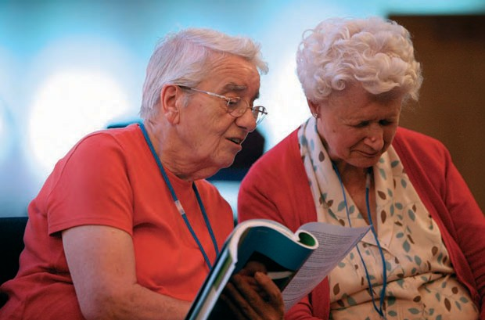
Record of the United Reformed Church General Assembly 2008 57
57


Resolution49
Amendments to Structure: Membership of Assembly
General Assembly Resolves to amend the Structure of the United Reformed Church paragraph 2(5)(f) to read

A staff representative and a student representative being members of the URC, from each of such theological colleges as the General Assembly has designated as resource centres for learning, and a staff representative and a student representative being members of the URC, from such
other colleges or centres as shall from time to time be designated by the Education and Learning Committee as engaged in significant training for the United Reformed Church.

and to add a new paragraph 2(5) (o) to read

The Chair of the United Reformed Church Trust

A vote was taken, and Resolution 49 was carried by the required two thirds majority.

The General Secretary moved that, in accordance with Paragraph 3(1) of the Structure, Resolution 49 be referred to Synods with the 31st March 2009 as the final date for responses to the General Secretary as to whether or not this constitutional amendment be proceeded with.

The Assembly agreed.

The Session was closed in prayer led by the Chaplain.

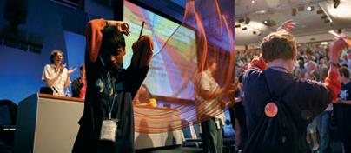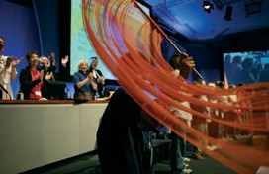

58 Record of the United Reformed Church General Assembly 2008

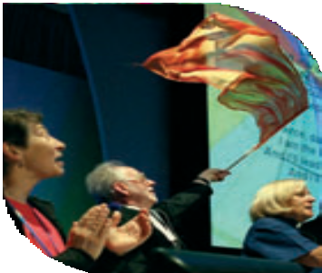Last Session
Monday July 14th
General Assembly 2008

Opening worship was led by the Chaplain and included the induction of the Revd Dr Michael Jagessar as Secretary for Racial Justice and Multicultural Ministry and the Revd Craig Bowman as Secretary for Ministries.

Energy4Life
The Revd Terry Oakley gave notice of the planned inter-Assembly
celebration in July 2009.

Children’s Assembly
The Assembly received a presentation from the Children’s Assembly.

Synod Moderators
The Revd Peter Noble presented the report of the Synod Moderators.

The Moderator greeted those Synod Moderators who had been appointed or re-appointed since the
last meeting of the Assembly, those Synod Moderators who had completed their terms of service, and Dr Ivan Andrews, retiring Youth and Children’s Work Trainer.

Mission Committee
The Convener, the Revd Ed Cox, reported on the discussion held in Group Sessions.

Assembly Arrangements Committee
The report of the Assembly Arrangements Committee was presented by the Convener, Mr William McVey.

Mr McVey moved adoption of Resolution 18:

Resolution18

General Assembly 2010
Assembly agrees that the General Assembly in 2010 will meet at Loughborough University from 2nd to 6th July.

Resolution 18 was carried by consensus.

59



The Clerk moved adoption of Resolution 58:
Resolution58
Appointment of Minute Secretary
Assembly appoints Mrs Irene Wren to act as Minute Secretary to Mission Council and Assembly from July 2008 until December 31st 2011.

Resolution 58 was carried by consensus.
The Moderator greeted the retiring Minute Secretary, the Revd Kenneth Forbes. The Clerk moved adoption of Resolution 53:

Resolution53

Changes to the Rules of Procedure
General Assembly resolves to amend the Rules of Procedure to read: Rules of Procedure for the conduct of the United Reformed Church
- General Assembly

  - The Assembly shall meet at least once in every alternate year.
The scheduled meeting in each such year, the place and dates of which shall be determined by a preceding Assembly, shall be the Ordinary Meeting of the Assembly. At the completion of the business of the Ordinary Meeting
of the Assembly, the Assembly is adjourned. The members of Assembly at any time between Ordinary Meetings of the Assembly remain those who were included on the Roll of Assembly at the constitution of the immediately preceding Ordinary Meeting of the Assembly. Any meeting of the Assembly other than the Ordinary Meeting shall be a special meeting.

  - A special meeting of the Assembly may be convened by the Mission Council or by either Moderator of the General Assembly.

  - All meetings of the Assembly shall be convened and held as provided by these rules. The Standing Orders which are printed each year in the Book of Reports to General Assembly shall apply to all meetings of the Assembly and, in so far as they are applicable, to meetings of synods, district councils and their committees.

  - The Roll of Assembly shall be made up by the General Secretary. Synods shall send to the General Secretary, the names and addresses of their representatives to the forthcoming Assembly so as to reach the General Secretary not later than fourteen weeks before the meeting of the Assembly. Any necessary amendments to the list shall be notified to
the General Secretary not later than two weeks before the meeting of the Assembly, at which time the roll shall be held to be complete.

  - When a synod cannot fill all its allotted places at Assembly, its vacant seats may be filled from other synods bearing in mind the need to balance lay and ministerial representation.

60 Record of the United Reformed Church General Assembly 2008



- BUSINESS OF THE ASSEMBLY

  - Notice of any meeting of the Assembly shall be sent by post to each member as defined by Article 2 (5) (a) to (j) of the Structure not less than 14 clear days before the date of meeting and shall contain a statement of the business to be transacted and the reports to be received. No business other than that specified in the notice calling the meeting shall be transacted except business accepted by the Assembly on the advice of the Assembly Arrangements Committee.

  - The General Secretary shall dispatch to every member with the notice of the meeting a registration card. No member of the Assembly shall speak or vote at the Assembly unless possessing such a card and unless, when required to do so by the Moderator or the Moderator’s deputy, displaying it.

  - The Assembly shall at its ordinary Meeting appoint the members of the Assembly Committees all of which shall be constituted in accordance with the decision of the Assembly. Each committee shall discharge the functions assigned to it by the Assembly and report to the Assembly

  - When a resolution which directly concerns the life, status or witness of a named member or minister of the United Reformed Church, a named local church or a church institution is brought to the Assembly by an assembly committee or synod, and the individual or group feels aggrieved thereby,

    - the individual or group may request the Clerk, not less than seven days before the opening of Assembly, for a hearing,

    - the individual or two representatives of the group will be received, will be permitted to speak and will have their travel costs within the United Kingdom paid,

    - and the time allowance for speaking will be equal in aggregate to that of the persons proposing the motion. Those speaking will follow the proposers at the start of the debate and precede the proposer at the end of the debate.

    - An individual appellant may be accompanied by one other person whose name and status shall be made known to the Assembly and who may be permitted by the Moderator to speak if the appellant requests this.

- MODERATORS

  - The Moderators of the General Assembly shall be elected by ballot in accordance with these Rules. Each Moderator shall serve for two years commencing at the Assembly following the Meeting at which the report of the election is received in accordance with Rule 3.10. The period of office shall be deemed to begin with the induction of each Moderator and shall continue until that Moderator’s successor is inducted into office.

  - The Moderators of the General Assembly shall be two in number,
a minister or a Church Related Community Worker and an Elder. The Elder may be serving or non-serving but in all cases the names of those persons nominated to serve as Moderator must be included on the membership roll of a local church for that person to be eligible for nomination.

Record of the United Reformed Church General Assembly 2008 61

  - A nomination for election as Moderator of the General Assembly shall be made by a synod, the consent of the nominee not being required. The nomination shall be in writing under the hand of the clerk of the synod and received by the General Secretary not later than the 31st March immediately preceding the Ordinary Meeting of the Assembly.

  - The General Secretary shall forthwith send to each person nominated a list of the nominations. Any nominee may, within ten days of the receipt of this list, withdraw from nomination by notice in writing to the General Secretary.

  - If after 31st March or after the period for withdrawal there shall be no nominations, in either or both categories, the General Secretary shall forthwith notify the clerks of the synods and invite them to request nominations from the executive committees or equivalent of their synods. Such nominations, accompanied in each case by a note of the consent of the person nominated and a brief biography, must be in the hands of the General Secretary by 15th May.

  - In either category if after the period for withdrawal there is only one nomination, this nomination shall be placed before the Assembly and voted upon by secret ballot.

  - If the number of those who have been nominated in either category and have not withdrawn is or exceeds two, the election shall
be by a secret ballot according to the principle of the single transferable vote. All members of the Assembly shall be entitled to vote. They shall vote by indicating their preference by figures 1, 2, 3 and so forth, but no voting paper shall be invalidated by the absence of alternative choices. If the tellers find that no name has an absolute majority of first choices, the second choices of those who gave as their first choice the name securing the smallest number of such choices shall be added to the first choices for other names. If necessary this process shall continue until one of the names has an absolute majority of votes cast. If the process
continues until only two names remain, the person who then has the larger number of votes shall be elected.

  - Members of the Assembly shall vote by means of a voting paper containing the name, the usual designation and the church of membership, of each of those accepting nomination which shall be sent by the General Secretary by ordinary post to each such member before the commencement of the Ordinary Meeting of the Assembly. Brief indication of the reasons for the nomination, as supplied by the synod, may be circulated with the ballot paper. The General Assembly may in any case authorise further means of informing the members about those accepting nomination.

  - Normally, the General Assembly shall vote to elect the Moderators of the Assembly by secret ballot as an item of business following prayer on either the second or third day of the meeting of the Assembly. The ballot boxes shall be delivered to the tellers by whom alone they shall be opened. They shall report the result of the ballot to the Assembly at a later session.

  - As soon as the voting papers have been examined and the result of the poll ascertained, the voting papers shall be closed up under the seal of the tellers or any two of them, and shall be retained by the General Secretary for one month after the election, and shall then be destroyed.

62 Record of the United Reformed Church General Assembly 2008

  - At each Ordinary Meeting the Assembly shall appoint, upon the nomination of the Nominations Committee, three tellers to be responsible for the ballot for that year. The counting of the votes cast shall take place in secret under their supervision and control and they shall:

    - inform the General Secretary of the names of the persons elected and the General Secretary shall thereupon individually inform those nominated whether or not they have been elected.

    - report to the Assembly the names of the persons elected, the number of papers received and the number of papers which were invalid.

  - If any of the tellers appointed by the Assembly shall become incapable of acting the Moderator shall fill any such vacancy or vacancies and report that action to the Assembly.

  - Upon receipt of the report of the tellers by the Assembly the persons elected shall thereupon become the duly elected Moderators for the two years commencing at the next Ordinary Meeting of the Assembly.

  - In the event of either or both of the persons elected to serve as Moderator becoming unable to serve, or where the previous General Assembly at its ordinary meeting has failed to elect, the General Secretary shall seek nominations from Synods in the manner prescribed in clauses 3.3 to 3.5 for persons available to serve as Moderator for the coming Assembly. On receipt of those names, the General Secretary will inform all those whose names appeared on the roll of the previous Assembly of the nominations and send them a ballot paper. Those ballot papers shall be returned by post within five working days of receipt. Thereafter, the General Secretary shall deliver these ballot papers unopened to the tellers for the election of the Moderator who shall open and count the votes cast and report the result of this election to the General Secretary in the same form as would have been reported to the General Assembly had this election been held during the Assembly.

- GENERAL SECRETARY

  - The General Secretary, who shall be a minister of the United Reformed Church shall be appointed for a period of seven years renewable for the same term or such shorter period as the Assembly may determine. The appointment shall be made according to the following procedure.

  - The group to appoint or review the General Secretary or Deputy General Secretary shall consist of the Moderators of the General Assembly (one of whom shall act as Convener), the Clerk of the General Assembly (who shall act as Secretary), three Conveners of the Assembly standing committees, and six members of the Appointment and Review Panel selected by the Nominations Committee. This group shall have the authority to make a nomination for the appointment or reappointment of a General Secretary or a Deputy General Secretary. That nomination shall be brought to the next General Assembly or Mission Council for agreement.

- CLERK OF ASSEMBLY

  - The General Assembly may appoint a Clerk of Assembly as distinct from the General Secretary. In that case the Nominations Committee shall submit a name to the General Assembly for appointment as Clerk, for five

Record of the United Reformed Church General Assembly 2008 63

years in the first instance, renewable for a maximum additional period of five years, but ensuring an overlap with a period of service of the General Secretary.

- STRUCTURE

  - In Wales and Scotland there shall in each case be a single synod. The area of the church in England shall be divided into such number of synods as the Assembly on the recommendation of the Mission Council may from time to time determine.

  - A synod may constitute such committees and subcommittees as are required for the conduct of its business and may delegate to those
committees or subcommittees such of its powers as it considers appropriate.

- MODERATORS OF SYNOD

  - A moderator for each synod who shall be a minister of the United Reformed Church shall be appointed by the General Assembly and be responsible to it.

    - Each moderator shall be appointed for such term not exceeding seven years as the General Assembly shall in each case think fit, beginning on a date to be determined by the General Assembly, subject always to the provisions of Rule 7.2.3.

    - The General Assembly shall have power to determine any such appointment during its term or to renew any such appointment for successive terms of not more than five years each, subject always to the provisions of Rule 7.2.3.

    - Moderators shall not be eligible to hold office following the elapse of six months from their sixty fifth birthday unless the General Assembly in special circumstances determines otherwise.

7.3 The moderators shall submit a report to each Assembly.

- APPEALS

  - If any church or church member wishes to appeal against a decision of any council in accordance with paragraph 5(2) of the Structure the rules of procedure set out below shall apply.

  - Any church or church member wishing to appeal against a decision of any council shall within ten days of the making of the decision request in writing the secretary of that council to supply a written copy of the minute of the decision. This copy shall be supplied within ten days and within ten days of the receipt of such minute the appellant shall notify in writing to the secretary of the body concerned of such desire to appeal.

  - Where an appeal is against the decision of any council, its effect shall be to stay the action of the council concerned pending consideration of the matter by the wider council to which it is referred and the decision of that council upon it.

  - An appellant shall have the right and may be required to appear at a meeting of the wider council when the matter is under review.

64 Record of the United Reformed Church General Assembly 2008



  - The council against whose decision there is appeal shall also be represented in support of its decision.

  - All appeals shall be accompanied by all relevant records and papers.

  - Appellants shall be entitled to see such papers as they deem necessary in order to bring the subject of their appeal before the wider council.

  - Councils hearing appeals proceed in the matter in the following order:

    - call for and read minutes and papers relevant to the case;

    - hear the parties to the difference or dispute, viz.
      - every appellant,
      - the appointed representatives of the council whose actions are under question;

    - give members of the council hearing the appeal an opportunity of
putting questions to the parties through the presiding officer;

    - consider and decide upon the matter in the absence of the parties;

    - the parties being recalled, intimate the decision to them by the
presiding officer who asks them whether they acquiesce;

    - through the clerk/secretary supply copies of the decision in writing to the parties.

  - Any such difference or dispute may with the consent of all parties concerned be referred to a committee or to the moderator of the synod for decision but if any of the parties refuse to accept such a reference the case must be heard by the full council.

  - There can be no appeal arising from decisions of the General Assembly whose decisions are final and binding upon the members and councils of the United Reformed Church.

  - The provisions of this Section headed ‘Appeals’ shall not apply to cases which are being determined by the Assembly Commission under the Disciplinary Process set out in Section O of the Manual of the United Reformed Church.

Resolution 53 was carried by consensus.

Record of the United Reformed Church General Assembly 2008 65

Communications
The Revd Dr Kirsty Thorpe presented the communications report, and moved adoption of Resolution 43:
Resolution43
Future publications
General Assembly agrees that the Communications and Editorial department will confine its publication of new books by United Reformed Church writers to matters of pastoral care, Reformed theology and history, and liturgy or worship. This policy will be reviewed in four years.

Resolution 43 was carried by agreement.

Dr Thorpe moved adoption of Resolution 45:
Resolution45
Bookshop
General Assembly reaffirms its support for the Church House Bookshop at
a time when other Christian bookshops are struggling to stay in business.

Resolution 45 was carried by consensus.

Synod Resolutions
The Revd Elizabeth Welch, on behalf of West Midlands Synod, moved adoption of Resolution 16, seconded by the Revd Paul Whittle:

The Revd John Howard of the Methodist Church addressed the Assembly.
Resolution16
Further conversations with the Methodist Church
General Assembly, noting the large number of Local Ecumenical Partnerships and increasing numbers of ecumenical areas, where Methodists and members of the United Reformed Church work closely together, the success of the Joint Public Issues Team, new initiatives such as the proposed interfaith reference group, the similarity of worship patterns, and the shared understanding of church life in many local Methodist and United Reformed churches invites the Methodist Church to engage in further conversations
to see how we can work together more closely, using more efficiently the resources of our two churches to increase our effectiveness in mission and outreach and to respond in obedience to Jesus’ prayer that we may be one that the world may believe.

Following discussion, Resolution 16 was carried by consensus.

66 Record of the United Reformed Church General Assembly 2008

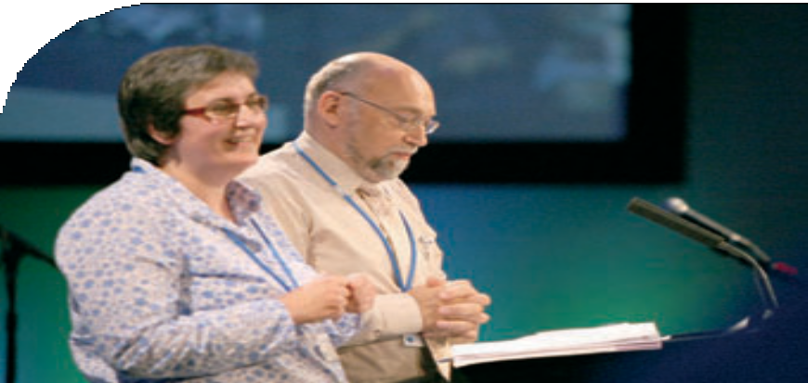
Revd Terry Oakley and
Revd Rachel Pullman

The Revd Kathryn Price, on behalf of the Synod of Scotland, moved adoption of Resolution 13, seconded by Dr James Merrilees.
Resolution13
Good Practice
The General Assembly of the United Reformed Church refers to Mission Council the development of the next edition of Good Practice to include, not only working with children and vulnerable adults, but all aspects of vulnerability and safety in church life and seek thereby to produce a clear and down to earth resource for use in congregations of all sizes.

Following debate, Resolution 13 was carried by agreement.

The Revd Terry Oakley and the Revd Rachel Pullman on behalf of North Western and
East Midlands synods, moved adoption of Resolution 12:

Resolution 12 Equality of opportunity for women
The United Reformed Church, despite its commitment to women’s ministry, has been unable to achieve proper gender equality and participation by women at all levels of the Church’s life.

Therefore General Assembly recognising that there are these and other imbalances in appointments throughout the church asks Mission Council to set up task groups to discover the underlying reasons why this is the case.

Assembly requests that recommendations to address these imbalances be brought to the 2010 General Assembly.

Following debate, neither consensus nor agreement could be achieved. The Moderator ruled that the matter be remitted to Mission Council to decide whether or not further work on the issue be undertaken.

The Revd Janet Flawn, on behalf of the Northern Synod, moved adoption of
Resolution 51, seconded by the Revd Colin Offor:

Record of the United Reformed Church General Assembly 2008 67


Resolution51
Support of Rural Community
General Assembly while noting that the majority of Christians support fairness in trade with farmers and growers in developing world economies and reaffirming its commitment to fairly traded goods recognises that domestic producers, farmers and growers, are often treated unfairly by British supermarkets and therefore
- asks the Ethical investments advisory group and the joint Public Issues Team to determine ways of influencing supermarket policies to reduce abuse of their powers in determining prices;
- calls upon supermarkets not to abuse their monopoly power in determining prices;
- urges the United Kingdom Government to re-examine whether the regulatory framework is adequate to ensure fairness and justice;
- renews its advice to churches and individuals to use fairly traded and locally produced goods as much as possible;
- requests all church members to consider the way in which their own purchasing and consumption patterns and expectations contribute to unfairness and injustice in the domestic market.

Following debate, Resolution 51 was carried by agreement. Mr Malcolm Townsend, Wessex Synod, requested that his dissent be recorded.

Mission Council
The Clerk moved adoption of Resolution 1:

Resolution 1

Ratification of Incapacity Procedure (Section P Part I)
General Assembly agrees to ratify its decision taken under Assembly Resolution 12 of 2007 to introduce a Procedure for dealing with cases of incapacity involving ministers of Word and Sacrament or church related community workers (CRCW) who are regarded as being incapable of exercising, or of continuing to exercise, their respective ministries on account of (i) medical and/or psychiatric illness and/or (ii) psychological disorder and/or (iii) addiction and approves the Introduction and Part I of that Procedure in the form set out below:

SECTION P

PROCEDURE FOR DEALING WITH CASES OF INCAPACITY INVOLVING MINISTERS OR CHURCH-RELATED COMMUNITY WORKERS
The Introduction which follows does not form part of the text of the Incapacity
Procedure

INTRODUCTION
The Procedure which follows allows the Church to deal with the cases of ministers of Word and Sacrament or church related community workers (CRCWs) who are regarded as being incapable of exercising, or of continuing to exercise, their respective ministries on account of (i) medical and/or psychiatric illness and/or (ii) psychological disorder and/or (iii) addiction. It is not a disciplinary process and will

68 Record of the United Reformed Church General Assembly 2008

only be invoked in situations where the Assembly Pastoral Reference and Welfare committee, if that committee has been involved, has said that it can do no more. Whilst considered as a last resort, the Incapacity Procedure will nevertheless enable the Church to take decisive action in cases where the continued exercise of ministry would undermine the promises made by the minister at ordination or, in the case of a CRCW, at his/her commissioning.

PART I – subject to Paragraph 3(1) of the Structure (governed by General Assembly Function 2(6)(a)(xi) of the Structure of the United Reformed Church)
Note: The words and expressions marked * (the first time they appear) are defined in
Part II of this Procedure.

- Under the provisions of this Incapacity Procedure (herein called ‘the Incapacity Procedure*’) a Review Commission* and, in the event of an appeal, an Appeals Review Commission* shall operate under the authority of the General Assembly for the purpose of considering and deciding upon cases properly referred to it
in which ministers* or church related community workers (CRCWs)*, whilst not perceived to have committed any breach of discipline, are nevertheless regarded as being incapable of exercising, or of continuing to exercise, ministry on account of (i) medical and/or psychiatric illness and/or (ii) psychological disorder and/or (iii) addiction.

- The Review Commission, the Standing Panel*, the Appeals Review Commission, and all aspects of the Incapacity Procedure shall at all times remain under the jurisdiction and control of the General Assembly which has the authority through the exercise of its functions as contained in Paragraph 2(6) of the Structure* to amend, enlarge or revoke the whole or any part of this Incapacity Procedure, save only that, as long as that Procedure remains in force, the decision reached in any particular case (whether or not on appeal) and any orders made in accordance with the Incapacity Procedure shall be made in the name of the General Assembly and shall be final and binding on the minister or CRCW and on all the councils of the Church*.

- Subject only to Section H of Part II, when the case of any minister or CRCW is being dealt with under the Incapacity Procedure, it must be conducted and concluded entirely in accordance with that procedure and not through any other procedure or process of the Church.

- The Incapacity Procedure shall not be initiated in respect of any minister or CRCW if his/her case is currently being dealt with under the Disciplinary Process, save
only where the Incapacity Procedure is initiated as a result of a recommendation from the Disciplinary Process, giving rise to a short transitional overlap between the commencement of the case within the Incapacity Procedure and the conclusion of the Disciplinary Process in relation to that minister or CRCW.

- Although the operation of the Incapacity Procedure is not based upon the conscious breach by the minister or CRCW of the promises made at ordination or commissioning, the Review Commission or, in the event of an appeal, the Appeals Review Commission shall, in considering the matter and reaching its decision, in every case have full regard to the Basis of Union* and in particular (in the case of ministers) Paragraph 2 of Schedule E thereto and (in the case of CRCWs) Paragraph 2 of Schedule F, Part II thereto which state the responsibilities undertaken by those who become ministers and CRCWs of the Church and the respective criteria which they must apply in the exercise of their ministries.

- Save only as provided in Paragraph 7, this Part I of the Incapacity Procedure is subject to Paragraph 3(1) of the Structure.

Record of the United Reformed Church General Assembly 2008 69



7 Mission Council acting in the name of General Assembly has authority by a single resolution of that Council to make as and when necessary and with immediate effect such changes to any part of the Incapacity Procedure as are, on the advice of the legal advisers to the Church, required to bring that procedure into line with the general law of the land consequent upon any changes in legislation and/or case law and any such changes as are made under this Paragraph shall be reported to the next annual meeting of the General Assembly.

A vote was taken and Resolution 1 was carried. The Clerk moved adoption of Resolution 2:
Resolution 2
Rules of Procedure for the Incapacity Procedure (Section P Part II)
General Assembly resolves to adopt the Rules of Procedure for the Incapacity Procedure (Part II of Section P) contained in Appendix 3

A vote was taken and Resolution 2 was carried.

The Clerk moved adoption of Resolution 3:

Resolution 3

Ratification of replacement of Section O (Part I)
General Assembly agrees to ratify its decision taken under Assembly Resolution 16 of 2007 to replace the whole of the existing Part I of Section O with the following:

SECTION O

PROCESS FOR DEALING WITH CASES OF DISCIPLINE INVOLVING MINISTERS AND CHURCH-RELATED COMMUNITY WORKERS

PART I – Substantive Provisions (governed by General Assembly Function 2(6)(A)(xi) of the Structure of the United Reformed Church)

  - 1.1 Under the provisions of this Section O an Assembly Commission (as defined in Section A of Part II) shall operate under the authority of the General Assembly for the purpose of deciding (in cases properly referred to it) the questions as to whether a minister or a church-related community worker (CRCW) has committed a breach of discipline and, if the Assembly Commission or, in the event of an appeal, the Appeals Commission should so decide, whether on that account his/her name should be deleted from the Roll of ministers or CRCWs as the case may be or alternatively whether a written warning should be issued to him/her. The Assembly Commission or, in the event of an appeal, the Appeals Commission may also decide to make a recommendation/referral in accordance with provisions of Paragraph 1.3. Under the Disciplinary Process (known as ‘the Section O Process’) the Assembly Commission or, in the event of an appeal, the Appeals Commission is also able to
make recommendations (other than recommendations under Paragraph 1.3) and offer guidance but only within the limits prescribed in Section F of Part II.

70 Record of the United Reformed Church General Assembly 2008



1.2 Subject only to Paragraph 1.3, once the disciplinary case of any minister or CRCW is being dealt with under the Section O Process, it shall be conducted and concluded entirely in accordance with that Process and not through any other procedure or process of the Church.

    - If it considers that the situation concerning a minister or CRCW involved in
a case within the Section O Process relates to or involves a perceived incapacity on the part of that minister or CRCW which might render him/her unfit to exercise, or to continue to exercise, the ministry of Word and Sacrament or the ministry of church related community work on account of (i) medical and/or psychiatric illness or (ii) psychological disorder or (iii) addiction, the Assembly Commission or, in the event
of an appeal, the Appeals Commission may make an Order in accordance with the Rules of Procedure referring the case back to the synod moderator/deputy general secretary or other person who called in the Mandated Group with a recommendation that the Incapacity Procedure (as defined in Section A of Part II) be initiated in respect of the minister or CRCW concerned, whereupon the Section O Process shall stand adjourned pending the outcome of such recommendation.
    - The Rules of Procedure contained in Part II shall provide for the service of the above Order (and any accompanying documentation if appropriate) on the synod moderator/deputy general secretary or other person who called in the Mandated Group and under those rules s/he shall be required, within the time therein specified, to notify the secretary of the Assembly Commission or the Appeals Commission in writing whether the recommendation has been accepted or rejected.
    - If the recommendation has been accepted, the notification shall specify the date on which the Incapacity Procedure was initiated, whereupon the Assembly Commission or the Appeals Commission shall make a further Order declaring the Disciplinary case to be concluded, subject only to the continuation of the minister’s or the CRCW’s suspension until the issue of his/her suspension has been resolved in accordance with the Incapacity Procedure.
    - If the recommendation has been rejected, the notification shall state the reasons and the Assembly Commission or the Appeals Commission shall forthwith reactivate the Disciplinary case.

  - The Assembly Commission, the Commission Panel, the Appeals Commission and all aspects of the Section O Process shall at all times remain under the jurisdiction and control of the General Assembly which has the authority through the exercise of its functions as contained in Paragraph 2(6) of the Structure to amend, enlarge or revoke the whole or any part of the Section O Process, save only that, so long as it remains in force, the decision reached in any particular case (whether or not on appeal) and any orders made in accordance with this Section O Process shall be made in the name of the General Assembly and shall be final and binding on the minister or the CRCW and on all the councils of the Church.

  - 3.1 Subject only to Paragraph 3.2, the Section O Process shall not be initiated in respect of any minister or CRCW if his/her case is currently being dealt with under the Incapacity Procedure.

3.2 The Section O Process may be initiated in respect of a minister or CRCW as a result of a recommendation issuing from the Incapacity Procedure, in which case there may be a short transitional overlap between the commencement of the Disciplinary case and the conclusion of the case within the Incapacity Procedure.

  - 4.1 In considering the evidence and reaching its decision, the Assembly Commission or, in the event of an appeal, the Appeals Commission, shall in every case have full regard to the Basis of Union and in particular (in the case of ministers) Paragraph 2 of Schedule E thereto and (in the case of CRCWs) Paragraph 2 of Schedule F, Part II thereto which state the responsibilities undertaken by those who become ministers and CRCWs of the United Reformed Church and the respective criteria which they must apply in the exercise of their ministries.

Record of the United Reformed Church General Assembly 2008 71

4.2 As part of such consideration, the Assembly Commission or Appeals Commission shall be entitled to have regard to any conduct on the part of a minister or CRCW occurring prior to his/her ordination to the ministry of Word and Sacrament or his/her commissioning to the ministry of church related community work as
the case may be which, in the Commission’s view and when viewed in the light of Schedule E or Schedule F to the Basis of Union, would have prevented, or was likely to have prevented, him/her from becoming ordained or commissioned, where such conduct was not disclosed by the minister or CRCW to those responsible for assessing his/her candidacy for ordination or commissioning.

  - 5.1 A minister or CRCW may appeal against the decision of the Assembly Commission to delete his/her name from the Roll of ministers or CRCWs under Section F of Part II or to issue a written warning under that Section by lodging a Notice of Appeal in accordance with the Rules of Procedure at Part II, stating the ground/s of such appeal.

  - The Mandated Group of the Council which lodged the Referral Notice in any case may in the name of that Council appeal against the decision of the Assembly Commission not to delete the name of the minister or CRCW from the Roll of ministers or CRCWs by lodging a Notice of Appeal in accordance with the Rules of Procedure stating the ground/s of such appeal. In any case where no written warning is attached to the decision not to delete, the Notice may state, if the Mandated Group so desires, that the appeal is limited to the question of the issue of a written warning to the minister or CRCW.

  - No-one other than the Parties has any right of appeal from the decision of the Assembly Commission.

  - Procedural matters shall in every case be dealt with in accordance with the Rules of Procedure as contained in Part II.

  - 7.1 Save only as provided in Paragraph 7.2, this Part I of the Section O Process is
subject to Paragraph 3(1) of the Structure.

  - Mission Council acting in the name of General Assembly has authority by single resolution of that Council to make as and when necessary and with immediate effect such changes to Part I as are, on the advice of the legal advisers to the United Reformed Church, required to bring the Section O Process into line with the general law of the land consequent upon any changes in legislation and/or case law.

  - All such changes to the Section O Process as are made by Mission Council
under Paragraph 7.2 shall be reported to the next meeting of the General Assembly.

A vote was taken and Resolution 3 was carried. The Clerk moved adoption of Resolution 4:
Resolution 4
Replacement of existing Section O Process (Part II)
General Assembly agrees to replace the existing Part II of the Section O Process with that included as Appendix 4.

A vote was taken and resolution 4 was carried.

72 Record of the United Reformed Church General Assembly 2008

The Clerk moved adoption of Resolution 5:
Resolution 5
Indemnity for the Section O Process and Incapacity Procedure
General Assembly resolves that the United Reformed Church shall provide a full indemnity for those persons who either as members of any Church- related Panel, Commission, Committee, Council or Group or by virtue of the office held by them within the Church are called upon to fulfil any function within or related to the Disciplinary Process set out in Section O of the Church’s Manual or the Incapacity Procedure introduced by virtue of Resolutions 1 and 2 and to be set out in Section P of the Manual or who are
appointed by Mission Council to any voluntary role within or related to either of these.

A vote was taken and Resolution 5 was carried.

Nominations

The Revd Malcolm Hanson moved adoption of Resolution 59:
Resolution59
Appointment of Standing Panel for the Incapacity Procedure
General Assembly appoints the following as the Standing Panel for the Section P Incapacity Procedure:
Secretary: Members:
Revd Arnold Harrison (2012)
Revd Bill Mahood (2012), Revd Rowena Francis (2013), Mr Donald Swift (2013), Dr Gillian Patterson (2013)

A vote was taken and Resolution 59 was carried. The Clerk moved adoption of Resolution 50:
Resolution50
Composite Resolution
General Assembly ratifies the amendments to the Basis of Union and the Structure approved for the first time by Resolutions 14, 15, 18, 19 and 24
of 2007.

It was reported that the Thames North Synod had declined to approve Resolution 24 of the Assembly 2007 and Mr Simon Fairnington, Synod Clerk, on behalf of the Synod made a brief statement.

A vote was taken and Resolution 50 was carried.

Record of the United Reformed Church General Assembly 2008 73

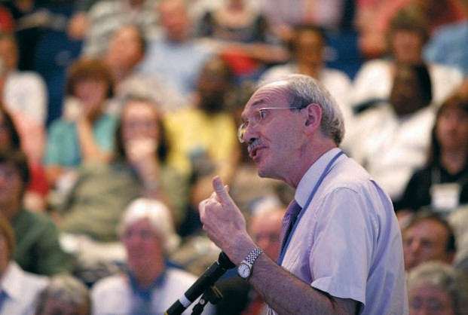

The Revd Peter Poulter, having consulted the Facilitation Group, moved adoption of Resolution 28:
Resolution28
United Reformed Church Recognition for lay preachers

General Assembly requests synods to:
- report to General Assembly, through the Ministries committee,
the names of those lay preachers to whom they have given Assembly Accreditation, following the completion of appropriate training;
- keep lists of other lay preachers whom they have recognised.

Resolution 28 was carried by agreement.

Assembly Commission
The Deputy General Secretary reported that, since the last General Assembly, one Section O case had been heard by an Assembly Commission at the cost of £1,444.68; and that the name of the Revd Ronald Alistair McNab had been deleted from the Roll of Ministers.

Revd Ray Adams, Deputy General Secretary

74

Address to the Throne
The Revd Prof Stephen Orchard presented the Address to the Throne:

To the Queen’s Most Excellent Majesty.

The General Assembly of the United Reformed Church, meeting in Edinburgh, sends greetings in this the 56th year of Your Majesty’s reign. May the God of peace be with you.

We extend our congratulations and best wishes to Your Majesty and Prince Phillip on the occasion of your diamond anniversary last year. We give thanks to God for Prince Phillip’s recovery from ill health earlier this year and trust that Your Majesty and Prince Phillip continue to enjoy good health.

The past year has been dominated by the banking crisis in the United States and
its impact, both on financial institutions and the poorest of the world’s peoples. The United Kingdom has not been spared the impact of this far reaching crisis. The run on the Northern Rock Bank and the subsequent rescue package by the Bank of England last summer has revealed the precarious nature of our own financial institutions
and markets. We commend Your Majesty’s government for the initiatives taken
to guarantee the savings of the public and for making financial institutions more accountable in the wake of this crisis. However, much remains to be done to address the concerns of ordinary people (particularly the elderly) about the security of their life savings and to assist first time home buyers to access affordable mortgages.

As Your Majesty is aware, the dramatic increase in the cost of living, together with the increase in home repossessions this year is contributing to the problem of homelessness and poverty here, in the United Kingdom. Our churches participated in the week of action on poverty and homelessness earlier this year. Events were organised around the country so that we might hear the stories of people living in these unfortunate circumstances.

A report of these hearings has been compiled and will be shared with political parties at their party conferences in the summer, in the hope of informing their policies.
Our churches will also be supporting the ‘Get Fair’ campaign, which is to be launched
in September, to draw attention to the different forms which poverty takes in the United Kingdom. We will seek creative ways of responding to these issues as churches and faith communities in partnership with local authorities and other voluntary sector organisations.

This year also marked the 5th Anniversary of the start of the war in Iraq and our Church through its Mission Council, adopted a resolution expressing deep sorrow and regret
at the devastating consequences of this war for the people of Iraq and the families of those who serve in the coalition forces. It also called for those with influence and authority, including Your Majesty’s Government, to work with renewed urgency and vigour to build sustainable security and livelihoods for the people of Iraq, in order to
allow the coalition forces to be brought home. We have expressed our concern about the deepening humanitarian crisis in Gaza and, also, the escalating political violence and disregard for democratic processes and the rule of law in Zimbabwe. We would urge Your Majesty’s Government to continue their diplomatic efforts to bring an end to the blockade of Gaza by Israel and to urge the leaders of Southern African countries to take the urgent steps necessary to end the governance crisis in Zimbabwe which is the root cause of all the other crises in that tragic country.

Record of the United Reformed Church General Assembly 2008 75

Finally, we would like to commend Your Majesty’s Government for continuing to highlight the issues of global poverty and the need to address both the root causes and the symptoms of this scourge in our world. Improvements in the health and education of the world’s children are particularly important. The dramatic rise in food and fuel prices over the past few months is of major concern and we would encourage Your Majesty’s Government to take the lead in dealing with the world food crisis by offering more food aid in the short term; help to farmers in the medium term; and
to set aside funding for more research into appropriate technologies for sustainable development in the longer term.

May the God who gives endurance and encouragement strengthen and sustain Your Majesty in the year to come.

We have the honour to remain Your Majesty’s faithful and loyal subjects.

Revd John M Marsh Revd Roberta Rominger
Moderator General Secretary Assembly received the Address with applause.

Moderators-elect
The Moderators-elect, Mrs Val Morrison and the Revd Dr Kirsty Thorpe addressed the Assembly.

Thanks
The East Midlands Synod Clerk, Mr Duncan Smith, proposed a vote of thanks to the Synod of Scotland for its hosting of the General Assembly.

The Moderator offered thanks to his Chaplain, the musicians and contributors to the worship; the Revd Elizabeth Nash and the facilitation group; to the members of FURY and the Children’s Assembly; to all who contributed to the smooth running of the Assembly; to the BSL signers and the staff of Heriot-Watt University. The Moderator offered special thanks to the retiring Convener of the Assembly Arrangements Committee, Mr William McVey.

The General Secretary thanked the Moderator for the humility, graciousness and vision of his leadership.

Closing Worship
Closing worship was led by the Chaplain.

The General Secretary formally announced that the Assembly had completed its business and would adjourn to meet as agreed at Loughborough University from 2-6 July 2010, or is such other place or on such other date as may be necessary.

••

76 Record of the United Reformed Church General Assembly 2008

Church Closures
Appendix 1
General Assembly 2008
omitted from the Book of Reports

Worrall Hill United Reformed Church (1884-2008)
Forest of Dean Group
Worrall Hill chapel held its final service on the 27th April 2008 having served the local community for 124 years. Nestled on the side of the hill on a road linking Lydbrook with the main road from Gloucester to Monmouth, the chapel was built from stone from old pit buildings,
carried by local men half a mile down the hill. In days of yesteryear it had a large Sunday school and was the only place of worship for the small hamlet. “The chapel on the hill” had electricity but no water, but the ample spiritual amenities it provided were focussed on a caring and loyal band of people. Diminishing numbers and structural deterioration led to the chapel struggling for survival. Over the years it was served with dedication by ministers and lay preachers from the Forest of Dean, and the former Gloucester District. The final service, led by the Revd.
Glyn Jenkins with 40 people present, paid tribute to the faithful witness
over 100 years and was a fitting end to the years of worship and service.

Whiteley LEP

This Local Ecumenical Project between the Anglican, Methodist and United Reformed churches was formed in 1999 to meet the opportunity of a new housing development.
It has progressed slowly and a building is still not present. Despite strenuous efforts on behalf of the Methodist and United Reformed churches to retain the Local Ecumenical Partnership (LEP), the Whiteley church has voted to become an Anglican church.
The sharing agreement and LEP have therefore been dissolved.

Ingleby.net
General Assembly in 2004 received Ingleby.net as a Mission Project, operating on the large Teesside private housing development of Ingleby Barwick. For four years the largely
Methodist-funded project was ably led by a Church Army Officer, with a brief to explore new
ways of being church and contribute to the growth of community and support networks.

With only nine months to go until the end of the project, the worker left in September 2007 to train for the Anglican priesthood. After a number of unsuccessful attempts to recruit someone to complete the project, even re-organising the funding to create a longer time horizon but on a part-time basis, it was decided in January to bring the project to a formal close. While this is a disappointment, many of activities begun under the project, particularly the youth work, are being carried on by the local parish church.

77



Appendix 1
Church of the Holy Family
Killingworth
This congregation began in the mid 1960s, at a time when large scale housing developments were providing particular challenges to the Church.

Killingworth Township was intended to provide its Tyneside residents not just with accommodation, but with all the necessities of life in community. It was clear that people’s worshipping needs would not be met by the church in the neighbouring village, and so the Township was quickly declared an Area of Ecumenical Experiment.

Commitment by Anglicans, Baptists, Methodists and Presbyterians to new ways of working led to the development of a single congregation worshipping in a shared building. This building was part of the Communicare Complex which also housed a health centre and community centre. A thorough and complex administrative system for this ecumenical church was set up by the four denominations (at a time when
off-the peg LEP constitutions were a thing of the future), and though this provided careful oversight, it perhaps also encouraged dependency.

The church in its early days was greatly influenced by patterns of sacrificial ministry which, together with the firm ecumenical witness, gave it credibility within the community. Although the United Reformed Church was always a minor player, we provided a fair share of ministry over the years, and were perhaps more influential in the church’s life than numbers in the year book indicated.

By the 1990s the surrounding shopping centre had been demolished, leaving the Complex out on a limb. The Council had plans for rebuilding, and the church found itself no longer a welcome partner. After long and difficult negotiations the church received a sum of money which would never have enabled it to rebuild; but instead it began a nomadic existence, first worshipping in a home for the elderly, and then in a series of neighbouring churches. Since these were always part of one of their constituent denominations, the continuing existence of this separate congregation became increasingly anomalous.

The Church of the Holy Family, which had been worshipping for some time at
the parish church in Killingworth Village, held a final service of celebration and thanksgiving in July 2007, after which members dispersed to a number of different churches. A charity is being set up, whose trustees will be representatives of the four denominations and former members of Holy Family, to underwrite ecumenical project work within the Township. This will be deliberately targeted to encourage Roman Catholic and Independent Church participation, and so do justice to the first of our Three Ecumenical Principles.

78 Record of the United Reformed Church General Assembly 2008



Appendix 1
Trinity United Reformed Church
Harehills Avenue, Leeds
The first steps towards founding the congregation took place on 19 December
1896, when a request was made to the Presbytery of Yorkshire in order that the residents of Roundhay Road and Chapeltown Road be supplied with public ordinances. In January 1897, the Presbytery of Yorkshire approved a preaching station and a religious service was held on the first Sunday in February of that year. The following week a Sunday School commenced with 25 scholars and 7 teachers. The preaching station was raised to a sanctioned charge in July.

On Friday 24 September 1897 a congregational meeting was held and the first enrolment of 31 members of Trinity Presbyterian Church of England took place. The young congregation lost no time in obtaining a site for the church and after several unsuccessful attempts, they secured a plot for £932.12s.

On Sunday, 8 January 1899, the hall opened for worship. The total cost for the construction was about £2,000. The congregation now numbered 48 and within two years from its inception had built and come to possess its own place of worship. Plans were then put in place to build a church and on Friday, 31 May 1907, ‘while rain was falling and in the presence of a large gathering of the congregation’ the Moderator of Synod unlocked the door and declared the church open for public worship, the total seating capacity was 500. The special opening services extended over a fortnight and chairs had to be placed in the aisles to accommodate the worshippers. The congregation grew in numbers all the time, mostly people in the 30-40 years age group. The weekly activities were held, amongst them a Literary Union, Reading Circle, Cycling Club, Tennis Club, Sunbeam Club for children, Scouts, Ladies’ Work party, Young Men’s and Young Women’s Class and the Women’s Missionary Society.

The records for the church tell the story of faithful people continually looking for ways to improve their buildings to enhance their worship. The ministry of 13 dedicated ordained ministers and 15 session clerks/church secretaries as well as many committed elders and lay people is also recorded. The congregation has reflected the diversity of the community it serves and Trinity Harehills Avenue has been the fulfilment of the United Reformed Church’s declaration of itself as a multicultural church.

The building has become home to several other congregations; The Pentecostal City Mission (more than 30 years), Shekinah Glory Fellowship (10 years) and more recently the Friday Apostolic Church of Zimbabweans numbering more than 100 people. Two annual community events have also been closely connected with the building: the first is the Good Friday procession which always ends in this building
after a service in the local park, the second is the Carnival when the church grounds are full of people watching the carnival and the hall is full of police officers who come in for refreshment and rest.

The decision to close a church is never an easy one but as the Church Secretary observes ‘churches are people and therefore churches cannot close’. And though buildings can close it is hoped this one will soon be owned by a community church and the worship of God will continue.

••

Record of the United Reformed Church General Assembly 2008 79



The full text of the constitutional documents agreed with the Charity Commissioners to be used in registering Local Churches as Charities as required by the Charities Act 2006. These three
Appendix 2
General Assembly 2008
paragraphs are the legal minimum required. Additional information will be produced to assist Local Churches in registering.

Version for Local Churches where the Elders are the Trustees
- Name and Assets

The Charity is called (“Anytown United Reformed Church Charity”) and comprises all assets and funds held by and on behalf of the (“Anytown United Reformed Church”) other than properties held under the trusts declared in Schedule 2 of the United Reformed Church Act 1972 (as amended by the United Reformed Church Acts 1981 and 2000) and those held on other specifically declared trusts.

- Objects

The object of the Charity is the advancement of the Christian faith for the benefit of the public in accordance with the Scheme of Union of the United Reformed Church.

- Trustees and their responsibilities

Those members of the Elders’ Meeting of (Anytown United Reformed Church) who are qualified to serve as charity trustees are collectively the Charity Trustees of the Charity and are appointed and shall act in accordance with the procedures for the time being laid down by the Church Meeting of (Anytown United Reformed Church) which shall be in conformity with the Scheme of Union of the United Reformed Church.

Version for Local Churches where Church Meeting appoints the Trustees
- Name and Assets

The Charity is called (“Anytown United Reformed Church Charity”) and comprises all assets and funds held by and on behalf of the (“Anytown United Reformed Church”) other than properties held under the trusts declared in Schedule 2
of the United Reformed Church Act 1972 (as amended by the United Reformed
Church Acts 1981 and 2000) and those held on other specifically declared trusts.

- Objects

The object of the Charity is the advancement of the Christian faith for the benefit of
the public in accordance with the Scheme of Union of the United Reformed Church.

- Trustees and their responsibilities

Those members of such body drawn from the membership as shall be appointed by the Church Meeting of (Anytown United Reformed Church) who are qualified to serve as charity trustees are collectively the Charity Trustees of the Charity and are appointed and shall act in accordance with the procedures for the time being laid down by the Church Meeting of (Anytown United Reformed Church) which shall be in conformity with the Scheme of Union of the United Reformed Church.

81

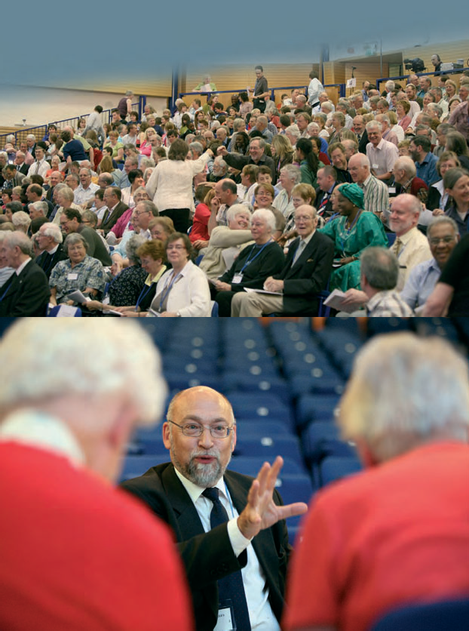



Index

Accounts |  | Reports | Record  54
Adams, Ray |  |  | 16
Address to the Throne |  |  | 75
Andrews, Ivan |  |  | 59
Appeals | Rules of procedure – change |  | 64-65
Appointments made by Mission Council on behalf of General Assembly 12
Assembly | Membership (amendments to Structure) | 57
 | Roll | 8
 | Rules of procedure – changes | 60-65
Assembly-appointed staff appointments and reappointments 12
Assembly Arrangements Committee 37-38 |  |  | 59
Assembly 2010 223 |  |  | 59
Assembly Commission |  |  | 74
Auditors, appointment of 224 |  |  | 55
Awards (see Congregational and General)
Basis of Union ratification of amendments (composite resolution) |  |  | 73
Bookshop 38b |  |  | 66
Bowman, Craig |  |  | 18
Bulley, Adrian 219 |  |  | 17
Capability Procedure for Ministers and CRCWs 230-234 |  |  | 42
Certificates of Limited Service (Ministries Committee) 235 |  |  | 42
Certificates of Limited Service – extension (Ministries Committee) 235 |  |  | 42
Challenge to the Church (Ministries Committee) 225-227 |  |  | 33,41
Children’s Assembly |  |  | 16,33,59
Church and Society 71-73 |  |  | 23
Church closures 31-36,223 |  |  | 38,77-79
Climate Change 76
Congregational and General Community Awards 2008 |  |  | 40
Commitment for Life 74
Communications Committee 38a-38b |  |  | 66
Future publications policy |  |  | 66
Bookshop |  |  | 66
Consensus
Facilitation Group |  |  | 15
Conversations with the Methodist Church |  | 222 | 66
Craven, Christine |  |  | 33
Deputy Clerk |  |  | 16
Education and Learning Committee |  | 39-50 | 56
Appointment of Secretary |  |  | 18
Energy4Life: inter-Assembly celebration 2009 |  |  | 59
Equality of opportunity for women |  | 220 | 67

Record of the United Reformed Church General Assembly 2008 83


Index

Reports Record
Equal Opportunities Committee – updated policy 113-126,
223 26
Faiths (see Other Faiths)
Finance Committee 51-52 54
FURY report 21
Fox, David 32
General Secretary
Induction 16
General Secretaries appointment 54
Rules of procedure – changes 63
Good Practice 221 67
Grievance Procedure for Ministers and CRCWs (Ministries Committee) 228-229 41
Hymn writers: a celebration 22
Incapacity procedure (see Section P)
Indemnity for Section O and Incapacity procedure 216 73
Index of resolutions 81-82
Jubilee ministers (see Ministers)
Lay Preachers: recognition (Ministries Committee) 236 43,74
London Synod Commission report 15

Living Wage 73,243 24
Local churches registration of assets 55
Trusteeship of 81
Lowes, Roy 244 18
Marsh, John (Moderator of Assembly) 7
Methodist Church, further conversations 222 66
Ministerial Stipend 12
Ministers Commemoration of ministers and
missionaries who have died 29
New ministers and CRCWs welcomed 29-30
Jubilee ministers 31
Ministers’ Pension Fund: valuation and amendment to the rules 12-13
Ministries Committee Appointment of Secretary 53-63 18
Capability Procedure for
Ministers and CRCWs 230-234 42
Certificates of Limited Service 235 42
Certificates of Limited Service – extension 235 42
Challenge to the Church 225-227 33,41 Grievance Procedure for
Ministers and CRCWs 228-229 41
Lay Preachers: recognition 236 43
Plan for Partnership – amendments 236 35-37
Report 33
Retired Ministers’ housing –
synod partnership 242 34
Retirement Housing 239 34
Ministry and Mission Fund, giving to 224 55
Minute Secretary 58
Mission Committee 65-76 23,24,
25,32,59
A mission strategy 65
Climate Change 76
Commitment for Life 74
Church and Society 71-73 23
Living Wage 73 24
Racial Justice and Multicultural Ministries 69,243 25

84 Record of the United Reformed Church General Assembly 2008


Index

Mission Council | Reports  9-22 |  | Record  27,68
 | Appointments on behalf of General Assembly 12 Basis of Union amendments –  composite resolution (ratification) |  | 73
 | Incapacity procedure Section P part I  (ratification) 211-212 |  | 68
 | Incapacity procedure Section P Part II
(rules of procedure) |  | 127-150,
Indemnity for Section O and Incapacity |  | 213 | 70
procedure |  | 216 | 73
London Synod Commission report |  | 15
Ministerial Stipend  Ministers’ Pension Fund – valuation and amendment to the rules |  | 12  12-13
Replacement of Section O (ratification)  Replacement of existing Section O (Part II) |  | 151-182, | 70
 |  | 215 | 72
Standing Panel for Incapacity procedure  Windermere Centre |  | 16 | 73
Moderators of General Assembly (2010-2012)  Election |  | 17
Announcement of election result Moderators of synod (see synod moderators)  Morrison, Val |  | 39 | 39,76
New churches and mission projects |  |  | 39
Nominations Committee Report |  | 77,244 | 17,
 |  |  | 43-53
Oakley, Terry |  | 219 | 17
Operation Noah |  |  | 24
Other Faiths Representatives |  |  | 38
Pilots |  | 92 | 24
Plan for Partnership – amendments (Ministries Committee) |  | 236 | 35-37
Prasad, Dr Andrew |  |  | 18
Publications – future policy  Racial Justice and Multicultural Ministries  Representation to General Assembly |  | 69,243 | 66  25
Reform |  | 38a | 27
Registration of Assets of local churches |  |  | 55
Resolutions, index of  Retired Ministers’ Housing – The Guidelines |  | 185-187 | 87-88
Retired Ministers’ housing – synod partnership (Ministries Committee) |  | 242 | 34
Retirement Housing (Ministries Committee)  Rominger, Roberta (see General Secretary) Rules of Procedure – changes |  | 239 | 34  60-65
Rural Community, support of |  |  | 68
Section O Replacement of Section O (ratification) |  |  | 70
Replacement of existing Section O (Part II)  Section P Incapacity procedure (Section P Part I)  (ratification) |  | 215  211-212 | 72  68
 | Incapacity procedure (Section P Part II)
(rules of procedure) |  | 127-150,
 |  | 213 | 70
Students sent by synods for ministerial or CRCW training  Synods Membership of |  | 189-196 | 27

Record of the United Reformed Church General Assembly 2008 85

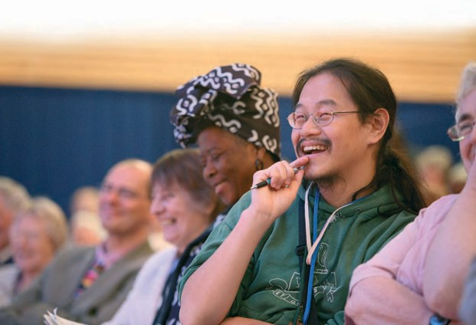
86

Index

 | Reports | Record
Synod Moderators’ Report | v | 1,59
Appointments and reappointments | 12,219 | 17-18
Rules of procedure – changes |  | 64
Thomas, Fiona |  | 18
Thorpe, Dr Kirsty |  | 27,39,76
Trustees Report and Accounts | separate report
 | and 224 | 54
Vision4Life | 5 | 32
Westminster College
Honorary Treasurer |  | 56
Trusteeship of the charitable funds |  | 55
Windermere Centre | 16
Youth and Children’s Work Committee Report | 89 | 19,25
Vision for youth and children’s work | 96-98,244 | 19
YCWTDO programme Review | 99-111,
 | 245 | 19,25
Line management | 110,245 | 20,25
Funding arrangements | 111 | 21
Children’s and Youth Officers | 111 | 21,26
Zimbabwe: emergency resolution |  | 23



Index of Resolutions

Record Page No. | Name | Resolution number | Reports Page No.
68-70 | Ratification of Incapacity Procedure  (Section P Part I) | 1 | 211
70 | Rules of Procedure for the Incapacity Procedure (Section P Part II) | 2 | 213
70-72 | Ratification of replacement of Section O (Part I) | 3 | 213
72 | Replacement of existing Section O Process  (Part II) | 4 | 215
73 | Indemnity for the Section O Process and  Incapacity Procedure | 5 | 216
 | Ratification of replacement of Section O (Part I) | 6 | 216
 | Replacement of Section O (Part II) | 7 | 218
 | Indemnity for Section O Process | 8 | 218
17 | Reappointment of the Revd Adrian Bulley as Wessex Synod Moderator | 9 | 219
17 | Reappointment of the Revd Terry Oakley as  East Midlands Synod Moderator | 10 | 219
 | CRCW membership of synods | 11 | 219
67 | Equality of opportunity for women | 12 | 220
67 | Good Practice | 13 | 221
66 | Further conversations with the Methodist Church | 16 | 222
38 | Closure of local churches and mission projects | 17 | 223
38 | New churches and mission projects | 17a
59 | General Assembly 2010 | 18 | 38/223
26 | Equal Opportunities updated policy | 19 | 223
54 | Trustees’ Report and Accounts | 20 | 224
55 | Appointment of Auditors | 21 | 224
55 | Giving to the Ministry and Mission Fund | 22 | 224
33/41 | Challenge to the Church | 23 | 225
 | Grievance Procedure for Ministers of Word and
41 | Sacraments and Church Related Community | 24 | 228
 | Workers
42 | Capability Procedure | 25 | 230
42 | Certificates of Limited Service | 26 | 235
42 | Extension of Certificates for Limited Service | 27 | 235
Record of the United Reformed Church General Assembly 2008 87

Index of Resolutions ...continued
Record Page No. | Name | Resolution number | Reports Page No.
43/74 | United Reformed Church recognition for lay | 28  29  30  31  32  33  34  35  36  37  38  39  40  41  42  43  44  45  46  47  48  49  50  51  52  53  54  55  56  57  58  59  60  61  62  63 | 236
 | preachers
35-37 | Amendments to the Plan for Partnership |  | 236
34 | A fairer and more affordable system for helping |  | 239
 | ministers, in retirement, with housing
34 | Retired Ministers’ housing – synod partnership |  | 242
25 | Representation to General Assembly |  | 69/243
24 | Living Wage |  | 73/243
18 | Appointment of the Revd Roy Lowes as |  | 244
 | West Midlands Synod Moderator
43 | Nominations |  | 244
19 | Vision for youth and children’s work |  | 98/244
19 | YCWTDO programme |  | 109/245
19/25 | A YCWTDO in every synod |  | 109/245
20/25 | Line management |  | 110/245
20 | Task Group |  | 110/246
21 | Funding arrangements |  | 111/246
21/26 | Children’s and Youth Officers? |  | 111/246
64 | Future publications |  | 247
27 | Reform |  | 247
66 | Bookshop |  | 247
55 | Trusteeship of the Charitable Funds of
 | Westminster College
54 | Appointment of General Secretaries
16 | Appointment of Deputy Clerk
57 | Amendments to Structure: Membership of
 | Assembly
73 | Composite resolution
68 | Support of Rural Community
27 | Membership of Synod
60-65 | Changes to the Rules of Procedure
56 | Westminter College Honorary Treasurer
55 | Registration of Assets held for Charitable
 | Purposes of Local Churches
18 | Appointment of Thames North Synod Moderator
23 | Emergency resolution Zimbabwe
60 | Appointment of Minute Secretary
73 | Appointment of Standing Panel for the Incapacity
 | Procedure
18 | Appointment of Secretary for Ministries
15 | Appointment of the Facilitation Group
18 | Appointment of Secretary for Education and
 | Learning

88 Record of the United Reformed Church General Assembly 2008

