TRIO - The Responsibility Is Ours

BACKGROUND

TRIO is a financial stewardship programme with proven success in a variety of demographic settings in encouraging generosity in giving. It was developed by the Diocese of Southwark and has been produced by the URC in the past.

In 2012 a pilot local-URC ran a ***TRIO*** campaign using an updated Anglican version. The result was a 46% increase in giving. On the basis of this, and feedback from the pilot church, the Stewardship Subcommittee negotiated with the Diocese of Southwark the publication of a version, tailored to the URC’s needs, under licence. This version also firmly embeds financial giving within the wider theological understanding of stewardship. The updated version was trialled across forty churches (including Local Ecumenical Partnerships) in 2013. Feedback indicates that the campaigns resulted in a 19%-61% increase in giving. The material was updated further in response to specific suggestions.

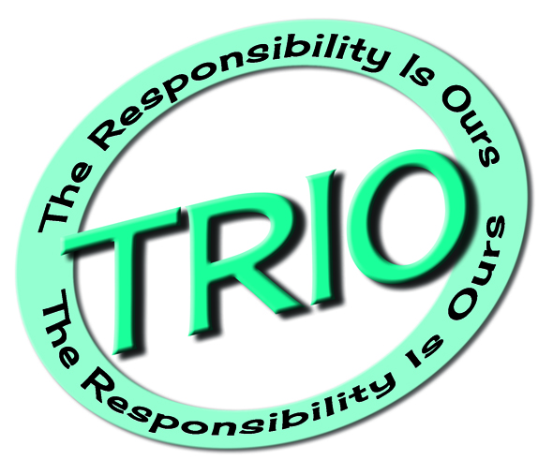

A TRIO CAMPAIGN

A TRIO campaign encourages people to consider their financial giving to the church by: presenting financial facts and figures, encouraging proportionate giving and tax efficient giving, and reminding people how best to give. The main feature is a financial presentation to which all of the fellowship is personally invited. This affirms what has already been achieved, helps people value their church and encourages taking responsibility for its day-to-day running costs. The presentation also gives clear guidelines on how to make a response and emphasises that giving should be proportionate, regular and tax-efficient.

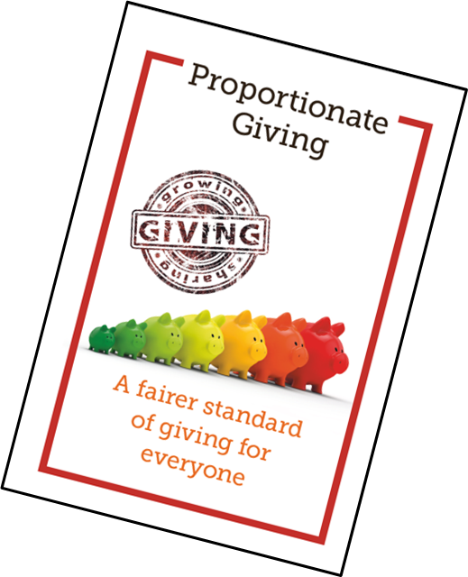

A successful campaign requires full preparation and three to four months are needed from deciding to run a TRIO campaign to the presentation. By informing members of the fellowship about the finances of the church everyone starts to recognise that, as far as the maintenance of the work, mission and ministry of their church is concerned……The Responsibility Is Ours.

**MATERIAL**

The ***TRIO*** material incorporates a manual, a sample Presentation, sample leaflets and a CD with electronic versions of resources. Microsoft Word 97-2003 or 2007 and Adobe Acrobat Reader are needed to open the resources. The manual gives detailed instructions on the planning, preparation, timetabling and work that are involved. Templates of leaflets and forms that can be adapted for the local situation and suggested wording for letters and pre-publicity are provided. There are also reference appendices to Bible passages and hymns that will support a stewardship campaign.

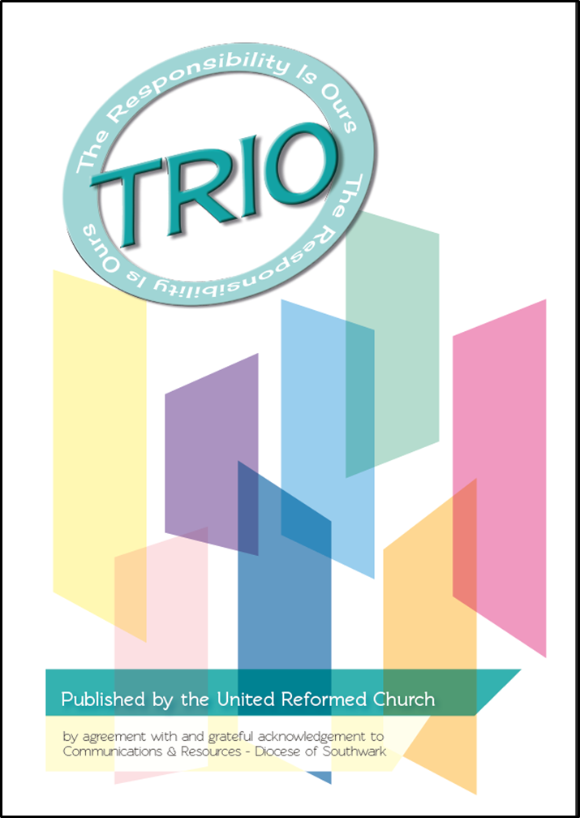

The cost of the ***TRIO*** material is £40 (dictated by the terms of licence) and additional pre-printed leaflets can be ordered @ 10p each plus postage. To order a ***TRIO*** pack please contact Beatrice Minta at Church House - mom.admin@urc.org.uk or 020 7916 8644 (direct line).