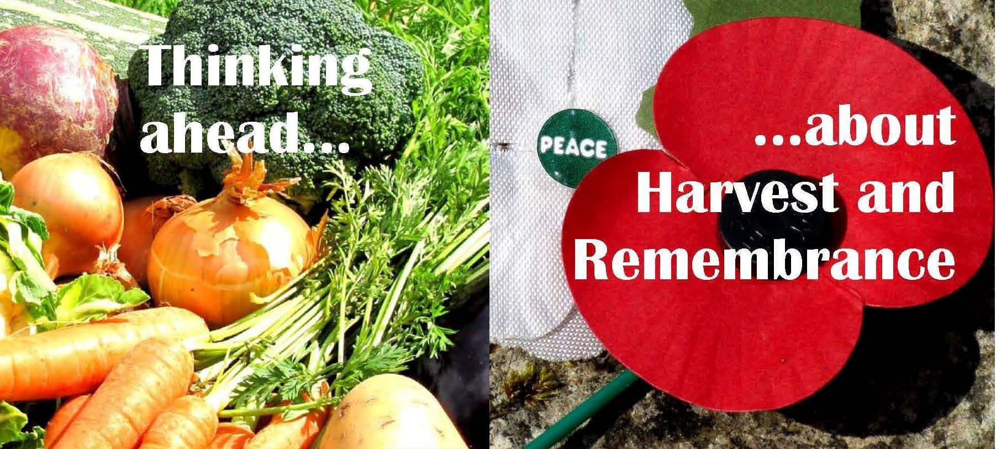

More resources

Bible ideas for exploring Remembrance

Here we share a slightly idiosyncratic list of Bible passages that could be used as the germ of an idea at Remembrance time – either for Bible Study or in a sermon. We also offer some indication of at least one way each of them could be developed. This is NOT meant to be an exclusive list, simply some suggestions to trigger your own ideas for using biblical texts at remembrance time…

Genesis 4.1-16 – Abel, Cain and the death of brotherhood

A chance to look at the basic ugliness, injustice and irreversibility of violence – the prototypical murder of Abel by Cain – and the resonating question, ‘Am I my brother’s keeper?’, but also to look at the apparently arbitrary actions of God (who accepts Abel’s sacrifice, but not Cain’s and gives no reason). The text provides a chance to explore the complex of emotion, violence and the aftermath and the place of God in all of this. Not easy, but important.

Genesis 18.16-33 – Must there always be brimstone?

An amazing story presenting Abraham trying to talk God out of an act of violence. Can we ever find a fitting threshold for violence? Can even God be justified in bringing brimstone and fire? There is no war here, but it relates to the questions about the role of God that are raise by Hiroshima and Nagasaki and the Holocaust. Where was God’s concern for the innocent when the Holocaust happened?

Deuteronomy 26.1-10 – Remembering the bad bits

The harvest recitation tells of the bad bits of Israel’s history as well as the rescues. Why remember the bad bits? – it’s right to take the suffering and sacrifice seriously; it’s good to try to learn from past failures; its in the dark places that the hope that can make us gracious has its birth. Tied in to the central Christian remembrance of a lonely violent death on a cross, this can offer a powerful explanation of the value of remembering that will hold true even for those who have no memories of their own of the two ‘world wars’ of the Twentieth Century.

1 Samuel 25. 1-42 – The role of the reconciler

A strange tale of the role of a reconciler and the compromises and costs that it takes to avoid disaster. It allows a reconsideration of appeasement and the moral dilemmas that force themselves upon people in times of conflict. Again, no easy or comfortable solutions, but Bible engagement with real questions.

1 Kings 22.1-36 – A King must have his battle

Rich and complex story about a king determined to have his battle, one way or another, whilst trying to elude his own prophesied fate (by locking up the prophet as a surety of his safe return). An exploration of just how difficult it can be to determine what is right, what is God’s will and what is self-delusion… whilst others die and conflict happens.

Psalm 122 – Prayer and the peace of Jerusalem in practice

A passionate psalm that envisages a future for Jerusalem as the centre of world peace – in stark contrast with the contested Jerusalem with house demolitions and a new security wall twice the height of the Berlin Wall that we see today. How many have prayed for peace – why do we not see it happening around us, shaping and changing our world?

Matthew 2.13-18 – The Slaughter of the innocents

The well-known bit of the Christmas story that regularly fails to make it into school nativity plays. Where, oh where is the love and justice in this story? Is there any sign of Gospel in this?

Philippians 2.1-11 – Jesus as victim and victor
The modern world, in Hollywood films and other stories, is fixated with ‘The Myth of Redemptive Violence’ – where the good guys, riled at the ugly violence of the bad guys, eventually engage in their own violence to ‘sort’ the situation…. and so the cycle continues as empires come and go. Is there, then, another way? Does the self-offering of Jesus, the overthrown victim who cracks the whole system apart offer hope of something else? Can this be held onto in the face of world violence and injustice?

Revelation 5 – Judah’s lion / Lamb of God

If you thought that Revelation was simply about that last battle in which God conquered, it’s worth returning to Revelation 5 where in the heart of the scene of triumph in heaven the Lion of Judah is expected, but instead John sees a slaughtered lamb. It is the slaughtered lamb who is ‘worthy’ (v.12) of all heavenly praise. Another route in to explore the ideas of victim and victor and where God might be in all of this.

Being Creative

Making a mega-poppy as a focal point for worship

In one local church someone made an enormous cut-out remembrance poppy (about a metre across) from an flattened cardboard box. The ‘petals’ shape was cut out of the cardboard and painted red. A ‘leaf’ shape was cut out and painted green. A number of circles of cardboard were cut out and glued one on top of the other then the pile was painted black to make the centre of the poppy. The paint used came from those squeezy bottles of ‘Ready-mix’ washable paint are available from places like WH Smith or Early Learning Centre in Red, White, Green and Black. It was applied with little sponges made by quartering those ½ cm thick sponge wipes for use in kitchens. The whole thing was then glued together using washable PVA glue (you can get big tubs of washable PVA glue from places like the Early Learning Centre). The assembled poppy was then hung at the front of the church. It made a striking visual focus for Remembrance Sunday worship. If your church chose to emphasise both Haig red poppies and Peace Pledge white ones you could make two mega-poppies, one white and one red.

Opening up quiet remembrance space in church or community

In the approach to Armistice Day create a prayer corner - in a part of your church, community hall, or, with permission, shopping centre, supermarket or workplace. Make both red and white poppies available. Invite people to write a name on a poppy outline or on a poppy and tie it to a tree/pin to notice board. A short service at 11.00am on 11th November would be appropriate with a silence and is usually welcomed by shops/supermarkets/retail malls as they frequently (and increasingly over recent years) honour the silence.

Visual support for prayers for current conflict

For a time of prayer for Remembrance Sunday, rather than just name places of current conflict invite members and friends, including Junior Church and any other youth organisations that might be involved in the worship to bring newspaper cuttings or other pictures from the internet or wherever that illustrate ongoing war and the suffering it brings and link the pictures to a world map. This can be done either with a mounted map and coloured cords or by placing the pictures on a massive map on the floor. Maybe a youth group would help by making the map.

Writing prayers and litanies

It might be worth inviting groups of people to work on appropriate prayers and litanies for Remembrance Sunday. How can we pray about war in a way that rightly remembers and allows for all the diverse levels of knowledge and experience of war that a local church and community might have in their midst?

Exploring peace-making

If we remember war and pray for peace you might like to explore how we can work at peace-making in our own communities and within our churches. You may like to explore 'Bridgebuilders' who run courses on peace making at local level. Link to their website - http://www.menno.org.uk/node/3

Including conscientious objectors’ stories?

For a long time the stories of conscientious objectors were hidden away and ignored at Remembrance time. Perhaps, it might be worth trying to uncover and include such stories (for they surely carry their own elements of hurt and pain). As we move from a world where the 1914-18 and 1939-45 wars were part of a memory that almost everyone shared to a way of remembering that is powerful and effective though most people never knew any of the people whose names appear on the war memorials, the time may have come to remember all the stories, including those of conscientious objectors. Whether and how it’s done and what stories are recovered and how they are referenced or retold is very much a specific, local matter. It might be worth a thought.

Remembrance Sunday Activities for children/young people & others
Have a ‘Reading Group’:
Michael Morpurgo has written some fantastic books about WW1, WW2 and the Afghan War. These can be done with children from 9+ and will work brilliantly with adults too.
“Private Peaceful”
“War Horse” (brilliant film too but a 12A, lots of issues come up)
“Kensuke’s Kingdom” (deals with Nagasaki and Hiroshima)
“The Amazing Story of Adolfus Tips” (Slapton Sands incident)
“Friend or Foe” (London Blitz)
“Run Rabbit, Run” by Barbara Mitchelhill deals with conscientious objectors. A really
good adventure story again with lots of good discussion starters.
Robert Westall an author of fiction books on war
Sandy Toksvig wrote “Hitler’s Canary”
“When Hilter Stole My Pink Rabbit” by Judith Kerr
Why not do this with adults too?

Cakes etc.
Have a bake and money can go to British Legion or any other charity. There is a little book, (see below) which has some great ideas in it.
Recipes for Remembrance is a new, pocket-sized book of family-friendly baking recipes published by The Royal British Legion. Written by Helen Nathan, creator of the "Flossie Crums™" cartoon character, the recipe book is presented through Flossie's eyes and uses her own inimitable words.
Designed to appeal to young cooks and bakers, the book is especially relevant to those with an interest in supporting Forces Families and features information on the Legion and the importance of Remembrance, as seen from a 7-year-old's perspective. All ten unique recipes have a Remembrance theme (from an '11 o'clock Remembrance Day sponge cake' to a 'Welcome home from duty cupcake tower') and are divided into three colourful sections - 'Easy Peasy' for the youngest cooks, through to 'Not too tricky' and 'Worth the effort' for older and more experienced bakers.
Priced at £2.50, the book is available via www.poppyshop.org.uk and from Flossie Crum's website (www.flossiecrums.com) with all profits from the sale of the book going to The Royal British Legion for their work supporting the whole Armed Forces family.

Peace:
The Peace Pledge Union offers resources:.
An art activity: with large sheets of paper children use grey, black and brown cubby stumps, felt pens and paints. Play music such as “Mars” from the “Planets” by Holst while children cover the paper with large warlike shapes (ask them not to do tint pictures of soldiers or you will never finish). On another piece of paper using yellow, white, light green, light pink, light blue do the same with ideas of what is peaceful. Use a piece of music to illustrate peace. There are many, many pieces that can be used, “Eternal Light” and “mass for Peace” (Jenkins) have good examples within them.
A dance activity: if your children use dance the above ideas can be translated into dance, without the graphic art.
A writing activity: using music as above children cover large piece of paper with words that make them think of war and then another piece of paper with words that make them think of peace.
All these activities can also be done with a group of adults.
Children’s stories which can engender discussions on peace and co-operation:
“Mr Gumpy’s Outing” by John Burningham
“The Grumpy Ladybird” by Eric Carle
“Old Turtle” by Douglas Wood
The “Rainbowfish” books – there are several
“War and Peas”
“Children Just Like Us” UNICEF
“If the World Were a Village”
Peace Builders URC from Synod Office
Good websites:
www.paxchristi.org.uk/pubs.HTML
www.quaker.org.uk/peace-resources
peace.mennolink.org/youth.htm
www.un.org/cyberschoolbus/peace/
worldpeace.org.au/lesson_plans.asp (this has loads of useful activities)

Services:
For younger children the concept of war and remembrance is very difficult, unless they have relatives in the Armed Forces, and the distance from WW is too great for them to contemplate.
WW2 is not done in school until Year 6 (10-11 years old). It never used to be done in primary schools at all! WW1 can be mentioned occasionally, but usually not in great detail at primary level.
At Secondary level it will depend on the area of history studied by that school for exam purposed, although WW1 & WW2 are usually part of the syllabus.
However, it is during long and boring parade services, that Rainbow, Brownies, Beavers, Cubs who have to attend, and who are not members of the worshipping community, make up their minds about whether church is relevant. Therefore it is incumbent upon ministers/service leaders to prepare well for Remembrance Services, bearing in mind the development of children.
Here is a chance to make irregular attendees at a church services sit up and recognise that church can be relevant and not something set in aspic or a fossil of a bygone age In many churches, where there are children (and in Primary Schools too) the 2 minute silence is not actually a full 2 mins, often just lasts 1 min, especially as we seem to have 2 minute silences on 11.11 and also the following Remembrance Sunday. At this age group standing still for 2 mins, thinking of something they have no experience of and don’t know anything about is an awful trial for a child.
During the 2 minute silence, if there is a Power Point Screen, why not use images of war – positive as well as negative (i.e. nurse helping, soldiers laughing) so that there is something visual for younger people to concentrate on.
There are lots of useful resources around, for working with children within the church or in their own settings, relating to war and peace.
The Royal British Legion has an absolutely excellent resource on its website for Assemblies. These are age/Key Stage graded. Some of the ideas could equally be used in church for adults too.
TES also has an assembly that can be used with the whole church.
If you Google “Remembrence Day Assemblies” you will get a great deal of very useful material from a variety of resources.
“The Assemblies Website” has lots of ideas – not just in war & peace that can be used in Sunday School/Junior Church and indeed for children’s addresses in church services
One of the ideas which I really like is the poem below. As the words “A candle....” are read at the beginning of each line, a member of the congregation can come forward and light a night light/candle which is on the communion/or other table at the front, or stand around the church holding a lit candle.

Night in al-hamra
by Saadi Youssef (translated from the Arabic by Khaled Mattawa)
A candle on the long road
A candle in the slumbering houses
A candle for the terrifi ed stores
A candle for the bakeries
A candle for the journalist shuddering in an empty offi ce
A candle for the fi ghter
A candle for the doctor at the sick bed
A candle for the wounded
A candle for honest talk
A candle for staircases
A candle for the hotel crowded with refugees
A candle for the singer
A candle for the broadcasters in a shelter
A candle for a bottle of water
A candle for the air
A candle for two lovers in a stripped apartment
A candle for the sky that has folded
A candle for the beginning
A candle for the end
A candle for the final decision
A candle for conscience
A candle in my hand

Useful Music:
Instead of using the usual, hackney pieces, why not try:
“Eternal Light” - part cantata, part musical piece by Howard Goodall (available
on CD), originally choreographed for a dance piece exploring war by Rambert
Dance Company. There are some excellent sections on this recording for war
and peace.
“A Mass of Peace” by Karl Jenkins. Again available on CD but a good choir can
also sing some of the numbers.

