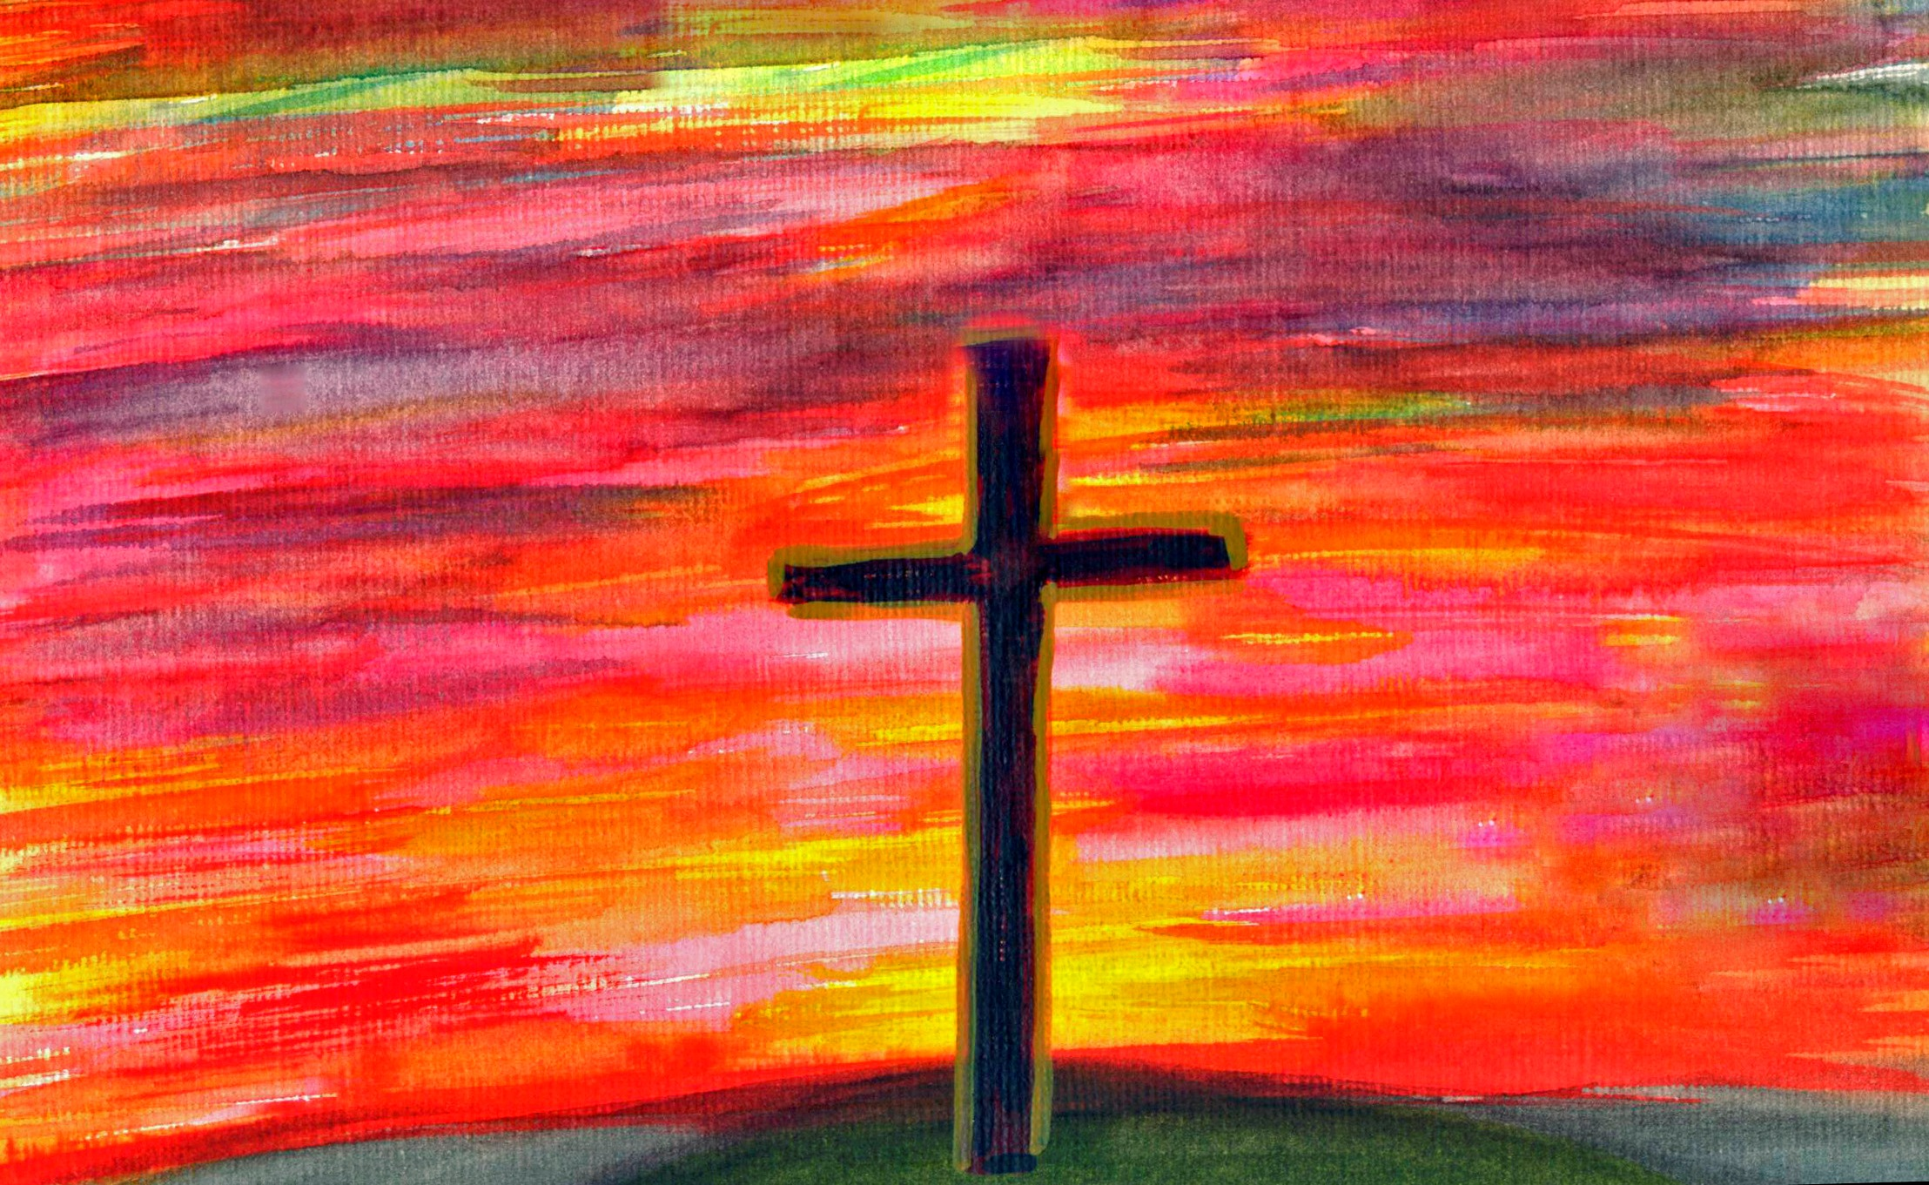

THE PASSION OF OUR LORD JESUS CHRIST
ACCORDING TO JOHN

Adapted for Four Voices and Congregation from JOHN 18:28-19-30

Before the narration starts The Congregation need to be warned that twice they will hear C/P (‘Crowds/Priests’) shouting “Crucify Him! Crucify Him!” and when they do they should all respond by chanting and shouting “Crucify Him! Crucify Him!” The Narrator (N) stands at the pulpit microphone throughout. ‘Pilate’ (P) operates a long-cabled microphone and uses it for himself, for Jesus (J) and (at times) for C/P’s. Movements are given in italics. At the start N is in place at the pulpit, P sits on a chair (side-on, near the top of the steps), holding the long-cabled microphone and C/P and J are at the back of the church. As the narration starts C/P roughly brings J to the front of the church and pushes him up the steps to stand in front of P. C/P remains waiting at the bottom of the steps.

N: Then they took Jesus from the House of Caiaphas, the High Priest, to Governor Pilate’s Headquarters at the Praetorium. It was still early in the day. The Jewish authorities did not go into the Praetorium, so that they would not be made ritually unclean and so be prevented from eating the Passover meal. (P moves down the steps)
So, Pilate came outside to them. He said:

P: What charge do you bring against this man?

N: They answered him:

C/P: If this man were not a criminal we wouldn’t have brought him here to you!

N: Pilate said to them:

P: Take him yourselves and try him according to your own law!

N: The Jewish leaders replied:

C/P: It is not lawful for us to put any man to death.

N: This meant that the words of Jesus came true – the words he said when he told of the way he would die.

(P goes back up the steps and sits facing the standing J,
C/P returns to the back, behind the congregation)

N: Pilate went back into the praetorium and, summoning Jesus, said:

P: Are you the King of the Jews?

N: Jesus answered:

J: Are you asking this of your own accord, or have other people told you things about me?

N: Pilate answered:

P: I am not a Jew, am I?.... Your own people and their chief priests have handed you over to me. So, what have you done?

N: Jesus answered:

J: I am not king of an earthly kingdom; if I were, my followers would fight to prevent me from being handed over to the Jewish authorities. But, as it is, my kingship is not of this world.

N: Pilate said to him:

P: So, you are a king, then?

N: Jesus replied:

J: You’re the one who says so. Yes, I am king. That’s why I was born.
That’s why I entered this world; to bear witness to the truth!
Everyone who belongs to the truth can hear what I am saying.

N: Pilate asked him:

P: What is truth? (P pauses, then shrugs, then goes to the top of the steps)

MUSICAL INTERLUDE FOR REFLECTION e.g. a stanza of the tune “Passion Chorale” on the piano

N; At this point Pilate went out to the Jews again, and addressed them:

P: (addressing the whole church) I can find no case against this man.
You have a custom that I should release one prisoner at the time of the Passover;
would you like me to release this ‘King of the Jews’?

N: They shouted back:

C/P: No! Not him! We want Barabbas!

N: Barabbas was a bandit.

(P goes back to his seat)

N: Then Pilate took Jesus and had him flogged.
The soldiers wove a crown out of pieces of thorn and put it on Jesus’ head
and dressed him in a purple robe.
They kept coming up to him saying “Long live the King of the Jews!”
then they would lean over and slap him in the face.

(P goes back to the top of the steps to address the crowd)

N: Pilate went out again and said to the crowd:

P: Look here, I’m going to bring the man out to you,
to let you all see that I can find no case against him!

N: So Jesus came out, still wearing the crown of thorns and the purple robe. Pilate said:
(J comes to top of steps, facing the congregation, P, beside him, gestures)

P: Here is the man himself!

N: When the chief priests and officials saw him they shouted out:

C/P: (shouting) Crucify him! Crucify him!

The Congregation: (shouting) Crucify Him! Crucify Him!

N: Pilate responded:

P: Take him yourselves and crucify him, for I can find no fault in him!

N: The Jews replied:

C/P: (shouting) We have a law. By that Law he ought to die. He claims to be the Son of God!

N: When Pilate heard these words he was quite shaken.
(P goes back with J. P sits and J stands facing him)
He went back into the Praetorium and asked Jesus:

P: Where do you come from?

N: But Jesus made no answer.
Pilate, therefore, said to him:

P: Are you refusing to speak to me?
Do you not know that I have the power either to release you or to have you crucified?

N: Jesus answered him:

J: You would have no power over me unless it had been given to you from above
That is why those who handed me over to you are even more guilty.
(P moves back to the top of the steps, as if to address the crowd again)

N: Hearing this, Pilate sought to release Jesus, but the people cried out:

C/P: (shouting) If you release this man, you are not Caesar’s friend!
Everyone who claims to be a king sets himself up against Caesar!

(During the next narration P brings J to the top of the steps, in the middle, facing the congregation, turns back & brings his chair forward, facing the congregation & sits on it)

N: When Pilate heard these words, he brought Jesus out, then sat down on the Judgement Seat at a place called ‘the Pavement’ (in Hebrew – ‘Gabbatha’).
It was almost noon on the day of preparation for the Passover.
Pilate addressed the people.

P: (shouting, but still seated) here is your King!

N: They shouted back:

C/P: (shouting) Away with him! Away with Him! Crucify Him! Crucify Him!

The Congregation: (shouting) Crucify Him! Crucify Him!

N: Pilate retorted:

P: Shall I crucify your King?

N: Even the chief priests answered:

C/P: (shouting) We have no king apart from Caesar!

N: Then Pilate handed Jesus over to them, to be crucified.
(P (gently) pushes J down the steps and follows him down the central aisle)

MUSICAL INTERLUDE FOR REFLECTION e.g. a stanza of the tune “Passion Chorale” on the piano

(During the music, P’s chair is removed. From this point onwards, P, J & C/P share the long-cable microphone at the back of the church, behind the congregation)

N: So they took Jesus and carrying his cross for himself, he went to what is called ‘The Place of the Skull” (in Hebrew, its ‘Golgotha’).
There they crucified him, and with him two others, one on either side, with Jesus in the middle.
Pilate also had an inscription made and placed on the cross.
….. Narrator Continues….

N: It read: “Jesus of Nazareth, the King of the Jews”.
Many of the people read it, for the place where Jesus was crucified was close to the city.
The inscription was in Hebrew, and in Latin, and in Greek.
The Jewish Chief Priests then said to Pilate:

C/P: You should not have put ‘King of the Jews’, but ‘This man said, I am the King of the Jews”’.

N: Pilate replied:

P: What I have written I have written!

N: Once the soldiers had put Jesus on his cross, they took his clothes, dividing them into 4 lots, one for each soldier. Then they took his tunic. Now, this tunic was seamless, woven continuously from top to bottom; so, they said to each other:

C/P: Let’s not tear it!
Let’s throw dice to see who will win it!

N: This happened so that the Scripture would come true that said ‘They divided my clothes among themselves, and gambled for my robes’.
And that is precisely what the soldiers did.

N: Standing close by the cross of Jesus were his mother, his mother’s sister, Mary the wife of Cleopas and Mary Magdalene. Seeing his mother and the disciple whom he loved standing near her, Jesus said to his mother:

J: Woman, let this be your son!

N: Then he said to the disciple:

J: Let this be your mother!

N: And from that moment the disciple took her into his own home. After this, Jesus knew that everything had happened that had to happen to let the Scriptures come true. He said:

J: I am thirsty.

N: A jar-full of cheap, vinegary wine had been left there.
So, someone soaked a sponge with the wine, put it on a hyssop-stalk and held it up to his mouth.
When Jesus had taken some of the wine, he said:

J: It is finished!

N: And Jesus bowed his head and died.

(After the music, N, J, P & C/P return to their places in the congregation)

MUSICAL INTERLUDE FOR REFLECTION e.g. a stanza of the tune “Passion Chorale” on the piano

