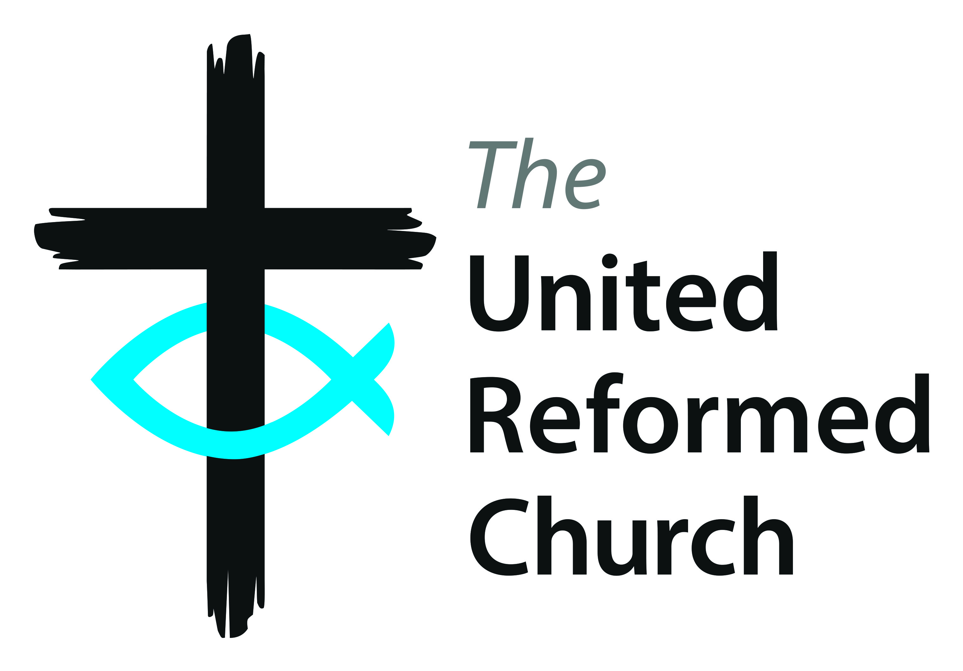

The United Reformed Church

**Community Project Awards 2021**

**ENTRY FORM**

**Up to three awards to be won for distinctive projects that make a positive contribution to the local community**



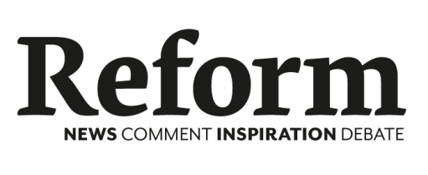Sponsored by

Congregational Insurance

**in association with**

***Reform* magazine**

To be awarded at the United Reformed Church General Assembly

Hayes Conference Centre, Swanwick, Derbyshire on Saturday 10 July 2021

# Name of Church:

# Name of project:

**Rules for Entrants**

1. No more than one entry will be accepted for any one project.
2. To be eligible, a project must be located within the UK. Church members of a United Reformed Church or a local ecumenical project where the United Reformed Church is present, must be actively involved in the running of the project.
3. Recipients of Community Project awards from 2007 onwards are not eligible to enter the 2021 Awards.
4. The Awards are intended as a form of recognition and are not intended to provide start-up finance.
5. Entries must be received by Friday, 26 February 2021.
6. The Judges will draw up a short list of entrants who will receive a visit. Following which the committee may select up to three projects to go forward as the short list for an award. The decision of the Judges is final and the selected projects will be notified by week ending 14 May 2021. The Judges reserves the right to select fewer than three projects, if in their opinion, these guidelines are not met or entries are not of the required standard.
7. A short film about the work of the winning projects will be produced by late June 2021. By applying, entrants confirm that if shortlisted they will take all necessary steps to protect vulnerable people, including children, and have sought and obtained the necessary approvals and written consents:
8. for filming taking place at their premises and,
9. from parents or guardians for the appearance of any children likely to be featured in the films or any promotional material.
10. i) Films made of shortlisted entrants may not be used by the respective projects for their own promotional purposes until after 17 September 2021. The films must remain in their original and unaltered form unless prior written permission allowing changes to be made has been obtained from the communications department of the United Reformed Church.

ii) Should an entrant that has been shortlisted withdraw from the awards, after a film has been made, but before a winner has been announced at General Assembly, the project may not use the film for their own promotional purposes until the full cost of production of the film has been reimbursed to the United Reformed Church and permission has been granted for the film to be used, which in any event will not be before 17 September 2021.

9. The promoter of the Awards is the ‘United Reformed Church’ (registered office is Church House, 86 Tavistock Place, London, WC1H 9RT) and sponsor of the awards is ‘Congregational’ (‘Congregational’ is a trading name of Integra Insurance Solutions Ltd. Registered office: Currer House, Currer Street, Bradford BD1 5BA. Registered in England and Wales Registered number 06760260).

10. The copyright and other intellectual property rights of all material brought into existence in connection with the Community Project Awards 2021 are the property of Integra Insurance Solutions Ltd. This includes, but is not limited to, all photographs and material appearing on the United Reformed Church website (www.urc.org.uk) and Congregational website (www.congregational.co.uk). The copyright of all films made of shortlisted entrants are the property of the United Reformed Church.

11. Entrants must agree to one or two representatives to attend the Awards Ceremony, which will take place during the General Assembly of the United Reformed Church, on Saturday 10 July 2021, approximately 12 noon at Hayes Conference Centre Swanwick, Derbyshire.

12. As a condition of winning an award, entrants must agree to any reasonable requests on the part of ‘Congregational’ and/or *Reform* Magazine and/or the Communications Team of the United Reformed Church, to participate in any promotional events connected with the competition such as interviews or photographs.

13. The total prize fund is up to £6,000 and this will be allocated to up to three projects short listed for final judging. The amounts awarded to each of the winning projects will be at the sole discretion of the judges.

14. The United Reformed Church and ‘Congregational’ reserve the right to amend these ‘Rules for Entrants’ as circumstances may require from time to time without prior notice to the entrants. By entering the Community Project Awards, the entrant accepts and agrees to abide by these ‘Rules for Entrants’.

15. Information and data provided by entrants whether ‘personal’ or ‘non-personal’ will be held for up to three years and used by the United Reformed Church and ‘Congregational’ to administer the awards programme and in respect of any related promotional activities.

**Completed entries must be received by Friday 26 February, 2021.**

Completed entry forms should be sent to:

Email: [awards@urc.org.uk](mailto:awards@urc.org.uk)

Post: Community Project Awards, Communications Department, United Reformed Church House, 86 Tavistock Place, London, WC1H 9RT.

**www.urc.org.uk/awards**

**Contact Details**

**Your name and church**

|  |
| --- |
| Named contact for correspondence: |
| Name and address of sponsoring United Reformed Church: |
|  |
|  |
|  |
|  |
|  |
| Position in church (if applicable): |
| Role in project: |

**Your address**

|  |
| --- |
| Correspondence address: |
|  |
|  |
|  |
|  |
|  |
|  |
| Contact phone number: |
| Contact email address: |

**Please review the form before commencing your application. Please type your answers in the boxes below. Many thanks for entering and good luck!**

1. **Please provide a summary of your community project in 100 words or less.**

**Then describe the project in more details including how it helps the church reach out to the local community. Please keep your response to this part of the question to no more than 750 words.**

1. **Please describe how you would you use the prize money to develop the project further.**
2. **Please list the typical activities undertaken at the project, giving details of their time and frequency, showing numbers of attendees and a description of the type of work done.**
3. **What is the annual running cost of the project?:**

**£**

1. **Please list the sources of finance for the project:**
2. **Please detail the people involved in the running of the project:**

Number of paid staff? _______

Number of church volunteers? _______

Number of other volunteers? _______

Total number involved: _______

1. **Please detail the practical benefits to the community and how the church’s involvement has made a difference:**

Signature:_______________________________________ Date: __________________

**Completed entries must be received by Friday 26 February, 2021.**

**Completed entry forms should be sent:**

**By email:** [awards@urc.org.uk](mailto:awards@urc.org.uk)

By post: Community Project Awards, Communications Department, United Reformed Church House, 86 Tavistock Place, London, WC1H 9RT