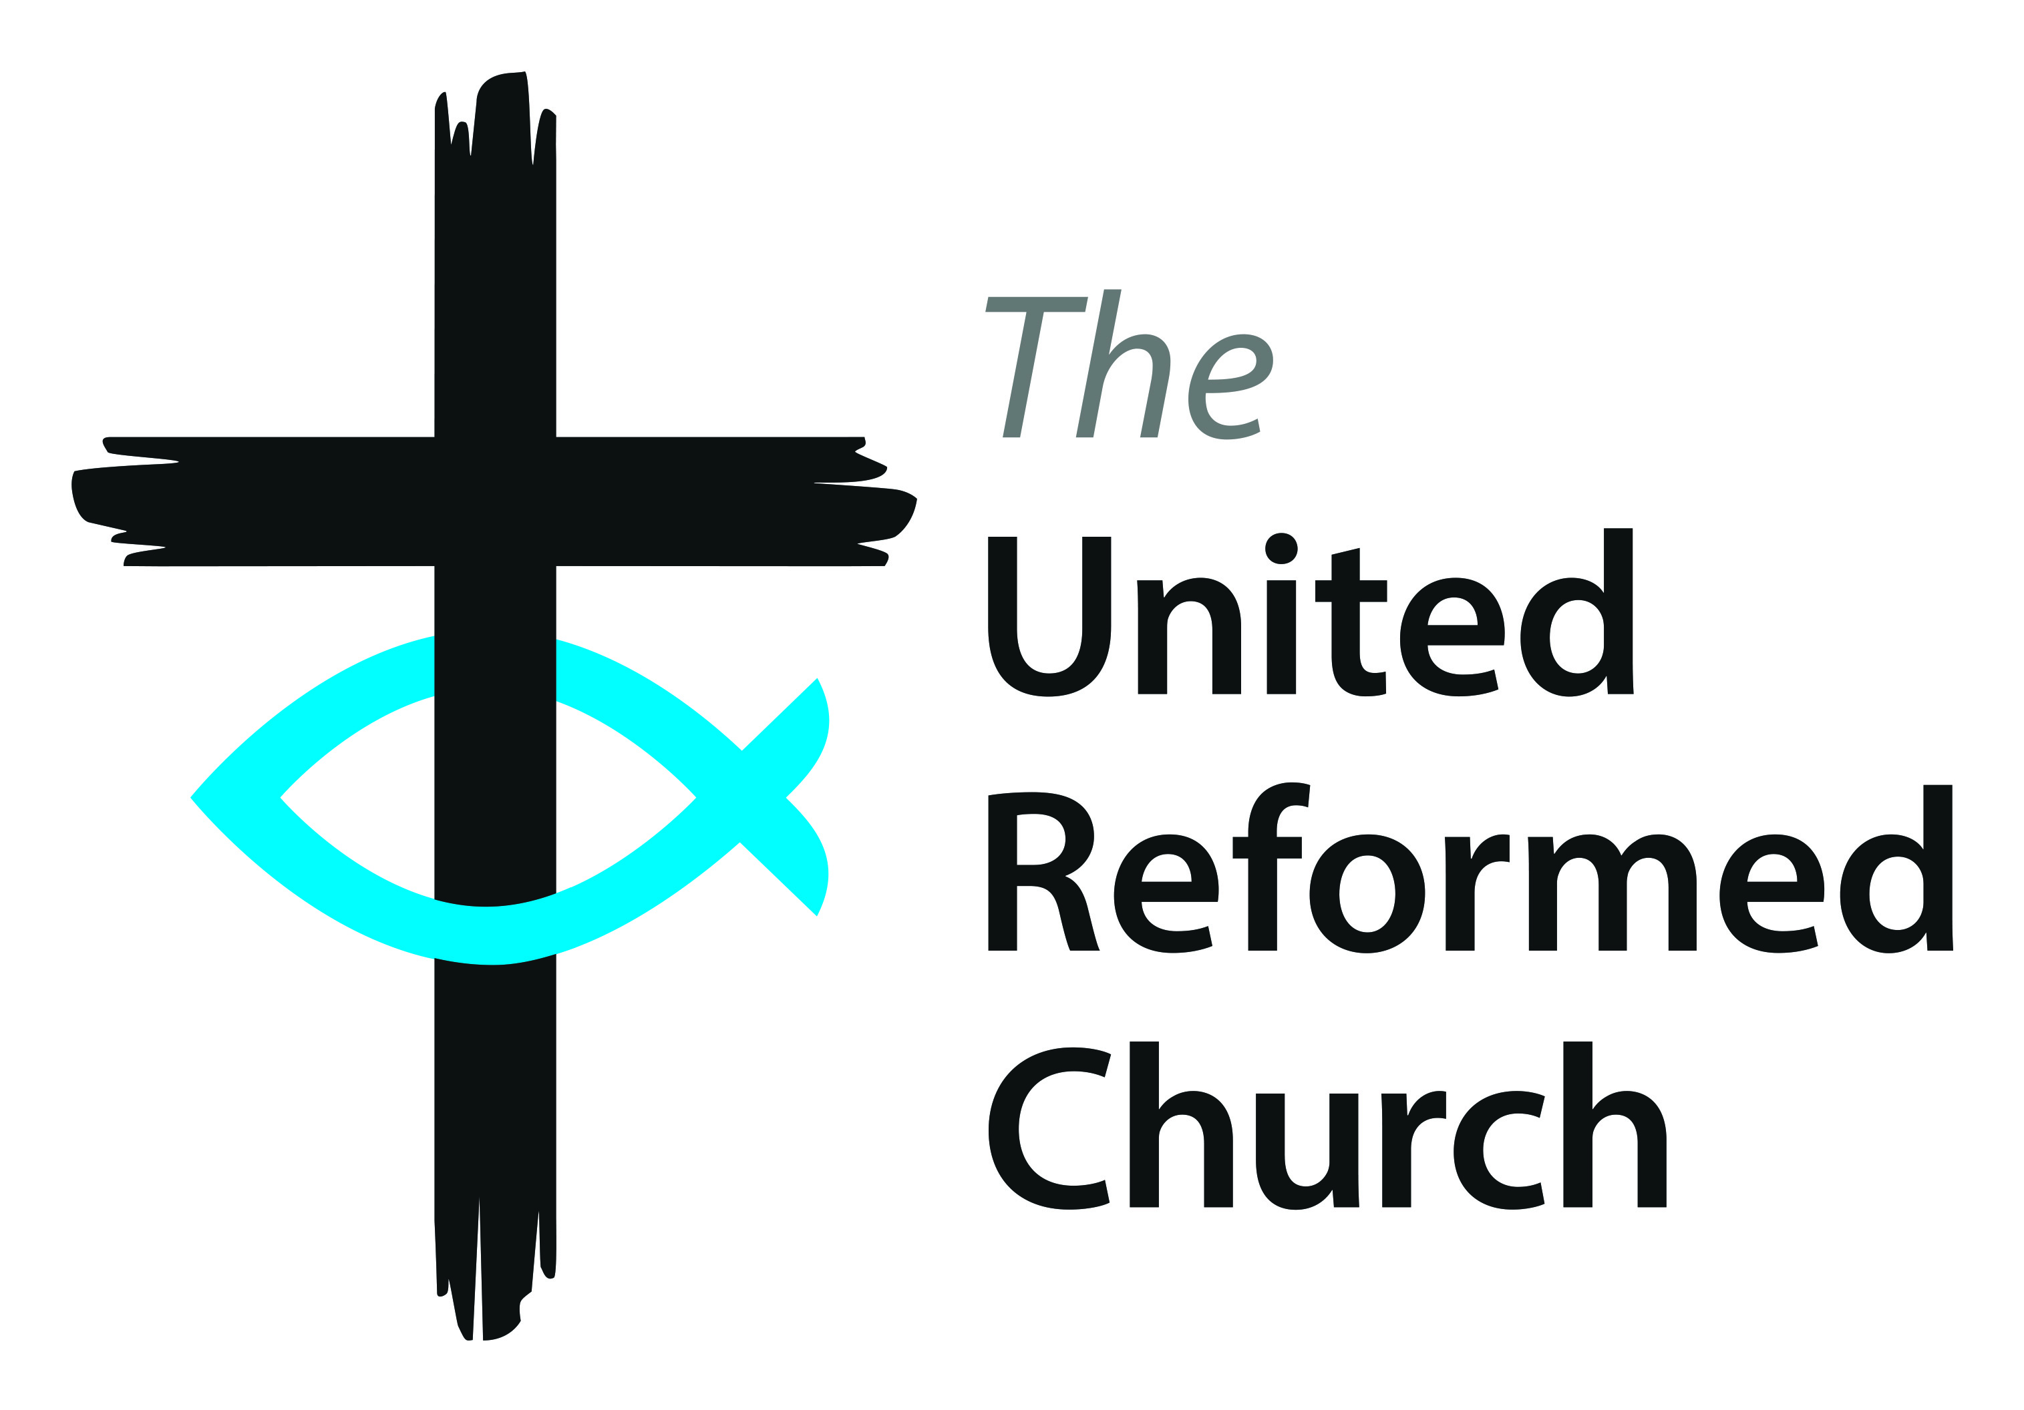



The United Reformed Church

**Community Project Awards**

2018

**Entry form**

**Up to four awards to be won**

for distinctive projects that make a positive contribution to the local community

Sponsored by  
Congregational Insurance

**in association with  
*Reform* magazine**

To be awarded at the United Reformed Church General Assembly

The Albert Hall, Nottingham on Saturday 7July 2018

# Name of church:

# Name of project:

**Rules for entrants**:

1. No more than one entry will be accepted for any one project.
2. To be eligible, a project must be run in the UK by members of the congregation of a United Reformed Church or by a local ecumenical project where the United Reformed Church is present.
3. Recipients of Community Project awards from 2007 onwards are not eligible to enter the 2018 Awards.
4. The Awards are intended as a form of recognition and are not intended to provide start-up finance.
5. Entries must be received by Wednesday, 28 February 2018.
6. A selection committee will draw up a long list of entrants. These long-listed projects will receive a visit from a member of the selection committee, following which the committee may select up to four projects to go forward as the short list for an award. The decision of the selection committee is final and the selected projects will be notified by week ending 11 May 2018. The committee reserves the right to select fewer than four projects, if in their opinion, these guidelines are not met or entries are not of the required standard.
7. A short film about the work of the winning projects will be produced by late June 2018. By applying, entrants confirm that if shortlisted they will take all necessary steps to protect vulnerable people, including children, and have sought and obtained the necessary approvals and written consents:
8. for filming taking place at their premises and,
9. from parents or guardians for the appearance of any children likely to be featured in the films or any promotional material.

8. i) Films made of shortlisted entrants may not be used by the respective projects for their own promotional purposes until after 7 September 2018. The films must remain in their original and unaltered form unless prior written permission allowing changes to be made has been obtained from the communications department of the United Reformed Church.

ii) Should an entrant that has been shortlisted withdraw from the awards, after a film has been made, but before a winner has been announced at General Assembly, the project may not use the film for their own promotional purposes until the full cost of production of the film has been reimbursed to the United Reformed Church and permission has been granted for the film to be used, which in any event will not be before 7 September 2018.

9. The copyright and other intellectual property rights of all material brought into existence in connection with the Community Project Awards 2018 are the property of the United Reformed Church. This includes, but is not limited to, all films, photographs and material appearing on the websites of the United Reformed Church and Congregational Insurance.

10. Entrants must agree to one or two representatives to attend the Awards Ceremony, which will take place during the General Assembly of the United Reformed Church, on Saturday 7 July 2018, time to be confirmed, at the Albert Hall, Nottingham.

11. As a condition of winning an award, entrants must agree to any reasonable requests on the part of Congregational Insurance and/or *Reform* Magazine and/or the communications department of the United Reformed Church, to participate in any promotional events connected with the competition such as interviews or photographs.

12. The prize money will be awarded as follows: first Prize up to £4000 and up to three further runners up prizes of up to £2000 each. These prizes are the final amounts payable at each level notwithstanding that there may be fewer than four projects short listed for final judging. The amounts awarded to each of the winning projects will be at the sole discretion of the judges.

13. The United Reformed Church and Congregational Insurance reserve the right to amend these ‘Rules for Entrants’ as circumstances may require from time to time without prior notice

to the entrants.

14. By entering the Community Projects Awards 2018 the entrant accepts and agrees to abide by these

‘Rules for Entrants’, which may be amended from time to time.

15. Information and data provided by entrants whether ‘personal’ or ‘non-personal’ will be held for up to three years and used by the United Reformed Church and Congregational Insurance to administer the awards programme and in respect of any related promotional activities.

**Completed entries must be received by 5pm on Wednesday 28 February 2018**

Completed entry forms should be sent to:

Email: [awards@urc.org.uk](mailto:awards@urc.org.uk)

Post: Community Project Awards, Communications, 86 Tavistock Place, London, WC1H 9RT

**Contact Details**

**Please complete the appropriate sections and tick the relevant boxes.**

**Your name and church**

|  |
| --- |
| Named contact for correspondence: |
| Name and address of sponsoring United Reformed Church: |
|  |
|  |
|  |
| Position in church (if applicable): |
| Role in project: |

**Your address**

|  |
| --- |
| Correspondence address: |
|  |
|  |
|  |
|  |
| Contact phone number: |
| Contact email address: |

**Please provide the name and contact details of someone who is willing to be a referee for the project.**

|  |
| --- |
| Name: |
| Contact phone number: |
| Contact email address: |
| Relationship to the project: |

1. **Describe your project in detail, outlining its main aims and objectives and indicating how you believe this project could be replicated by others.**

|  |
| --- |
|  |
|  |
|  |
|  |
|  |
|  |
|  |
|  |
|  |
|  |
|  |
|  |
|  |
|  |
|  |
|  |
|  |
|  |
|  |
|  |
|  |
|  |

If you require more space, please attach a separate sheet; if submitted electronically the

box will expand.

1. **If your project won one of the awards, please describe how you would you**

**use the prize money to develop the project further.**

|  |
| --- |
|  |
|  |
|  |
|  |
|  |

1. **Please list the typical activities undertaken at the project, giving details of their time and frequency, showing numbers of attendees and a description of the type of work done.**

|  |
| --- |
|  |
|  |
|  |
|  |
|  |
|  |
|  |
|  |
|  |
|  |

1. **What is/was the maximum annual budget available to fund the project:**

**At start-up: £ ______**

**For ongoing capital costs: £ ______**

**For annual running costs: £ ______**

1. **Please list the major sources of finance for the project:**

|  |
| --- |
|  |
|  |
|  |
|  |
|  |

1. **Please provide a summary of last financial year’s accounts (if any).**

|  |
| --- |
|  |
|  |
|  |
|  |
|  |

1. **Details of people involved in the running of the project.**

How many paid staff? _______ How many church volunteers? _______

How many other volunteers? _______ Total number involved: _______

**8. Emphasising what is different because of the project, please detail any practical benefits to the community**

|  |
| --- |
|  |
|  |
|  |
|  |
|  |
|  |
|  |
|  |
|  |
|  |
|  |

Signature_________________________________________ Date: __________________

**Completed entries must be received by 5pm on Wednesday 28 February 2018**

**Completed entry forms should be sent to:**

**By email:** [awards@urc.org.uk](mailto:awards@urc.org.uk)

By post: Community Project Awards, Communications, 86 Tavistock Place, London, WC1H 9RT