Prayer
P
artners
2021 A Commitment for Life resource
This resource offers prayers based on ‘Life-giving faith, defiant hope, generous love’.
The prayers can be used for church websites, magazines, and displays, to help people focus on generosity of mind and spirit.

Prayer for the Children: Heroes and villains
Kevin Snyman

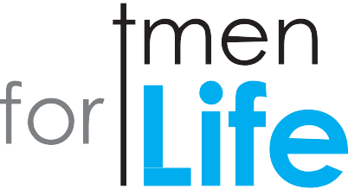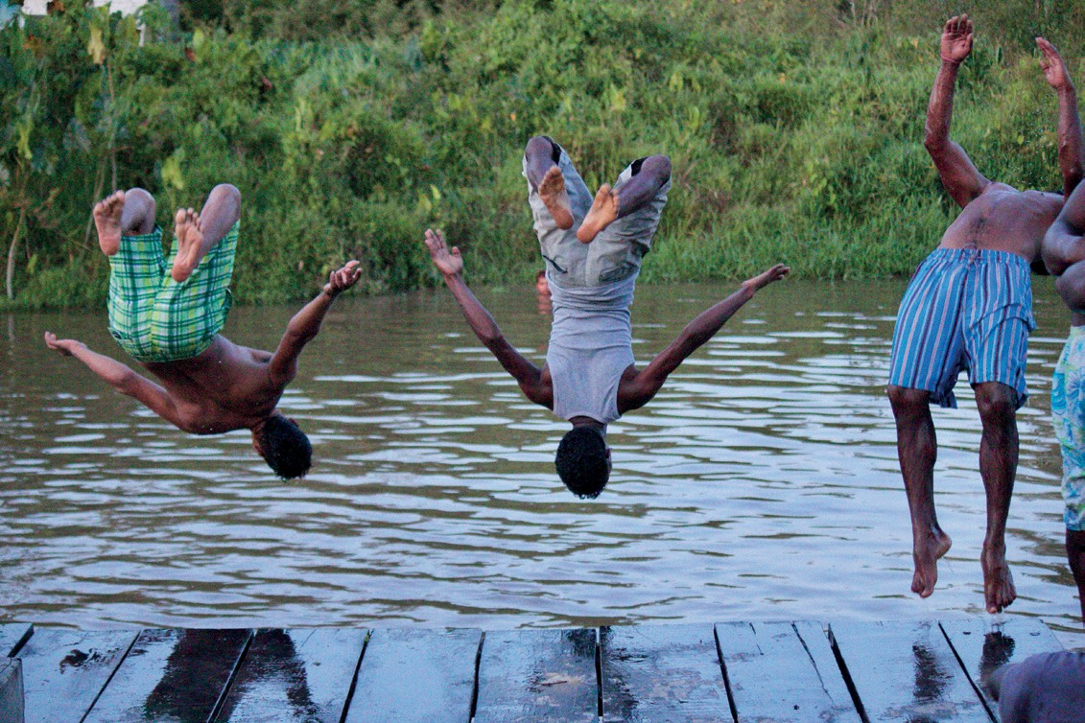Jesus, we love to sit beside our and listen to stories of heroes and villains. What must fill your
when you hear the children ! What desolation you must feel when you see a child hurt, frightened or . Jesus, just as you called all the children to
be by your side, offering food and life, protection and safety, may we too be a people rising up like heroes to love, honour, and protect all the children of the world. Amen.

Prayer for Bangladesh
David Jonathan

God, we thank you for the rich tapestry of the art, poetry and the cultural heritage of Bangladesh. We thank you that despite being the eighth most densely populated country, Bangladesh is assisting Rohingya
refugees and helping them during the life- confining Covid-19 pandemic. We pray for Bangladesh’s poverty and environmental crisis, including groundwater metal contamination and increased salinity due to human and industrial greed for profit.
Help us to act responsibly, Lord. Help us to live simply so that others in countries like Bangladesh can simply live. Amen.

Prayers for our Partners
Suzanne Pearson

Gracious God, creator, provider and sustainer of all things; we have not taken good care of the wondrous creation that you gave us to oversee. We have not loved as you commanded, but have allowed selfishness, self- importance, injustices and inequalities to invade our societies leading
to climate disruption, social and economic disparities. Through our actions people all over the globe have been left vulnerable, desolate and open to disease and poverty.
We pray that you will bless the work of organisations such Christian Aid, Global Justice Now, Fairtrade, Jubilee Debt Campaign and other groups
as they seek to respond to global spiritual, moral, social and economic issues to make it a fairer and more equal world. In your mercy, hear our prayer. Amen.

Economic Justice
Richard Lewney

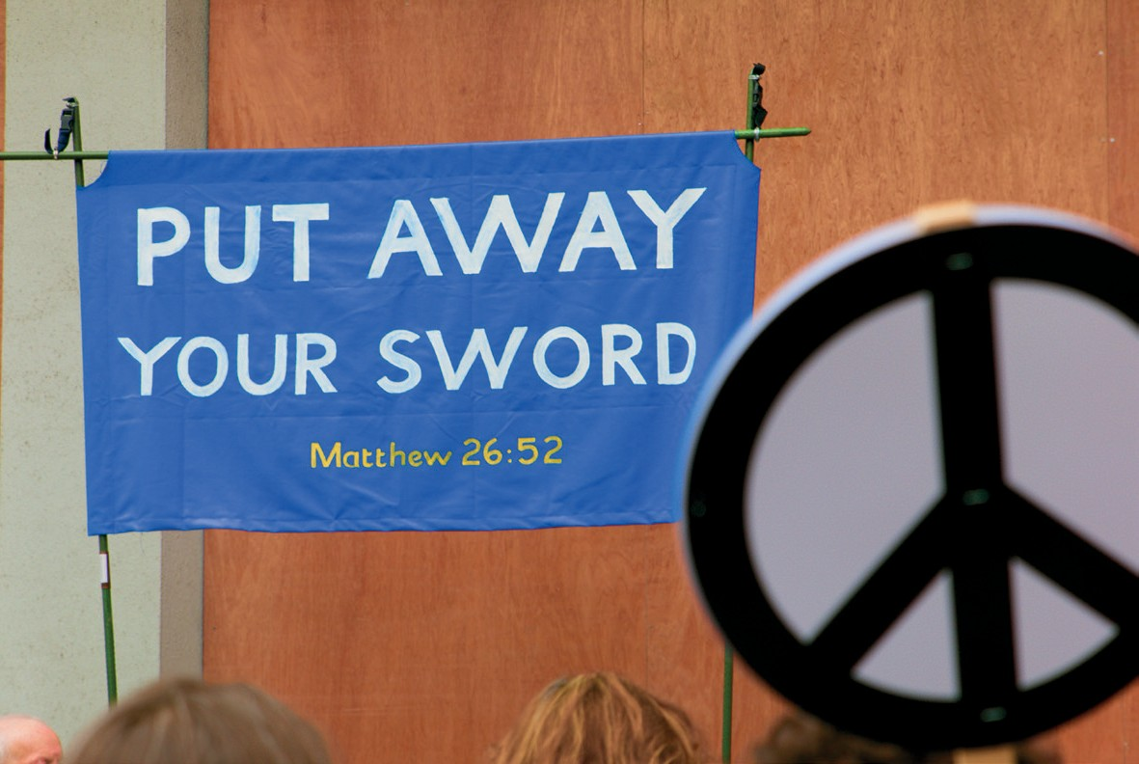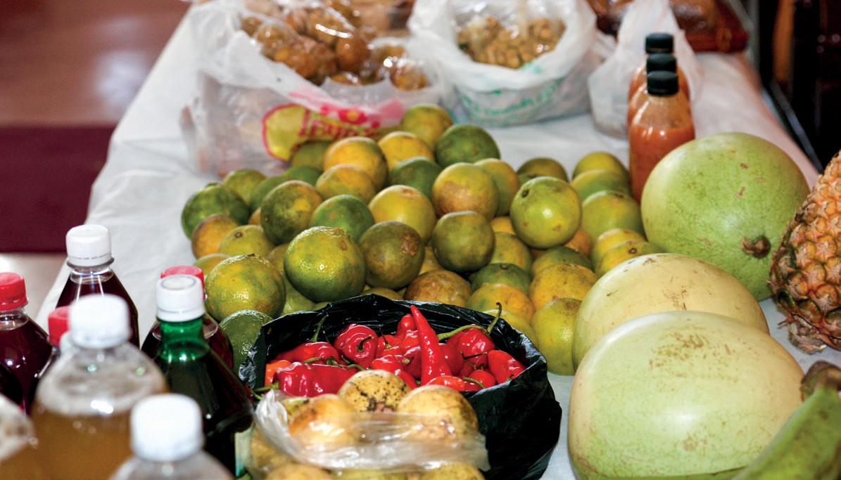“God said, ‘You fool! This very night your life is being demanded of you. And the things you have prepared, whose will they be?’
So, it is with those who store up treasures for themselves but are not rich towards God.” (Luke 12:20-21)
Holy God, we confess the times when we have tried to grasp security by hoarding your gifts. We confess the times when we have tried to grasp life in all its fullness by medicating ourselves with another dose of more stuff. We confess the times when we have tried to grasp self-respect by acquiring the trappings of success. Free us, we
pray. Give us an open heart and a generous spirit to respond to our neighbour in need, whether nearby or far away. Show us the part we can play in redeeming our economic system, bringing it under the rule of your kingdom.

Prayer for Israel and the Occupied Palestinian Territories
Felicity Tunnard

We pray for all the people in Israel and Palestine. Help us to seek peace, justice, hope, and dignity for all people living in this situation. Help us to be their voice and help us to share their stories with others, even though there is uncertainty, indifference, and opposition. Give us the strength to seek an end to the occupation, so that both Israelis and Palestinians can create a better future for themselves. Help us to prepare tables of dialogue, and opportunities for truth-telling around us. We pray that the people may start to witness small signs of hope and remember they’re not alone. For all our Christian brothers and sisters in Israel/Palestine, this day, we pray “the peace of Christ”. Amen.

A Prayer for Fairtrade
Kevin Snyman

Jesus, you prayed that we might forgive all debt: not forgive debt once only, but forgive consistently and relentlessly. That is hard. We confess that we are trapped utterly by an economics of debt, an economics of death. We don’t know how to operate differently. We cry for your help: show us another way! Nevertheless, we can subvert this economics of death starting today through simple acts of reckless generosity. We can buy Fairtrade. We can choose to pay more. We can choose to place the needs of farmers and workers above our wants and desires. Yet even as we foster Fairtrade, we ask that you give us the wisdom and willingness
to discover an entirely new economics of life; one that is no longer is predicated on debt. In Jesus’ name we pray for the sake of all life on earth. Amen.

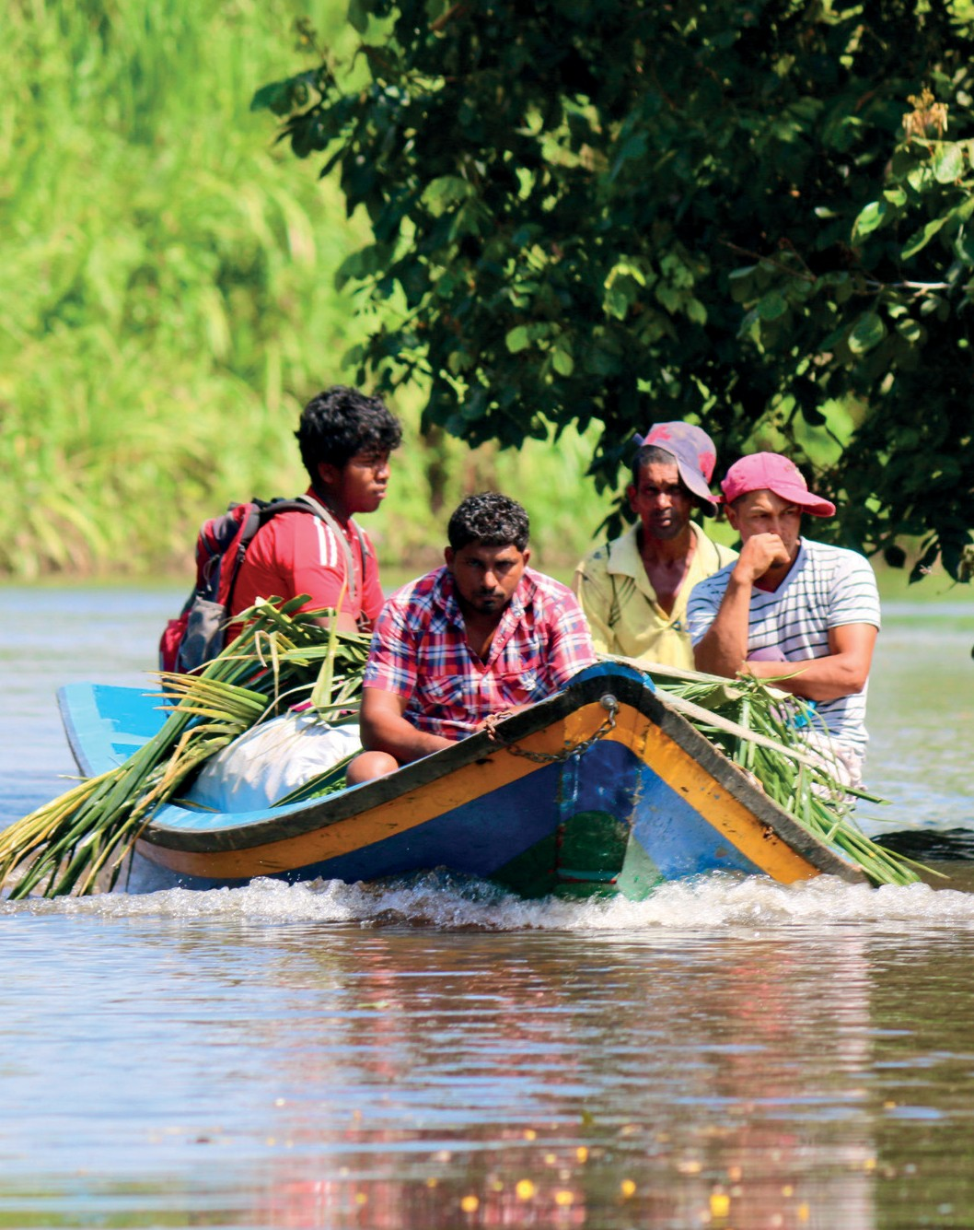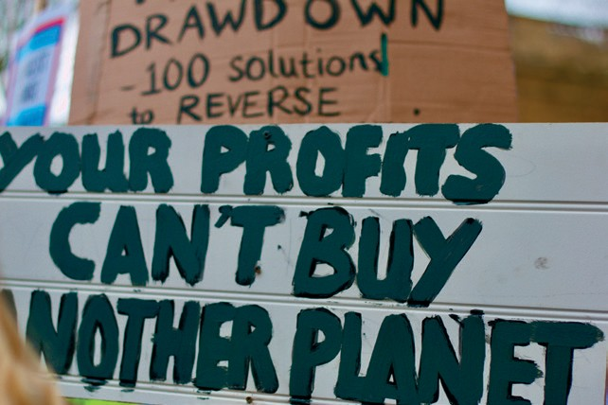Prayer for Divestment from Fossil Fuels
Diana Paulding

The fuels that we dug from your earth drove revolution and let us build industries
and create new things. Let us give thanks for the benefits they brought, but accept that it is time to let them go. And having given thanks, let us build a future where you guide us through wind, tide and sun to energy
that does not exhaust your earth. We pray for a renewed and renewable world, where politicians are willing to embrace new ways and we are prepared
to let go of practices that do not serve your Kingdom.
Amen.

Prayer for Zimbabwe
Wilbert Sayimani
Prayer for Central America
Wendy Cooper

Loving God, you constantly remind us that all people are made in
your image. Thank you that as we support the work of our partners, we can put names to faces and be challenged by their example to be change makers in our lives. We pray for our partner countries in
Central America, especially as they struggle to cope with the ongoing impact of coronavirus on the most vulnerable. We give thanks: for the inspiring people working together in projects that are transforming the lives of their communities; for those speaking out against injustice,
motivating others in the fight against corruption and for transparency; and for those training and empowering indigenous young people. In the love of Jesus, we pray. Amen.

Lord God, in pursuit for justice, freedom and civil liberties, we pray for the leadership of Zimbabwe. Give them wisdom, vision and a desire for justice. We bring before you men and women serving prison sentences for crimes they did not commit. Men, women, and children struggling to put food on
their tables as all their means of survival have been thwarted. Lord, we pray for the eroding economy of this land. Weed out all corrupt elements to prepare for the kind of
governance that you desire. We pray for those risking their lives crossing borders in search for greener pastures elsewhere, which for some remains a “pie in the sky” even when they get there. We bring before you those dying in hospitals or at home with no access to drugs or better facilities. We do not forget those sacrificing their own lives for the sake
of others. Doctors, nurses, teachers and all other civil servants fighting for the good of all. You are a good God and you hear the prayers of your people. Hear us Lord and come and heal Zimbabwe. Amen.

Prayer for Creation
Charles Jolly

Creator God, eternal loving parent – when I stop to think, I have to pinch myself to check that we really are here! I mean,
how come this mind- boggling universe has precisely the properties that make life possible? Then scientists, with all
their brilliant tools, tell us that the chance of intelligent life evolving (us) is probably vanishingly small. Maybe you needed those
countless galaxies with all their untold stars so that (just once?) you might find beings who had hearts and souls and minds and strength for you? A race that gave you a way to step into your creation to crown
it with your glory? How can we bear the responsibility of being your children? Your purpose in creation hangs in the balance; our race stands at a fork in the road. The narrow way leads to peace of heart, to harmony with each other, to harmony with earth, your other than human creation. The broad way leads to spiralling chaos, bringing untold suffering on humanity and wantonly destroying, in a few short years, what
took billions to produce and can never be replaced. Amen.

Prayer for Black Lives Matter
Naison M Hove

God of all life, Lord of all nations, God of all peoples. We thank you for our lord Jesus Christ, who did not allow any colour, or shade of the skin, to divide and break your community using the mantra of race, religion and ethnicity. Lord, O Lord, we are dying because of blackness. Lord, we rejoice at the
resurrection of our risen Lord, who conquered the evil of racial divide for all peoples on the Cross of Calvary. Lord Jesus Christ, you died on the Cross and rose to life. You liberated all, including people of colour and the caucasian. Lord, do “Black Lives Matter” in your world? Can black women and men sing a song of praise to God? Lord take pity upon the sheep of your flock. Grant us life, grant us hope, grant us a cure to the virus of racism.
In the name of the risen Lord, we beseech you.
Amen.

A Prayer for Christmas
Kevin Snyman

Ho! Ho! Ho! Dearest God, as we hear Santa’s sleigh approaching this Christmas Eve, may the gifts under our Christmas tree be bigger and better than ever! Yes
God, far, FAR bigger portions of food for the hungry! A much, MUCH better economic system – one that works brilliantly for the poor and really not-
so-well for the super-rich! Much, MUCH more justice for the oppressed.
Far, FAR bigger taxes on the rich. Huge windfarms and batteries

www.cforl.org.uk
These prayers and photos can be reproduced for non-commercial use.
that decimate fossil fuel companies, and not forests and lakes. Ah yes God, may this be the biggest, bestest Christmas ever!
Ho, Ho, Ho - Amen.

The United Reformed Church, 86 Tavistock Place, London WC1H 9RT www.urc.org.uk tel: 020 7916 8638 email: cforl@urc.org.uk

Working with Christian Aid and
the World Development Movement

Charity number 1105851

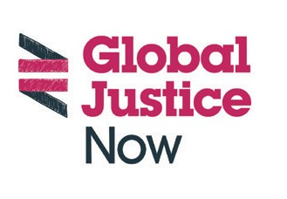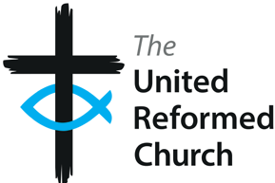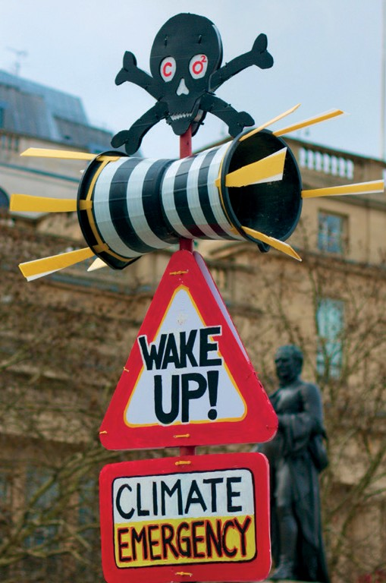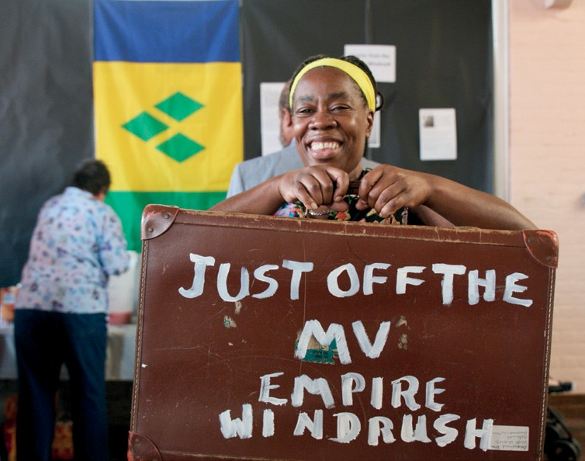
The United Reformed Church Trust (URC Trust) is a limited company in England and Wales (Registered Number 135934) and a charity (1133373). Christian Aid UK charity (1105851) and company (5171525). Global Justice Now is a charity (1064066) and company (2098198).

