Advent candle liturgy

olive tree project

Revd David Coaker

Grays United Reformed Church Permission received from Embrace the Middle East

# 

## Introduction

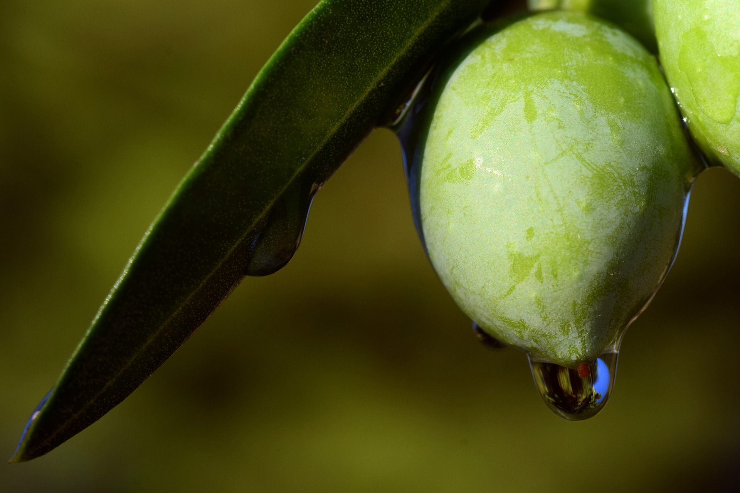The following brings together an Advent candle-lighting liturgy based on the lectionary readings for Year A, with the theme of olive trees. The intention is to encourage congregations to learn and pray and act in support of *Commitment for Life*, and in support of the Olive Tree Project of the charity Embrace the Middle East:

(https://www.embraceme.org)

## background

(To be shared in church newsletter / notices or in worship before or on Advent Sunday.)

The olive tree is a universal symbol of peace and a powerful symbol of Palestinian rootedness in their land.

But in the political turmoil of the Middle East today, trees that have survived hundreds of years have become casualties in the struggle for the control of the land.

Olive trees are also a major source of income for Palestinians for centuries, with trees covering over 50% of agricultural land.

The olive and olive oil industry supports the livelihoods of around 100,000 Palestinian families.

Since the Israeli occupation of the West Bank began in 1967, Palestinian farmers have lost hundreds of thousands of olive trees.

Trees planted and cared for by generations of the same family have been destroyed or uprooted as Israeli settlers seek to claim Palestinian land as their own.

Through an initiative called 'Keep Hope Alive', Embrace the Middle East partner with the Joint Advocacy Initiative to plant saplings in Palestinian-owned areas that are at risk of confiscation.

Video clip: https://youtu.be/cFsWxeacXzo

ADVENT LITURGY

Week 1

Opening Words: Matthew 24:36, 42 (NRSV)

But about that day and hour no one knows, neither the angels of heaven, nor the Son, but only the Father. Keep awake therefore, for you do not know on what day your Lord is coming.

Advent hymn (see below) verse 1 Light Advent Candle (1)

Prayer

As we begin our journey of Advent, liberate us loving God from falling into the pattern of four predictable weeks. Free us to be more aware of the world around us. To see the variety of experiences, feelings and traditions that are before us in this season. Help us to be watchful, aware, awake, ready and prepared to encounter Christ within our hearts, and in the people we come across in the coming days. Amen.

Week 2

Opening Words: Matthew 3:1-2, 10 (NRSV)

In those days John the Baptist appeared in the wilderness of Judea, proclaiming, “Repent, for the kingdom of heaven has come near.” Even now the ax is lying at the root of the trees; every tree therefore that does not bear good fruit is cut down and thrown into the fire.

Advent hymn (see below) verse 1 & 2 Light Advent Candle (1 & 2)

Prayer

Eternal Father amidst all the noise and busyness of this time of year, may we hear your voice crying out for us to prepare your way. May we hear, but may we also truly listen, reflect and respond. May we not discount any words we hear because of who they come from, or how they make us feel, or how many times we have heard them before.

In this season of Advent may we be prepared for change, to listen for your challenge, and truly listen, reflect and respond. Amen.

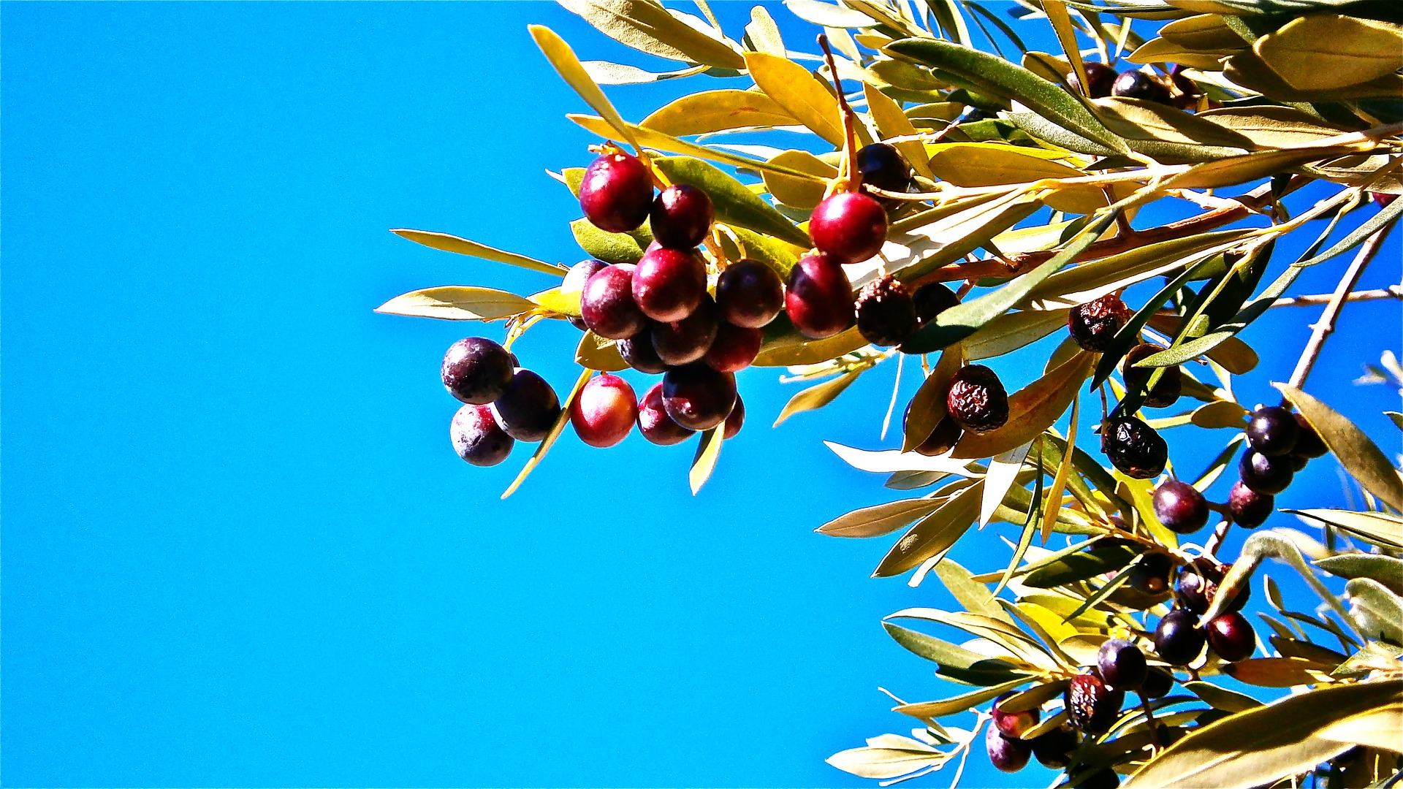

Week 3

Opening Words: Matthew 11:7-8 (NRSV)

“What did you go out into the wilderness to look at? A reed shaken by the wind? What then did you go out to see?

Advent hymn verse 1 - 3 Light Advent Candle (1 - 3)

Prayer

Holy God, may we truly see the signs of your Kingdom in the world around us, in our lives, and reflected in our hearts. May we be able to see what we have ignored, whatever holds us back, the ways in which we fall short, the aspects of our faith that have withered on the vine, to hear the voices we have drowned out, and then go out to share the good news beyond these walls.

May we be your messengers, putting aside our comfort and standing firm in the wilderness winds that may come. May we truly see the signs of your Kingdom in the world around us, in our lives, and reflected in our hearts. Amen.

Week 4

Opening Words: Matthew 1:20, 23 (NRSV)

“Joseph, son of David, do not be afraid to take Mary as your wife, for the child conceived in her is from the Holy Spirit. ... name him Emmanuel,” which means, “God is with us.”

Advent hymn verse 1 - 4 Light Advent Candle (1 - 4)

Prayer

God is with us. A promise that echoes down the ages. A promise we particularly celebrate in this season. Yet a promise we sometimes find hard to truly live.

Parent God, remind us that we are your children. Encourage us to step forward in faith, trusting in you, in each other, and in ourselves.

God is with us. In the life of Christ, in the prophets that have gone before, in people of faith throughout the ages, and in each and every one of us, that promise lives. God is with us. Let us live it, celebrate it, and foster it in our lives and in the world around us. Amen.

Christmas Eve / Day:

Opening Words: John 1:3-5 (NRSV)

What has come into being in him was life, and the life was the light of all people. The light shines in the darkness, and darkness did not overcome.

Advent hymn verse 1 - 5 Light Advent Candle (1 - 5)

Prayer

Let us testify to the light of God. The light that shines through Jesus, his life, death, and the Resurrection. The light that has shone throughout the world and time whenever the flame of God’s Kingdom has burned. The light that we are called to tell, teach, tend, be transformed by, and treasure. The light that still shines, however dark it seems to be. Let us testify to the light of God. In our joy and regret, in our solitude and company, in our noise and our silence. Let us testify to the light of God. Amen.

ADVENT HYMN (Sussex Carol LM Irregular)

**The olive tree against the sky**

1. The olive tree against the sky strong and healthy as time goes by.

The olive tree means life and health to those who tend and till the earth.

They connect us to ages gone, and keep watch over ages to come.

2. The seasons come, the seasons go, the trees are pruned and harvests grown.

Through constant change their needs are met, for oil and wood for the market.

Not every change is for the good, man and weather can harm the wood.

3. The hands that tend see more than we, they know the stories of every tree.

The harvests grown, the storms that wrack, are there in every twist and crack.

We see a wilderness spotted with trees, they see all times connected by these.

4. To plant a tree shows commitment, to trust a future not seen yet.

Roots that spread to gather the rain, leaves them open to harm and pain.

Yet in that trust are promises true, God is with us, and all is new.

5. So in this season let us be light, and shine a love that is so bright.

We celebrate the birth of a man, light of hope since the world began.

Hold the branch of an olive tree, and live the peace we’re called to be.

Lectionary Gospel Readings: (Advent Year A)

1. Matthew 24:36–44 (NRSV) The Necessity for Watchfulness

36 “But about that day and hour no one knows, neither the angels of heaven, nor the Son, but only the Father. 37 For as the days of Noah were, so will be the coming of the Son of Man. 38 For as in those days before the flood they were eating and drinking, marrying and giving in marriage, until the day Noah entered the ark, 39 and they knew nothing until the flood came and swept them all away, so too will be the coming of the Son of Man. 40 Then two will be in the field; one will be taken and one will be left. 41 Two women will be grinding meal together; one will be taken and one will be left. 42 Keep awake therefore, for you do not know on what day your Lord is coming. 43 But understand this: if the owner of the house had known in what part of the night the thief was coming, he would have stayed awake and would not have let his house be broken into. 44 Therefore you also must be ready, for the Son of Man is coming at an unexpected hour.

2. Matthew 3:1–12 (NRSV) The Proclamation of John the Baptist

3 In those days John the Baptist appeared in the wilderness of Judea, proclaiming, 2 “Repent, for the kingdom of heaven has come near.” 3 This is the one of whom the prophet Isaiah spoke when he said, “The voice of one crying out in the wilderness: ‘Prepare the way of the Lord, make his paths straight.’ ”

4 Now John wore clothing of camel’s hair with a leather belt around his waist, and his food was locusts and wild honey. 5 Then the people of Jerusalem and all Judea were going out to him, and all the region along the Jordan, 6 and they were baptized by him in the river Jordan, confessing their sins.

7 But when he saw many Pharisees and Sadducees coming for baptism, he said to them, “You brood of vipers! Who warned you to flee from the wrath to come? 8 Bear fruit worthy of repentance. 9 Do not presume to say to yourselves, ‘We have Abraham as our ancestor’; for I tell you, God is able from these stones to raise up children to Abraham. 10 Even now the ax is lying at the root of the trees; every tree therefore that does not bear good fruit is cut down and thrown into the fire.

11 “I baptize you with water for repentance, but one who is more powerful than I is coming after me; I am not worthy to carry his sandals. He will baptize you with the Holy Spirit and fire. 12 His winnowing fork is in his hand, and he will clear his threshing floor and will gather his wheat into the granary; but the chaff he will burn with unquenchable fire.”

3. Matthew 11:2–11 (NRSV) Messengers from John the Baptist

2 When John heard in prison what the Messiah was doing, he sent word by his disciples 3 and said to him, “Are you the one who is to come, or are we to wait for another?” 4 Jesus answered them, “Go and tell John what you hear and see: 5 the blind receive their sight, the lame walk, the lepers are cleansed, the deaf hear, the dead are raised, and the poor have good news brought to them. 6 And blessed is anyone who takes no offense at me.”

7 As they went away, Jesus began to speak to the crowds about John: “What did you go out into the wilderness to look at? A reed shaken by the wind? 8 What then did you go out to see? Someone dressed in soft robes? Look, those who wear soft robes are in royal palaces. 9 What then did you go out to see? A prophet? Yes, I tell you, and more than a prophet. 10 This is the one about whom it is written, ‘See, I am sending my messenger ahead of you, who will prepare your way before you.’

11 Truly I tell you, among those born of women no one has arisen greater than John the Baptist; yet the least in the kingdom of heaven is greater than he.

4. Matthew 1:18–25 (NRSV) The Birth of Jesus the Messiah

18 Now the birth of Jesus the Messiah took place in this way. When his mother Mary had been engaged to Joseph, but before they lived together, she was found to be with child from the Holy Spirit. 19 Her husband Joseph, being a righteous man and unwilling to expose her to public disgrace, planned to dismiss her quietly. 20 But just when he had resolved to do this, an angel of the Lord appeared to him in a dream and said, “Joseph, son of David, do not be afraid to take Mary as your wife, for the child conceived in her is from the Holy Spirit. 21 She will bear a son, and you are to name him Jesus, for he will save his people from their sins.” 22 All this took place to fulfill what had been spoken by the Lord through the prophet: 23 “Look, the virgin shall conceive and bear a son, and they shall name him Emmanuel,” which means, “God is with us.” 24 When Joseph awoke from sleep, he did as the angel of the Lord commanded him; he took her as his wife, 25 but had no marital relations with her until she had borne a son; and he named him Jesus.

Christmas Eve / Day: John 1:1–14 (NRSV) The Word Became Flesh

1 In the beginning was the Word, and the Word was with God, and the Word was God. 2 He was in the beginning with God. 3 All things came into being through him, and without him not one thing came into being. What has come into being 4 in him was life, and the life was the light of all people. 5 The light shines in the darkness, and the darkness did not overcome it.

6 There was a man sent from God, whose name was John. 7 He came as a witness to testify to the light, so that all might believe through him. 8 He himself was not the light, but he came to testify to the light. 9 The true light, which enlightens everyone, was coming into the world.

10 He was in the world, and the world came into being through him; yet the world did not know him. 11 He came to what was his own, and his own people did not accept him. 12 But to all who received him, who believed in his name, he gave power to become children of God, 13 who were born, not of blood or of the will of the flesh or of the will of man, but of God.

14 And the Word became flesh and lived among us, and we have seen his glory, the glory as of a father’s only son, full of grace and truth.