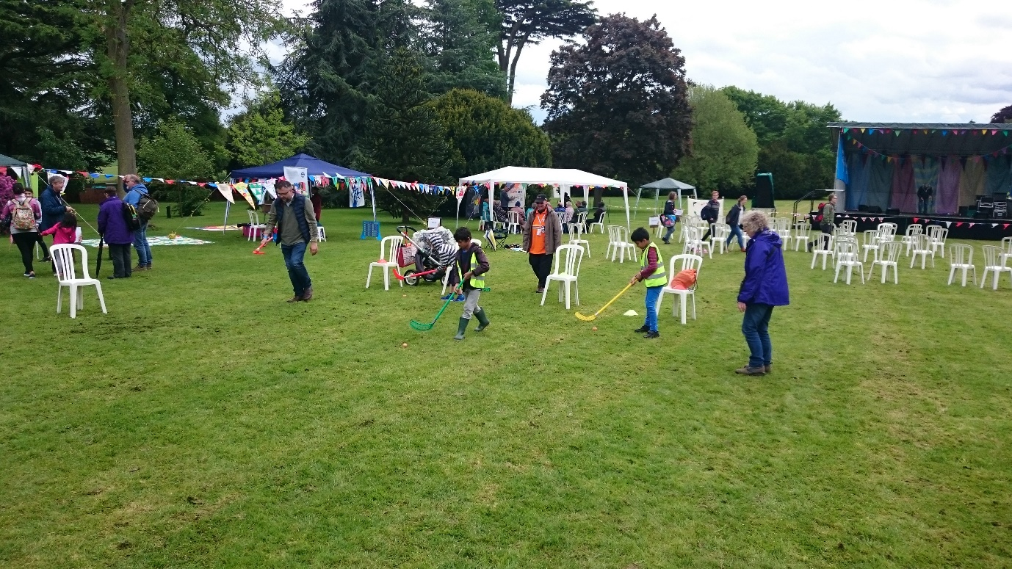

**VINE URC PILOTS Big Day Out at Warwick Castle, May 2017**

Twenty-five people came for Vine URC, including Pilots (ages 5 to 15 years); 6 Pilots leaders and 4 parents. Despite the weather, everyone had a good day, especially the teenagers. There was a lot to do and most of the group experienced most of what was on offer. The highlights were the birds of prey, the historic maze and the Arts and Crafts tent. Some joined in the sports and parachute games and the younger girls enjoyed the sticker activity.

Unfortunately, most of us missed the main worship due to the fact that many of the children were cold and wet by this time so we took them indoors. The few who did make it found the worship interesting but felt that the platform would have been better placed in the middle of the field with chairs all around it, central to all the activity stalls around the day.

Many of the children and young people we work with do not usually venture out of their area of London, except when visiting the country of origin of their parents. Therefore, outings such as this help to extend their horizons and they always appreciate such experience. We had a verbal evaluation at the Pilots meeting following the Big Day Out and gave them the opportunity to say what they gained from the outing and what they learnt, including some of the history of Warwick Castle. We also have outings attached to the August Week Holiday Club that we run each year as well as encouraging as many as possible to access opportunities provided by Pilots and other Youth and Children’s initiatives of the URC.

Thank you for arranging this day.