Website resources - Generosity

Intro - In the Bible there are many stories about people being generous. The small child with his packed lunch, the widow and her offering and Jesus’ example of giving your time and life for others. Generosity comes out of a place of gratitude, realising that all we have is a gift and pouring out our thankfulness by giving on to others less fortunate or in need.
As a church, we need to consider how we enable and encourage people to be thankful and generous in the world, sharing God’s love in practical ways.

Resources for specific Age groups

- Resource for work with children under 11

The 3 jars

A fun idea to encourage children to establish healthy generous habits. Excellent for children who receive pocket money. The child has 3 jars labelled, Save, Spend and Give. Encourage the child to put some of their money in each jar. When they are ready, they can decide what to do with the giving jar, buy something for a friend, give to charity or someone they know who needs pennies.

- Resource for work with young people aged 11-18

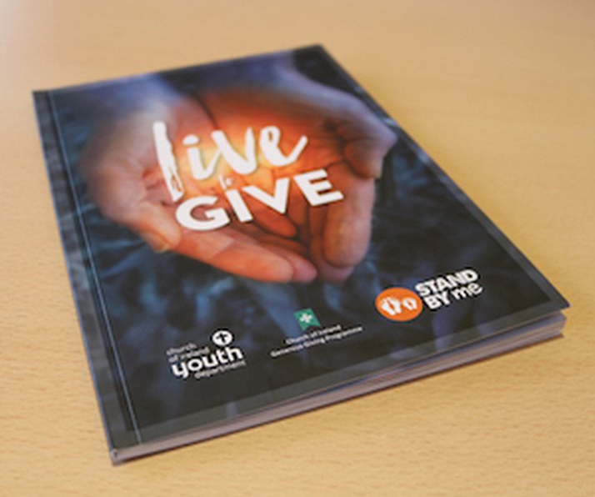
Live to Give Resource

The Church of Ireland Youth Department has launched Live to Give – a resource on generosity, giving and money, and what the Bible has to say about those issues. The resource has been written by CIYD National Youth Officer Simon Henry, Nicola Brown from the Church of Ireland’s Generous Giving Programme, and Jonny Farrell from Stand By Me – a charity working with children in the developing world.

Live to Give seeks to help young people to think seriously about how they give their time, talents and money, to carefully and prayerfully consider how their decisions may affect others, and to learn more of God’s generosity.

Live to Give is free and copies are available from the CIYD offices in Belfast (028 9082 8890) and Dublin (01 497 8422), and from The Book Well bookshop, in Belfast (www.thebookwell.co.uk). Orders can also be placed by email at admin@ciyd.org

- Resource for work with young adults aged 18-25

Lifeway provide extensive resources to explore generosity in small group settings. They have around 7 different 4 – 6 week resources to offer.

Check them out here: https://www.lifeway.com/en/product-family/generosity-resources

● Resources for Church together, Community or families

World Vision – Offer 5 top tips to parents and carers in how to develop generosity at each developmental stage of childhood into adolescence. You can find the top tips here:
https://www.worldvision.org/christian-faith-news-stories/top-5-ways-raise-generous-child-age

Reversed Advent Calendar

A simple idea for families to do together. Get an empty box and each day of advent put something in the box that a family might need and appreciate over Christmas. Food, presents and toys for example.

Creative ideas on Pinterest
Always check out Pinterest for lots of creative ways to explore and enable generosity.
https://www.pinterest.co.uk/search/pins/?q=teaching%20children%20generosity&rs=typed&term_meta[]=teaching%7Ctyped&term_meta[]=children%7Ctyped&term_meta[]=generosity%7Ctyped

Modern Parables
Story and picture books with a message about generosity.

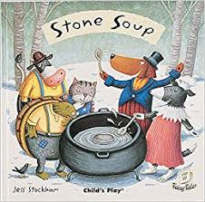
Stone Soup by Jess Stockham

This story is about a group of travellers (dogs in this version) arriving in a village in the grip of winter and food scarcity and meeting with initial mistrust and hostility from the villagers, but, by enticing the villagers to share their jealously guarded food stores to make 'stone' soup, they leave the village a much happier place than they found it.

The Starry Giraffe by Andy Bergman

Poor starry giraffe: every time he reaches for a yummy red apple from a tall tree, one of his hungry friends comes along and the generous giraffe shares the treat. Just when you think he has nothing left to eat for himself, a turn of the page shows otherwise: the starry giraffe is at an apple orchard and there are apples and trees galore!

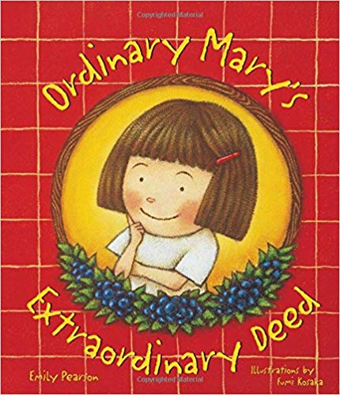
Ordinary Mary’s Extraordinary Deed

Mary is just an ordinary girl, but her simple act of generosity – picking a bowlful of blueberries and leaving them for a neighbor – sparks a pay-it-forward bonanza of kind acts, which leads to “… in only fifteen days – love was sent to every person everywhere!”

Reflection (5 Minutes’ Peace)

If your spiritual gift is “giving”, then give generously!

Scripture Reading: Romans 12:6-8
We have different gifts, according to the grace given to each of us. If your gift is prophesying, then prophesy in accordance with your faith; if it is serving, then serve; if it is teaching, then teach; if it is to encourage, then give encouragement; if it is giving, then give generously; if it is to lead, do it diligently; if it is to show mercy, do it cheerfully.

Reflection Thoughts:
Sometimes I feel guilty when I see other people around me that just seem to give so generously and so easily. My grandfather was one of those people – he just loved, loved, loved people. And would easily give the shirt off his back if asked – or maybe even if not asked. I so desperately want to be one of those people, even though I know I’ve got a long way to go. Romans 12:6-8 helps give me some perspective, though. “Giving” is a gift from the Holy Spirit. Wow!! It’s a spiritual gift – like prophecy, like teaching, like leading – giving is right up there!!

As Christians, we so easily exalt some gifts over others – the spiritual gift of preaching in Church – we lift it up on a pedestal, don’t we? But this verse reminds us – no! God hasn’t just made a few exalted spiritual gifts. He’s given each of us a gift. His church is made up of all kinds of different members with all kinds of different gifts. And we’re all crucial, critical, and important to His ministry, His work, and His purpose here on earth. To compare the “toe” to the “eye” isn’t fair, nor is it necessary. What this verse is saying is that – if you’re a toe – be the very best toe you can be. You don’t need to strive to be like an eye – that isn’t your purpose, isn’t your gifting, and that’s okay!! But it is your responsibility to be a really great toe.

Being the person with a gift of giving, it seems so attainable doesn’t it? Why not ask for the gift of giving? How amazing would that be, to be a giver? And yet, don’t down-play the gift of giving just because it seems so humanly attainable. This kind of giving has got to be spirit-led. It’s not just any type of giving, it’s generous, inspired, selfless, continuous giving. It’s jovial, cheerful, loving. It’s a beautiful gift that breathes life into every person it touches.

Application:
What is your spiritual gift? God promises to give good gifts to his children, and He bestows spiritual gifts on the members of his church. Has He blessed you with the gift of giving? Or would you love to be one of His faithful givers? Why not pray and ask for this gift? Take on the responsibility of giving in your church. Watch out for those that are struggling to make ends meet, watch out for those single parents who could use a homemade, pre-made meal delivered to them, watch out for those kids that need a mentor, watch out for the leader who needs a gift of thanks in a sometimes lonely job. Be the giver, the cheerful, generous giver, in your church community. Ask the Holy Spirit to open your eyes to the gaps around you, gaps that can be filled by you and your giving. Those people are just my favourite, aren’t they yours?!

Copyright belongs to biblelessonstuff.com

