Welcome to Families on Faith Adventures @ Home!

This resource has been put together for you by the United Reformed Church Children’s and Youth Work team and the synod CYDOs and their equivalents.

We hope you will enjoy sharing a time of faith and fellowship together as a family through these stories, games, activities and prayers. They are designed as a ‘pick and mix’ of ways to experience God’s message through the Bible, exploring what it means to you and express that in words and action. They are not linked to the lectionary but can be used in any order as we explore all the different parts of the Bible.

The Walking the Way challenges are one way of continuing our walk with Jesus throughout the week.

These ideas are designed to be intergenerational - maybe even to be shared with members of the family you can’t see now except via the internet.

The resources are based on our non-uniformed children’s groups, Friends on Faith Adventures and Pilots, but have been modified to make them suitable for all families at home.

These activities are planned to be used together as a family and under adult supervision. Please be aware of your family’s ages and abilities as some activities may need more adult support than others. Stay safe and have fun!

This week’s Bible story is:

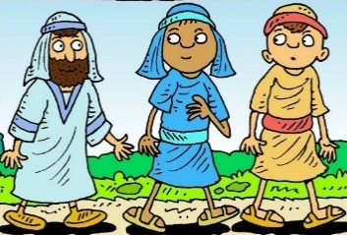
Journeying On
Luke 24 verses 13-35

With many varieties of activities and things to do to help explore the theme. Look out for this ‘hands on’ symbol.

From
and

Illustration by lambsongs.co.nz via freebibleimages.com

Get to know your Bible

The Bible is like a library made up of 66 books written by many different people over many years.

The Old Testament books were written before Jesus was born. They are the holy stories he would have grown up hearing and reading. There are 39 of these.

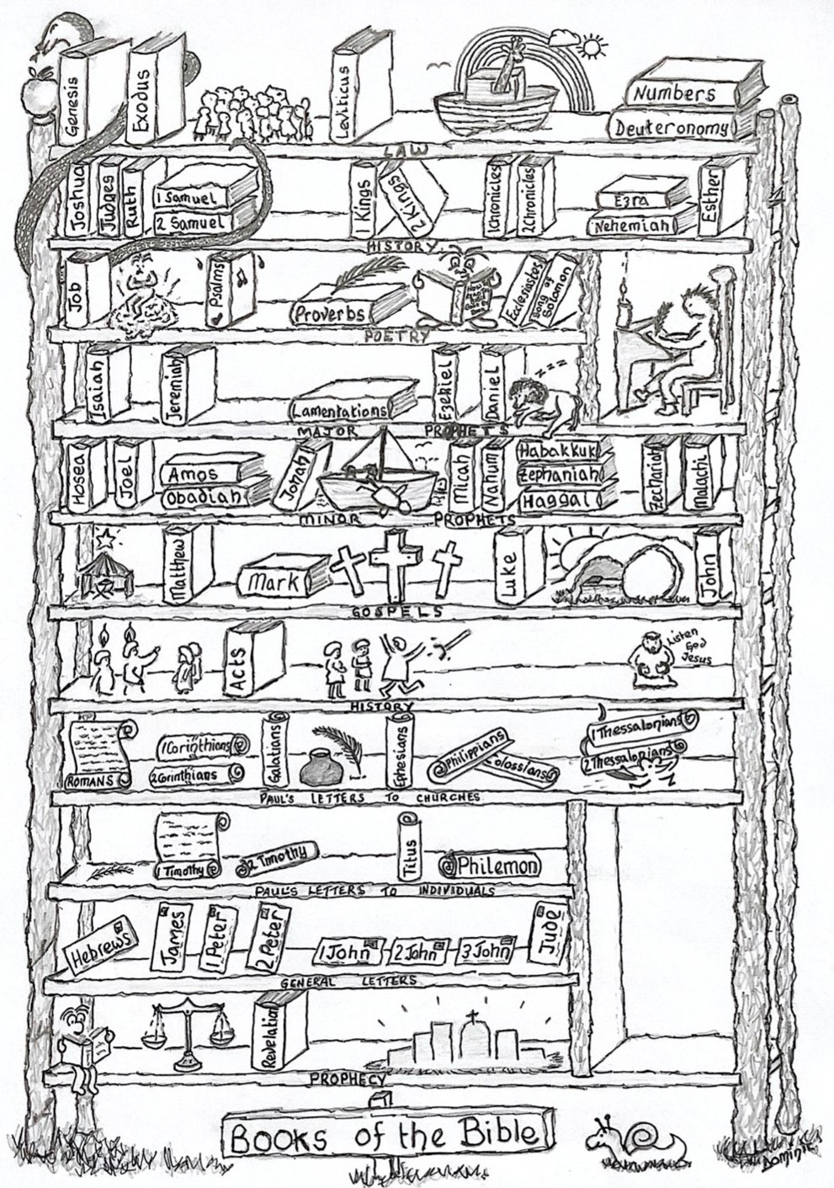
The New Testament tells us the stories of Jesus and his followers. There are 27 books in the New Testament.
Image by - Dominic Barton

Can you find and colour the book on the bookshelf that this week’s story is from?

If you have a Bible, see if you can find the story in there.

You could print this out once and colour each new book on the bookshelf as you read stories from it.

Bible context – Luke

The book of Luke was written around 60 AC by Luke the doctor who became a disciple of Jesus. Luke wanted to show Jesus being with people and remind us that Jesus came as the saviour for Gentiles as well as Jews.

This story takes place the same day that Mary found the tomb empty. Two of Jesus’ followers are on their way back home, going back from all that has happened in Holy Week and returning to their ‘normal lives’. Jesus is there with them but they don’t recognise him at first. The story reminds us that, as we walk on and carry on with our lives after the sadness and celebration of Easter, Jesus goes with us. I wonder how we recognise when he is with us.

Online versions of the story

Watch and Listen
Story told by the Bible Society https://www.youtube.com/watch?v=ndtnZV-5QTo&t=22s
Cartoon by Saddleback Kids https://www.youtube.com/watch?v=K3QkZsKLU2o
Retold by children https://www.youtube.com/watch?v=dwySzn1cxMc
Godly Play storytelling https://www.youtube.com/watch?v=ntuIbq6aaug
A disguise by Nicola Grieves https://www.youtube.com/watch?v=Hwi4pZtjsEE&list=PLkmvtYy-o_QvQzSJRvAfPLTTbcx-aeqRk&index=20

Dance and Sing
God Is Always With Us by VBS kids https://www.youtube.com/watch?v=0S9iU7B_lzY
Always With Me by Allstars kids club https://www.youtube.com/watch?v=N3nUpMnEUWE
Every Step by Nick and Becky Drake https://www.youtube.com/watch?v=nZBhKp5_HwE
Alive by Hillsong https://www.youtube.com/watch?v=qEvEVALLjNQ
Everywhere I Go by Preschool Worship https://www.youtube.com/watch?v=f_tS-g6z7l0

The Story – Luke 24 v 13-35 (The International Children’s Bible)

That same day two of Jesus’ followers were going to a town named Emmaus. It is about seven miles from Jerusalem. They were talking about everything that had happened. While they were discussing these things, Jesus himself came near and began walking with them. (They were not allowed to recognize Jesus.) Then he said, “What are these things you are talking about while you walk?”
The two followers stopped. Their faces were very sad. The one named Cleopas answered, “You must be the only one in Jerusalem who does not know what just happened there.”
Jesus said to them, “What are you talking about?”
The followers said, “It is about Jesus of Nazareth. He was a prophet from God to all the people. He said and did many powerful things. Our leaders and the leading priests gave him up to be judged and killed. They nailed him to a cross. But we were hoping that he would free the Jews. It is now the third day since this happened. And today some women among us told us some amazing things. Early this morning they went to the tomb, but they did not find his body there. They came and told us that they had seen a vision of angels. The angels said that Jesus was alive! So some of our group went to the tomb, too. They found it just as the women said, but they did not see Jesus.”
Then Jesus said to them, “You are foolish and slow to realize what is true. You should believe everything the prophets said. They said that the Christ must suffer these things before he enters his glory.” Then Jesus began to explain everything that had been written about himself in the Scriptures. He started with Moses, and then he talked about what all the prophets had said about him.
They came near the town of Emmaus, and Jesus acted as if he did not plan to stop there. But they begged him, “Stay with us. It is late; it is almost night.” So he went in to stay with them.
Jesus sat down with them and took some bread. He gave thanks for the food and divided it. Then he gave it to them. And then, they were allowed to recognize Jesus. But when they saw who he was, he disappeared. They said to each other, “When Jesus talked to us on the road, it felt like a fire burning in us. It was exciting when he explained the true meaning of the Scriptures.”
So the two followers got up at once and went back to Jerusalem. There they found the 11 apostles and others gathered. They were saying, “The Lord really has risen from death! He showed himself to Simon.”
Then the two followers told what had happened on the road. They talked about how they recognized Jesus when he divided the bread.
Scriptures quoted from the International Children’s Bible®,
copyright © 1986, 1988, 1999, 2015 by Tommy Nelson, Used by permission.

Ideas to Retell/Explore the Story

Finding Jesus in the Ordinary
This story is a reminder that Jesus is in every moment, though we don’t always feel it and are not always aware of God’s presence. Take a look at the picture provided and place a token (this can be anything you make to represent Jesus) onto the picture to show where you think Jesus might be found. Have a conversation together about where he is and why. Is it always in the good parts of the picture or is he in the sad, angry parts too?
You could do this activity with your own pictures too. Take photos during the week and play the game of placing Jesus where you think he would be found. This can also be done with newspaper pictures.
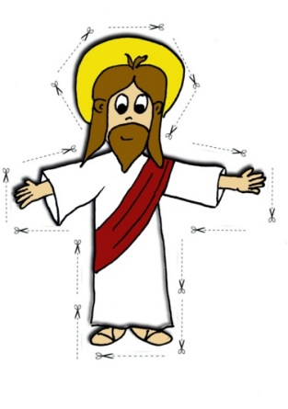
Where is Jesus found? What is Jesus doing, saying, feeling?

Where Would You Find Jesus?
Well, that is the question. Where would you find Jesus today? Would you find him in a fight? Would you find him in a quiet corner? Would you find him when you’re running away?
Cut out the picture of Jesus and place him on the playground picture where you think you might find him. Different people may see Jesus in different places.

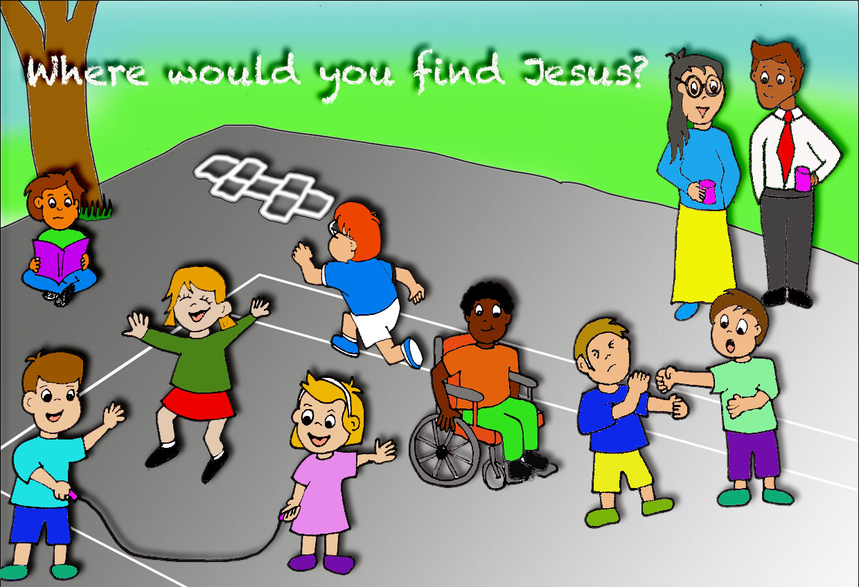

Looking Back to Recognise Jesus
This is a similar activity to the picture game. Draw a timeline of your life, or this last time in lockdown, or even just over the past week/day. Mark the times when you can recognise that Jesus was with you and think about how you knew that.

Zoom Games

Who was it?
This game works well on screen and is very simple. Everyone turns off their videos and replaces their names with an X. Then the leader sends via private message a phrase to one person that they need to say, disguising their voice. Everyone else has to guess who it was. The person who spoke can also play along with the guessing to throw everyone off the scent.

Where’s Jesus?
Cut out a small picture of Jesus or a colourful J. Hide it somewhere in your room so that it could be just visible on your screen. Each time your friends or family are together on zoom, you try to find Jesus in each other’s spaces.

Modern Parable
Modern stories that explore the themes.
Where is my darling daughter? By Mij Kelly and Katharine McEwen
A father spends all day looking for his darling daughter, only to find she has been nearer than he thought.

Together by Emma Dodd
An excellent resource for under 5s. Beautiful pictures and simple words that encourage us to think about how God is always with us. A perfect bedtime story.
https://www.youtube.com/watch?v=KIHCm7ilosw

Table Top Discussions
Each day over a mealtime, have a quick conversation. Here are a few questions to get you going.
In the story, the disciples said that they felt different when Jesus was with them, they felt it in their hearts. What do you feel when you know Jesus is near? (perhaps a thumping in your chest, or a lightness)
I wonder why the disciples went back to Jerusalem to tell the other disciples, and didn’t stay on their home town telling the people there?
If Jesus appeared next to you right now, in the flesh, what would you ask him or say?
What does it mean to walk with Jesus every day?
How can we get better at recognising when Jesus is with us? How can we help others to be aware that He is with them too?

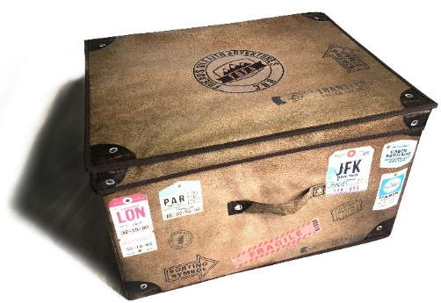
What’s in the box? What treasures can you find to put in the box for your
little ones to explore?

Perhaps older children could help find the things.

Use a box or a bag to hold the treasures and encourage any little ones to explore what’s in the box/bag each week to go with the Bible story.

Green or yellow fabric and a strip of brown fabric or paper to represent the road
Something with rainbow colours for God’s promise

Three small toy people

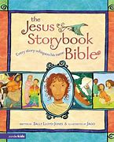

Children’s Bible book

Child’s shoes or sandals

A bread roll (real or toy or plasticine)

Toy sunglasses or a mask which hides a face
A beaker or unbreakable cup

Pray Together

Be Still Prayer
Sometimes all we need to do to come close to God is to be still. Just as the friends recognised Jesus in the prayer over the breaking of the bread, we to can come close to God in prayer and all we need to do is just be still.
Find a quiet and comfy place, close your eyes and take a few deep breaths.

Quietly to yourself say the words, “Be still and know that I am God.”

Take a couple of deep breaths and say, “Be still and know that I am.”

After a couple breaths, pray “Be still and know.”

After a couple breaths, pray, “Be still.”

After a couple breaths, pray, “Be.”

When you are ready, pray, “Amen.”

Be still and know that I am God.
Be still and know that I am.
Be still and know.
Be still.
Be.

A video version is available here: Be Still on Vimeo

Pray Together

Dot to Dot Prayer
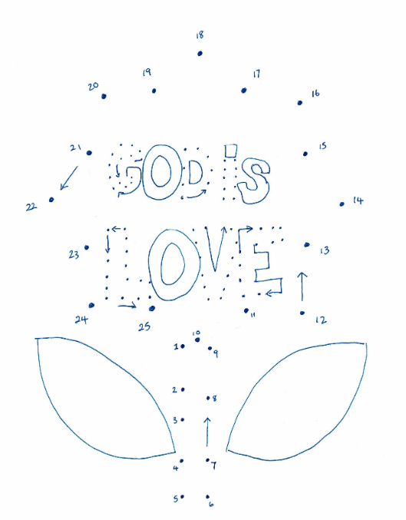
The friends did not recognise Jesus at first, although later they realised that there had been something different in their conversation with him.
Try doing this dot to dot picture. The image and words are not clear but, by joining the dots, the full picture will be revealed. As you follow the dots you will come to some arrows along the way. Just as the friends in the story shared a conversation with Jesus, when you land on an arrow pause for a moment and talk to God.

A4 version picture is available at the back of the resource.

Sensing God – Prayer Activity

You will need: A Cloth bag, box (recycled is fine), or a pillowcase to make a hidden container for your things.
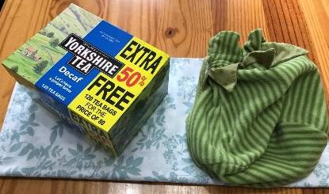
Into your bag, place everyday items that help you remember Jesus is with us in all situations. When times are hard, tough and cold, or comfortable and soft. It’s good to be reminded that in everything we can be connected through prayer. The paperclip helps us remember this as it links things together just as prayer can. The heart reminds us that no matter how we feel, Jesus is always there alongside us, willing to hear our prayers and talk with us. He always listens when we pray. The small ball of wool reminds us that sometimes life becomes knotted and unravels and that might be the very time prayer can help.

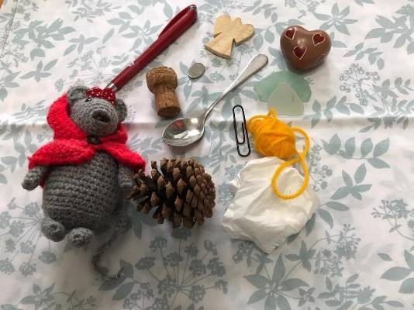
Place things that have a range of different textures into the bag. In turn, put a hand in without looking and see what you can feel. Can you link the texture you feel to a prayer for yourself, a friend or member of the family or a situation where God’s love, strength, and comfort may be needed at this time?
Please be mindful of small parts if you have younger family members, and avoid things that may be too sharp to touch without seeing first.

Pray Together

A Prayer Walk
The earth and everything in it belong to the Lord. Psalm 24:1
On the road to Emmaus, the friends walking together did not realise immediately that they were walking with Jesus. We do not always notice what is all around us. Everywhere we look, God is close to us. There are signs in nature, our surroundings and the people we meet.
Go for a walk in your community.
What can you see? I wonder where you see God?
Stop, look and listen at various stages of your walk and talk to God about the things you can see and hear: gaze at the sky and the patterns the clouds make, listen to the trees and the birds, look at the colours and feel the different textures. How many different plants, animals, insects can you see and how many different textures can you explore? Who do you meet on your walk? What about the buildings and signs you see and the traffic that passes – where is God in these? What do you notice about your community?
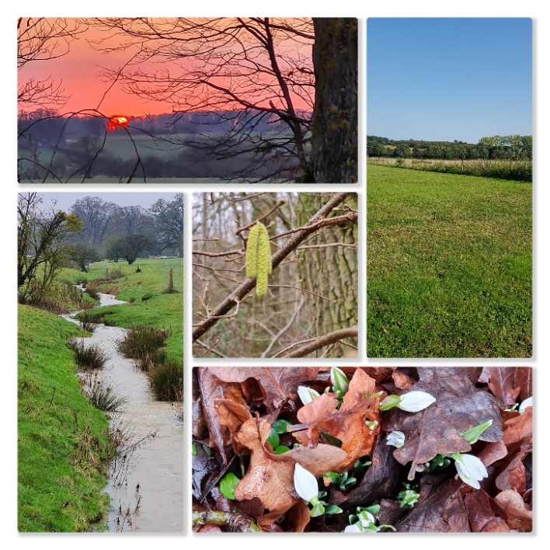
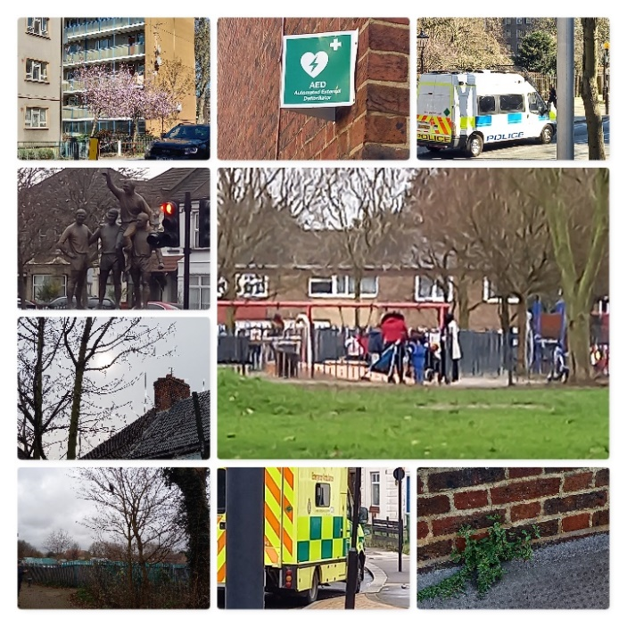
When you get back from you walk write up your thoughts and feelings or make a picture. Where have you seen God?

I wonder which is your favourite part of this story?

I wonder what the followers would have done if they hadn’t met Jesus?

I wonder if there’s ever been a time when you’ve not recognised someone you know?

I wonder whether you can recognise Jesus in the people who walk alongside you every day?

I wonder why you think Jesus disappeared when they recognised him?

Illustration by lambsongs.co.nz via freebibleimages.com

TO DO TOGETHER…

The Bible story tells us that God made it so that the two followers of Jesus did not recognise him, even though he was walking alongside them and talking to them.
Sometimes we are so busy looking at what we think we see that we do not see what’s right there in front of our eyes. It is as though they are camouflaged. Sometimes it is even as though God is camouflaged – we have to look for him in the world around us.

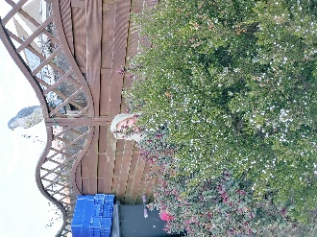
Camouflage
You will need: A big pile of cushions
soft toys and blankets
What you do:
Camouflage yourself, using the cushions, blankets, and soft toys. Maybe even put on your rainbow glasses.
See how long it takes someone to spot you.
If you are doing this outside, wear something the same colour as your surroundings and see if you can disappear into the background. You may even have some camouflaged clothing.

Rainbow Coloured Glasses
All sorts of things can change how we see things. Sometimes it depends on our mood; sometimes whether we are distracted by something else; sometimes we may only see what we expect. Make these rainbow coloured glasses to remind you that you may be seeing things differently to someone else, or even differently to how things really are.
You will need: A piece of card
Some coloured cellophane from sweet wrappers
or clingfilm or tissue paper
What you do
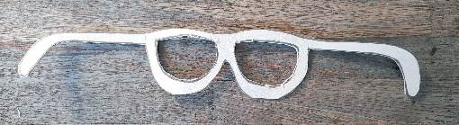
Draw out the shape of a pair of glasses, (see the template) and cut them out.
Spread some glue around the edges and stick strips of cellophane to create a rainbow effect.

Alternatively:
using felt pens, colour some cling film and then glue to the glasses.

TO DO TOGETHER…

Texture Rubbing
Our story today shows Jesus walking with his followers but the followers not recognising him. They didn’t even recognise him when he started to talk with them, although afterwards they looked back and realised that the clues had all been there. As you do your texture rubbings, think about the clues that showed that Jesus was with them on their journey and how exciting it must have been when they suddenly realised who or what they were looking at.
You will need: Paper
Crayons or pencils

What you do:
Take some paper and a pencil, look around your house or outside for interesting textures which you can make a rubbing of, it may be bark from a tree, leaves, a metal plate, a carved stone in a building. You can also find some coins, or keys or shoes.
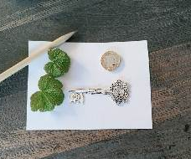
Place the paper over the item and gently rub the crayon or pencil over it, (be careful not to rip the paper) If you are using a pencil use the side of the pencil tip.
See the image come through, it may not be an exact imprint, but it should resemble it.
Maybe the people on the road recognised Jesus but couldn’t remember who it was.
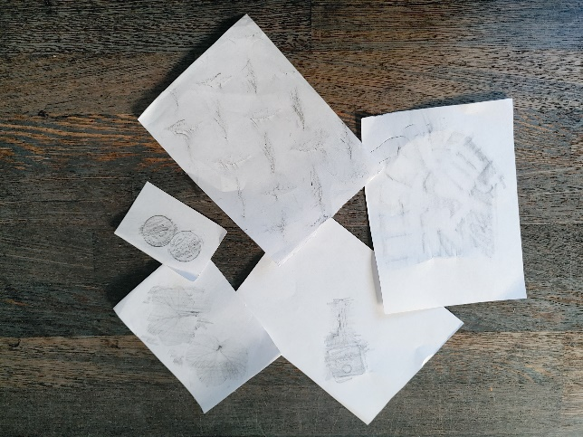

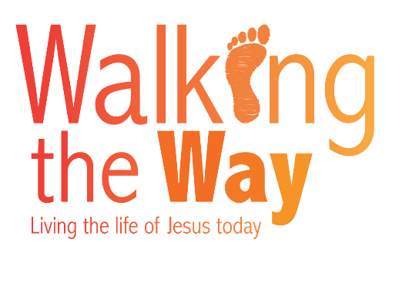

Although we know that God is with us all the time, it is easy to forget. This week be intentional about reminding each other that God is with us, whether we’re doing homework, playing, washing the dishes or doing the shopping.

Our Walking the Way Challenge
this time is…

At Home:

In our prayers this week we had a prayer walk. Try to be aware of God’s presence whenever you’re outside this week, especially in the playground at school. How can you be like Jesus for others when they’re finding things tough?

Outside:

Make a prayer dot-to-dot for someone else that you know and share it with them.

For Others:

Adventurers Go!
You’ve shared together, now share with us!

Why not send photos of your crafts, your treasure boxes, your Walking the Way challenges - or dress up to make a tableau of the Big Story and take a photo to send in.

Email your photos to: lorraine.webb@urc.org.uk
with parental permission for them to be used in publicity and online URC social media.

Alternatively, share them on our Facebook page https://www.facebook.com/URCchildren.and.youth/

Remember you can find more resources on our website:
https://urc.org.uk/resources-for-children-and-youth

And if you’ve enjoyed these activities, why not see whether your local church runs Pilots or Friends on Faith Adventures (FOFA) when things get back to normal again.

Created for you by Nicola Grieves (Eastern Synod), Judy Harris (National Synod of Wales), Hannah Middleton (Northern Synod), Philip Ray (Wessex Synod, North), Lorraine Webb (Programme Officer for CYW), and Ruth White (Wessex Synod, South) on behalf of the CYDO+ and Children’s and Youth Work team and Pilots.

Templates

Templates

