Welcome (Parents and Carers asked to stay until after the Pilots Prayer)
Welcome back to Friends on Faith Adventures. We are looking forward to going on a journey and nobody knows where we will end up. All we know is we have got our crate filled with adventure and an open path ahead. So, hold on tight and enjoy the ride!!
Let’s hear about FOFA bear and FOFA cam’s adventures this week and how everyone got on with the Walking the Way challenge. (Encourage everyone, including parents and carers, to join in.)
The Pilots Prayer
Lord help us to be:
Prepared for adventure
In all we do.
Loving and caring,
Open to others
Together as one community
Sharing the love of Jesus on our way.
Amen

Fun Together
Game 1
Required for the game
A large torch that will spin on the floor.
A number of challenges
Get the children to sit in a large circle and place the torch on the floor in the middle of them. Spin the torch and who ever the beam lands on has to do one of the challenges. Examples of this could be to say a tongue twister 5 times really fast, to pat your head and rub your tummy, eat 5 dry crackers with out water at once, pretend to be a farm animal etc.

Game 2
Place a sheet or get a projection screen in front of a lamp and get the children to make shadow animals on the screen. See examples below:
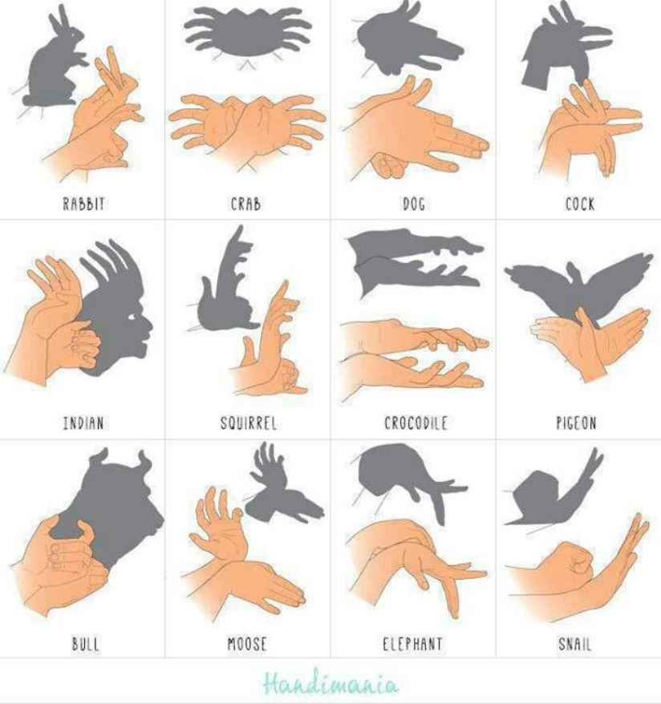
The aim is to introduce the theme that Jesus was surrounded in great light.

Today’s theme is about how when you’ve been close to God, other people can tell
The Big Story: Mountain Top Vision John 21
Required in the bag:
- Small Desk lamp
- White sheet with hole cut in the middle (to place over Jesus)
- Wooden walking sticks, ropes etc
[You will need 6 volunteers]
Reader 1: So today we are looking at a time when Jesus and some of his friends went for a walk up a mountain.
Reader 2: Cool! Is this like one of those action films where they swing across glaciers and hang one handed off cliff faces and make it to the top by holding on with just one finger nail?
Reader 1: Errr no, not really
Reader 2: (big sigh and look glum)
Reader 1: This is the story of what is called the transfiguration.
Reader 2: The trans whaty what?
Reader 1: Well listen and I will tell you. Jesus went on a walk with three of his disciples Peter, James and John. They went to the mountain to pray.
(get 4 children to play the parts of Jesus and the three disciples)
Reader 2: Why do they sometimes have to go to extreme places to pray?
Reader 1: Mainly because they were quiet and they could feel closer to God.
Reader 2: But they will need the right equipment to get up a mountain!
(go in to the bag and get out walking stick and rope)
Reader 1: When they got to the top they were preparing to pray when something amazing happened.
Reader 2: What? Did they meet a yeti?
Reading 1: I think you’re being a silly! No suddenly Jesus began to shine really brightly.
(Plug in and shine the desk lamp on Jesus)
Reader 2: Woah!
Reader 1: It gets better! Suddenly someone was standing next to Jesus. It was Elijah, a man who had told people about God many years before that. His story is in the Bible.
(get a young person to be Elijah)
Reader 2: No way! Elijah must have been dead 900 years by then
Reader 1: I know! and it get better on the other side of him was Moses, In the Bible you can read about Moses being sent by God to save God’s people from being slaves in Egypt.
(get child to be Moses)
Reader 2: What he must have been dead by at least 1500 years by then
Reader 1: Amazing, isn’t it? Well, the disciples were amazed. Peter said to Jesus, “It’s a good job we are here. We can build a tent each for you, to keep you warm.”
Reader 2: That’s a great idea. It can get really cold at the top of a mountain.
Reader 1: But before Peter could finish his sentence, a great voice could be heard saying (in booming voice): ”This is my son with whom I am well pleased. Listen to him.”
Well you can imagine the disciples were REALLY frightened and fell to the floor!
(get children to fall to the floor)
Reader 2: I’m not surprised I think I would have. Seeing to dead men and hearing GOD!!!
Reader 1: But Jesus came to them and touched them saying “rise and have no fear” and when they looked up it was only Jesus again.
Reader 2: Well that would make a good story to go and tell their friends over the camp fire that night.
Reader 1: Actually it wasn’t. On the way down Jesus told the disciples not to tell anyone about what happened until he rose from the dead, because he knew that would happen.
Reader 2: That’s some experience for the disciples!
Reader 1: Yes, it was and from then those disciples knew for sure who Jesus really was and they were changed from that moment on.
Reader 2: I wonder whether people can see a difference in us when we’ve been talking to God?

Creative Adventure
You will need:
Cardboard Tubes (kitchen rolls, mailing tubes etc)
Tracing paper/baking paper
Keyring torches https://www.amazon.co.uk/Keychain-Flashlight-Camping-Keyring-Portable/dp/B07B1YYCHZ/ref=sr_1_3?keywords=vadiv+keyring+torch&qid=1571049963&sr=8-3
Scissors
Glue or sellotape
Sharpies/ felt tips
Take the cardboard tube and cut out a square about 10cm high and 5cm wide, then cut out a piece of the tracing paper a little bit bigger (12 x 7cm). Get the young people to draw a picture of Jesus on the paper.
When they have done this, stick the image of Jesus on to the inside of the tube so that it can be seen through the hole in the tube.
Take a torch and cut a hole in the cardboard directly behind the image of Jesus, just big enough to fit the front of the torch through. Then you can press the on and off button to illuminate Jesus and make him glow with great light.
If you would like to extend the session the children could decorate the tube itself and add the bible reference to it.
Wondering questions to use during creative time:
I wonder what you would have done if you had been there?
I wonder if God still sends people to share his message and how we can tell?
I wonder how we can show the earth Gods message?

The Adventure Map
Explain the Adventure Map and how a lot of the books were written shortly after Jesus’s time. They tell us about what Jesus said and did and how his friends lived their lives, sharing with others how to be good followers of Jesus.
Take the young people to the Adventure Map that you have created on the wall. Get the children to find where on the Map today’s story came from. Choose one or some of the things created by the children to be photographed and attach this to the wall to create a visual reminder of where the story came from and your adventure together. The aim is that in a year you will have lots of reminders of the stories and where in the Bible they come from. Use a piece of string or ribbon to connect the photo of the craft work to the book of the Bible.

Walking the Way
This is a time to invite the parents and carers back in to share what the children have been up to during the session. They will also be here to hear about the Walking the Way challenge and the tasks (should they choose to accept them) that the children (and parents) are about to undertake.
For the Younger: FOFA the bear
This is FOFA. FOFA likes nothing more than to go on an adventure; FOFA is a little more adventurous than me. FOFA believes that faith is a journey and that’s why FOFA would love to take you on a journey with him and walk the way of God in our everyday lives. Each session FOFA would like to go home with one of you and add to FOFA’s scrapbook of things you do together. FOFA doesn’t mind if you draw a picture of what you have done, take a photograph or just write a story about it. FOFA also doesn’t mind if you just come and tell the rest of us what you got up to together. But because FOFA’s memory isn’t very good as FOFA’s brains are made of stuffing, it would be better to save the memories in the book if you can. At the end of our time together we can always remember the great adventures we have been on together with FOFA and hopefully you will walk a little closer with God.
For the Older: FOFA cam
This camera is your window on the world. You have one shot at this, so choose carefully. You will be given a very precious piece of equipment – a FOFA cam. You have one photo to take with the camera, that records one thing – a way you have met the challenge. If there are other people in the photo, please ask their permission first and explain this photo will be put on display here. Bring back the camera and your photo next time to share your moment - and remember you only have ONE shot at this!
Every time we will choose someone to take FOFA bear and someone to take FOFA cam to help them with the challenge – but we can all have a go at the challenge!
Our Walking the Way Challenge this time is: Find someone older than you who follows Jesus. Ask them to tell you a bit about their faith adventures and tell them about the things you have learned through FOFA

Adventurers Go!
So, today’s story was about how God showed the disciples that Jesus linked the old stories in the Bible with what was happening in their lives. Jesus looked different when he was talking to God and the disciples could tell he was a very special person, someone they could listen to and trust. We can trust Jesus too and know that the stories in the Bible link with what’s happening in our lives. As we get to know God and Jesus better, people will be able to see it in the things we do and say.

Prayers (choose one/both)
Dear God
Help us to try to listen to you and trust you and get to know you better every day.
Help us to see you clearly and to spread your light in our world through the things we say and do.
Help us to know that you are always with us.
Amen
Active Prayer
Get the table lamp and place it in the middle of the room.
Invite the children, if they want to, to come up and say “Jesus, let your light shine upon me”
Close by saying: Jesus we have seen and felt your light upon us. Let it shine through us to everyone we meet.
Amen

End Prayer Every Session: Altogether
We are Friends on Faith Adventures, travelling together with God.
Adventurers go! Amen

What you will need:
Game:
- A Torch that will spin on a floor
- Some challenges written down
- Projector screen/ white sheet
- Lamp
For the BIG story
- Small Desk lamp
- White sheet with hole cut in the middle (to place over Jesus)
- Wooden walking sticks, ropes etc
For the creative adventure
Cardboard Tubes (kitchen rolls, mailing tubes etc)
Tracing paper/baking paper
Keyring torches https://www.amazon.co.uk/Keychain-Flashlight-Camping-Keyring-Portable/dp/B07B1YYCHZ/ref=sr_1_3?keywords=vadiv+keyring+torch&qid=1571049963&sr=8-3
Scissors
Glue
Sharpies/ felt tips

Location | Possible hazard | Action required | Action taken | Signature
During session | Children being hit by tables | Help child acting as Jesus to turn over tables | Member of team identified in advance to support
During session | Use of sharpies and possible damage to clothes | Consider offering protective clothing | Offer children protective clothing and warn older children of the indelible nature of the pens.
During session | Use off scissors possible cutting of hands | Use rounded end scissors or closely supervise young children | Allocate a helper to the younger children or get an adult to do the cutting

