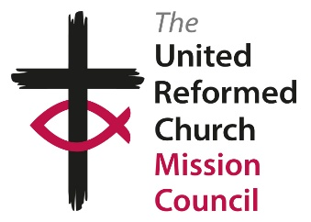
The United Reformed Church
Mission Council Agenda
10 July 2020

First Session: 10.30 to 11.30
In the Chair – Derek Estill
Call to Order and Notices Clerk and General Secretary
Welcome Moderator
Opening Devotions David Coaker
Welcome to New Members, etc Moderator
Resolutions 32 and 33 Michael Hopkins
En bloc items John Proctor
The En bloc resolutions are 10-19, 21, 23, 26, 28, 31, 34-35, 37-42.
There is a correction to Resolution 10: David Livingstone URC, Harlow, Eastern Synod has not yet closed.
N.B. Resolution 36 is withdrawn entirely from the agenda, at the request of the Convenor and decision of the Moderators. After further consultation, the Education and Learning Committee will hope to bring the matter to a future meeting.

In the Chair – Nigel Uden
Resolution 25 Pastoral Supervision Ministries Committee: Paul Whittle
Resolution 29 Safeguarding Safeguarding Adv Gp: Richard Church
Resolution 27 Walking the Way Mission and Discipleship: Francis Brienen

Second Session: 11.45 to 12.45
In the Chair – Nigel Uden – continuing as necessary with Resolutions 25, 29 and 27

If time in second session allows,
In the Chair – Derek Estill
Resolutions 20+22 Pension Funds Finance Committee: John Piper

Third Session: 14.00 to 15.00
In the Chair – Derek Estill – continuing as necessary with Resolutions 20 and 22
Resolution 30 Defibrillators Wessex Synod: Sue Brown

In the Chair – Nigel Uden
Address to the Throne John Proctor
Final actions including farewells Moderator
Closing Prayers David Coaker

